Introduction to MacOS Environment Setup

GitHub RepoCreate New Issue

In this module, we will walk through the process of setting up your macOS local development environment.

Note: If you are not using a Mac computer for this course, skip the lessons in this module.

Brief History

Understanding Environments

A software environment describes the set of tools that work together to enable you to develop and execute the code that you write. Environments typically include the operating system, databases, programming languages, and related tools like text editors or browsers.

Comparing Environments with Machines

You may hear us use the term "software environment" and "machine" to mean similar things. A machine describes the physical hardware that your software environment runs on. You'll hear the term machine and computer used interchangeably. Different machines (like PCs and Macs) use different hardware to run the programs that they use. Differences in those machines mean that setting up your development environment on one type of machine could look much different than setting it up on another.

macOS Operating System

To work around some of the differences between machines, and specifically between operating systems, we recommend that all students whose computers come pre-installed with the Windows operating system use a tool called Windows Subsystem for Linux (WSL). Windows Subsystem for Linux provides a Linux-based environment for interfacing with and developing on a Windows operating system.

macOS is a UNIX-based operating system. UNIX-based operating systems are very commonly used in professional software engineering settings. Learning how to use a UNIX-based operating system will be valuable for your future software engineering career. You may have heard of other UNIX-based operating systems like Ubuntu, Debian, or Fedora, which include the Linux kernel (core software). These types of operating systems work similarly.

Terminals and Shells

You may be familiar with opening files and applications on your computer by clicking icons, or viewing a website by typing an address into the address bar and seeing what pops up. These graphical user interfaces (GUIs) created a revolution in computing and are still extremely helpful in getting work done for many non-technical computer users.

Before graphical user interfaces (GUIs), the way to tell the computer to do something was through a terminal. The terminal included a screen, which would display only text, and a keyboard. The screen and keyboard were connected to a computer and you type into the keyboard what you wanted the computer to do. Then, you press <Enter> and would wait for the computer to finish.

Terminals are still used frequently today, especially in software development. We can connect to another computer on the internet, give it instructions by typing in commands, and view the result on our screen. The way that modern computers emulate the terminals of yesterday is through a program called a command-line interface, or a shell.

Similar to operating systems, there are many different types of shells. The shell that we use supports on the macOS operating system is called zsh, short for Z Shell.

macOS Terminal

The "Terminal" application is a text-based way to browse and work with files on your computer. We will be using the "Terminal" application during the environment setup and the duration of the program. For now, let's start to see what "Terminal" and more generally, shells can do.

View Your Desktop in "Finder" and "Terminal" Applications

To complete the environment setup, you will need to be able to open applications. You can open new applications by using the search bar at the bottom of your screen. The search bar says, "Type here to search".

Action Item: View Your Desktop in the "Finder"

The "Finder" application is a visual way to browse the files on your computer. You may already be familiar with the "Finder" application. This application allows you to quickly see the files on your desktop, downloads, documents, pictures, music, videos, and much more.

Click on the "Spotlight Search" magnifying glass icon in the top-right corner of your window

Type "Finder" and open the application

Find and open the "Desktop" folder in your "Finder" application

Action Item: View Your Desktop in the "Command Prompt" Shell

The "Terminal" application is the terminal that will allow us to interface with our computer through a shell. This action item is to primarily get you comfortable running commands in any shell so that you can work through the environment setup on your own.

Open the "Terminal" application using the "Spotlight Search"

Type cd /Users into the terminal and press <Enter>

Type ls (lowercase L and lowercase S together) into the terminal and press <Enter>

Look for your username in the list

Type cd into the terminal, add a space, and type your name as it appears in the list and press <Enter>

Type ls into the terminal and press <Enter>

Look for the "Desktop" folder in the list

Type cd Desktop into the terminal and press <Enter>

Type ls into the terminal and press <Enter> (Note: if prompted, allow "Terminal" to access files in your Desktop folder.)

Check Your Work

If you were able to open your desktop in the "Finder" application and you were able to open the "Terminal" application and cd to your desktop in that application, you should see that you can see the same list of files in both the graphical user interface (GUI) and in the command-line interface (CLI) or shell.

This may be your first time using the "Terminal" application or any terminal or shell. Now you know how to see the items on your desktop through the "Finder" application and through the "Terminal" application.

Preparing for Your Environment Setup

During the environment setup, you will be spending a lot of time in your "Terminal" application.

As much as possible, copy and paste commands that we ask you to run there instead of typing by hand to prevent environment setup issues.

Specific keys that you need to press will be surrounded by < > (for example, <Shift>, <Space>, <Enter>).

You will need to be comfortable switching between windows; we will primarily be using the browser and the "Terminal" application.

You should be able to start and stop the environment setup.

If you get stuck, reach out to your classmates or an instructor.

**MacOS System Setup**

The following instructions are for macOS Catalina through BigSur. If you are not on Catalina or a later operating system like BigSur but have the option to update, we recommend doing so before following the instructions below.

**Note**: Throughout the environment setup, you will see commands that look like this:

$ whoami

Any time you see a command like this with a $ at the beginning, those commands should be entered in your terminal **without** the $. So for the example above, you would type whoami in the terminal (without a $).

**Check That Your macOS System is Compatible with Moringa's Requirements**

When working on software, it is important that your computer and the software you’re using are compatible. In this step, we’ll ensure that you can install all the tools you will need to complete the program.

**Action Item**

1. Click on the Apple () menu in the top left of the window
2. Choose "About This Mac" from the menu
3. Look for the version name (for example, "macOS Big Sur")
4. Look for the version number (for example, "Version 11.4")

**Check Your Work**

If your version name is macOS Catalina or Big Sur and your version number is greater than "Version 10.15.0", your computer meets our requirements for the course and you can continue below.

If your computer does not meet the requirements listed above, but you can upgrade, we recommend that you upgrade after completing the environment setup.

If your computer does not meet the requirements and you can't upgrade, some programs may not work for you. Please reach out to an instructor for more information.

**Check that Your macOS System Has Enough Space for Moringa’s Requirements**

The programs that we’ll be installing during environment setup and all of the work you’ll do with us will need at least 4 GB of free disk space. Follow the steps below to ensure that you have enough disk space to install all the programs needed during environment setup.

**Action Item**

1. Click on the Apple () menu in the top left of the window
2. Choose "About This Mac" from the menu
3. Click the "Storage" tab header
4. Look for your macOS partition (for example, "Macintosh HD")
5. Look for the storage (for example, "119.59 GB available of 186 GB")

**Check Your Work**

If your free space for your macOS partition is greater than 4 GB, continue below. Otherwise, click "Manage..." to open the System Information window and free up some storage space.

**ALERT - For New M1 Mac Laptops ONLY**

If you are using a Mac laptop with the new **M1** chip (released in late 2020), there are some additional steps required at this stage to ensure all necessary tools install correctly. Follow the steps below instead of the normal instructions provided for installing Xcode, Homebrew and Ruby.

**1.** Instead of installing Xcode via the directions in the next section, open your terminal and run the following to install Xcode:

$ xcode-select --install

**2.** Create a duplicate copy of the terminal app that can run x86 programs with Rosetta. Follow the steps [detailed in this articleLinks to an external site.](https://www.notion.so/Run-x86-Apps-including-homebrew-in-the-Terminal-on-Apple-Silicon-8350b43d97de4ce690f283277e958602) ([https://www.notion.so/Run-x86-Apps-including-homebrew-in-the-Terminal-on-Apple-Silicon-8350b43d97de4ce690f283277e958602Links to an external site.](https://www.notion.so/Run-x86-Apps-including-homebrew-in-the-Terminal-on-Apple-Silicon-8350b43d97de4ce690f283277e958602)) to do this.

**Note: Every installation step should now be done in the terminal window that has Rosetta enabled**

**3.** Install Homebrew with the following command:

$ arch -x86\_64 /bin/bash -c "$(curl -fsSL https://raw.githubusercontent.com/Homebrew/install/master/install.sh)"

**4.** Run the following three commands one after the other to install RVM and Ruby:

$ curl -sSL https://get.rvm.io | bash -s stable

$ source $HOME/.rvm/scripts/rvm

$ rvm install 2.7.4

**In addition, if you are using an M1 laptop, you will already have Zsh installed and in use, so you can move on to installing Chrome and VS Code below.**

**Install Command Line Tools for Xcode**

Command Line Tools for Xcode is a suite of development tools from Apple, including tools for building Mac and iPhone applications. It will help you to quickly set up your environment by downloading and installing essential tools for other programs we'll be installing.

**Action Item**

1. Open the [Apple Developer Download webpageLinks to an external site.](https://developer.apple.com/download/all) ([https://developer.apple.com/download/allLinks to an external site.](https://developer.apple.com/download/all))
2. Look for the most recent version of "Command Line Tools for XCode (**Note**: Make sure to look for "Command Line Tools" in the name, as there is also a separate "XCode" package. You want the "Command Line Tools for XCode"). At the time of writing, the most recent version is "Command Line Tools for Xcode 12.5".
3. Click "View Details" to see more information about the download
4. Click "Command Line Tools for XCode 12.5.dmg" to download
5. When the download is finished, click on the file to install

**Check Your Work**

Open the "Terminal" application using "Spotlight Search", at the terminal prompt type xcode-select --install and press <Enter>. If your terminal says "xcode-select: error: command line tools are already installed...", continue below.

**Install Homebrew**

Homebrew is a package manager for macOS. It allows us to quickly install a number of programs we will need.

**Action Item**

1. Open the "Terminal" application using "Spotlight Search"
2. Type /bin/bash -c "$(curl -fsSL https://raw.githubusercontent.com/Homebrew/install/master/install.sh)" and press <Enter>
3. Follow the prompts on the screen during the installation (Note: this could take a while.)
4. Close the "Terminal" application
5. Reopen the "Terminal" application using "Spotlight Search"

**Check Your Work**

You can verify that Homebrew is successfully installed by running brew help. If your terminal outputs a list of brew commands, you're all set.

**Check Whether You Need to Install Zsh**

Zsh is the new standard shell for the macOS and comes pre-installed with the latest version of macOS, but it may need to be installed on older Macs.

**Action Item**

1. Open the "Terminal" application using "Spotlight Search"
2. Type echo $SHELL and press <Enter>
3. **If you see /bin/zsh or /usr/local/bin/zsh DO NOT continue with the next steps. Move on to "Check Your Work".**

Otherwise, to install Zsh:

1. Type brew install zsh and press <Enter>
2. Type echo /usr/local/bin/zsh | sudo tee -a /etc/shells and press <Enter> (Note: you will need to enter your password.)
3. Type chsh -s /usr/local/bin/zsh and press <Enter>
4. Close the "Terminal" application
5. Reopen the "Terminal" application using "Spotlight Search"
6. If you receive a message starting with "This is the Z Shell configuration function for new users, zsh-newuser-install", press 0.

**Check Your Work**

If you run echo $SHELL, the terminal should output /bin/zsh or /usr/local/bin/zsh. This indicates that Zsh is in use and you are set to continue below.

**Troubleshooting**

If you see the following message when opening your terminal:

zsh compinit: insecure directories, run compaudit for list.

Ignore insecure directories and continue [y] or abort compinit [n]?

Type y and press enter, then run the following command:

$ compaudit | xargs chmod g-w

Close and reopen your terminal to clear the error.

**Install Google Chrome**

Google Chrome is the browser that we will use for your Moringa student Portal account and also for front-end web development. You are not required to use Google Chrome for personal work, but we highly encourage you to download it for access to your account and for development in the browser.

**Action Item**

1. Open the [Google Chrome download webpageLinks to an external site.](https://www.google.com/chrome) ([https://www.google.com/chromeLinks to an external site.](https://www.google.com/chrome))
2. Click "Download Chrome" and "Accept and Install"
3. Wait for the "googlechrome.dmg" file to download and find it in the "Finder" application
4. Open the "googlechrome.dmg" file and install Google Chrome
5. Drag the "Google Chrome" application to your "Applications" folder

**Check Your Work**

If you can open the "Google Chrome" application using "Spotlight Search", continue below.

**Install Visual Studio Code (VS Code)**

Visual Studio Code (VS Code) is the tool that you’ll use to edit your Ruby and JavaScript files. It is a text editor that provides some beneficial extensions for developers. One such tool is an integrated terminal! This means that you can edit your code and use your terminal in the same window. Follow the steps below to get both set up.

**Action Item**

1. Open the [Visual Studio Code download webpageLinks to an external site.](https://code.visualstudio.com/Download) ([https://code.visualstudio.com/DownloadLinks to an external site.](https://code.visualstudio.com/Download))
2. Click on the Mac download option and start the download
3. Wait for the ".zip" file to download and find it in the "Finder" application
4. Open the ".zip" file and install Visual Studio Code
5. Drag the "Visual Studio Code" application to your "Applications" folder
6. Open the "Visual Studio Code" application using "Spotlight Search"
7. Click "View" in the toolbar, then click "Command Palette" in the dropdown menu, or use the shortcut <Command ⌘> + <Shift> + P
8. Type "shell command" in the box and click on "Shell Command: Install 'code' command in PATH"
9. Close the "Visual Studio Code" application
10. Open the "Terminal" application using "Spotlight Search"
11. Type code and press <Enter>

**Check Your Work**

If Visual Studio Code (VS Code) opened after typing code in your "Terminal" application, continue to the next lesson, **Installing Node on macOS**.

**Mac NodeJS Install**

**Install Node Version Manager (NVM)**

Node Version Manager (NVM) is a tool that will allow you to download and install multiple versions of Node.js, one of the environments for the JavaScript programming language that we teach at Moringa. Installing NVM is the first step in installing Node.js on your macOS operating system.

**Action Item**

1. Open the "Terminal" application using "Spotlight Search"
2. Type curl -o- https://raw.githubusercontent.com/nvm-sh/nvm/v0.38.0/install.sh | zsh and press <Enter>
3. Close the "Terminal" application
4. Reopen the "Terminal" application using "Spotlight Search"
5. Type nvm and press <Enter>

**Check Your Work**

If you see a message ending with "Note: to remove, delete, or uninstall nvm", continue below.

**Install Node.js**

For our JavaScript labs and lessons, we expect that students use Node.js on their macOS operating system. If Node Version Manager (NVM) has been successfully installed, you can quickly install Node.js with a couple of commands.

**Action Item**

1. Open the "Terminal" application using "Spotlight Search"
2. Type nvm install node and press <Enter>
3. Type nvm list and press <Enter>

**Check Your Work**

If you see a message starting with "-> v14.13.0" (or any higher number, like "-> v14.13.10" or "-> v15.0.0"), continue to the next lesson, **Installing Ruby on macOS**.

**Installing Ruby on macOS**

**Install the GMP and GnuPG Packages**

Before installing RVM and Ruby, we will need to add two tools which help us to verify that we're installing the software that we're expecting.

**Action Item**

1. Open the "Terminal" application using "Spotlight Search"
2. Type brew install gmp and press <Enter>
3. Type brew install gnupg and press <Enter>

**Check Your Work**

If you get an error saying "Warning: gnupg-1.4.19 already installed", GnuPG is installed, but it may not be linked properly. To fix:

1. Open the "Terminal" application using "Spotlight Search"
2. Type brew link gnupg and press <Enter>

**Install Ruby Environment Manager (RVM) on macOS**

Ruby Environment Manager (RVM) is a tool that will allow you to download and install multiple versions of Ruby, one of the programming languages that we teach at Moringa. This is the first step in installing Ruby on your macOS operating system.

**Action Item**

1. Open the "Terminal" application using "Spotlight Search"
2. Type curl -sSL https://rvm.io/mpapis.asc | gpg --import - and press <Enter>
3. Type curl -sSL https://rvm.io/pkuczynski.asc | gpg --import - and press <Enter>
4. Type \curl -sSL https://get.rvm.io | bash and press <Enter>
5. Close the "Terminal" application
6. Reopen the "Terminal" application
7. Type rvm and press <Enter>

**Check Your Work**

If you see a long message ending in "For additional documentation please visit [https://rvm.ioLinks to an external site.](https://rvm.io/)", continue below.

If rvm is not found, check out the troubleshooting steps in the **Verify and Troubleshoot your macOS Environment Setup** lesson later on in this module.

**Install Ruby version 2.7.4 on macOS**

For our Ruby labs and lessons, we expect that students use Ruby version 2.7.4. If Ruby Environment Manager (RVM) has been successfully installed, you can quickly install Ruby with a couple of commands.

**Action Item**

1. Open the "Terminal" application using "Spotlight Search"
2. Type rvm install 2.7.4 --default and press <Enter>
3. Type rvm list and press <Enter>

**Check Your Work**

If you see a message starting with "=\* ruby-2.7.4", continue below.

**Install Ruby Gems**

Ruby Gems are small programs written in Ruby that help you to code more easily in Ruby. The gems you will install today include: Bundler, which allows you to keep track of which gems your projects need to work, and Pry, which allows you to pause Ruby code execution when it runs and inspect it.

**Action Item**

1. Open the "Terminal" application using "Spotlight Search"
2. Type gem update --system and press <Enter>
3. Type gem install bundler and press <Enter>
4. Type gem install pry and press <Enter>
5. Type gem list | wc -l and press <Enter>

**Check Your Work**

If you can complete each step without any issues and you see an output of a number around or above 40 from the last command, continue to the next lesson, **Configuring Git and GitHub on macOS**.

**Mac Git And Github Configuration**

**Install git**

Git generally comes pre-installed with most operating systems, but you can check by running git version in the terminal. If this gives you an error or does not come back with a version number, you'll need to install Git. You can install it using Homebrew.

**Action Item**

1. Open the "Terminal" application using "Spotlight Search"
2. Type brew install git and press <Enter>
3. Close the "Terminal" application
4. Reopen the "Terminal" application using "Spotlight Search"
5. Type git version and press <Enter>

**Check Your Work**

If you see a message starting with "git version...", continue below.

**Create a GitHub Account**

To work on and get credit for the labs and lessons that you work on during the program, you will need to sign up for a GitHub account *if you don’t already have one*.

**Action Item**

1. Open the [GitHub signup webpageLinks to an external site.](https://github.com/join) ([https://github.com/joinLinks to an external site.](https://github.com/join))
2. Fill out the form and create your account
3. Verify the email address connected to your GitHub account

**Check Your Work**

If you were able to verify your email address, continue below.

**Configure Git and GitHub**

Git is the tool that we’ll use to download and upload the work that we do in labs and lessons. To use Git without signing in every time, you can create a Secure Shell (SSH) key and associate that to your GitHub account. Lastly, you will want to run a few commands to make sure that when you use Git, you get the proper credit for your work. This step will ask you to do work both in your browser and your terminal.

**Action Item**

1. Open the "Terminal" application using "Spotlight Search"
2. Type git config --global color.ui true and press <Enter>
3. Type git config --global user.name + <Space> + your name and press <Enter> *(Note: this should be your full name, not your GitHub username, in quotes.)*
4. Type git config --global user.email + <Space> + the email address you used to sign up to GitHub and press <Enter>
5. Type git config --global init.defaultBranch main to [update the default branch nameLinks to an external site.](https://github.com/github/renaming) to main
6. Type ssh-keygen and press <Enter>
7. For each prompt **do not type anything**, just continue to press <Enter>. It's particularly important that you **do not enter a passphase** and leave the passphrase empty when prompted; otherwise, you'll have to enter that passphrase any time you interact with GitHub (which will happen a lot during the program); and you may run into issues submitting assignments later.
8. Type cat ~/.ssh/id\_rsa.pub | pbcopy and press <Enter>. This will copy your SSH key to your clipboard
9. Open the [GitHub New SSH key formLinks to an external site.](https://github.com/settings/ssh/new) ([https://github.com/settings/ssh/newLinks to an external site.](https://github.com/settings/ssh/new)) *(Note: you need to be logged in to GitHub to access that link.)*
10. Type "My personal Mac" in the "Title" input field
11. Paste what’s on your clipboard from step 8 in the "Key" input field
12. Click "Add SSH Key"

**Check Your Work**

If you see your new SSH key beneath the "SSH keys" heading, continue to the next lesson, **Verify and Troubleshoot Your Environment Setup on macOS**.

**Verify and Troubleshoot your macOS Environment Setup**

**Action Item**

1. Open your "Terminal" application using "Spotlight Search"
2. Type curl -so- https://raw.githubusercontent.com/learn-co-curriculum/flatiron-manual-setup-validator/master/mac-os-phase-0-validation-script.sh | zsh 2> /dev/null

**Check Your Work**

If all checks pass, you have completed your environment setup and are ready to move on!

If something does not pass, that is okay. Revisit the installation instructions for the item that did not pass. If you are able to run the commands listed in the **Check Your Work** section for that item, this may just be an issue with the validator.

**Troubleshooting**

**Fixing NVM and RVM Dotfile Issues for MacOS**

If you are having trouble getting RVM, Ruby, NVM, or Node to work, you may have an issue with your .zshrc file. To fix, we need to run two commands.

The first command makes a backup of your current .zshrc file:

$ mv ~/.zshrc{,.bak}

The second command replaces the contents of your .zshrc file with a default dot file:

$ curl -sSL https://raw.githubusercontent.com/flatiron-school/dotfiles/master/.zshrc > ~/.zshrc

Close and reopen your terminal. With a new .zshrc file, we can now test out each tool.

**Verify RVM is Installed**

To confirm that RVM is working, run:

$ rvm

If you see a long message ending in "For additional documentation please visit https://rvm.io", RVM is installed.

If the command rvm is not recognized, do the following in your terminal:

1. Type brew install gmp and press <Enter>
2. Type brew install gnupg and press <Enter>
3. Type curl -sSL https://rvm.io/mpapis.asc | gpg --import - and press <Enter>
4. Type curl -sSL https://rvm.io/pkuczynski.asc | gpg --import - and press <Enter>
5. Type \curl -sSL https://get.rvm.io | bash and press <Enter>
6. Close the "Terminal" application
7. Reopen the "Terminal" application

**Verify Ruby is Installed**

To confirm Ruby is installed, run:

$ rvm list

If you see =\* ruby-2.7.4, Ruby is installed and 2.7.4 set as the default version and you are all set for Ruby.

If you do not see ruby-2.7.4 at all, install it with the following command:

$ rvm install ruby-2.7.4

If ruby-2.7.4 is listed, but is not preceded by =\*, make it the default version by running:

$ rvm use 2.7.4 --default

**Verify NVM is installed**

To confirm NVM is installed, run:

$ nvm

If you see a message ending with "Note: to remove, delete, or uninstall nvm…", NVM is installed.

If the nvm command is not recognized or you see an error complete:13: command not found: compdef, run the following command:

$ curl -o- https://raw.githubusercontent.com/nvm-sh/nvm/v0.38.0/install.sh | bash

**Verify Node is Installed**

To confirm Node is installed, run:

$ nvm list

If you see a message starting with "-> v14.13.0" (or any number higher than this), a version of Node is installed that will work for this course.

If you don't see this number, install the newest version of Node:

$ nvm install node

[Previous](https://moringa.instructure.com/courses/318/modules/items/59106)[Next](https://moringa.instructure.com/courses/318/modules/items/59108)

**Introduction to Windows Subsystem for Linux (WSL2) Environment Setup**

In this module, we will walk through the process of setting up your Windows 10 local development environment.

**Note:** If you are not using a Windows computer for this course, skip the lessons in this module.

**Brief History**

**Understanding Environments**

A **software environment** describes the set of tools that work together to enable you to develop and execute the code that you write. Environments typically include the operating system, databases, programming languages, and related tools like text editors or browsers.

**Comparing Environments with Machines**

You may hear us use the term "software environment" and "machine" to mean similar things. A **machine** describes the physical hardware that your software environment runs on. You'll hear the term machine and computer used interchangeably. Different machines (like PCs and Macs) use different hardware to run the programs that they use. Differences in those machines mean that setting up your development environment on one type of machine could look much different than setting it up on another.

**Windows Subsystem for Linux (WSL)**

To work around some of the differences between machines, and specifically between operating systems, we recommend that all students whose computers come pre-installed with the Windows operating system use a tool called **Windows Subsystem for Linux (WSL)**. Windows Subsystem for Linux provides a Linux-based environment for interfacing with and developing on a Windows operating system.

**Linux** is a family of operating systems that share the same core operating system programs. Operating systems based on Linux are very commonly used in professional software engineering settings. Learning how to use a Linux-based operating system will be a valuable skill for your future software engineering career.

The version, or distribution, of Linux that you will use is called **Ubuntu**. It is one of the leading Linux distributions and has great support with Windows Subsystem for Linux. There are others like Debian and Fedora, and those should work similarly.

The advantage of using Windows Subsystem for Linux is that it's highly integrated into Windows 10, works on most machines that support Windows 10, and only needs to be enabled and configured.

The first version of Windows Subsystem for Linux (WSL 1) was groundbreaking! It translates commands that you run with Linux into commands that Windows can understand. For this course, we'll use the second version of Windows Subsystem for Linux (WSL 2). The first version had some compatibility issues and was slower compared to native Windows.

**Terminals and Shells**

You may be familiar with opening files and applications on your computer by clicking icons, or viewing a website by typing an address into the address bar and seeing what pops up. These **graphical user interfaces (GUIs)** created a revolution in computing and are still extremely helpful in getting work done for many non-technical computer users.

Before graphical user interfaces (GUIs), the way to tell the computer to do something was through a **terminal**. The terminal included a screen, which would display only text, and a keyboard. The screen and keyboard were connected to a computer, and you type into the keyboard what you wanted the computer to do. Then, you press <Enter> and would wait for the computer to finish.

Terminals are still used frequently today, especially in software development. We can connect to another computer on the internet, give it instructions by typing in commands, and view the result on our screen. The way that modern computers emulate the terminals of yesterday is through a program called a **command-line interface**, or a **shell**.

Similar to operating systems, there are many different types of shells. The shell that Moringa supports on the Ubuntu operating system is called **bash**, short for Bourne Again Shell.

**Windows Command Prompt**

Before we get to **bash**, however, we need to do some work in the "Command Prompt", which is the built-in shell on Windows computers.

The "Command Prompt" application is a text-based way to browse and work with your computer files. We will only be using the "Command Prompt" application at the beginning of the environment setup. For now, let's start to see what "Command Prompt" and more generally, **shell**s can do.

**Action Items: View Your Desktop in "File Explorer" and "Command Prompt" Applications**

To complete the environment setup, you will need to be able to open applications. You can open new applications by using the search bar at the bottom of your screen. The search bar says, "Type here to search".

**View Your Desktop in the "File Explorer"**

The "File Explorer" application is a visual way to browse the files on your computer. You may already be familiar with the "File Explorer" application. This application allows you to quickly see the files on your desktop, downloads, documents, pictures, music, videos, and much more.

1. Click on the "Start" menu search bar
2. Type "File Explorer" and open the application
3. Find and open the "OneDrive" folder located on the left-hand side in your "File Explorer"

**View Your Desktop in the "Command Prompt" Shell**

The "Command Prompt" application is the terminal that will allow us to interface with our computer through a shell. This action item is to primarily get you comfortable running commands in *any* shell so that you can work through the environment setup on your own.

1. Click on the "Start" menu search bar
2. Type "Command Prompt" and open the application
3. Type cd /Users into the terminal and press <Enter>
4. Type dir into the terminal and press <Enter>
5. Look for your username in the list
6. Type cd into the terminal, add a space, and type your name as it appears in the list and press <Enter>
7. Type dir into the terminal and press <Enter>
8. Look for the "OneDrive" folder in the list
9. Type cd OneDrive into the terminal and press <Enter>
10. Type dir into the terminal and press <Enter>

**Check Your Work**

If you were able to open your OneDrive folder in the "File Explorer" application and you were able to open the "Command Prompt" application and cd to the same folder, you should see the same list of files and folders in both the **graphical user interface (GUI)** and in the **command-line interface (CLI)** or shell.

This may be your first time using the "Command Prompt" or any terminal or shell. Now you know how to see the items in a particular folder through the "File Explorer" *and* through the "Command Prompt". This step is to get you familiar with using a terminal to be able to complete the environment setup.

**Preparing for Your Environment Setup**

* During the environment setup, you will be spending a lot of time in the "Ubuntu" application.
* As much as possible, copy and paste commands that we ask you to run there instead of typing by hand to help prevent environment setup issues.
* Specific keys that you need to press will be surrounded by < > (for example, <Shift>, <Space>, <Enter>).
* You will need to be comfortable switching between windows; we will primarily be using the browser and the "Ubuntu" application.
* You should be able to start and stop the environment setup.
* If you get stuck, reach out to your classmates or an instructor.

**Updating Your Windows System and Installing Applications**

WSL2 is compatible with the Home, Pro, or Server editions of Windows but not Windows 10 S (although you can often upgrade to the Home edition for free).

**Check That your Windows system is Compatible with Moringa’s Requirements**

When working on software, your computer and the software you’re using must be compatible. In this step, we’ll ensure that you are able to install all the tools that you will need to complete the program.

**Action Item: Check your Windows System Specifications**

1. Open the "Settings" application using the "Start" menu
2. Select the "System" option
3. Select "About" at the bottom of the list
4. Scroll down to the "Windows specifications" heading
5. Check that your "Edition" is one of the following: Windows 10 Home, Windows 10 Pro, Windows 10 Server
6. Check that your "Version" is greater than or equal to "2004"
7. Check that your "OS build" is greater than "19041.000"

**Check Your Work**

If your "Edition", "Version" and "OS build" meet the requirements listed above, skip the next step and continue below. Otherwise, continue with the next step to update to the latest version of Windows 10.

**Update to the Latest Version of Windows 10**

Before moving on, make sure that you’re using the latest version of Windows 10. The Windows May 2020 update is essential. Follow the steps below to update your operating system.

**Action Item: Update to the Latest Version of Windows 10**

1. Open the Windows 10 Disc Image webpage ([https://www.microsoft.com/en-us/software-download/windows10Links to an external site.](https://www.microsoft.com/en-us/software-download/windows10))
2. Click the "Update now" button
3. Select "Run" from the pop-up and allow the app to make changes to your device
4. Progress through the computer update

**Check Your Work**

If you can successfully update to the latest version of Windows 10, continue below. Otherwise, reach out to your instructor for next steps.

**Check That Your Windows System has Enough Space for Moringa’s**

**Requirements**

The programs that we’ll be installing during environment setup and all of the work you’ll do with us will need at least 1 GB of free disk space. Follow the steps below to ensure that you have enough disk space to install all the programs needed during the environment setup.

**Action Item: Check Your Storage**

1. Open the "Settings" application using the "Start" menu
2. Select the "System" option
3. On the left-hand side, select "Storage"
4. Check that the amount of free space listed beneath the "C:" drive heading is greater than 1 GB

**Check Your Work**

If your free space for your "C:" drive is greater than 1 GB, continue below. Otherwise, use the [Disk Cleanup utilityLinks to an external site.](https://www.lifewire.com/free-drive-space-with-disk-cleanup-3506869) to free more space on your computer.

**Install Google Chrome**

Google Chrome is the browser that we will use for your Moringa account and also for front-end web development. You are not required to use Google Chrome for personal work, but we highly encourage you to download it for access to your account and for development in the browser.

**Action Item: Download and Install Google Chrome**

1. Open the [Google Chrome webpageLinks to an external site.](https://www.google.com/chrome) ([https://www.google.com/chromeLinks to an external site.](https://www.google.com/chrome))
2. Click "Download Chrome"
3. Select "Run" from the pop-up and allow the app to make changes to your device

**Check Your Work**

If you can open the "Google Chrome" application using the "Start" menu, continue below.

**Install Visual Studio Code (VS Code) on Windows**

Visual Studio Code (VS Code) is the tool that you’ll use to edit your Ruby and JavaScript files. It is a text editor that provides some really useful extensions for developers. One such tool is an integrated terminal! This means that you can edit your code and use your terminal in the same window. Follow the steps below to get both set up.

**Action item: download and install Visual Studio Code**

1. Open the [Visual Studio Code Download webpageLinks to an external site.](https://code.visualstudio.com/Download) [https://code.visualstudio.com/DownloadLinks to an external site.](https://code.visualstudio.com/Download) in your browser
2. Click on the Windows download option
3. Download and run the Visual Studio Code installer
4. Complete the installer

**Check Your Work**

If you can open the "Visual Studio Code" application using the "Start" menu, continue below.

**Install the "Ubuntu" Application from the Microsoft Store**

You are ready to install and set up the Ubuntu operating system! Ubuntu is a Linux-based operating system and this is the application we’ll use to run the remainder of the environment setup.

**Action Item: Install the "Ubuntu" Application**

1. Open the "Microsoft Store" application using the "Start" menu
2. Search for "Ubuntu" (note: do not choose "Ubuntu 16.04 LTS", "Ubuntu 18.04 LTS", or "Ubuntu 20.04LTS". Instead, choose the option that has no number next to it.)
3. Click "Get" and "Install" and wait for the application installation to complete
4. Open the "Ubuntu" application

**Check Your Work**

If you can open the "Ubuntu" application using the "Start" menu, do not type anything into the window, and continue to the next lesson, **Setting up WSL2**. Otherwise, reach out to your teaching team for next steps.

**Setting Up WSL2**

Windows Subsystem Linux (WSL) is **not** automatically enabled on windows. So, to start, we need to enable it!

**Enable the Windows Subsystem for Linux (WSL) and Virtual Machine Platform**

Now that we know your computer is ready for the rest of the environment setup, we need to enable two more settings before moving on. We’ll be using the Windows Subsystem for Linux (WSL) and the Virtual Machine Platform to create a space on our computer for our Ubuntu operating system.

**Action Item: Enable Windows Subsystem for Linux (WSL) and Virtual Machine Platform Settings**

1. Open the "Turn windows features on and off" application using the "Start" menu
2. Check the box next to "Virtual Machine Platform"
3. Check the box next to "Windows Subsystem for Linux"
4. Click "OK" to save your work; your computer should restart

**Check Your Work**

If you can check both of those checkboxes and your computer restarts, continue below. Otherwise, reach out to your teaching team for next steps.

**Set up the "Ubuntu" Application**

After you have installed the "Ubuntu" application from the Microsoft Store and enabled Windows Subsystem for Linux (WSL) and the Virtual Machine Platform, we have to set up the Ubuntu operating system.

**Action Item**

1. Open the "Ubuntu" application using the "Start" menu
2. When it says "Enter new UNIX username:" add a simple username and press <Enter> *(Note: usernames may not start with a number, usernames may not include capital letters)*
3. Where it says "New password:" add a simple password and press <Enter> *(Note: you will not see any text when you are typing your password.)*
4. Where it says "Retype new password:" retype the same password from before and press <Enter> *(Note: store this password somewhere safe. You will need it to be able to run commands in the future)*
5. The terminal should output "Installation successful!" and then print about 50 lines that you can ignore

**Check Your Work**

Now, the last line in your "Ubuntu" application should say your username + "@DESKTOP" + some random numbers and letters. If you see that, continue below.

**Update the Windows Subsystem for Linux (WSL) to WSL 2**

Now that we have the Windows Subsystem for Linux (WSL) enabled and we have the "Ubuntu" application installed, we can update WSL to version 2 and update the "Ubuntu" application to use WSL 2.

**Action Item**

1. Download the WSL Update file by visiting the following webpage in your browser: [https://wslstorestorage.blob.core.windows.net/wslblob/wsl\_update\_x64.msiLinks to an external site.](https://wslstorestorage.blob.core.windows.net/wslblob/wsl_update_x64.msi)
2. Open the file, follow the prompts, allow the program to make changes to your device, and click "Finish"
3. Search for the "Command Prompt" application using the "Start" menu
4. Select "Run as administrator" from the right side of the search window
5. Allow the program to make changes to your device and wait for the "Command Prompt" application to open
6. Type wsl --set-default-version 2 into the terminal and press <Enter> (Note: you should see a message starting with "For information on key differences…")
7. Type wsl --set-version Ubuntu 2 into the terminal and press <Enter>
8. Wait for the "Conversion complete" or "This distribution is already the requested version" message in the terminal

**Check Your Work**

If you saw the "Conversion complete" or "This distribution is already the requested version" message in the "Command Prompt" application, close the "Command Prompt" application and continue below.

**Note:** If you encounter an error message that you need to enable the Virtual Machine Platform, but you've already enabled it, you may not be able to use WSL2. However, you may still be able to use WSL1. Run wsl --set-default-version 1, then run wsl --set-version Ubuntu 1. Wait for the "Conversion complete" or "This distribution is already the requested version" message in the terminal, then continue on with these instructions.

**Configure VS Code to Work with WSL**

**Action Item**

1. Open the "Visual Studio Code" application using the "Start" menu
2. Click "View" in the toolbar, then click "Extensions" in the dropdown menu, or use the shortcut <Control> + <Shift> + X
3. Search for "Remote - WSL" and click on the item in the list with the same name (Note: the description should start with "Open any folder in the Windows Subsystem for Linux (WSL) …")
4. Click the "Install" button near the top of the page
5. Click "Terminal" in the toolbar, then click "New Terminal" (Note: a new terminal should appear at the bottom of your VS Code window)
6. Click on the dropdown in the terminal that says "1: powershell" and choose "Select Default Profile"
7. A dropdown should appear at the top of your VS Code window
8. Click on "Ubuntu (WSL)" to enable VS Code to display your Ubuntu terminal
9. Close the "Visual Studio Code" application
10. Open the "Ubuntu" application using the "Start" menu
11. Type code and press <Enter>

**Check Your Work**

If the "Visual Studio Code" application opens when you type code in the "Ubuntu" application, continue to the next lesson, **Installing Node on WSL2**.

**Installing Node.js on WSL2**

**Install Node Version Manager (NVM) on Ubuntu**

Node Version Manager (NVM) is a tool that will allow you to download and install multiple versions of Node.js, one of the environments for the JavaScript programming language that we teach at Moringa. Installing NVM is the first step in installing Node.js on your Ubuntu operating system.

**Action Item**

1. Open the "Ubuntu" application using the "Start" menu
2. Type curl -o- curl -o- https://raw.githubusercontent.com/nvm-sh/nvm/v0.38.0/install.sh | bash and press <Enter>
3. Type curl -sSL https://raw.githubusercontent.com/flatiron-school/dotfiles/master/nvm-shell-script >> ~/.bashrc and press <Enter>
4. Close the "Ubuntu" application
5. Reopen the "Ubuntu" application
6. Type nvm and press <Enter>

**Check Your Work**

If you see a message ending with "Note: to remove, delete, or uninstall nvm", continue below.

**Note:** If nvm is not recognized, or you are seeing new errors when restarting the "Ubuntu" application, check out the troubleshooting steps in the **Verify and Troubleshoot your WSL2 Environment Setup** lesson later on in this module.

**Install Node.js on Ubuntu**

For our JavaScript labs and lessons, we expect that students use Node.js on Ubuntu. If Node Version Manager (NVM) has been successfully installed, you can quickly install Node.js with a couple of commands.

**Action Item**

1. Open the "Ubuntu" application using the "Start" menu
2. Type nvm install node and press <Enter>
3. Type nvm list and press <Enter>

**Check Your Work**

If you see a message starting with "-> v14.13.0" (or any higher number, like "-> v14.13.10" or "-> v15.0.0"), continue to the next lesson, **Installing Ruby on WSL2**.

**Windows WSL2 Ruby Installation**

**Install Ruby Environment Manager (RVM) on Ubuntu**

Ruby Environment Manager (RVM) is a tool that will allow you to download and install multiple versions of Ruby, one of the programming languages that we teach. Installing RVM is the first step in installing Ruby on your Ubuntu operating system.

**Action Item**

1. Open the "Ubuntu" application using the "Start" menu
2. Type sudo apt-get install software-properties-common and press <Enter>
3. You may be asked to enter your Ubuntu terminal password
4. Type sudo -E apt-add-repository -y ppa:rael-gc/rvm and press <Enter>
5. Type sudo apt-get update and press <Enter>
6. Type sudo apt-get install rvm and press <Enter> *(Note: if you are asked "Do you want to continue [Y/n]", type "Y" and press <Enter>)*
7. Type source /etc/profile.d/rvm.sh and press <Enter>
8. Type curl -sSL https://raw.githubusercontent.com/flatiron-school/dotfiles/master/rvm-shell-script >> ~/.bashrc and press <Enter>
9. Close the "Ubuntu" application
10. Open the "Ubuntu" application using the "Start" menu
11. Type rvm and press <Enter>

**Check Your Work**

If you see a long message ending in "For additional documentation, please visit [https://rvm.ioLinks to an external site.](https://rvm.io/)", continue below. If rvm is not found, check out the troubleshooting steps in the **Verify and Troubleshoot your WSL2 Environment Setup** lesson later on in this module.

**Install Ruby Version 2.7.4 on Ubuntu**

For our Ruby labs and lessons, we expect that students use Ruby version 2.7.4 on Ubuntu. If Ruby Environment Manager (RVM) has been successfully installed, you can quickly install Ruby with a couple of commands.

**Action Item**

1. Open the "Ubuntu" application using the "Start" menu
2. If the "Ubuntu" application is still open from the last step, close and re-open to prevent errors with running the next command.
3. Type rvm install 2.7.4 --default and press <Enter>
4. Enter your Ubuntu password if prompted
5. Type rvm list and press <Enter>

**Check Your Work**

If you see a message starting with =\* ruby-2.7.4, continue below.

**Note:** If you see that Ruby 2.7.4 is installed, but does not display =\* before it, close and reopen the "Ubuntu" application, then run rvm use 2.7.4 --default.

**Troubleshooting Ruby Installs**

If you encounter issues installing a version of Ruby via RVM, try the following in Ubuntu:

* Run rvm group add rvm $USER
* Close Ubuntu and reopen
* Run rvm fix-permissions

After running the last command, try installing Ruby again with rvm install 2.7.4 --default

If you are continuing to have issues installing RVM, try running the following:

$ sudo usermod -a -G rvm $USER

After running, try installing Ruby again.

**Install Ruby Gems on Ubuntu**

Ruby Gems are small programs written in Ruby that help you to code more easily in Ruby. The gems you will install today include: Bundler, which allows you to keep track of which gems your projects need to work, and Pry, which allows you to pause your Ruby code when it runs and inspect it.

**Action Item**

1. Open the "Ubuntu" application using the "Start" menu
2. Type gem update --system and press <Enter>
3. Type gem install bundler and press <Enter>
4. Type gem install pry and press <Enter>
5. Type gem list | wc -l and press <Enter>

**Check Your Work**

If you are able to complete each step without any issues and you see an output of a number around or above 40 from the last command, continue to the next lesson, **Configuring Git and GitHub on WSL2**.

[Previous](https://moringa.instructure.com/courses/318/modules/items/59112)[Next](https://moringa.instructure.com/courses/318/modules/items/59114)

**Configuring Git and GitHub on WSL2**

**Create a GitHub Account**

To work on and get credit for the labs and lessons that you work on during the program, you will need to sign up for a GitHub account *if you don’t already have one*.

**Action Item**

1. Open the [GitHub signup webpageLinks to an external site.](https://github.com/join) at [https://github.com/joinLinks to an external site.](https://github.com/join)
2. Fill out the form and create your account
3. Verify the email address connected to your GitHub account

**Check Your Work**

If you were able to verify your email address, continue below.

**Configure Git and GitHub**

Git is the tool that we’ll use to download and upload the work we do in labs and lessons. To use Git without signing in every time, you can create a Secure Shell (SSH) key and associate that to your GitHub account. Lastly, you will want to run a few commands to make sure that when you use Git, you get the proper credit for your work. This step will ask you to do work both in your browser and your terminal.

**Action Item: Update Git**

1. Open the "Ubuntu" application using the "Start" menu
2. Type sudo add-apt-repository ppa:git-core/ppa and press <Enter> to add a package repository for downloading the latest version of Git. Follow the prompts in the terminal.
3. Type sudo apt update and press <Enter> to update your local repository cache
4. Type sudo apt install git and press <Enter> to install the latest version of Git

You can check your work by typing git --version in the terminal. You should see a version greater than 2.30.0.

**Action Item: Configure Git**

1. Open the "Ubuntu" application using the "Start" menu
2. Type git config --global color.ui true and press <Enter>
3. Type git config --global user.name + <Space> + your name and press <Enter> *(Note: this should be your full name, not your GitHub username, in quotes.)*
4. Type git config --global user.email + <Space> + the email address you used to sign up to GitHub and press <Enter>
5. Type git config --global init.defaultBranch main to [update the default branch nameLinks to an external site.](https://github.com/github/renaming) to main
6. Type ssh-keygen and press <Enter>, for each prompt **do not type anything**, just continue to press <Enter>. It's particularly important that you **do not enter a passphase** and leave the passphrase empty when prompted; otherwise, you'll have to enter that passphrase any time you interact with GitHub (which will happen a lot during the program); and you may run into issues submitting assignments later.
7. Type cat ~/.ssh/id\_rsa.pub | clip.exe and press <Enter>. This will copy your SSH key to your clipboard
8. Open the [GitHub New SSH key formLinks to an external site.](https://github.com/settings/ssh/new) ([https://github.com/settings/ssh/newLinks to an external site.](https://github.com/settings/ssh/new)) *(Note: you need to be logged in to GitHub to access that link.)*
9. Type "My personal PC" in the "Title" input field
10. Paste what’s on your clipboard from step seven in the "Key" input field
11. Click "Add SSH Key"

**Check Your Work**

If you see your new SSH key beneath the "SSH keys" heading, continue to the next lesson, **Verify and Troubleshoot Your WSL2 Environment Setup**.

# Verify and Troubleshoot your WSL2 Environment Setup

## Action Item

1. Open your "Ubuntu" application
2. Type the following:

$ curl -so- https://raw.githubusercontent.com/learn-co-curriculum/flatiron-manual-setup-validator/master/wsl-phase-0-manual-setup-validator.sh | bash 2> /dev/null

## Check Your Work

If all checks pass, you have completed your environment setup and are ready to move on!

It may be that you are setup correctly, but the validator script can't tell. If there is some sort of error, revisit the instructions for the item that is not passing. If you can run the commands listed in the **Check Your Work** section of that item, you should be all set and can disregard the validator.

### Fixing NVM and RVM Issues for WSL2

If you are having trouble getting RVM, Ruby, NVM, or Node to work, you may have an issue with your .bashrc file. To fix, we need to run two commands.

The first command makes a backup of your current .bashrc file:

$ mv ~/.bashrc{,.bak}

The second command replaces the contents of your .bashrc file with a default file:

$ curl -sSL https://raw.githubusercontent.com/flatiron-school/dotfiles/master/minimal-bashrc > ~/.bashrc

Close and reopen your terminal. With a new .bashrc file, we can now test out each tool.

#### Verify RVM is Installed

To confirm that RVM is working, run:

$ rvm

If you see a long message ending in "For additional documentation please visit https://rvm.io", RVM is installed.

If the command rvm is not recognized, do the following in your terminal:

1. Type sudo apt-get install software-properties-common and press <Enter>
2. Type sudo -E apt-add-repository -y ppa:rael-gc/rvm and press <Enter>
3. Type sudo apt-get update and press <Enter>
4. Type sudo apt-get install rvm and press <Enter>
5. Type source /etc/profile.d/rvm.sh and press <Enter>
6. Close the "Ubuntu" application
7. Reopen the "Ubuntu" application
8. Type rvm and press

#### Verify Ruby is Installed

To confirm Ruby is installed, run:

$ rvm list

If you see =\* ruby-2.7.4, Ruby is installed and 2.7.4 set as the default version and you are all set for Ruby.

If you do not see ruby-2.7.4 at all, install it with the following command:

$ rvm install ruby-2.7.4 --default

If ruby-2.7.4 is listed, but is not preceded by =\*, make it the default version by running:

$ rvm use 2.7.4 --default

#### Verify NVM is installed

To confirm NVM is installed, run:

$ nvm

If you see a message ending with "Note: to remove, delete, or uninstall nvm…", NVM is installed.

If the nvm command is not recognized, install NVM with the following command:

$ curl -o- https://raw.githubusercontent.com/nvm-sh/nvm/v0.36.0/install.sh | bash

Close and reopen the "Terminal" application, then run nvm again.

#### Verify Node is Installed

To confirm Node is installed, run:

$ nvm list

If you see a message starting with "-> v14.13.0" (or any number higher than this), a version of Node is installed that will work for this course.

If you don't see this number, install a new version of Node:

$ nvm install node

### Enabling Virtualization In the BIOS

For most Windows machines, enabling WSL and the Virtual Machine Platform should be enough to get Ubuntu running. Some devices, however, require an additional step - enabling hardware virtualization in the BIOS.

**WARNING:** Fiddling with your BIOS settings can **trash your PC**! Be careful when making changes. Consult your manufacturer’s help pages or search for online advice about your specific make and model.

Accessing your BIOS is typically done by rebooting your computer and hitting a specific key, usually DEL, F2, or F10, as the system starts. In the BIOS, look for **Virtualization Technology, VTx** or something similar.

**Graduation or Completion Requirements**

What to Expect During Software Development Phases

Here is a quick overview of what to expect during each phase of learning. You are currently in phase 0, an introductory course. Next, you will explore:

* Phase 1:

Front-End Development. After diving into the fundamentals of programming, you’ll get comfortable with creating and designing web pages with HTML and CSS, while customizing user experience with JavaScript and ReactJS.

* Phase 2:

Front-End Web Applications. You’ll learn two key Ruby frameworks, first mastering the fundamentals of web programming with Sinatra before learning how to build incredible apps with Rails.

* Phase 3:

Back-End Development. You’ll gain a thorough understanding of Ruby basics before getting comfortable with object-oriented programming and storing information in databases using SQL and Object Relational Mappers.

* Phase 4:

Back End Web API. First, you’ll learn Rails – an object-oriented, Ruby framework – before applying it to your own JSON API along with productive, scalable front-ends with ReactJS and Redux, creating slick, functional, reactive code.

* Phase 5:

Projects. Each of the 4 curriculum phases includes a group project that provides experience in real-world software engineering team environment that recaps what you’ll learn. The program completes with a large-scale project which begins with a project concept guided by your instructor. You’ll receive plenty of instructor feedback along the way while diving deep into various advanced technologies needed to bring your concepts to life.

You will further develop your soft skills and skills to build your career after phases 1, 2, and 3. These soft-skills experiences are mandatory and essential to your growth as a developer. Take them seriously and ensure you fully engage in both your technical and soft-skills development.

To progress from one phase to the next and to graduate from Moringa, you must:

* **Earn 90% completion rate of labs**
* **Complete all code challenges (complete 4/7 code challenges in phase 3)**
* **Complete the project in each phase**
* **Score at least 60% on the project**
* **Maintain an average grade of 50% or higher**
* **Pass soft skills with at least 50%**
* **Maintain attendance of 90% or higher**

Within phases 1, 2, and 3, your grades are *weighted*as follows:

* Soft skills: 15%
* Formative assessments: 25% with emphasis on quizzes (TMs want students to complete 90% of labs)
* Summative 60% (30% code challenge; 30% project)

For example, if you scored 100% on soft skills, 80% on quizzes, 70% on code challenges, and had 70% on your project within a phase, your final weighted grade would be 77%. If you do not understand why we will explore more during your session with TMs.

Phases 0, 4, and 5 are weighted as follows:

* Phase 0 all assignments equal weighting
* Phase 4: summative 75% and quizzes 25%
* Phase 5: 100% summative

[Previous](https://moringa.instructure.com/courses/318/modules/items/59120)[Next](https://moringa.instructure.com/courses/318/modules/items/59122)

**Code Editors**

**To-Do Date: Mar 3 at 1:59pm**

**Visual Studio Code.**

Visual Studio Code is a freeware source-code editor made by Microsoft for Windows, Linux and macOS. Features include support for debugging, syntax highlighting, intelligent code completion, snippets, code refactoring, and embedded Git.

[Download linkLinks to an external site.](https://code.visualstudio.com/)

**How to install vscode extensions:**

To install extensions from within Visual Studio:

1. From Extensions > Manage Extensions, find the extension you want to install. (If you know the name or part of the name of the extension, you can search in the Search window.)

2. Select Download.

The extension is scheduled for install. Your extension will be installed after all instances of Visual Studio have been closed.

You can visit the [market placeLinks to an external site.](https://marketplace.visualstudio.com/VSCode) to find extensions.

Proceed to install the following extensions:

(ALWAYS PICK THE EXTENSION WITH THE MOST INSTALLATION)

* colorize
* prettier
* icon fonts
* live server
* bracket pair colorizer
* js ES6 snippet
* lice share extension

**ATOM**Atom is a free and open-source text and source code editor for macOS, Linux, and Microsoft Windows with support for plug-ins written in JavaScript, and embedded Git Control, developed by GitHub.

[Download linkLinks to an external site.](https://atom.io/)

[Links to an external site.](https://atom.io/)

**How to install an atom package**

There are two ways to install packages for Atom,

1. Enter *apm install package-name* on your terminal. Obviously, the Atom package manager, apm, must be installed (you can enter apm to verify installation).

2. Open Atom, go to edit > preferences > install and search for the package you wish to install.

visit the atom packages [official siteLinks to an external site.](https://atom.io/packages) and install the following packages:

(ALWAYS PICK THE EXTENSION WITH THE MOST INSTALLATION)

* Teletype - useful for code sharing.
* atom-beautify - helps clean and arrange code.
* minimap - helps with scrollability and code navigation
* highlight-selected - easy to spot multiple instances of a variable across the code
* colorpicker - helps to pick a color for your styling.
* icon-fonts - connects to font repository e.g fontawesome

feel free to go an extra mile 😀

[Previous](https://moringa.instructure.com/courses/318/modules/items/59132)[Next](https://moringa.instructure.com/courses/318/modules/items/59134)

**Introduction to the Command Line Interface**

**Learning Goals**

* Define "Command Line Interface"
* Describe the purpose of CLIs
* Identify differences between command-line interface, terminal emulator, and shell

**Introduction**

Have you ever noticed in movies or TV shows that when the "awesome computer hacker person" needs to do something *really important*, you see them typing a lot of text on a screen and *voilà* something seemingly magical happens?

Like this...



or this...



You might have wondered what's going on there. These computer "heroes" are often using a way of working with the computer called the "command-line interface" or "CLI." In the next lessons, you're going to learn to use the CLI so that you can do *awesome* stuff like move files, create directories, and even ***run programs***.

We're sorry to tell you that you'll probably never use the CLI to upload a virus to the alien spaceship or to see "The Matrix." In reality, the CLI is a pretty basic tool for doing basic, daily work. The most important reason to become very familiar with the CLI is this:

***Tools you will need to be a developer will require you to use them through the command-line interface.***

So let's start our journey toward mastering this way of working with our computers.

**Fighting Fear**

Many computer users are familiar with performing actions and executing tasks with *graphical* interfaces (also known as the GUI - Graphical User Interface) *instead of* command-line interfaces. Since the early 90's CLIs, which ruled the world from about 1950 to 1990, started giving ground to the tools of GUI operating systems.

Having seen nothing but things like

* MacOSX's "Finder"
* Windows' "File Explorer"
* or Linux's "Commander"

people began to find the CLI "mysterious." But it's only mysterious because you've not had a chance to work with it. Once you get a bit of practice, you're going to love it..

Lots of people worry that using the CLI will get them in trouble, that they'll break their computer. We encourage you to think about the CLI like a high-quality, sharp kitchen knife: if you pay attention when you use it, you're going to have a valuable ally on your side.

**WARNING**: It's true, it is easier to run dangerous commands through the CLI than through a GUI. Commands that list files or create directories are not likely to break anything. Commands that remove files or directories, however, *should* be used with caution. Just like that kitchen knife, sometimes you need something that cuts through steak like a hot knife through butter. But you must make sure your fingers are well clear of the blade when you cut.

**Define "Command Line Interface"**

A CLI is a text-based conversation with the computer in which we type the commands for

* viewing, handling, and manipulating files on your computer
* launching software
* working with devices like printers or networks

The CLI asks (or "prompts") the user for a command, the user types it in, and then the computer runs the "sentence" that was typed in. It returns output, too (where appropriate).

**Describe the Purpose of CLIs**

With a CLI, users have wide control over the file system and operating system, and the tasks become simple.

For example, you can ask, through the CLI, which files are located on the Desktop. You can create a new folder or delete it. But on top of file-management kinds of activities, you can also find out how busy your CPU is, how full your hard drive is, and whether your computer can find a network path to flatironschool.com. On top of this, you don't have to click through several menus to get there!

Experienced developers would say "the CLI gives you more control" or that it's "more powerful." With a GUI you use the mouse and the keyboard to control the file system or the operating system, which is going to be slower than using the command line (once you become familiar with the commands). In a CLI, users only use the keyboard and may need to execute only a few short commands to complete their equivalent GUI tasks. CLI users' fingers never leave the "home row" (assuming they can touch type) which *adds* to their speed.

While some tasks may seem "easier" to do with a GUI, development-like tasks are often much more easily completed in the CLI. If you had a task such as renaming 100+ files in a folder according to a formula based on their file size, you might well spend hours on it in the GUI. Doing the same with the CLI on your side could be completed in seconds. And if you do that sort of thing often, you can save that process and run it again whenever you wish! This is called "scripting."

Other advantages include:

* Working with computers remotely
* Managing files on a file server or web server (e.g., managing a web page)
* Automating commonly performed tasks
* Learning even more about computers

**Identify Differences Between Command-Line Interface, Terminal Emulator, and Shell**

When you want to use the CLI, you launch a "terminal" program. For Mac users, the default program is called **Terminal**. For WSL users, the **Ubuntu** application will act as your "terminal."

"Terminal" is short for "terminal emulator." A long time ago, people only had keyboards and monitors (no mouse or graphic interface!) that were tied to a computer that they all shared. This monitor + keyboard device was called a "terminal."



Terminals connected to a shared computer called a "mainframe."

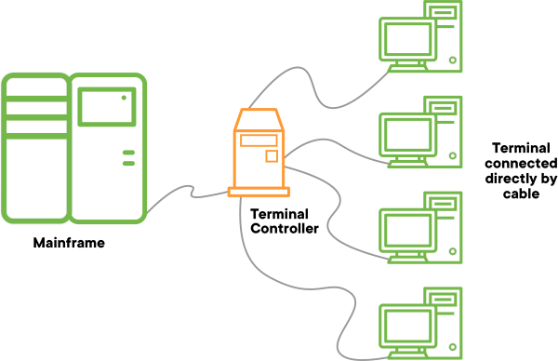

Nowadays, the "terminal" is "emulated" in software. It's "virtual." You launch the "emulator" by opening a program. And instead of being connected to a remote computer by a cable, your "terminal emulator" talks to the computer you're actually typing on.

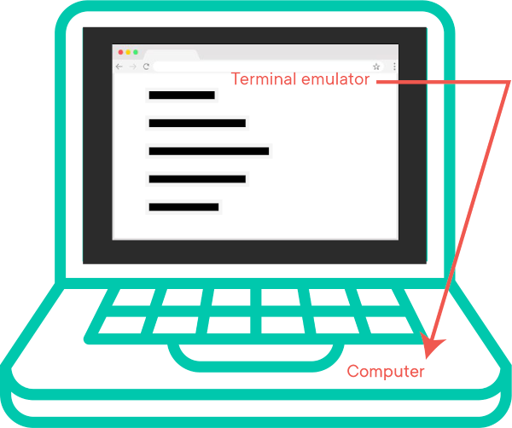

When you launch the "terminal emulator" program, it will immediately start a program called a *shell* program. The *shell* program is what actually prompts you for input and returns the output. The shell most computers default to using is known as bash.

To help keep these terms straight, here's a guide:

* When discussing the terminal, we mean the "terminal emulation" program, i.e. the thing that handles raw input and output. *NOTE:* Interpretation of the commands themselves is handled by the shell, not the terminal. You can *type* commands into the terminal, though
* The shell takes input, thinks, prints things out. It knows when a command doesn't exist or make sense. It knows how to ask the CPU to do work. But it **doesn't** listen for keyboard keys being pressed and it **doesn't tell your terminal emulator how to display the results it calculated**. The terminal handles the input/output (as we said) while the shell works with the operating system and the CPU
* bash and zsh are a specific shells used by Unix systems (like Mac OSX and Linux).
* The phrase "command-line" is roughly the same as shell. It's a style of interaction with the shell

**Conclusion**

Although using a command line interface might seem intimidating at first as it requires the memorization of dozens of different commands, it can be a valuable resource that makes using a computer easier. Using a command line, you can perform almost all of the same tasks that can be done with a GUI. However, many tasks can be performed quicker and can be much easier to automate.

Ultimately though, many programming languages and programming tools assume that you're comfortable with the CLI. You must have this comfort in order to be a successful programmer.

**Resources**

* [Lifehacker on the Command LineLinks to an external site.](http://lifehacker.com/5633909/who-needs-a-mouse-learn-to-use-the-command-line-for-almost-anything)
* [Command Line Interface (CLI) vs. Graphical User Interface (GUI)Links to an external site.](https://www.cybrary.it/0p3n/command-line-interface-cli-vs-graphical-user-interface-gui/)

[Previous](https://moringa.instructure.com/courses/318/modules/items/59144)[Next](https://moringa.instructure.com/courses/318/modules/items/59146)

**Bash Navigation**

**Learning Goals**

* Demonstrate How to Navigate with bash
* Identify our "home directory"
* Identify my logged-in username with whoami
* Identify the "current working directory" with pwd ("print working directory")
* Navigate up one directory in the file system
* Change directories using cd

**Introduction**

Using the CLI (command line interface) might seem like a big challenge to first-time users who are afraid of making mistakes that could break their computers or ruin their files. Fear not! We'll step you through it.

The command-line interfaces, or "shells", used on OSX, Linux, and the "Windows Subsystem for Linux (WSL)," are called bash. We'll document how to use the bash CLI in this module.

**Note**: if you are using a Windows machine, you will not be able to use the commands covered in this lesson until you have set up WSL.

**Demonstrate How to Navigate with bash**

To review: bash is a text-based interpreter that provides a *command-line interface* for controlling your computer (or operating system).

**ASIDE**: Bash is actually an acronym which stands for **B**ourne-**A**gain **SH**ell. As the word "again" suggests, there are *other* shells, some of which came before bash. There are also shells that have come along *since* > bash. Nevertheless most programmers use bash or something very similar.

A great place to start learning about the CLI is by using it to do a task you're already familiar with: looking to see what's inside folders like your directories and desktop. Programmers call this activity: *navigating*. In the CLI we imagine that we're "traveling" to different places. We'll use metaphors like "go into the folder" or "go up one folder" or "visit the location at such-and-such *path*."

As you learn to navigate with the shell and get to used to it, you'll see that it's friendlier than it might seem at first. In no time, you'll be looking like this typing-machine from "Ghost in the Shell:"



**Identify Our "Home Directory"**

Whenever you open a terminal session (new window, new terminal tab, launching the program for the first time after a reboot), you will be placed in (remember our "travel" metaphor!) your home directory. Directory names on Unix systems are written like:

/parentdirectory/subdirectory/another/subdirectory

We call a bit of text meant to communicate location on a file system a *path*. Paths use / to show levels of "nesting."

For example, a user's home directory is often written like: /Users/username or /home/username. The / on the far left of the path name means the very top of the file system "tree." The / directory is also called the "root" directory. It contains all the "top-level directories" that can contain sub-directories (...which can contain sub-directories, which can contain sub-directories, on and on).

**NOTE:** When navigating through a directory, it often helps if we picture the file structure like a tree. With this visualization, we can refer to "moving up" or "moving down" between directory levels, and keep better track of not only where our files are but where we are among our files. Here's an example:

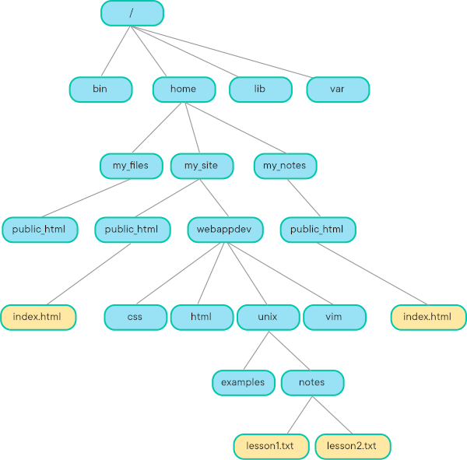

Let's take a second to look at some typical home directories:

/Users/username

This means the "root" contains a directory called Users and Users contains username. Paths like this are typical for Mac OSX.

/home/username

This means the "root" contains a directory called home and home contains username. Paths like this are typical for Linux.

Obviously, our names (well, most of our names) are not username. Instead we log into our systems as Byron Poodle or Nancy the Cat. How can we find out what our logged-in-user name is?

Let's ask the shell to tell us who it thinks we are. We'll use whoami to do just this in the next section.

**Identify My Logged-In Username with whoami**

Let's start simply. Let's ask the computer who I am logged in as:

$ whoami

**Note:** *Any time you see the* $ *character, you shouldn't type it in. This is just a standard way to represent a bash prompt. Yours may or may not be a* $.

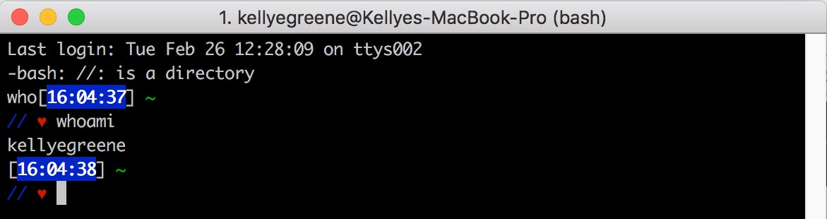

The whoami command lets you see which user account you're logged in to from the CLI. This might seem obvious, especially if you're logged in on your personal computer. But Unix machines have multiple accounts by default (though you may not have seen them yet).

My system says I am kellyegreene. Based on what we learned about home directories, what do you think my home directory *path* is? In the next section, we'll ask the shell to tell us what our home directory's path is.

**Identify the "Current Working Directory" With pwd ("print working directory")**

$ pwd

You should see some output describing the directory you are currently in. It's probably something like /Users/byron\_the\_poodle.

The pwd command stands for "**p**rint **w**orking **d**irectory". As you "navigate" your file system, you might get lost. Just like wandering in a big city, you can look for street signs to find out where you are. The pwd command acts like those street signs. You'll never be lost again!

We've just used pwd to demonstrate that when we open a bash session the operating system automatically "puts" us in our home directory. Let's now do some real "navigation." In the next section we'll learn to move "up" one containing directory.

**Navigate Up One Directory in the File System**

Try typing this in the command line:

$ cd ..

$ pwd

You "moved up" one level of nesting, so you should now see that you are one level up from where you were and one level closer to the "root" directory. In your terminal see this by using pwd:

/Users

The cd command stands for "**c**hange **d**irectory".

The .. is a shortcut for the directory *above* the working directory. The bash shell provides a series of "shortcuts" for some commonly-used file system paths. .. means "this directory's containing folder". These shortcuts look strange but they're designed to be *short* and therefore *easy to type* and therefore *fast* and, as we've hinted, the CLI is all about speed.

So in this command example we said: change directory to the parent folder. You can do this all the way back up to the / directory.

Let's use cd to get back to our home directory.

**Change Directories Using cd**

The bash shell provides default shortcut for your home directory: ~. Use cd .. to go "up" a few directories (why not all the way to the root?).

Then, when you run this command:

$ cd ~

$ pwd

You'll see you're back in your home directory. Use pwd to verify!

**SHORTCUT** By the way, if you enter cd with no argument, you'll be taken to your home directory.

Another shortcut, that might seem not too useful at first, is . meaning "the current directory I'm in.

If you try this command:

$ cd .

$ pwd

You should see you are still in the same directory where you wrote the command.

Instead of using shortcuts like .., ., or ~, you can give a path to cd and it will "take" you there.

Try cd /Applications or even cd /. You can run a pwd in these directories and see that you've "navigated into" them. Try cd alksdjfalksdjfalskdjf. What error does bash give you? Is that what you expected? We'll discuss more about the types of paths you can give bash in the next section.

**Paths in Shell**

The path supplied to the cd command can be either *absolute* or *relative* paths. An absolute path is a path that always gets you to the same folder. You can recognize them because they start with /. For example /Users/kellyegreene, is an absolute path.

A relative path is a path **relative** to the working directory you're "in" at the time you write the command. They start with the name of a directory or a file. For example kellyegreene/Documents, is a relative path.

If I were in my home directory /Users/kellyegreene and said cd mixtapes/the-masked-rapper-vol-1, it would work! If I were in /Users/annoyingbrother and said cd mixtapes/the-masked-rapper-vol-1, bash would return an error because that sub-directory doesn't exist there (because I, Kellye Greene, am the Masked Rapper, while my brother can't rhyme).

Absolute paths and relative paths might sound confusing in CLI universe, but we intuitively understand this difference in our day-to-day lives. We usually call this difference *context*.

If someone asks if you want to go get a slice of pizza for lunch they're probably thinking of somewhere close to where you're currently located – somewhere close *relatively* speaking. They're expecting you to say something like:

"Oh yeah, let's go West on 18th street, cross 6th Avenue and go to the place on the corner."

What would surprise the heck out of them would be if you gave them absolute coordinates; and it would be *even more* surprising if that location were far away. How might they react if you said:

"Oh yeah, let's go to 41.890221 and -87.633904!"

Latitude and longitude give *absolute* directions based on the Equator and Prime Meridian. They're not commonly used by humans to make decisions on where to get lunch (even if they point, in fact, to one of our favorite pizzerias in Chicago).

So far we've been finding out where we are in the file system "tree," how about we find out what's *in* these directories (besides other directories)? We'll cover that in our next lesson.

**Time-Saving Tip: Tab Completion**

As you type in commands in the shell, you can use "tab completion." Tab completion allows the shell to be smart and to try and guess what command you want to run when you hit the tab. If there's only one logical way to complete your command, bash will fill in the rest for you, or will show you the possibilities and you can add more letters until you can tab-complete your command.

For example let's say we have the following directory structure with two sub- directories:

/flatiron\_school

/flatiron\_building

If I type $ cd f and then hit tab, it will fill in everything up until the conflict so I'll see $ cd flatiron\_. If I then add the s and hit tab it will fill in $ cd flatiron\_school and I can hit enter.

**Conclusion**

As we keep exploring and working with the command line, we will start to unlock and understand its full potential! Adopting the terminal can allow us to become more productive users.

**Resources**

* [Lifehacker on the Command LineLinks to an external site.](http://lifehacker.com/5633909/who-needs-a-mouse-learn-to-use-the-command-line-for-almost-anything)
* [Environment VariablesLinks to an external site.](http://cbednarski.com/articles/understanding-environment-variables-and-the-unix-path/)
* [Built-in Shell CommandsLinks to an external site.](https://www.gnu.org/software/bash/manual/html_node/Bash-Builtins.html) *Very useful*
* [15 Useful Bash CommandsLinks to an external site.](http://www.thegeekstuff.com/2010/08/bash-shell-builtin-commands/)
* [The One True PathLinks to an external site.](http://blog.seldomatt.com/blog/2012/10/08/bash-and-the-one-true-path/)
* [More on paths - WikipediaLinks to an external site.](http://en.wikipedia.org/wiki/Path_(computing))

[Previous](https://moringa.instructure.com/courses/318/modules/items/59145)[Next](https://moringa.instructure.com/courses/318/modules/items/59147)

**Navigating Files and Directories in Bash**

**Learning Goals**

* List directory files in the shell with ls
* Move or rename files and directories with mv
* Copy Files with cp
* Create empty files with touch
* Make new directories with mkdir
* Remove files with rm

**Introduction**

In the previous lesson we learned how to "navigate" the directory structure of our file system. But our file systems (and lives) would be so boring without *files*. Copying files, moving files, reading the contents of files, feeding files to the ruby program, cat .gifs. We looooooove files.

This lesson will show you how to work with your files. In time, you might stop using Finder and other tools because it's so much faster (and fun!) to use the CLI.

**List Directory Files in the Shell with ls**

In a new terminal, which automatically puts you in your *home directory*, try this:

$ ls

The command ls stands for "**l**i\**s*\*t" — the first character is a lower case letter L. After you run it, you should then see a list of all the files within your working directory.

**Note:** For Ubuntu/WSL users, your home directory may start out empty, so you might not see anything running ls. If this is the case, try creating a folder. In fact, now is a good time to create a Development folder where you can store your coursework. We'll use mkdir to create the folder (more on this in a moment):

$ mkdir Development

Once the folder is created, run ls again and you should see Development listed.

True to Unix style the ls command is easy to type and ***short*** (both keys on the home row of a keyboard, one letter on one hand the other on the other hand, it's about as fast as it can get; handy for a command we will run *all the time*).

We can list the contents of another directory by providing an absolute or relative path

$ ls pathname

**Using Flags with Commands**

We can use flags on most Unix commands to give more specific instructions or to change the output. Most programs accept flags, or options for execution.

A flag is denoted by a - ("dash").

$ ls -l

This prints out a list of all the files with "long form" output: it will tell us details about which user account owns the file, what the permissions for users are on that file, and the file name.

For example:

$ ls /var/tmp

SIMToolKit

hi

pfwtfp-dice-thrower-from-a-file

sinatra-user-auth

becomes:

$ ls -l /var/tmp

total 0

drwxrwxrwx 3 byron.poodle wheel 96 Jun 5 2018 SIMToolKit

drwxr-xr-x 2 byron.poodle wheel 64 Jun 5 2018 hi

drwxr-xr-x 12 byron.poodle wheel 384 Nov 9 15:35 pfwtfp-dice-thrower-from-a-file

drwxr-xr-x 18 byron.poodle wheel 576 May 21 2018 sinatra-user-auth

You don't need to know what all those extra bits of information mean now, but realize that flags can really enrich the output you get.

Single-character options can typically be combined with each other. For example, in the ls command, h is an option on the l flag meaning "**h**uman readable formats." They can be combined with a meaning "**a**ll information" including "hidden files" (files that start with a ., often used for internal operating system configuration — we'll expand on this in a moment).

Try these three together:

$ ls -lah

And also:

$ ls -l -a -h

Both are valid input options and mean the same thing, as far as ls is concerned.

When you entered $ ls -lah above, you should have a received a list of files including some that you hadn't seen from entering just $ ls before:

drwxr-xr-x 6 kellyegreene staff 204B Jun 2 11:21 .

drwxr-xr-x 5 kellyegreene staff 170B May 28 15:52 ..

-rw-r--r--@ 1 kellyegreene staff 6.0K May 28 15:52 .DS\_Store

drwxr-xr-x 13 kellyegreene staff 442B Jun 2 11:02 .git

-rw-r--r-- 1 kellyegreene staff 66B May 28 15:49 .learn

-rw-r--r-- 1 kellyegreene staff 11K Jun 2 11:21 README.md

Notice that at the top of the file output there are a bunch of files that start with a ., like .DS\_Store

Files like .DS\_Store are not listed. That's because files and directories that start with a . are *hidden* files. Shells are often configured by putting information in these *hidden* files. We'll not talk about these types of files in this lesson except to say that sometimes things are hidden until you add a flag.

**Note:** *Combining flags is only valid for single-letter options. A "long option" such as* --force *is defined with more than one character and must be entered with its own flag.*

**Move or Rename Files and Directories with mv**

Move, or mv is a command that moves one or more files or directories from one place to another. To move a file from the current directory to another location, enter a path as the third word on the command line.

$ mv filename ./dir1

We can also rename a file or directory using the mv command. To rename a file with mv, the third word on the command line must end in the new filename.

$ mv original\_program.rb renamed\_program.rb

We could combine these two usages as:

$ mv temp\_download.gif ~/Desktop/cats\_with\_weapons/ninja\_cat.gif

**NOTE**: Look how we're using the ~ shortcut!

**Copy Files with cp**

If you think about it, move is really "copy, but delete the original." Well, cp does a mv, but doesn't delete the original. It's therefore a "copy."

It uses the same syntax as mv:

$ cp letter\_to\_mom.txt letter\_to\_mom-2019-02-15.txt

If you want to copy a directory and its file contents, you need to use the -r flag.

$ cp -r february\_cat\_gifs ~/Desktop/vital\_media\_files

**NOTE**: Look how we're using the ~ shortcut! This expands into /Users/username/Desktop/vital\_media\_files

**Create Empty Files with touch**

We can use the touch command to create empty files in the current directory. Try:

$ touch hello\_world.rb

Now try:

$ ls

You should see the file you just created, hello\_world.rb, in the working directory. Note that this is an empty file and has nothing inside of it, because you just created it.

**Make New Directories with mkdir**

We can make directories with the mkdir command:

$ mkdir name\_of\_directory

Now if you enter ls you should see the empty directory you just created in the working directory.

**Remove Files with rm**

To delete a file, we can enter rm at a shell prompt. **Note:** Deleting a file with rm is *permanent*. This action cannot be undone!

$ rm hello\_world.rb

Much like cp, if you want to delete a directory, you need to provide the -r flag

$ rm -r ~/Desktop/pokemon\_fan\_fiction

There are additional options to rm:

* -i (interactive): Prompts you to confirm the deletion. This option can stop you from deleting a file by mistake.
* -f (force): Overrides interactive mode and removes the file(s) without prompting. Use this with caution. This action cannot be undone!
* -v (verbose): Shows the progress of the files as they are being removed.

**Conclusion**

There are a variety of commands you can use to manipulate files via the command line. If this list seems overwhelming at first, remember that it takes all programmers a little time to practice their CLI workflows. Refer back to these resources as you need to, and it will get easier as you go along.

**Resources**

* [Lifehacker on the Command LineLinks to an external site.](http://lifehacker.com/5633909/who-needs-a-mouse-learn-to-use-the-command-line-for-almost-anything)
* [Environment VariablesLinks to an external site.](http://cbednarski.com/articles/understanding-environment-variables-and-the-unix-path/)
* [Built-in Shell CommandsLinks to an external site.](https://www.gnu.org/software/bash/manual/html_node/Bash-Builtins.html) *Very useful*
* [15 Useful Bash CommandsLinks to an external site.](http://www.thegeekstuff.com/2010/08/bash-shell-builtin-commands/)
* [The One True PathLinks to an external site.](http://blog.seldomatt.com/blog/2012/10/08/bash-and-the-one-true-path/)
* [More on paths - WikipediaLinks to an external site.](http://en.wikipedia.org/wiki/Path_(computing))
* [How Dot Files Became Hidden FilesLinks to an external site.](https://linux-audit.com/linux-history-how-dot-files-became-hidden-files/)

[Previous](https://moringa.instructure.com/courses/318/modules/items/59146)[Next](https://moringa.instructure.com/courses/318/modules/items/59148)

**Working with Programs in Bash**

**Learning Goals**

* View file contents with cat and open
* Print text with echo
* Redirect text
* Set PATH and environment variables
* Look up Bash documentation with man

**Introduction**

Sometimes when we interact with computers via the graphical user interface (GUI), it takes several clicks or deep dives into the controls to accomplish what we want. We've started to see in the earlier lessons that interacting via the command line interface (CLI) can make us faster!

As we begin to build applications, it will become important to also be familiar with tasks related to displaying files, editing them with a code editor, or getting information from the operating system.

**View File Contents With cat and open**

We can print the contents of a file by using the cat command. Entering $ cat filename reads a file and prints the content to your command line. (In the previous command filename is just a placeholder for where you would write out a valid file name).

**ASIDE**: cat comes from catenate a middle-English word that means "make like a chain". Unix thinks of a file as a "chain of bytes" that it feeds to the screen.

**Note:** *Any time you see the* $ *character, you shouldn't type it in. This is just a standard way to represent a bash prompt. Yours may or may not be a* $.

The open command is interesting because it will trigger the default action associated with the file type. "Default actions" are defined by the operating system. This command is only available on Mac OSX.

$ open . will popup a Finder window with the current directory in finder (recall: . is an alias to the current directory). Entering $ open hello\_world.rb will run the default program for files of a "Ruby" type — usually a code editor. Some other platforms have adopted an open program because they liked OSX's idea. Try it out on your computer and see if it's supported.

**Print Text With echo**

Developers will often find themselves needing to write text in the terminal. The echo command has a number of uses — probably the most common is to have a program display a message or instructions, such as "Please enter Y or N" in a dialog with users.

The echo command takes a string and prints it to the screen.

$ echo "Hi world"

Hi world

**Redirect Text**

You can "redirect" echo text into a file:

$ echo "I'm printing to the screen" >> my\_file.txt

This is called *redirection*. We're "redirecting" what we see on the monitor into a file. The >> symbol will ***append*** content into the file while > means ***overwrite***.

**BE CAREFUL** Using > when you mean >> can make you real sad because > "clobbers" or "overwrites" the file. Some files on your system are **very** important and "clobbering" them could hurt your machine!

**Set PATH and Environment Variables**

An *environment variable* is a variable which can be configured to change the way the shell works and used by multiple applications or processes. You might tell the shell, via an environment variable "use colors whenever you can" or "never use colors in output". Discussing how to set these up is beyond our scope right now. But it's important to see that environment variables, like directory path shortcuts, or those mysterious *hidden files* configure and adjust our CLI experience.

For example, PATH is a very important environment variable. In Unix, programs are often installed in many different directories. Directories whose names are listed in the PATH variable can have their programs run without having to cd to the directory where they are to run them (OR provide a long absolute path).

Paths are assigned to the PATH and separated by :.

Let's try viewing the current PATH.

$ echo $PATH

/Users/kellyegreene/.rvm/gems/ruby-2.7.4/bin:/Users/kellyegreene/.rvm/gems/ruby-2.7.4@global/bin:/Users/kellyegreene/.rvm/rubies/ruby-2.7.4/bin:/Users/kellyegreene/.nvm/versions/node/v8.9.4/bin:/Applications/Postgres.app/Contents/Versions/9.4/bin:/usr/local/share/npm/lib/node\_modules/grunt-cli/bin:/usr/local:/usr/local/bin:/usr/local/sbin:/usr/bin:/usr/local/bin:/usr/local/bin:/usr/bin:/bin:/usr/sbin:/sbin:/Users/kellyegreene/Library/Android/sdk/tools:/Users/kellyegreene/Library/Android/sdk/platform-tools:/Users/kellyegreene/Library/Android/sdk/tools:/Users/kellyegreene/Library/Android/sdk/platform-tools:/Users/kellyegreene/.rvm/bin

Any program in these directories can be run by simply typing the program name. When kellyegreene types ruby the shell starts by looking at the first directory in the PATH to see if it finds a program that matches.

In this case it *would* find the ruby program in /Users/kellyegreene/.rvm/rubies/ruby-2.7.4/bin and run it. The first match in the PATH variable wins so the order of the PATH is important.

If this directory **were not** in the PATH, kellyegreene would have to do one of the following to run ruby -v — a command that shows the program's version.

$ cd /Users/kellyegreene/.rvm/rubies/ruby-2.7.4/bin

$ ./ruby -v

ruby 2.7.4p191 (2021-07-07 revision a21a3b7d23) [x86\_64-darwin20]

or

$ /Users/kellyegreene/.rvm/rubies/ruby-2.7.4/bin/ruby -v

ruby 2.7.4p191 (2021-07-07 revision a21a3b7d23) [x86\_64-darwin20]

In the shell, all programs that are not in the path have to be run with an absolute path. In both of these examples, you should see how we send the shell a full absolute path (remember what . means!).

**Top Tip:** *If you want to find out where the program being run is located when you type a command at the command line, use the which command; entering* $ which ruby *will tell you where the Ruby binary is located.* Whenever you type a command the path is going to be searched in order until it finds an executable that matches name

There are a lot of environment variables and, as you grow as a developer, you will encounter more of them. Others you might see include:

* Execution mode (e.g., production, development, staging, etc.)
* Domain names
* API URL/URIs
* GIT\_AUTHOR
* GIT\_AUTHOR\_EMAIL

Eventually, you'll learn to configure your shell environment to help you do work more efficiently. You'll define variables like BIG\_PROJECT\_DIRECTORY or write custom programs that you can run from the CLI that make you more efficient.

**Look Up Bash Documentation With man**

The man command is the key to command line wisdom. It brings up a **man**ual page for almost any command. It's the equivalent of a help system for the command line. When Unix was first invented, its manuals were so big and heavy and expensive to print the developers had the idea to write the manual in the operating system itself. This is an idea that's been popular with programmers and environmentalists and mail-carriers ever since.

For example, if you're curious what the options on ps mean, you can go to your terminal and enter:

$ man ps

In the terminal output, read about what the a and u options do. Notice that the x option is a suffix on the a option. The man command reveals very useful reference documentation on the various bash commands. You'll notice that your command prompt has disappeared. Don't panic! You're just inside the documentation. Enter $ q ("**q**uit") to return to your command prompt.

**Conclusion**

Software developers still rely heavily on command-line interfaces to perform tasks more efficiently, configure their machine, or access programs and program features that are not available through a graphical interface. File interactions and process management may be difficult for new CLI users to grasp because the tools used are different from their graphical counterparts. However, with a little practice, these new ways of working will become your ally.

**Resources**

* [Using The Terminal Command cat To View The Contents Of FilesLinks to an external site.](https://www.freecodecamp.org/news/the-cat-command-in-linux-how-to-create-a-text-file-with-cat-or-touch/)

**Organizing Your Work for this Course**

**Learning Goals**

* Configure a directory for storing lessons
* Understand the relationship between navigating directories in the terminal and navigating directories in a graphical user interface like Finder
* Practice common terminal commands such as pwd, ls, mkdir, and cd

**Instructions**

From now on, you'll be executing code on your own computer. For each and every lab, you'll be copying the code to your computer using [GitLinks to an external site.](https://git-scm.com/" \t "_blank). You will then be able to run and test your code in your terminal, and submit your work using the learn-co gem.

**Setting Up Your Directory Structure**

\*\*Note for WSL Users: Although the video above is for the macOS, the commands shown in the terminal will be the same in your Ubuntu shell. When you open Ubuntu, you should start in your home directory. Confirm this with the command pwd. In Ubuntu, your home directory will start off empty, so there will not be a Development folder present, and running ls will not produce any results. You can create a Development folder with mkdir Development.

Complete Your First Software Engineering Assignment

* **Due** No Due Date

* **Points** 1

* **Submitting** a website url

**Learning Goals**

* Understand the steps needed to work on an assignment in GitHub and Canvas

**Introduction**

During this course, you will work on various assignments as you learn to code. All assignments will be interactive pieces of curriculum that require some work. Some assignments may ask you to follow a set of instructions, while others will ask you to figure out your own solution to pass specific tests. This lesson is your first assignment!

All assignments are hosted on GitHub. In order to work on them, however, you will need to complete work on your local machine. The general process is:

* Go to the assignment's GitHub page
* Create a personal copy (a 'fork') of the assignment
* Download your personal copy (referred to as 'cloning') to your environment
* Complete the required work
* Upload the work you've done to your personal copy of the assignment on GitHub

For this assignment, we'll do a quick walkthrough of these steps so you will know what to do in future assignments.

**A Quick Note on Organizing Work on Your Machine**

Through this course, you will be downloading many assignments, so it is important to take a moment now to think about how you'll organize this work on your computer. You are welcome to do what you like, but we recommend setting up a directory where you can keep all of your work for this course.

* Go to your terminal and navigate to your home directory by typing cd ~
* Create a Development folder by typing mkdir Development (if you're a mac user, this folder already exists)
* Navigate into this folder with cd Development
* In here, create a code folder with mkdir code
* Navigate into this folder with cd code

You'll be going through multiple phases in this course, so it may also be helpful to go one step further and create folders for phases 0 through 5 within code.

Having a specific place for your work will make it easier to find if you ever need to look back at an earlier project. It'll also keep the rest of your computer's folders clear of random code.

**Note:** The process we'll go through in this lesson will create sub-folders automatically. Whenever you are starting a new assignment, navigate back to your main code folder (cd ~/Development/code) to ensure these sub-folders don't get created *within each other*.

**Accessing GitHub and Forking**

All the lessons in this course have a corresponding repository in GitHub. On this page in Canvas, you should see three icons in the **upper right** corner. The first says **Fork**. The second is a button that looks like a large-headed cat (GitHub's 'Octocat' icon); this button will open the lesson's GitHub repo *without* forking. The third is a flag, which you can use to submit an *issue* for the lesson (e.g., if you find a typo or other error).

One way to fork an assignment is to click the Octocat button to go to the assignment's GitHub repo and fork directly from that page. (We'll go through that process in a later lesson.) However, the easiest way to fork the assignment is by clicking the **Fork** button. Either method will work, but we recommend you use the **Fork** button because it will automate some assignment steps for you when you get a bit farther along in the curriculum.

This is just a picture, the button is up at the top of the page

Clicking the **Fork** button will do one of two things — it will either start the forking process or bring you to a page where you select where to create your fork. If you're prompted to choose, select your personal GitHub account. The forking process will begin and may take a few moments. When complete, you will be redirected to a new copy of the assignment that exists under *your* GitHub account.

Forking is a process which creates an exact copy of a collection of code and files. Once you've created a fork on your own GitHub account, you will be able to edit the files in the repository and write your own code solution without interfering with the original copy.

Go ahead and fork this assignment. The README.md file in the repository contains these instructions, so you can continue here or in GitHub.

With a fork created, the next step is to download your new repository to your local machine.

**Cloning to Your Local Machine**

To download the repository for this lesson, on your personal GitHub fork, first click the **Code** button. A pop-up will appear that says **Clone with HTTPS**. You'll see a URL provided starting with https://....

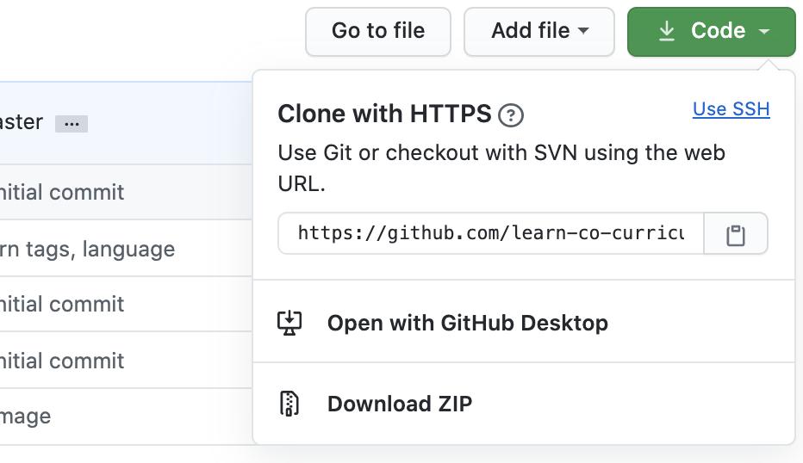

**Before doing anything else**, make sure to switch from **HTTPS** to **SSH** by clicking the **Use SSH** link. When clicked, the pop-up will change to display **Clone with SSH**. Instead of a URL, you'll see what sort of looks like an email, starting with git@github.com:. You should see your GitHub name after the :.

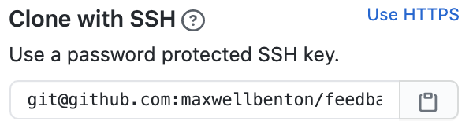

**Aside:** Why SSH? If you followed the setup instructions, you have added your personal SSH key to GitHub. GitHub will store your personal copies of all the work you do in this course. Because you've added your SSH key, GitHub will know who you are when you send work from your local machine to GitHub to be stored. Using HTTPS instead would require you to sign in from your terminal using your log-in credentials each time you try to push your code to GitHub; it also may not work at all for some assignments.

From here, click the clipboard icon.

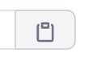

Now, open your terminal and navigate to where you'd like to download the assignment (e.g. cd ~/Development/code). Type git clone then paste in the copied SSH link from GitHub. It should look something like this:

$ git clone git@github.com:<your-user-name>/phase-0-completing-assignments.git

Press enter, and you should see a flurry of terminal activity. Once the terminal gives you control to type again, a new folder with the GitHub name of the assignment will be present. Change directory into this folder to access the assignment files.

$ cd phase-0-completing-assignments

Now, if you've set up VS Code, type code . to open up a text editor window with access to all of the assignment's files. The instructions are now also available on your local machine in README.md.

**Completing an Assignment**

Most assignments will have tests that check your work and provide immediate feedback in the terminal. We'll walk through some examples in upcoming lessons.

This assignment has a single test: check to see if you've correctly cloned this assignment to your local machine. If you've followed the steps above, you've completed everything you need to do to pass the test; all that is left to do is run it.

To run an assignment's tests, first you'll need to set up the tools used to run the test. Fortunately, all the tools required are included as part of the assignment, so all you need to do is type the following:

$ npm install

This command will again cause a flurry of activity in your terminal. You may see some warnings in the mix of output, but that is normal. After a few moments, you should see some messaging about packages being added and regain control of the command line. You're now ready to run this assignment's tests. Type the following to do so:

$ npm test

You should see the test results print out. For this assignment, they'll look like this:

This assignment

✓ has been correctly cloned to your local environment

1 passing (5ms)

Congratulations! You've passed this assignment's test.

**Note:** If you did not receive a passing test, or if your terminal produced some sort of error, walk through the steps in this lesson again and make sure you've followed each one. If you're still receiving errors, we recommend going back through the local environment setup instructions again to ensure everything is set up properly.

**Uploading Your Work to GitHub**

When all tests are passing, the next step is to upload your work. To do this, we run three commands in the terminal. First, type the following, then press <Enter>:

$ git add .

This 'stages' any work you've done (changes to your local copy of an assignment) so it will be ready to upload.

Second, we create a record of these changes that includes a message describing the change. Type the following, then press <Enter>:

$ git commit -m 'Done with assignment'

This is known as creating a 'commit.' A commit preserves all *staged* changes from the previous command. Any work you've done is now recorded as part of your copy of the assignment. This copy, however, is still only on your local environment.

To upload your completed assignment, there is one final command to run. Type the following, then press <Enter>:

$ git push

This command sends the changes you've made to GitHub. If you revisit your *personal* copy of the assignment on GitHub, the commit you just created (with the message 'Done with assignment') will be the most recent commit on the assignment.

Each assignment will be slightly different and will include instructions on what is required to complete it. Depending on the testing tools in an assignment, the specific commands may change. For this lesson, we ran npm install and npm test: npm install to set up the necessary tools, and npm test to run the actual test.

You'll also see some assignments that ask you to run bundle and rspec — bundle, like npm install, will set up necessary tools and rspec will run the tests. We'll include instructions indicating which commands to run. In all cases, you can run the tests as many times as you would like. Some labs will have many tests and may require running the tests many times while you solve them.

**Uploading Your Work To Canvas**

To register completion of an assignment in Canvas, you must submit a link to your GitHub repository.

1. After pushing your code up following the previous steps, go to your repository and copy the URL link in the browser's URL bar.
2. In Canvas, navigate to the assignment you've been working on. In the upper right corner of the assignment, you should see a **Submit Assignment** (or **Start Assignment**) button. You'll be directed to the bottom of the page, where you can provide a URL as your submission.
3. Paste in your repository's GitHub URL and click **Submit**.

Canvas will indicate a successful submission and refresh the page. In the Modules view of your course, you should now see a checkmark next to the assignment, indicating a successful submission.

**Review**

Let's quickly review the process for completing assignments:

**1.** Create a personal fork of the GitHub assignment by clicking the **Fork** button in the upper right corner of the assignment on Canvas.

**2.** Once forked to your personal account, start the **cloning** for your assignment. Do this by clicking the **Code** button in GitHub, choosing **SSH**, then clicking the **clipboard** icon to copy the assignment's GitHub info.

**3.** Go to your local environment's terminal and navigate to where you'd like to store your assignment locally.

**4.** Type git clone, then paste in what you copied from GitHub. This will create a copy on your local machine.

**5.** Navigate into the new cloned assignment and complete any work required

**6.** Install testing tools with npm install (or bundle if tests use Ruby)

**7.** Run tests with npm test (or rspec for Ruby)

**8.** If all tests are passing, stage and commit your solution with the following commands

$ git add .

$ git commit -m 'Done with assignment'

**9.** Push your work to your personal fork on GitHub with the git push command

**10.** Go to your repository in GitHub and copy the URL. Note, this should be copied from the browser's address bar, and should start with https://github.com/

**11.** Go to the assignment in Canvas and click **Submit Assignment** (or **Start Assignment**)

**12.** Paste in your GitHub URL as your submission

**Conclusion**

Congratulations! You've completed your first assignment! You now know how to work on and submit assignments. We'll remind you of this process in upcoming lessons, but we recommend bookmarking this lesson so you can refer back here in case you forget. Equipped with this knowledge, you are now ready to tackle greater challenges!

**Intro to Version Control**

**Learning Goals**

* Define the purpose of a version control system
* Identify benefits of version control systems
* Recognize useful Git vocabulary terms

**Introduction**

Let's imagine a very stressful situation. Your manager comes to you and says:

Hi there, we're looking to present a report to investors. If we get this investment, we'll all be millionaires. If we don't get this investment, we're going to have to close down the company. The key to success is going to be a report that **you** are going to manage. Three things will make it stand out:

1. It must be absolutely correct: no errors, no typos, the math has to check out in every figure.
2. It must have the most up-to-date information
3. The investors will tolerate *slightly* older data if it means that we can be *sure* the facts are correct.

One last requirement is that for auditing purposes we need to be able to save a unique version of all the versions of this report. We have to know what the report looked like, for example, 3 days ago, or 3 weeks ago.

Suman, Nibaal, and Taylor will all be doing research for you and contributing new data as much as possible. You have to make sure that all the parts integrate correctly. Thanks! And we're all counting on you!

How could you achieve these goals? Take a few minutes to imagine, or sketch out what your strategy might be.

**Naive Strategy**

A *naive* way of managing *versions* would be to start with a file called investor-report-latest.txt. You'd also copy that to investor-report-master.txt.

You'd share investor-report-latest.txt with Suman, Nibaal, and Taylor.

When they made a change to the report, you'd find the changes, verify them, and then update them into investor-report-master.txt.

You'd make a copy of investor-report-master.txt and give it a date-stamp like investor-report-2019-02-13T1017.txt (here you've added an [ISO8601Links to an external site.](https://en.wikipedia.org/wiki/ISO_8601) date-time label to the end of the file. This means when ls prints out the directory all the file names will be shown in ascending date order).

You'd then overwrite investor-report-latest.txt with investor-report-master.txt and tell everyone to start working off of the newly updated investor-report-latest.txt.

Before long, we might have a directory full of files like:

investor-report-2019-1-01T1017.txt

investor-report-2019-1-02T1123.txt

investor-report-2019-1-04T4340.txt

investor-report-2019-1-05T1017.txt

investor-report-2019-1-08T2217.txt

investor-report-2019-2-08T2317.txt

investor-report-2019-2-09T0017.txt

investor-report-2019-2-10T914.txt

investor-report-2019-2-13T1017.txt

investor-report-2019-2-15T1127.txt

investor-report-2019-2-20T1237.txt

investor-report-2019-2-21T1330.txt

investor-report-2019-2-22T1545.txt

investor-report-latest.txt

investor-report-master.txt

...

Wow! What a mess! And there are other messes waiting.

What if Suman and Taylor both start work from the latest investor-report-latest.txt and Taylor makes changes to the same section Suman was working on. Taylor gets their work in first and that gets integrated by you. Now Suman's changes no longer apply. Suman is frustrated because their work will have to be re-done!

**Reflection**

This is a pretty stressful bit of imagination. You've got to make sure that a report is as current as possible and absolutely, positively, correct. You might think this manager is a jerk or that these expectations are unreasonable. Maybe this could be possible with *one* writer, not *four*.

But the expectations that manager gave you for the report are ***the exact same expectations we have for code***. It should be as good as possible, absolutely correct, and ready to ship to users at a moments' notice.

The great news is that *all* the manual work you had to do (and so much more!) can be done by a type of software called a *version control system (VCS)*. That is, software that *controls* our collection of *versions*. The most popular VCS is called "Git." When we have a VCS on our side we can work confidently; we can even experiment without fear. Getting back to a "last known good state" is just a few key-clicks away. You're going to love writing code, text, letters, knowing a VCS is on your side!

**Define the Purpose of a Version Control System**

"Version Control System (VCS)" describes a whole group of software. VCS software includes Git, Mercurial, Subversion, and others. Some other web-based applications like Google Docs have embraced the idea of "versions" and have added features like "tracked changes" or "view change history."

The key benefit of version control is that you can experiment and **throw away bad ideas** and *instantly* get back to your last-known "good" state.

Think about it this way: when you were learning arithmetic, you knew the way to undo a bad calculation was to turn the pencil upside down and erase. As a result, you were **free** to try, experiment, and explore, knowing you could always easily get back to the original starting point. Because of this, most of us did our math homework in pencil, not ink!

Because of the **freedom** that VCS provides, we can be **unafraid** to look at an ugly bit of code and *try* something new. We can take a new technique a co-worker told us about and we can *try* to replace our old code with this new idea. We can read about a new feature provided in a framework and *try* it out in our old code. **VCS helps us be unafraid to try new and improved techniques**.

**ASIDE** The programmer, entrepreneur, and venture capitalist Paul Graham notes that oil paints unlocked a revolution in experimentation in visual arts because they were undo-able. Oils provided the **freedom** to err and recover that other paint media did not provide (e.g. watercolor). Because of this **freedom** these painters were free to explore perspective, light, and composition in completely new ways. Because of their *tools* they had more *freedom* and were able to make their burst of exploration a *movement*: The Renaissance.

Read more in his essay ["Hackers and Painters."Links to an external site.](http://www.paulgraham.com/hp.html)

**Identify Benefits of Version Control Systems**

Beyond the advantage of being able to safely experiment, there are several *other* benefits we get when we manage our work with Git:

* Automatically create a backup of your work
* Provide an easy way to undo mistakes and restore a previous version of your work
* Document changes, including a log of what's changed with messages explaining why it was changed
* Keep file names and hierarchies consistent and organized
* Branch work off into multiple "sandboxes" that can be experimented with but won't impact each other
* Collaborate with others without disturbing each other's or our own work

And beyond these are even more advanced features that will help you optimize your workflow, once you master the basics. If that feels daunting, it's OK. Most people learn a few patterns of Git and never learn more until they absolutely have to. Over years they build up a rich set of techniques, but it's rare to find someone who knows **everything** about Git. You don't need to memorize every command and optional flag to get some of its best benefits.

**Recognize Useful Git Vocabulary Terms**

We're about to get busy learning Git, but we first need to establish some common vocabulary. Git, perhaps more than any other software, has some special words that you'll hear a lot. Don't worry if you're not sure how some of these terms work in practice—that part will come later.

* **repository (or repo, for short)**: A directory of files that are *tracked* by Git.
* **track**: When a file is *tracked* by Git, it means that Git will notice any changes to that file. We call these changes "differences" or "diffs". Git will allow you to choose whether to *add* the change, or "diff," in order to keep it
* **diff**: Short for "difference," the "diff" of a file is all the changes that happened in it since the last *commit*. The "diff" of a repo is all the diffs in all the *tracked* files in the *repo* that have been made, but which have not yet been *committed* (sometimes programmers call this "the diffset").
* **commit**: When a diff is decided to be a good thing to save, we *commit* the diff to the repo's history using the commit command. When we make a commit we are asked to write a "log" message which describes what happened in the diff. Each commit also knows when it happened and what the repo's "diff" was.
* **log**: The record of what happened in each commit
* **local/remote**: When we start working with a git repo, we "clone" it from a *remote* source and have a copy of that directory on our own system. We call the repo on our personal system the *local* repo. (We'll talk more about the "clone" command later.)
* **default branch**: You'll learn in advanced Git that a repo can support multiple branches (we called those "sandboxes" earlier). For the moment, just remember this: by default, when you create a Git repo, you will be working on the default branch. The name of this branch may be either main or master, depending on your configuration.
* **branch**: The combined history of all the changes of all the files in the repo.

**Conclusion**

If we are afraid to edit our code we won't remove complicated code that's hard to work with, try awesome new libraries, or take chances with fun new features. Version control helps us maintain the overall stability of our code so that we can feel free to explore.

**Resources**

* [Getting Started - About Version ControlLinks to an external site.](http://git-scm.com/book/en/Getting-Started-About-Version-Control)
* [Git Basics - What is Git?Links to an external site.](http://git-scm.com/video/what-is-git)

[Previous](https://moringa.instructure.com/courses/318/modules/items/59151)[Next](https://moringa.instructure.com/courses/318/modules/items/59153)

**Git Basics**

**Learning Goals**

* Identify how to initialize a Git repository with git init
* Check the status of a repository with git status
* Keep track of file changes with git add
* Create a commit and apply a commit message with git commit

**Introduction**

In our overview of version control systems, we saw that using a VCS helps us organize our work and keep track of changes we make. We also determined that the VCS we're going to use is Git. Now we can begin learning the commands we need to make Git work for us.

**Identify How to Initialize a Git Repository with git init**

Git operates on a directory level. When we have a new directory that we want to track our files in, we need to *initialize* the directory as a Git repository. That means Git will then pay attention to what goes on in the directory and give us all the Git superpowers.

To get started, we'll create a new directory. In your terminal, type the following:

**REMEMBER**: Don't type the $. That's the universal symbol for a command prompt. It's how technical documentation says "Here's a thing for the shell to process."

$ mkdir my-git-project

This command creates new a directory. Then:

$ cd my-git-project

This command moves into the newly created directory.

Now that we're in the directory where we want Git to watch for changes (adding, removing, and editing files), let's set up this directory by *initializing* it. In the terminal type git init. It should look like this:

$ git init

Initialized empty Git repository in /Users/avi/my-git-project/.git/

Git lets us know that it has put /Users/avi/my-git-project under its protection. Git also tells us that it stores its own data in the .git directory. This hidden directory, .git, is where Git keeps important stuff, like the commit history. Don't go in there and start randomly deleting things! That said, if ever you do git init in the wrong directory, you can rm -rf .git and return the directory to a plain-old, unprotected directory.

Be careful about making an entire directory, like our home directory or our desktop, into a Git repository accidentally. Make sure you only type git init *within* the directory you want git to track.

**Check the Status of a Repository with git status**

Now that we have Git watching this directory, let's see what it can tell us about the directory. The command we use for this is git status.

$ git status

Since we have not added any files yet, we'll see:

On branch main

No commits yet

nothing to commit (create/copy files and use "git add" to track)

**Note:** Older repositories may state On branch master. Branching is beyond the scope of this lesson, but to briefly explain - main and master both refer to the same thing - the core (***main****, get it?*) branch of a repository. A single repository can have many branches, but always has only *one* core branch. In the past, this branch defaulted to the name master. Going forward, the branch will be named main. You'll likely see both as you work with repositories new and old.

Let's create a README.md that describes the project. Make our new file by typing touch README.md from within the my-git-project directory. We won't see any output after touch, but we will see a new file has been created if we type ls (which gives a list of all the files in the directory).

$ touch README.md

$ ls

README.md

With at least one new project file we can enable Git to start tracking changes. Type git status. Git will show us what our current repository looks like and what changes it sees.

$ git status

On branch master

No commits yet

Untracked files:

(use "git add <file>..." to include in what will be committed)

README.md

nothing added to commit but untracked files present (use `git add` to track)

Git confirms that it's aware of the file README.md, but it's not "tracking" it. Git's not doing anything with the file and the file is not doing anything with Git...*yet*. Let's change that!

**IMPORTANT**: Whenever we want to check the status of our Git repository — which we do often — type git status.

**Keep Track of File Changes with git add**

Currently, the file in our repository is not being tracked by Git. We have to tell Git about all the files we want it to keep track of and consider as part of our project. We can do this by *adding* the files to our git repository with git add <filename or path>. To add our new README.md to the repository and check the status, we type:

$ git add README.md

$ git status

On branch master

No commits yet

Changes to be committed:

(use "git rm --cached <file>..." to unstage)

new file: README.md

We can now see that Git is ready to keep track of README.md. All the changes in the file at the time we added it are "staged." If we were to change README.md, we'd need to re-add the file. As it happens here, this staged change is "create the file, nothing inside of it" because touch created an empty file.

To save a new *version* of this new file (or, later, to "capture" changes to a file) we need to *commit* the set of changes or "diff." We "save" the changes in our repository by making *commits*.

**Create a Commit and Apply a Commit Message with git commit**

Remember: git add got our changes to the repository ready in the previous step. Those changes are the ones that will be "captured" in the commit.

To make our first commit, type:

$ git commit -m "Initial commit"

This tells git that our commit message, represented by the -m flag, is "Initial commit".

$ git commit -m "Initial commit"

[main (root-commit) e55477d] Initial commit

1 file changed, 0 insertions(+), 0 deletions(-)

create mode 100644 README.md

We can see that Git has created a new version of our repo, represented by the *SHA* e55477d. SHAs are the identification system that git uses to keep track of versions; they're long complex numbers and letters that are unlikely to be duplicated.

The commit command committed 1 file.

Now, if we type git status, we'll see that it is at a "clean state", and there is nothing to commit and no new changes.

$ git status

On branch master

nothing to commit, working tree clean

If we make another change, for example, to README.md, we can add another commit with this new set of changes with

$ git commit -am "Updates README.md"

The use of the -am flag here is a shortcut that combines the steps of adding changed files and committing them. The -a flag tells git to add 'all changes', i.e., all files that have been changed since the last commit. The -m flag, like before, tells git that we want to specify a commit message, in this case, "Updates README.md". To review some of your Unix CLI skills, this could also be written as:

$ git commit -a -m "Updates README.md"

The commit would look like:

$ git commit -am "Updates README.md"

[main (root-commit) e55477d] Updates README.md

1 file changed, 4 insertions(+), 0 deletions(2)

Good work! Commits are amazingly powerful in Git. They are the heart of many of Git's advanced features. Understanding the basic workflow of Git initialization and setup is the foundation for success.

**Conclusion**

To make a new Git repository out of a directory — which we'll only have to do once per project — use git init. Whenever you make a change to a file or create a new file, you can check the status of these changes with git status. When you're ready to preserve changes, you can add the files (or directories of files) with the git add <filename or path> command.

Once your changes have been added, or "staged," use git commit -m to commit them with an explanatory message. You can shorten the add + commit process, provided that all the files are being tracked, by using git commit -am "A message".

If we've followed all these steps, our my-git-project directory is now a local git repository.

**Resources**

* [Git Basics at git-scm.comLinks to an external site.](https://git-scm.com/book/en/v1/Git-Basics)

**Getting Code with Git**

**Learning Goals**

* Copy a repository to your local machine with git clone
* List remotes with git remote
* Duplicate other organizations' repositories into your own via GitHub with the "Fork" button

**Introduction**

Git repositories let us create logged histories of the versions of the files we "track." Just think, right now, around the world people are using Git to track their projects: Star Trek Fan Fiction, resumes, Ruby Code, JavaScript code, PhD theses, etc.

Git not only lets you track files in a local repo on your machine, you can "share" your repo on the internet so that others can use your code. In this lesson we'll discuss how to get others' repositories.

In a later lesson we'll cover how to push *our* locally-created repositories onto the internet so that others can see our projects.

**Copy a Repository to Your Local Machine with git clone**

We use git clone to copy someone else's repo from the internet to our *local* machine. We are not getting *their* repo from *their* local machine (that would be very creepy).

Instead, they must have already "mirrored" their *local* repository onto the internet. In Git-speak we'd say they would have had to have created a *remote repository*: a copy of their local repository, but on the internet. We'll be cloning that *remote repository*.

Let's get the code for the popular ReactJS framework.

**1.** Navigate to the [https://github.com/facebook/reactLinks to an external site.](https://github.com/facebook/react) repository. **2.** Click the green "Code" button on the right. **3.** Make sure you select Use SSH as your URL type.



**4.** Click the "Copy to clipboard" button (highlighted below). This will copy the URL for us to use when we clone.



**5.** In the terminal, run the git clone command. It takes the URL we just copied as an argument, like so:

$ git clone your-copied-github-url

This will create a *local* copy of the GitHub repository on our own machine.

**List Remotes with git remote**

If you use the ls command, you'll see Git created a directory called react. Use cd to enter that directory.

$ cd react

Type git remote to see the names of each remote repository (or, "remote") available.

Since you cloned your repository, you should see a remote name called origin. The remote name origin is the default name Git gives to the remote you cloned from:

$ git remote

origin

Let's prove that the origin name has some relationship to the address GitHub gave us.

$ git remote show origin

\* remote origin

Fetch URL: git@github.com:facebook/react.git

The "remote address" git@github.com:facebook/react.git assigned to the "remote name" - origin - is the same thing you copied from the GitHub web interface. This confirms that the *remote repository* you *cloned* automatically set up a *remote name* called origin.

**Duplicate Other Organizations' Repositories into Your Own via GitHub with the "Fork" Button**

Forking a GitHub repository is just a way to create a personal, online duplicate of it. When you fork a repository, GitHub creates a duplicate of that repository under your control.

If my GitHub username were octocat and I "forked" facebook/react, GitHub would copy the remote repository facebook/react and create it under my name as octocat/react. It's making a copy of one *remote repository* to a new *remote repository*.

It's like saying "Hey, can I have the Louvre's version of *The Mona Lisa*?" The Louvre would say, "No." If you were to create a perfect online duplicate by *forking* it from louvre/mona\_lisa to your-name/mona\_lisa, and then were to clone from *that* remote repository, then the Louvre can keep their copy and you can update your copy as you choose.

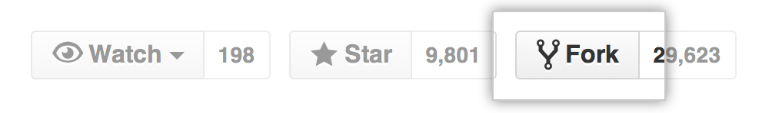

Let's try a *fork* and *clone* workflow.

Click the GitHub **Octocat** icon at the top of this page:



This will bring you to the "learn-co-curriculum" version of this lesson. Click the 'Fork' button in the upper right corner of the page. You will be prompted to choose where the repository should be forked to, so go ahead and choose your account. GitHub will take a few moments to create the fork, then navigate to your copy of the repository.

If all has gone well, you will see your username at the top of the page, followed by a / and the name of the repository, along with a link just below to the original repository. ([More on forking in the GitHub docsLinks to an external site.](https://help.github.com/enterprise/2.2/user/articles/fork-a-repo/).)

The important take away is to **not** misuse the words "fork" and "clone" when speaking with other Git users. To get a local copy: **clone**; to make an online copy of a repository to your personal organization so that you have the ability to update its master (or main) branch, **fork**.

**Important Note for Assignments on Canvas**

All Software Engineering lessons in Canvas will have an **Octocat** icon linking to a repository of that lesson. Using the process discussed in this lesson, you can fork any lesson you'd like.

For *assignments* in Canvas, you will also see an additional **Fork** button beside the **Octocat**



We encourage you to use this button when you see it to start the forking process. During this phase of the course, the **Fork** button in Canvas will do the same thing as clicking GitHub's **Fork** button. Later on in the course, the Canvas **Fork** button will behave differently as some assignment steps will be automated.

**Conclusion**

GitHub gives developers many ways to collaborate. Using GitHub's "Fork" button and git clone together allows you to make copies of others' code.

Often, the original authors will include license information regarding how you can use their repository, so make sure to check before you publish, sell or distribute any material you've forked, cloned and modified.

**Pushing Code with Git**

**Learning Goals**

* Create a remote repository on GitHub
* Connect a local repository to a remote repository
* Set the destination of a repo with git remote
* Send code to the remote repo with git push

**Introduction**

You may have heard of [GitHubLinks to an external site.](https://github.com/" \t "_blank) before. In the previous lesson, you used it to get Facebook's code for the React framework. For all the amazing power that GitHub provides (Microsoft thought it was so powerful that they bought GitHub for a cool $7.5 billion), as far as Git is concerned they're just a big old server that hosts a whole bunch of remote repositories ("remotes").

You've seen how valuable *remotes* are for *getting* software. Now we can take a look at the other side of the transaction: how we mirror our *local* repository to a *remote* repository using git push and git remote.

Once your code is on a *remote*, it's backed up — which is always a good thing. Also, once you push to a remote, you can choose whether to let others fork or clone and benefit from it. Let's learn how to push our code!

**Create a Remote Repository on GitHub**

There are a few steps to follow to create a *remote* repository on GitHub.

1. Go to: [github.com/newLinks to an external site.](https://github.com/new), while logged into GitHub.
2. Enter a name for your repository in the "Repository name" field. You can name it whatever you'd like; be creative! The default options are fine as-is — don't initialize the new repository with a README or add a .gitignore or license. Click the green 'Create repository' button.
3. After you create the *remote* repository, you should see a "Quick setup" page. Make sure the 'SSH' option is selected, then click the "Copy to clipboard" symbol next to the repo URL (pictured) to copy the URL. (We'll use this in the next section.)

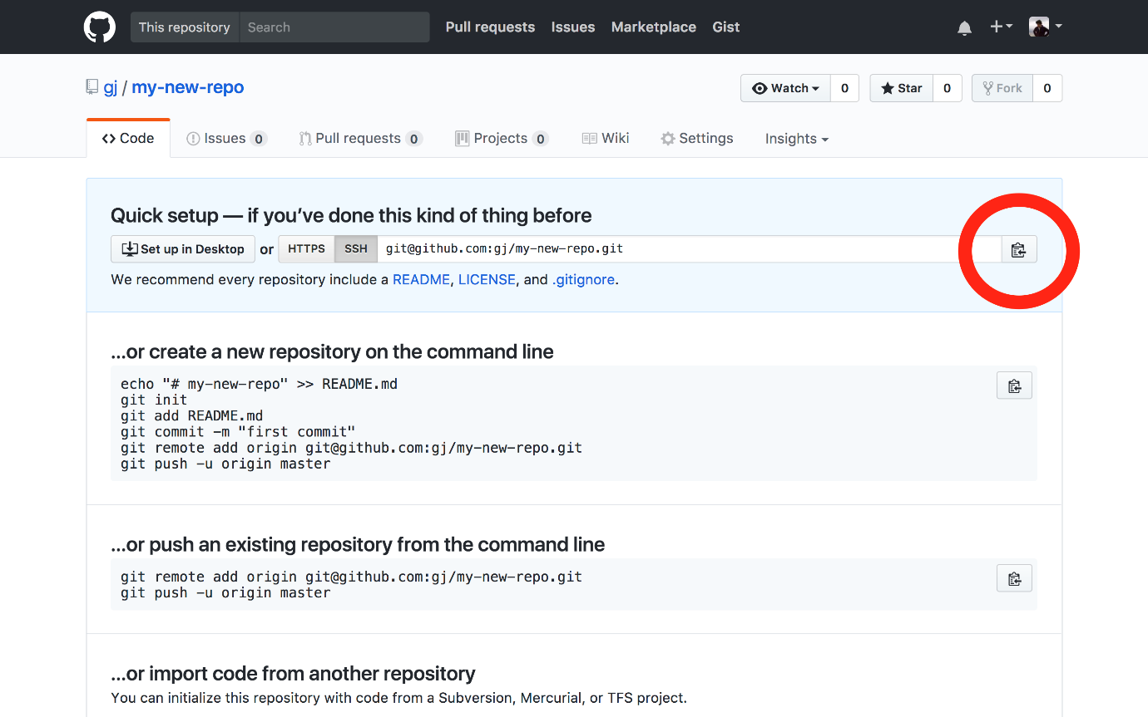

Behind the scenes, GitHub has essentially git init'd a blank directory.

**Connect a Local Repository to a Remote Repository**

After you've created your *remote* GitHub repository, you'll want to get your *local* repository uploaded to GitHub. Follow the steps below:

1. First, we want to create a folder for our repository, which we'll call my\_new\_directory. In the terminal, navigate to the ~/Development/code directory (or wherever you are storing your code) and type mkdir my\_new\_directory.
2. To navigate into this new folder, type cd my\_new\_directory. Your terminal should display my\_new\_directory, indicating that you are now inside of the new folder. Open the directory in VS Code by typing code ..
3. Next, we need to create a new file named README.md. You can do this in the terminal, by typing touch README.md, or in VS Code, by choosing File -> New File.
4. We can directly type in content for our README file in VS Code, but we can also use our terminal skills to add content. So, in the terminal, type echo "This is my readme file" > README.md. If you've got the README file open in VS Code, the new text will appear!
5. Now that we've got some basic content, we can initialize our local repository. In your terminal, type git init. Your terminal should show that an 'empty Git repository' has been initialized.
6. Type git add README.md to stage the new README.md file so it will be tracked by git.
7. Now, type git commit -m "Initialize git". This will create the first commit for this local repository, which will allow us to push our work to the remote repository we created earlier.

**Set the Destination of a Repo with git remote**

To connect your local repository to the newly created GitHub repository, you must add a new remote to a remote name. Adding a remote involves giving git a "short name" and a "repository path." You copied the repository path from GitHub a few steps above.

The repository path is a long bunch of technical words. The creators of Git thought it would be easier to type a "nickname" or a "short name" that points to that long repository path. It's common to have a "default" remote. The default remote short name is called origin. So we're going to create a new remote with a short name of origin.

Make sure you still have your remote Git info copied from GitHub, and type the following into the terminal:

$ git remote add origin your-copied-remote-repository-url

This sets the remote so you can now ***push*** your code.

You can use git remote -v (the -v is for "verbose") to view the remote(s).

$ git remote -v

View existing remotes

origin git@github.com:OWNER/REPOSITORY.git (fetch)

origin git@github.com:OWNER/REPOSITORY.git (push)

**Send Code to the Remote Repo with git push**

Now that we have added a remote repo, we need to send our latest work to the remote. We use this command when we want to send some code from the local repository to the associated remote repository. Git will push all the local, committed work to the remote repository.

The git push command takes two arguments. The first is the name of the remote repo. Remember, origin is just an alias or "short name" that refers to the repository name. You don't actually have to enter the repository name. Instead, you can just use origin. The second is the name of the remote branch you want to send code to. In the example below, we're pushing to our remote repository's *default* branch.

Depending on your system configuration, your default branch's name might be either main or master. You can find out what the default branch for your current repository is by running:

$ git branch --show-current

Whatever the branch listed in the terminal is will be your default branch (it should be either master or main).

If your default branch name is master, run this command to push your code up to GitHub:

$ git push -u origin master

**Otherwise**, if your default branch name is main, run this command to push your code up to GitHub:

$ git push -u origin main

This will push your code up to the remote repo/branch. The first time you push code up to a newly-added remote repository, use the -u flag to tell Git to "save" the remote repository as the default push destination for your current branch.

For every subsequent push, you only need to enter git push.

**An Aside and a Small Shortcut**

In this lesson, we've gone through the steps of both connecting a local repository, and pushing code up to GitHub. During this course, you'll be creating a few local repositories from scratch, but more often, you'll be cloning existing repositories to your local machine. In these situations, you won't need to use commands like git init, since the repo is already set up with Git and will already have a remote configured. However, you *will* often need to add, commit and push work you've done locally to the remote repository. In these situations, you should be able to just run the following commands:

$ git add .

$ git commit -m "commit message"

$ git push

As a small shortcut, you can also combine adding all tracked files and committing by using an additional option flag, -a, with the commit command:

$ git commit -am "commit message"

$ git push

Note that the -am flags will work for adding and committing changes to existing tracked files, but if you need to create a new file as part of any lesson, you'll need to use git add to track that file before committing.

**Conclusion**

Being able to add Git remotes allows you to back up your local repository to a remote server. If you remember git init, git remote add origin your-remote-repository-URL, add, and push your changes, you'll be able to get your project up to GitHub in minutes!

**Resources**

* [GitHub guide on pushingLinks to an external site.](https://help.github.com/articles/pushing-to-a-remote/)

[Previous](https://moringa.instructure.com/courses/318/modules/items/59154)[Next](https://moringa.instructure.com/courses/318/modules/items/59156)

# Git Basics Lab

* **Due** No Due Date

* **Points** 1

* **Submitting** a website url

## Learning Goals

* Understand how to complete assignments
* Apply what you've learned about Git version control
* Initialize a new Git repository
* Stage and commit new content
* Create a remote repository on GitHub
* Connect the newly created local repository with the remote on GitHub

## Introduction

So far lessons have only contained written content on specific topics. All you needed to do was read through each lesson and continue on. This lesson, however, is considered an assignment. Assignments are exercises that have some written content to guide you, but also ask you to complete some work of your own. Many assignments, like this one, include tests that must be passed in order to complete the lesson. Assignments with tests are often referred to as a labs in our course.

Now that you've learned about Git version control, in this lab, we're going to go through the entire process of creating a local Git repository, creating an initial commit and pushing that work to a remote repo stored on [GitHubLinks to an external site.](https://github.com/" \t "_blank).

## Getting Started

To start work on this lab, you will first need to fork this assignment and clone it to your local environment. Let's quickly review this process:

### Steps

#### Step 1

Click the **Fork** button at the top of this page in Canvas.



**Reminder:** This button does the same thing as [forking in GitHubLinks to an external site.](https://guides.github.com/activities/forking/) (via the **Octocat** button). We recommend using the **Fork** button in Canvas.

#### Step 2

Choose to fork to your personal account if prompted. Once the forking process is complete, you should be looking at your personal copy of the assignment on GitHub.

#### Step 3

Click **Code**, choose **SSH**, then click the clipboard icon to copy the information we'll need about this repository.

#### Step 4

In your terminal, type git clone, and paste the info you copied from GitHub. The command should look something like this (but with your personal account name):

$ git clone git@github.com:<your-github-username>/phase-0-git-basics-lab.git

#### Step 5

A folder will be created wherever you run this command. The folder name will be the same as the repository, so in this case, phase-0-git-basics-lab. Navigate into this folder with cd phase-0-git-basics-lab.

Once inside the folder, you are ready to work on the lab.

## Solving this Lab

Once you're in your local clone of this lab, the first step is to run the lab's tests to get a sense of what you need to do. We do this with two terminal commands. First, we run the following:

$ npm install

This sets up the tools we'll use for testing. To run the tests, type the following once you regain control of the command line:

$ npm test

This will run all the tests included for this lab. You should see a lot of output, enough that you may need to scroll up in your terminal to see it all. Six failed tests should print out, starting with this:

$ npm test

this lab

1) has a folder named my-repository

2) has a valid git repository initialized for the my-repository folder

3) has a README.md file in the my-repository folder

the local repository

4) has README.md as a tracked file

5) has at least one commit

6) has been pushed up to the remote repository

0 passing (42ms)

6 failing

1) this lab

has a folder named my-repository:

AssertionError: no folder name "my-repository" was found: value: expected './my-repository' to exist

at Function.<anonymous> (node\_modules/chai-fs/lib/assertions/directory.js:21:53)

at Function.ctx.(anonymous function) [as directory] (node\_modules/chai/lib/chai/utils/addMethod.js:41:25)

at Function.assert.isDirectory (node\_modules/chai-fs/lib/assertions/directory.js:34:35)

at Context.it (test/index-test.js:11:19)

...

Each failed test includes an explanation.

In the first test seen above, for instance, it says this lab has a folder named my-repository, followed by AssertionError: no folder name "my-repository" was found.

This first test is looking specifically for a folder, my-repository, to exist inside this lab's main directory (or "folder"). You probably have a theory on how to correct that test after seeing that error! We're going to use these tests to let us know when we're all done.

## Instructions

**IMPORTANT TIPS TO AVOID GETTING STUCK**

1. The work you will do to set up the Git repository will be done in the my-repository directory (after you create it ;)). If you're doing git commands in the same directory as THIS README that you're reading right now, you're not going to get to working tests.
2. When you run the tests, you will need to be in the top-level directory of this lab, (phase-0-git-basics-lab, the directory with the README you're reading right now in it).

Follow the steps provided below carefully to help ensure you are doing things in the right location.

### Steps

As we saw above, there are **six** broken tests. Let's get them working.

#### Step 1

Create a new directory locally named my-repository. This directory should be side by side with the test directory of this lab. Use the Unix command to create this directory. From the top-level of this lab, the parent directory of my-repository, run npm test and verify there are only 5 broken tests left.

#### Step 2

Navigate into the new directory my-repository using cd on the command line.

#### Step 3

While inside my-repository, using the command line, initialize a new git repository. You'll know you've done it if you see 'Initialized empty Git repository in <...your local directory>/my-repository/.git/'>. **Change back-up to the parent directory** and you should be back in the top-level directory. Run npm test again and you should be down to **four tests** left. If that's true, **change back into my-repository**.

#### Step 4

Create a **file** (not a folder) called README.md inside my-repository.

#### Step 5

If you run git status at the command line, you should see that README.md is now listed as an untracked file. Add README.md so that it is tracked by Git.

#### Step 6

Once the file is tracked, running git status again will show that README.md is staged and ready to be committed. Go ahead and create a commit on the command line (don't forget to add -m when committing to include a message!).

**NOTE:** If you forget to include -m when committing, you may find you've opened vi, the built in terminal text editor. To escape out of this editor, press the 'esc' key once, then type :q! to close the editor and return to the normal terminal.

#### Step 7

**Change back to the top-level directory**, run npm test, and you'll see that the test output is looking pretty successful:

$ npm test

this lab

✓ has a folder named my-repository

✓ has a valid git repository initialized for the my-repository folder

✓ has a README.md file in the my-repository folder

the local repository

✓ has README.md as a tracked file

✓ has at least one commit

1) has been pushed up to the remote repository

5 passing (18ms)

1 failing

1) the local repository

has been pushed up to the remote repository:

AssertionError: no record of pushing to a remote was found. Follow the instructions on GitHub to connect and push to a new remote repository: value: expected './my-repository/.git/logs/refs/remotes' to exist

Almost done! **Change back into the my-repository directory**.

#### Step 8

Create a remote repository on [GitHubLinks to an external site.](https://github.com/" \t "_blank) using your personal GitHub account and connect it to your newly created local repository.

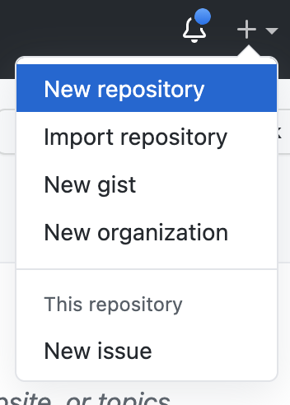

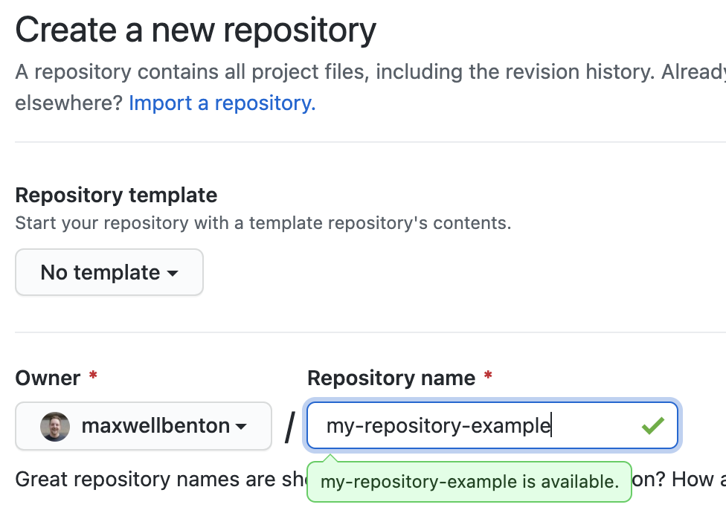

When we create a blank repository, we are given multiple options for how to get started. Since we have a local folder with Git initialized already, we'll use the instructions for creating a new repository using the command line.

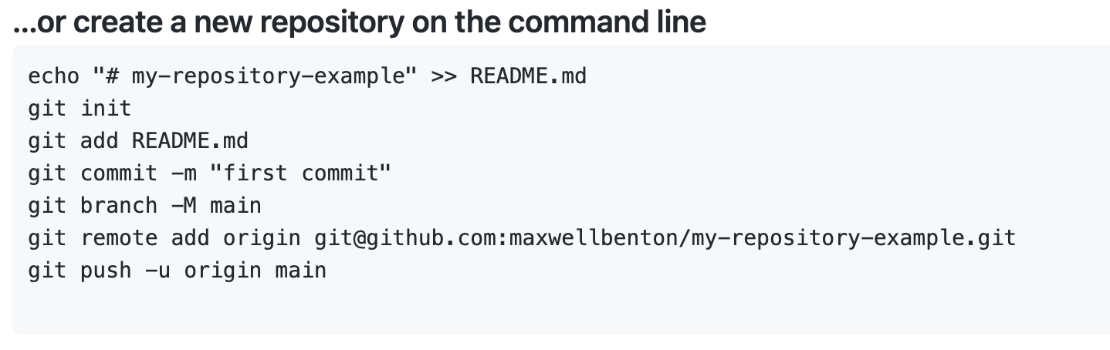

If you've been following along, you may notice that the first commands listed are things you've already done - git init initialized the my-repository directory as a local Git repository; git add README.md tracks the README.md file (you may have used git add ., which will work too); git commit -m "first commit" commits the newly created README.md file with a message.

The remaining commands still need to be run. First we run the following:

$ git branch -M main

If you recall from the version control basics lesson, going forward main will be used as the default name of the... main... branch in a repository. Depending on your environment you may still have a version of Git that defaults to master. If this is the case, the above command will change this master branch to main.

After setting the branch, we need to add the newly created GitHub repo as the remote for your local my-repository repo. This command will include info specific to your GitHub account and the name you gave your GitHub repo:

$ git remote add origin git@github.com:<your-github-username>/<your-github-repository>.git

#### Step 9

The last step listed pushes your local work up to the remote:

$ git push -u origin main

#### Step 10

**Change back up to the top-level directory** and run npm test once more, your tests should all be passing.

Once you've passed all tests, if you visit the newly created remote repository on GitHub, you should see that the README.md file you created is now present.

## Additional Practice

We recommend taking time to become familiar with Git commands since you'll be relying on them a lot. If you'd like to practice further, **change directory back into the my-repository folder** and try the following:

* Create another file, then add, commit, and push to the remote
* Modify the contents of README.md, then add, commit, and push to the remote
* Rename README.md, then add, commit, and push to the remote

## Wrapping Up

If you would like to preserve the work you've done for this lab on GitHub, you'll need to push it up to your fork of this assignment. **Change directory to the top-level** once again, then run the following:

$ git add .

$ git commit -m "Done with assignment"

$ git push origin master

Note that this assignment was created with a master branch as the default, so the push command is different than when you pushed my-repository.

## Conclusion

As you become more comfortable with the terminal and Git, you'll find yourself using the workflow of initializing, adding, committing and pushing your work on a regular basis. These commands are at the core of Git version control. By knowing them, you now have the ability to create your own repositories and contribute to repositories that already exist.

In this lab you used tests to guide you in the basics of setting up a new local Git repository and binding it to a remote repository on GitHub. By pushing your work to a remote repository you've backed it up and made it available for the world to see via GitHub. Professional developers use this process to share code with each other, to document their code, and to earn interview slots by showing off what they're capable of. You did this guided by tests. It's common for developers to write tasks as tests that all fail and then slowly work to get them all passing. It's like a to-do list that verifies you've actually done the work!

[Previous](https://moringa.instructure.com/courses/318/modules/items/59155)[Next](https://moringa.instructure.com/courses/318/modules/items/59157)

**A Quick Tour Of The Web**

**Learning Goals**

* Define "internet"
* Define "server" role
* Define "client" role
* Identify which role possesses the data that browsers display
* Identify what type of content defines what's seen in browsers

**Introduction**

Welcome to the web, the largest canvas in the world. Roughly 40% of the world's population has access to the web. Never before has it been possible to reach so many across such vast distances!



To orient you in these first steps of your study of HTML and web programming we want to give a broad overview of the web and how it works in the broadest terms. While you might have heard "web," and "internet" and "server" in many different contexts and places over the years, it's possible that you've never built a cohesive model in your mind that connects those concepts.

In this lesson, we'll go over the essential steps in how the web works.

**Define "internet"**

When people share information, great things can happen. Politics can change. Our place in the universe can change. Disease can be conquered. The ability to share knowledge is *power*. In the earliest days of computing, engineers looked for ways to have computers share information. Technical limits meant networked computers had to be within the same office.

Eventually, improvements allowed small networks to "inter"-"network" with each other. This discipline was called "internetworking." By the technology and knowledge of "internetworking," these small local networks (or, "local area networks" or LANs) became "internetworked" into "Wide Area Networks" or WANs.

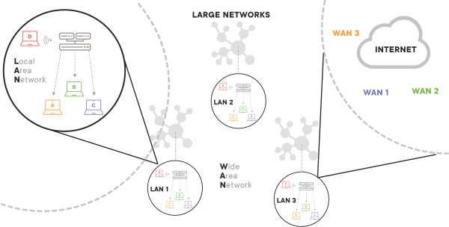

The natural next dream was to "internetwork" WANs into some sort of "larger" inter-network, something city-scale, country-scale, or global scale. Technology for "inter-networking" WANs was difficult and slow to develop, but eventually produced a backbone internetwork, "**The Internet**work" which encompassed all of its constituent WANs and their constituent LANs. Eventually, in common usage, it became called "The Internet."



It was upon *this* "The Internet" that "The Web" was built.

**Note:** For many reasons, style guides no longer capitalize "internet" or "web." The global network linking computers globally is "the internet."

**Define "server" Role**

All machines on the internet are computers. For ease of discussion, we're going to discuss them in two "roles:" client and server. Historically a "server" would be a larger, more powerful computer with more memory, bigger hard drives, and more computer chips. But today, "server" roles can be handled quite well by Arduino devices no bigger than a credit card! Nevertheless, in diagrams and on whiteboards they tend to be drawn as large "tower-style" computers.

Regardless of its size, a "server" has the responsibility of arranging the data that is presented to the "client." It's because of this "arranging" being computationally demanding that servers have tended to have extra resources.

Historically, computers were very expensive and well-appointed servers were very, very expensive. As such, when possible, it was more economical for servers to do heavy processing and for the clients to request updates.

**Define "client" Role**

A computer fulfilling a client role has the responsibility of presenting the data that is sent from the server. Historically, these machines could be more lightly equipped (and thus cheaper). You'll generally see them drawn in diagrams or on whiteboards as laptops.

The *client* displays data that is provided to it by the *server*. A verb that's commonly used is "render" as in, "The client *renders* data provided by the server." That is, it only displays the server's data and any change to the data has to be done *by the server*, caused by a *request* from the *client*.

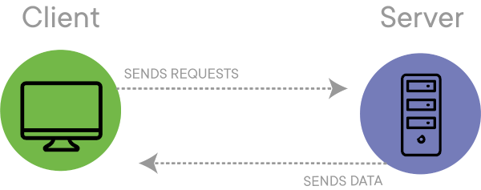

**Client/Server Example**

Let's take a moment to consider client/server in a common scenario: the supermarket.

If you ask the cashier for the price of a bottle of water, they can look it up for you. But their client computer's "source of truth" on the price lives on the server. The *client* must request this information by "asking" or "sending a request" to the *server*.

Similarly, when you buy that bottle of water, the (lightweight) client says "Sold a bottle of water!" to a server. The server, in turn, updates its inventory record to show -1 water bottle.

Now, at the end of the sales day, the management team would like to do some analytics about how profitable they were that day. They *could* go to each client computer, determine its revenue for the day and which departments contributed to that number, but on a cheap client machine that process would be s..l...o.....w — like trying to play a PS4 game on an iPhone!

*However*, if each client computer merely logged its actions to the server by sending requests, the management could ask that high-power machine to print out analytics in an economical and efficient fashion. Many businesses still have their IT architecture on this model, known as "the client/server" model.

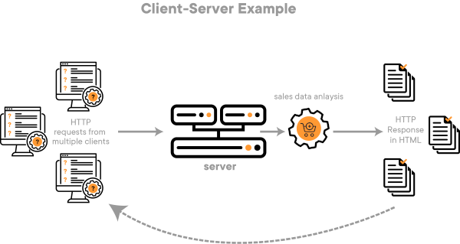

**Identify Which Role Possesses the Data That Browsers Display**

The web was developed with a client/server model. Home PCs were relatively underpowered (like our checkstands) *clients* and web content sharing programs were installed on high-power *servers*. Thus web *clients* running *browser* software were created that would send a *request* for a web page and the server would return the web page.

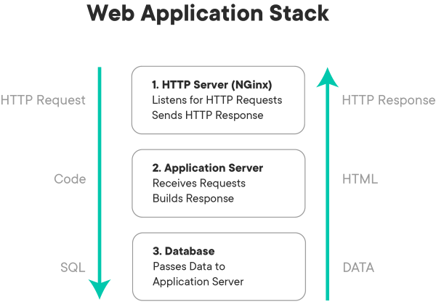

The specification on how *clients* and *servers* interact is called HTTP (HyperText Transfer Protocol). This is why URLs start with http://: you're telling the browser: "Browser, act as a client and use the HTTP standard to talk to flatironschool.com and find a file called index.html." The browser expresses this wish by transmitting a message that looks like:

GET flatironschool.com /index.html 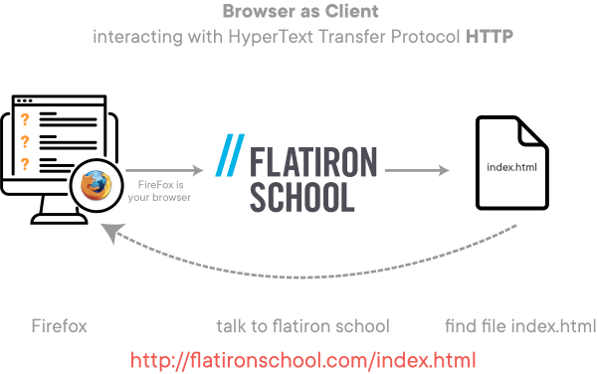

Here it asks flatironschool.com for an HTML file called index. We'll explore this *much* more in subsequent lessons!

In return, the *server* returns... HTML that's contained in the index.html file.

**Identify What Type of Content Defines What's Seen in Browsers**

Having been told which file on *its* hard drive to consult, the web *server* takes the contents of a file, pushes them across the internet *back* to the *client*. The client then receives the raw HTML. It looks something like this:

<!DOCTYPE html>

<html lang="">

<head>

<title>Home | The Metropolitan Museum of Art</title>

<meta charset="UTF-8">

<meta name="viewport" content="width=device-width, initial-scale=1.0">

<meta name="title" content="Home" />

<meta name="keywords" content="Metropolitan Museum, Met, Metropolitan Museum of Art, Met Museum, Metropolitan" />

<meta name="description" content="The Metropolitan Museum of Art is a...">

...

Obviously, this is *not* what you see when you visit [http://www.metmuseum.orgLinks to an external site.](http://www.metmuseum.org/). The difference hinges on that special verb *render*. Your *client's* browser *renders* the "raw" HTML and turns it into something *humans* find nice to read.

And this is the essence of how the web works!

**Conclusion**

In conclusion, we've talked about the history of the word *internet* and how it connects computers fulfilling *client* and *server* roles. We've identified that *client* machines use web browsers to make *requests* of the *server*, according to the HTTP standard, and the *server* returns HTML data, stored on their hard drives in files *back* to the requesting *client*. The *client* machine, running browser software, then converts that raw HTML data into a *rendered* format which is what you experience as a web page.

As a summary, we've provided the following video that gives an introduction to the web. If you are only interested in building web pages, you can stop at 3:48; if you are studying a web programming technology e.g. Ruby or JavaScript, we recommend watching the entire video.

* [The Web in a NutshellLinks to an external site.](https://www.youtube.com/watch?v=7AS96jRnquI)[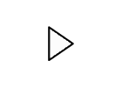](https://www.youtube.com/watch?v=7AS96jRnquI)
* [SlidesLinks to an external site.](https://docs.google.com/presentation/d/1m6SPR13MdfF7YRhfx7HtvkOmFnrRyVQOEFgWhI8Bc0I/edit?usp=sharing)

**Resources**

* [World Wide Web - WikipediaLinks to an external site.](https://en.wikipedia.org/wiki/World_Wide_Web)
* [HTML basics - Mozilla Developer NetworkLinks to an external site.](https://developer.mozilla.org/en-US/docs/Learn/Getting_started_with_the_web/HTML_basics)
* [An overview of HTTP - Mozilla Developer NetworkLinks to an external site.](https://developer.mozilla.org/en-US/docs/Web/HTTP/Overview)
* [Static vs DynamicLinks to an external site.](https://noahveltman.com/static-dynamic/)
* [Client Server Model - WikipediaLinks to an external site.](https://en.wikipedia.org/wiki/Client%E2%80%93server_model)

[Previous](https://moringa.instructure.com/courses/318/modules/items/59157)[Next](https://moringa.instructure.com/courses/318/modules/items/59159)

**Welcome to HTML**

**Preview**

In the next few lessons, we'll be introducing you to HTML (HyperText Markup Language).

HTML is a *documentation-based* technology. The word *documentation* probably inspires a mental image of someone carrying heaps of papers, folders, files. But what is a *document* in the digital realm?

We'll start our exploration of HTML by thinking about files and learning the vocabulary technologists use to discuss them in the process of creating HTML documents. This will assist your searches for help and your ability to interact with professionals on the topic.

We'll then proceed to a collaborative lab where you'll be guided in editing a simple HTML document. The point here is not to memorize the full detail of HTML's vocabulary, but to experience the joy and excitement of being able to adjust and customize HTML.

After that, we'll learn a core set of HTML features that will enable you to create simple HTML documents with less-explicit guidance. Around this time, you'll then begin tying these discoveries together and will start creating your first HTML documents.

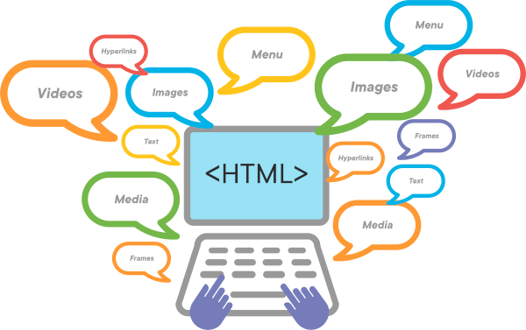

**Repetition & Getting Stuck**

In the lessons ahead, many of the ideas are deliberately repeated. You might not get "attributes" the first time you see them, but, after some hands-on experience, they'll make sense the second time you see them.

**Beyond**

At the close of the unit, you'll be ready to learn a series of HTML expressions that will allow you to create a meaningful web page.

[Previous](https://moringa.instructure.com/courses/318/modules/items/59158)[Next](https://moringa.instructure.com/courses/318/modules/items/59160)

**Files, Extensions, and File Types**

**Learning Goals**

* Define a file
* Contrast *text files* and *binary files*
* Identify the function of file extensions

**Introduction**

Have you tried to memorize a phone number "for a second" as you tried to write it down? Maybe you kept repeating it over and over? Have you ever felt a little overwhelmed when someone was giving you too much information at once and you were trying to keep up--but felt relief when you finally "got it"? As humans, we can only hold a few things in our heads before they start to, well, vanish or get mixed up. Our *working memory* is not too reliable!

Computers also have limited working memory. Just like us, they keep things in working memory that they're, well, working with.

When computers or people run out of space, they write down information stored in their *working memory*. Humans sometimes use a napkin, Post-It Notes or the back of their hands. Computers use *files*. The stuff computers write into their files fits into two main categories:

1. Information humans can read ("text files")
2. Information only computers can read ("binary files")

Developers create *lots* of files. This README will help us all get on the same page with how to talk about them.

**Define a File**

A file is a thing computers use to store facts ("data") or processes ("programs") for later use.

**Contrast *Text Files* and *Binary Files***

Computers think in electricity.

Whoa!

Computers' thoughts are usually shown as 1's and 0's. This is called *binary code*. When computers write things down, they often write them down in files in *their* language, *binary*. These files are *binary files*.

Types of *binary* files are images, music, and software programs. We can create these files with Adobe Photoshop, the C programming language, or Ableton.

Nobody is exactly sure how humans think. That's a question for science or philosophy. When we write our ideas down, we write them in files in *our* language, *text*. These files are *text files*.

Types of *text* files are HTML, letters to grandma, a list of student grades for a grade book program, directions to Carnegie Hall, etc. We create these *text* files with *text editors* like the LearnIDE editor, Atom, Sublime Text, vim, or emacs.

**ASIDE:** You might hear some developers call text files "[plaintextLinks to an external site.](https://en.wikipedia.org/wiki/Plain_text" \t "_blank)" or "[plain textLinks to an external site.](https://en.wikipedia.org/wiki/Plain_text) files" They all mean the same thing.

**The Curious Case of Word Processing Files**

What about files made by word processors Microsoft Word or MacOSX's TextEdit? While you're typing text, those programs store the text *as well as information* about the text (which font to use, which words are in bold, whether these next five lines are part of a bullet-list, etc.) in the *same* file. To make the loading and saving fast, these programs save the file in *binary*.

**Word Processors and HTML, Code**

Since word processing programs store their output in *binary* files and programs that read HTML (like browsers) or run code (like Ruby, Python, JavaScript, or Java) need *text*, **Word Processors should not be used to create HTML or code. Developers do their work in *text editors*, not *word processors*.**

**Identify the Function of File Extensions**



Many file names have an "extension" that comes after a .. It is not a requirement, but it's a best practice. The extension is a "hint" to the operating system of which program should be used to work with the file. For example, LetterToGrandma.docx has a *docx* *extension* which *hints* to the OS that it should open the file with the Word word processing program by Microsoft. The file job\_offer.pdf *hints* to the OS that it could open the file with either Acrobat or MacOSX's Preview application. When the OS finds many good options, it will ask for the user's help in selecting the right program.

Changing an extension **does not** change the type of file you have. A text file called groceries.txt could be renamed groceries.mp3 **but it would still be a text file**. A Toyota with a BMW medallion does not suddenly become a BMW. Our groceries did not suddenly become music because we changed the extension.

Some operating systems, like MacOSX, *hide* the file extension by default. They reckon that most users "no longer care about it." Since we're developers, though, we will frequently dig below the "end-user" layer. When in a terminal, we will see full file names - including extensions.

Here's a table to help train your instincts in seeing text-files versus binary-files:

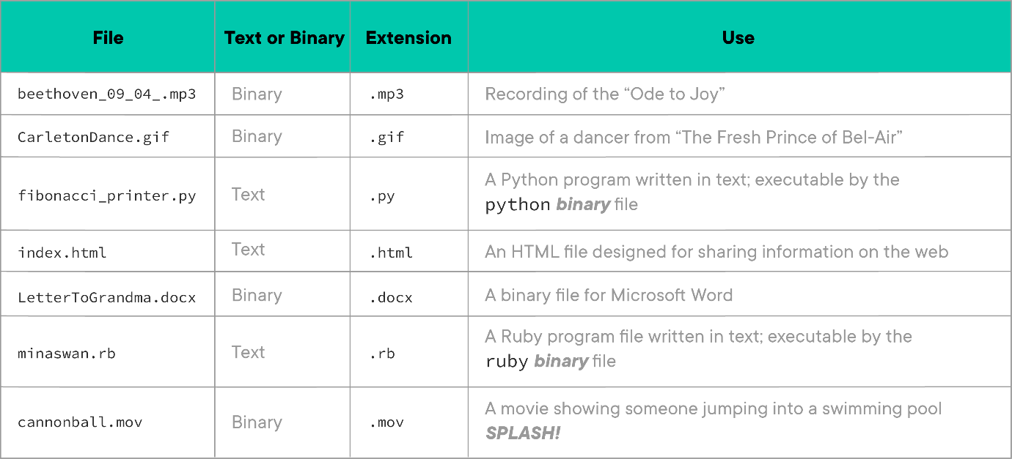

**Conclusion**

In this lesson, we have taken some time to get to know files. Files are things in which computers store data that needs to last a while or which their users might want to refer to again later. We've noted that files generally come in binary and text formats. And we saw that many files also have an extension that provides hints about which program should be used to work with the file.

# Experiencing HTML Lab

* **Due** No Due Date

* **Points** 1

* **Submitting** a website url

## Learning Goals

* Create an ordered HTML list
* Create an unordered HTML list

## Introduction

How do we go about writing text for the web? How is that different from the text that we write in a text file? We're going to experience for ourselves how these things are different in this lab.

You don't need any prior knowledge of HTML for this lab. We're going to tell you what to type. Don't focus on specific commands or taking notes. Everything will be covered thoroughly later. Instead, the goal of this exercise is to feel the joy of editing a file and seeing the change "out there."

**NOTE:** We don't expect you to know markup, content, source text, or rendered text yet. We'll be defining them in this lab.

## Getting Started

If you haven't already, fork and clone this lesson into your local environment.

**Quick Review:** To fork this lab:

1. click the **Fork** icon in the upper right of this page. This will bring you to GitHub. You may be prompted to choose where to fork — choose your personal GitHub account.
2. Once your fork is created, click the **Code** button in GitHub, choose **SSH** and copy the provided git URL info.
3. Clone to your local machine with git clone followed by the git URL you copied. This will create a folder in the location you're currently in containing your fork of this lab's repository.

cd into the repository that you just cloned down in the terminal, then run code . to open the files in Visual Studio Code. (If you are using a different text editor, the command will be different. For the AWS Cloud9 IDE, for example, you must click on the file in the left navigation to open it.) Finally, run npm install to install the lab's dependencies.

## Create an Ordered HTML List

Think of a collection of things united by theme: Pokémon, Old-school MC's, Prime Ministers of New Zealand, Magical Beasts and Where to Find Them, etc. We're going to walk through how to create a list of things marked up with HTML.

### Create a Text File with Content

In your terminal, while still inside of this labs directory, create a new file called my\_list.txt by running touch my\_list.txt. The file extension suggests to humans and operating systems that it contains text. Open the file in VS Code by typing code my\_list.txt; you will do all editing for this lesson in VS Code.

Below is a collection of song titles (songs in the English post-punk genre). Copy and paste the songs into your my\_list.txt file.

"Love Will Tear Us Apart"

"Bela Lugosi's Dead"

"A Forest"

"Nine While Nine"

"Girlfriend In a Coma"

The material we typed into the file is called the content. It's the thing we're trying to communicate.

### Content as a List in a Text File

A problem with our content is that it doesn't explicitly state anywhere that it's a list. In the example, we see a list of songs. But a browser doesn't know what a "list" is.

We need to help the browser **know** what a list is. The secret is to add "notes" or "breadcrumbs" to the content that tell the browser that it has list items and that these items "go together" in a list. To add these "notes" we surround the content with bits of markup, with bits of HTML.

We will take the text content from our text file, paste it into a new HTML file and then we will add markup so that a browser "sees" a list. Let's write an HTML file!

### Text Inside an HTML File

Now we're going to create an HTML list together.

1. Create a new file called my\_list.html. You can either do this in the terminal and then open it in VS Code, or create the file directly in VS Code.
2. Copy the contents of my\_list.txt and paste them into my\_list.html
3. Save the my\_list.html file
4. Open the my\_list.html file in the browser. For Mac users, you can do this with open my\_list.html. For Windows users, you can do this in your Ubuntu app with explorer.exe my\_list.html. Make sure you've [set Chrome as your default browserLinks to an external site.](https://support.google.com/chrome/answer/95417?co=GENIE.Platform%3DDesktop&hl=en).
5. Hit enter to run the command

**Note:** If you are using the AWS Cloud9 IDE, the process for opening HTML files is slightly different. In the lefthand file navigation, right click my\_list.html (command + click for Mac users). In the context menu that appears, click the **Preview** option:

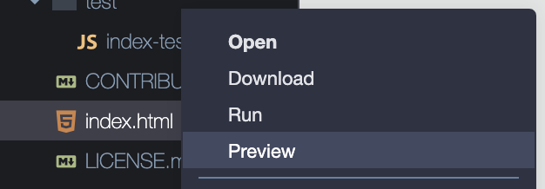

This will open the HTML page as a new tab in the IDE. You can also open this preview tab as a separate browser tab by clicking the 'pop out' button in the upper right corner of the tab

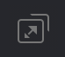

Once you've opened the file in the browser, you should see:



As noted above, the browser doesn't know that items on new lines means "items in a list." Browsers ignore when HTML is split onto new lines. We cover why a little later in this README. Since the browser doesn't know we intend this to be a list **and** since browsers ignore when content is split onto different lines, it displays all the content on one line. Not what we wanted.

### A Text Not-Really-A-List Into a Real-HTML-List

**REMEMBER**: This lab will provide you what to type. Subsequent labs will deeply examine details of HTML markup. However, our goal here is to show how slight changes to markup can quickly alter the browser's display of content. If you're fuzzy on a detail that's fine.

#### Marking-Up List Items

OK, we've reached the critical moment. We're going to tell the browser that these bits of letters represent **list items**. To do so we "wrap" each line with <li> and </li>:

<li>"Love Will Tear Us Apart"</li>

<li>"Bela Lugosi's Dead"</li>

<li>"A Forest"</li>

<li>"Nine While Nine"</li>

<li>"Girlfriend In a Coma"</li>

Flip back to the **viewing tab** and refresh the page. You should see something like the following:

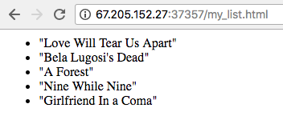

**AWESOME**.

In this step we added some HTML markup:

* The <li> is an HTML **list item** opening tag
* The </li> is an HTML closing tag
* We would call this pair of opening and closing tags a "li tag"
* The whole length of text of opening markup plus "wrapped" content plus closing markup (<li>...content...</li>) is called "an HTML element;" or, more exactly, an li element

Again, you don't need to memorize these terms yet, but we want to help you develop an intuition for how these words are used. You will be using these terms when speaking with other developers and HTML authors.

It may not seem like we did much work, but the idea of a method for "marking up" content and linking it is the foundation of the web. It's what made Tim Berners-Lee's reputation. And **you** just experienced Sir Tim's great insight. **AWESOME**.

Let's work with additional HTML tags to see how we tweak our HTML a bit more. Let's tell the browser "Hey! These list items, they go together!"

### Indicating that List Items Are Connected

Wrap the entire set of <li> items with an <ol> and </ol> like so:

<ol>

<li>"Love Will Tear Us Apart"</li>

<li>"Bela Lugosi's Dead"</li>

<li>"A Forest"</li>

<li>"Nine While Nine"</li>

<li>"Girlfriend In a Coma"</li>

</ol>

Save the file and refresh the **viewing tab**. It should display:

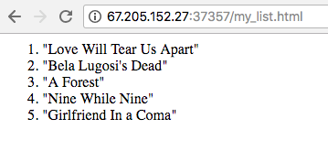

We told the browser that this set of list items that we "wrapped" in the **ordered list** tag go together **as a list**. Because we told the browser that the list is **ordered** it decided to be helpful and put numbers next to the list items for us.

### Wrapping and Indentation

With all these angle-brackets of markup and content mixed together, HTML authors like to use indentation to make HTML easier to read. Here's how most HTML authors would expect our code from the previous section to be arranged:

<ol>

<li>"Love Will Tear Us Apart"</li>

<li>"Bela Lugosi's Dead"</li>

<li>"A Forest"</li>

<li>"Nine While Nine"</li>

<li>"Girlfriend In a Coma"</li>

</ol>

Update your document. Save it and refresh your **viewing tab**.

Remember earlier when the browser ignored that content was on separate lines? Cleaning up your code requires splitting lines, adding spaces, and adding tabs. Browsers ignore those characters that humans use to make their HTML reader-friendly.

## Create an Unordered HTML List

Let's change our ordered list to be **unordered**. If <ol> means **ordered list**, you might guess that <ul> means **unordered list**. Make the change and refresh your **viewing tab**.

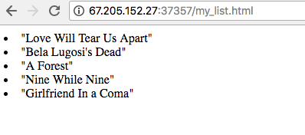

Here we return to a "bulleted" unordered list.

**ASIDE**: If you've been following along closely, you might be wondering, if we didn't have a <ul> tag around our <li> items earlier, how did the browser know to treat those <li> as if they were in a <ul>? When browsers detect problematic HTML they guess! This can lead to some very strange results when you make an error, but if you write invalid HTML, they try to recover. HTML validity will be discussed further soon!

### Add a Description Paragraph

Let's introduce our list by adding some background:

<p>Some of my favorite post-punk and Goth songs!</p>

<ul>

<li>"Love Will Tear Us Apart"</li>

<li>"Bela Lugosi's Dead"</li>

<li>"A Forest"</li>

<li>"Nine While Nine"</li>

<li>"Girlfriend In a Coma"</li>

</ul>

Take a look at your "rendered page" and verify the result is to your liking.

### Put a Header on It

Lastly, let's put a "heading" on the top of our document. Add a h1 element with an appropriate title inside.

<h1>My Music List</h1>

Here's the full example code:

<h1>My Music List</h1>

<p>Some of my favorite post-punk and Goth songs!</p>

<ul>

<li>"Love Will Tear Us Apart"</li>

<li>"Bela Lugosi's Dead"</li>

<li>"A Forest"</li>

<li>"Nine While Nine"</li>

<li>"Girlfriend In a Coma"</li>

</ul>

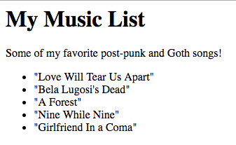

When you're done, it is time to run this assignment's tests. Make sure that you have your HTML content in a file called my\_list.html in order to pass the check. Type npm test and verify that your tests pass.

## Saving Your Work Remotely

Currently, the work you've done on this assignment is only on your local machine. To preserve work on your GitHub fork, you will need to stage the changes you've made, commit them, and push the commit up to GitHub. Use the following commands to do this:

$ git add .

$ git commit -m "Completed assignment"

$ git push

If you visit your fork on GitHub, you should now see that you've made the most recent commit, and your solution will be present in the files.

Once you've pushed your code to GitHub, do the following steps to submit your work on Canvas:

1. Go to your repository in GitHub and copy the URL. Note, this should be copied from the browser's address bar, and should start with https://github.com/
2. Go to the assignment in Canvas and click Submit Assignment (or Start Assignment)
3. Paste in your GitHub URL as your submission

## Conclusion

In this lab, you have done the job of an HTML author. You receive raw content, you mark it up to create source text. You test, tweak and adjust your source text until the rendered text displayed in the browser is to your liking.

In upcoming lessons, we will learn additional tags which provide us more ways to describe our content. We might be starting with lists today, but soon we'll be using HTML in even more exciting ways!

Welcome to the community of web page creators!

[Previous](https://moringa.instructure.com/courses/318/modules/items/59160)[Next](https://moringa.instructure.com/courses/318/modules/items/59162)

Document Structure Continued

* **Due** No Due Date

* **Points** 1

* **Submitting** a website url

**Learning Goals**

* Recognize basic HTML document structure
* Recognize HTML comments
* Describe the head section and its contents
* Create an HTML document

**Introduction**

Every HTML document has a specific set of required tags. Because these are required *every* time we create a web page, it is valuable to gain a more in-depth understanding of what these tags do, why they are useful, and how they work in context to the modern web.

We will be both reviewing setting up well-formed HTML documents and expanding a bit on the DOCTYPE, html and head tags, as well as introducing how to add comments within our HTML code.

**Getting Started**

If you haven't already, fork and clone this lesson into your local environment. Navigate into its directory in the terminal, then run code . to open the files in Visual Studio Code (If you are using a different text editor, the command will be different). Finally, run npm install to install the lab's dependencies.

**Recognize Basic HTML Document Structure**

Let's start by adding the bare essentials of an HTML document to the provided index.html file:

* A DOCTYPE tag, which looks like this: <!DOCTYPE html>
* Opening and closing html tags
* Opening and closing head tags nested inside the html tags
* Opening and closing body tags nested inside the html tags

If written correctly, running npm install && npm test now will pass the **first** test of this lab. **However** you will not be done yet! We have to make **all** the tests pass in order to make the test code happy! Fixing this first one means that we get to attack the next one. Let's get to it!

Let's take a closer look at these tags.

**<!DOCTYPE html>**

At the top of every HTML document, you're always going to start off with the same element, DOCTYPE. In the early days of the internet, there were fewer standards, and it was important to declare the specific way we wanted browsers to interpret the file at the top of each file. Netscape and Internet Explorer would look for this declaration and handle the content differently depending on what it found. These days, every current browser is compatible with HTML5, and DOCTYPE is mainly used to tell the browser to render the page in standards compliant mode.

The DOCTYPE element, as with all HTML, starts with a < and ends with a >. Uniquely, the DOCTYPE tag starts with an exclamation point, !, followed by DOCTYPE, then specifies which version of HTML we want to use. In HTML5, we just write html and the browser interprets the rest of the document as HTML5.

**<html>**

The next element is also always required: <html>. This tells the browser that everything that falls between the opening and closing html tags is to be interpreted as HTML code.

One attribute that is important to include in the <html> tag is lang, which declares what language the webpage is written in. In our case, writing in English, we will use lang="en". This helps search engines to know what language a page is written in. Google, for instance, can use the lang attribute to know when to prompt users about translating web content.

<html lang="en"></html>

**Recognize HTML Comments**

Sometimes we want to leave notes either for ourselves or for other developers inside of our HTML files. An example might be a brief explanation of what some part of the code is doing, or an important message or reminder. We can write comments by wrapping the text we want like so:

<!-- This is a comment! -->

Text included in a comment will not be visible on the webpage, but will be visible in the browser console and .html file.

**Describe the head Section and its Contents**

Inside our html tags, we divide the page into two main sections, head, and body, which both play unique roles. The remainder of our HTML lessons will cover everything within the body section, but before we get there, there are some additional bits of information we need to understand regarding the head. The head section is not visible to a website visitor, but it contains a lot of useful info about our webpage.

In the head section, we place a number of specific tags, most notably:

* <link>
* <title>

Let's look at each of them in turn:

**link**

The <link> tag is for importing files.

**CAREFUL**: It's easy to get confused here because web pages are full of links, but also use a <link> tag. "Links" that you click on are located within the <body> element. The <link> tags are located in the <head> element.

Most commonly, we'll use <link> to import CSS files. Like so:

<link rel="stylesheet" type="text/css" href="style.css" />

Linking style sheets this way allows multi-page websites to share a source of styling content for every page, making for a consistent, easy to maintain file structure. Often, on fully developed websites, multiple style sheets are linked in the head. For example, when doing the final polishing of a web site you might see a series of <link> definitions like:

<link

rel="stylesheet"

href="https://stackpath.bootstrapcdn.com/bootstrap/4.1.1/css/bootstrap.min.css"

/>

<link rel="stylesheet" type="text/css" href="company.css" />

<link rel="stylesheet" type="text/css" href="engineering-department.css" />

<link rel="stylesheet" type="text/css" href="project-x-launch.css" />

<link rel="stylesheet" type="text/css" href="typography.css" />

In this example we're getting some CSS information from the [BootstrapLinks to an external site.](https://getbootstrap.com/" \t "_blank) project, we're integrating a company style standard, an engineering style standard, a style motif for the launch of "Project X" and then we're adding some specific rules about font display. You can bring in a **lot** of information with the <link> tag!

This specific example aside, you'll be learning a lot more about linking files to create stylistic effect in later lessons.

**title**

One more common tag we find in the head is title. The title, as its name implies, is where the title of the webpage should be entered. Text added inside the title tags will appear up on your browser tab. Adding a title for our index.html page would look something like:

<title>Cat Perry's Favorite Cats</title>

Notice that unlike the previous tags we've discussed, title has an opening and closing tag. In most modern browsers, tabs are fairly small, so it is often best to keep the title brief, or it will not be fully visible.

**Create an HTML Document**

Okay, time to put what we've learned to the test. To complete this lab, you must apply all the tags we've discussed in this lesson. Run npm test to see what is required to pass each test. Each test will urge you on.

**Saving Your Work Remotely**

Currently, the work you've done on this assignment is only on your local machine. To preserve work on your GitHub fork, you will need to stage the changes you've made, commit them, and push the commit up to GitHub. Use the following commands to do this:

$ git add .

$ git commit -m "Completed assignment"

$ git push

If you visit your fork on GitHub, you should now see that *you've* made the most recent commit, and your solution will be present in the files.

**Conclusion**

In this lesson, we've reviewed the basics of document structure, as well as what is typically contained within the head. Using the head section, we are able to add relevant data about our webpage as a whole. As a bonus surprise, by learning how to make our web pages *search engine friendly*, we've also dabbled a bit into the basics of Search Engine Optimization! We are now ready to take a deeper dive into the visual content of HTML pages.

Your First HTML Tag Lab

* **Due** No Due Date

* **Points** 1

* **Submitting** a website url

**Learning Goals**

* Code an h1 tag
* Set the inner text of the h1 to Hello, World!

**Introduction**

So far, we've seen how to markup content with HTML, how to structure an HTML document and what HTML tags look like. Now let's focus on writing a single HTML tag from scratch and examining each of its parts.

**Getting Started**

Fork and clone this lesson into your local environment. Navigate into its directory in the terminal, then run code . to open the files in Visual Studio Code. Finally, run npm install to install the lab's dependencies. Run npm test as you go to see your test progress.

**Code an h1 Tag**

Open index.html in your text editor. Add the h1 opening and closing tags.

**Set the Inner Text**

Inside of the opening and closing h1 tags, insert the text: Hello, World!.

You can run the tests with this lab via the npm test command. Make sure you save the file before running the test suite. Failing tests will provide helpful error messages that you can use to debug your code — read them closely for hints!

**Viewing Your Work in the Browser**

While working through these assignments, your general workflow should center on writing code in the text editor and periodically running the test suite in the terminal to check your work.

Another great way to track your progress is to open up the HTML document in your browser and watch how each change you make in the text editor affects the visual layout in the browser.

Once you have the HTML document open in your browser, you can make changes to it in the text editor, save the file, refresh the page in the browser, and see the changes instantly.

**Saving Your Work Remotely**

Currently, the work you've done on this assignment is only on your local machine. To preserve work on your GitHub fork, you will need to stage the changes you've made, commit them, and push the commit up to GitHub. Use the following commands to do this:

$ git add .

$ git commit -m "Completed assignment"

$ git push

If you visit your fork on GitHub, you should now see that *you've* made the most recent commit, and your solution will be present in the files.

**Conclusion**

Congratulations! You wrote your first HTML tag. Now you can use your knowledge of this basic building block to learn more HTML tags and see how they work with each other to create an entire HTML document structure.

**Resources**

* [h1-h6 TagsLinks to an external site.](https://www.w3schools.com/tags/tag_hn.asp)
* [Solving the First HTML LabLinks to an external site.](https://www.youtube.com/watch?v=Jc0HIoTLxe4)[](https://www.youtube.com/watch?v=Jc0HIoTLxe4)(If you're stuck, here's a video walk-through of the lab to help you out.)

[Previous](https://moringa.instructure.com/courses/318/modules/items/59162)[Next](https://moringa.instructure.com/courses/318/modules/items/59164)

**Nested HTML Tags And Attributes**

**Learning Goals**

* Assess HTML document structure
* Identify HTML tag attributes and their purposes

**Introduction**

When you take a look at an entire HTML document, it's sometimes challenging to keep track of where tags begin and end. But understanding more about HTML tag nesting and attributes can help everything fall into place.

**Assess HTML Document Structure**

Whenever we nest an HTML tag inside of another tag, we indent the inner tag so that the overall tag hierarchy is clear. Take a look at the following example of a well-structured HTML document.

<!DOCTYPE html>

<html>

<head>

<title>Web development course</title>

</head>

<body>

<header>

<!-- header element documentation: https://developer.mozilla.org/en-US/docs/Web/HTML/Element/header -->

<nav id="main-navigation">

<!-- nav element documentation: https://developer.mozilla.org/en-US/docs/Web/HTML/Element/nav -->

<ul>

<!-- ul element documentation: https://developer.mozilla.org/en-US/docs/Web/HTML/Element/ul -->

<li><a href="/web">Introduction to the web</a></li>

<!-- li element documentation: https://developer.mozilla.org/en-US/docs/Web/HTML/Element/li -->

<li><a href="/html">Learn HTML</a></li>

</ul>

</nav>

</header>

</body>

</html>

Keeping your HTML well indented so that every tag and "level" of nesting is aligned will make your code easier to read and maintain.

**Identify HTML Tag Attributes and Their Purposes**

An HTML attribute is extra information we can add to a tag to identify, classify, style or modify the default behavior of the element the tag contains.

<element attribute\_name=attribute\_value another\_attribute\_name=another\_attribute\_value></element>

A common use case for HTML attributes is element identification (id attribute) and/or classification (class attribute). The id attribute is used to uniquely identify an element within the whole document. The class attribute is used to group together similar elements.

Both <id> and <class> attributes are often used for styling purposes since they allow us to find a specific element or style similar elements with a single style declaration.

<p id='main\_paragraph'>This element can be uniquely identified using the 'main\_paragraph' id HTML attribute</p>

<p class='other\_paragraphs'>This element belongs to a group of elements who share the 'other\_paragraphs' HTML class attribute</p>

<p class='other\_paragraphs'>This element also belongs to a group of elements who share the 'other\_paragraphs' HTML class attribute</p>

Attributes that identify or classify are not necessary for the HTML tag to work as intended, but other attributes *are* — for example, an a tag, which links a piece of text to another location on our own web page or another web page.

<a href="https://flatironschool.com/">Flatiron School</a>

Here we use the href attribute to tell the HTML tag where the destination of the linked text should be. Without this information, our link won't work and we won't be able to send more people to the Flatiron School website. Certain attributes go hand in hand with certain HTML tags, and as you learn the tags, you'll learn their attributes.

**Conclusion**

We use nesting to keep the elements of our HTML document organized, and we use attributes to give our elements more power. With these strategies, we can construct a solid HTML structure that serves as a foundation for anything else we want to build.

**Resources**

* [Nested TagsLinks to an external site.](https://www.thoughtco.com/nesting-html-tags-3466475)
* [Best Practices Web DesignLinks to an external site.](http://www.iraqtimeline.com/maxdesign/basicdesign/principles/prinnest.html)
* [HTML AttributesLinks to an external site.](https://www.w3schools.com/html/html_attributes.asp)
* [AttributesLinks to an external site.](https://www.tutorialspoint.com/html/html_attributes.htm)

[Previous](https://moringa.instructure.com/courses/318/modules/items/59163)[Next](https://moringa.instructure.com/courses/318/modules/items/59165)

Create a Link Using the href Attribute

* **Due** No Due Date

* **Points** 1

* **Submitting** a website url

**Learning Goals**

* Write an a tag to create a link

**Introduction**

We've got our HTML tags, and we've got our HTML tag attributes. How do we use them together? We can figure it out by exploring the a tag and creating a link.

**Getting Started**

Fork and clone this lesson into your local environment. Navigate into its directory in the terminal, then run code . to open the files in Visual Studio Code. Finally, run npm install to install the lab's dependencies.

**Write an a Tag to Create a Link**

Open index.html in your text editor. Add an a tag with the inner text (the text between the <a> tag and the </a> tag) of Flatiron School anywhere in the file. Then set the href attribute of your new link element to https://flatironschool.com.

You can run the tests with this lab via the npm test command. Make sure you save the file before running the test suite. Failing tests will provide helpful error messages that you can use to debug your code — read them closely for hints!

**Viewing Your Work in the Browser**

While working through these assignments, your general workflow should center on writing code in the text editor and checking to see what it looks like in-browser.

Working in your local environment, you can open index.html a few ways, depending on the environment you are in:

For Mac users:

* Open from the Terminal by running open index.html in the root directory of this lab
* Use Finder to navigate to this lab's local folder and click the index.html file

For WSL users:

* Open from Ubuntu by running explorer.exe index.html in the root directory of this lab
* Open a new Explorer window. There is a bar that says "Quick Access" along the top of the window (similar to a URL bar in a browser). Click this and type \\wsl$ to access files and folders on Ubuntu. Navigate to /home/<your-user-name>/ to get to your home directory, then locate this lab's local folder and click the index.html file.

Once you have the HTML document open in your browser, you can make changes to it in a text editor, save the file, refresh the page in the browser, and see the changes.

**Saving Your Work Remotely**

Currently, the work you've done on this assignment is only on your local machine. To preserve work on your GitHub fork, you will need to stage the changes you've made, commit them, and push the commit up to GitHub. Use the following commands to do this:

$ git add .

$ git commit -m "Completed assignment"

$ git push

If you visit your fork on GitHub, you should now see that *you've* made the most recent commit, and your solution will be present in the files.

**Conclusion**

Here we saw how an attribute helps the a tag do its job, which is to link to another location. Now we can go on to explore some additional HTML tags.

**Resources**

* [Mozilla Developer Network: HTML <a> TagLinks to an external site.](https://developer.mozilla.org/en-US/docs/Web/HTML/Element/a)

**HTML Lists, Images and Links**

**Learning Goals**

* Identify ordered, unordered and definition lists
* Identify images
* Identify links
* Identify HTML validation tools

**Introduction**

You might be wondering what else is available to use to build out full webpages now that you are more familiar with the basics of HTML. How do you display an image? How do you add a formatted list of topics? How do you link page elements beyond text? Now you're ready to explore these fundamental tools. Here's a high-level overview before you dive into practicing with the labs.

**Identify Ordered, Unordered and Definition Lists**

When we want to present a list of items in a clear, readable format, we turn to the HTML unordered list, represented by the ul tag.

<ul>

<li>One item</li>

<li>Another item</li>

</ul>

Here is how the HTML above looks when rendered in the browser:

* One item
* Another item

If it's important to distinguish a particular order of the items (as for a recipe or ranking), we use an ordered list, or the ol tag.

<ol>

<li>First item</li>

<li>Second item</li>

</ol>

Here is how the HTML above looks when rendered in the browser:

1. First item
2. Second item

Notice the nesting of our items within the lists. Each li is a list item contained in the larger ul or ol container.

Another type of list we can use is a definition list, which defines specific types of items.

<dl>

<dt>First term</dt>

<dd>Term definition</dd>

</dl>

Here is how the HTML above looks when rendered in the browser:

**First term**

Term definition

**Identify Images**

To include an image in our page, we use an img tag.

<img

src="https://via.placeholder.com/800x600.png"

alt="Alternative Text"

title="Display Title"

width="800"

height="600"

/>

There are two notable things about the img tag: The first is that it does not have a closing tag. The image tag closes itself. Secondly, it handles a lot of *attributes*. Attributes are special keywords used on the tag to control the element's behavior, or provide additional information about the HTML element.

The alt attribute provides descriptive text the browser can display if it can't find the image file. The browser can also display the title text to give the user more information about the image. The width and height attributes define the size of the image that shows up in the browser.

Here is how the image element above looks when rendered in the browser:



**Identify Links**

You might be familiar with basic link structure already, but here are other ways we can use them.

Beginning with a standard text hyperlink, we can wrap other elements inside of them.

<a href="http://example.com/">This is a link</a>

Here is how the HTML above looks when rendered in the browser:

[This is a linkLinks to an external site.](http://example.com/)

What if we want to link an image instead of text? We can replace the text within the a tags with our image tag.

<a href="http://example.com/">

<img src="https://via.placeholder.com/800x600.png" alt="Alternative Text" />

</a>

Here is how the HTML above looks when rendered in the browser:

[](http://example.com/)

What about a link that will direct to an email address?

<a href="mailto:webmaster@example.com">Send an email</a>

Here is how the HTML above looks when rendered in the browser:

[Send an email](mailto:webmaster@example.com)

Sometimes we might want to link to a specific location on the same webpage. We can then target an element that we identified or classified earlier.

<p id="tips">Useful Tips Section</p>

<a href="#tips">Jump to the Useful Tips Section</a>

Here is how the HTML above looks when rendered in the browser:

Useful Tips Section

[Jump to the Useful Tips Section](https://moringa.instructure.com/courses/318/pages/html-lists-images-and-links?module_item_id=59166#tips)

When considering what location links point to, you will choose between relative or absolute links. A relative link directs to content within the same website.

<a href="about.html">This is a relative URL link</a>

Here is how the HTML above looks when rendered in the browser:

[This is a relative URL link](https://moringa.instructure.com/courses/318/file_contents/course%20files/about.html)

An absolute link, on the other hand, links to external content and requires a fully defined URL path. This is likely the type of link you see most often.

<a href="http://example.com/">This is an absolute URL link</a>

Here is how the HTML above looks when rendered in the browser:

[This is an absolute URL linkLinks to an external site.](http://example.com/)

**Identify HTML validation tools**

An HTML validator is used to check HTML markup elements for syntax errors. Syntax errors, such as open tags, extra spaces, or forgotten quotation marks, can cause a web page to look drastically different than the creator intended, or render correctly in one browser, but not in another.

It's easy to forget a closing HTML tag or miss a piece of punctuation when writing HTML. Fortunately, we have a tool that will check our markup for us and point out any errors. To validate our HTML, we can use the [W3 HTML validatorLinks to an external site.](http://validator.w3.org/).

**Conclusion**

Now that you've taken a first look at these new HTML elements, you'll be better prepared to practice them in labs, where you'll learn more about each one and how to use it effectively.

HTML Lists

* **Due** No Due Date

* **Points** 1

* **Submitting** a website url

**Learning Goals**

* Recognize unordered and ordered HTML Lists
* Create unordered lists
* Identify the ordered list tag
* Create ordered lists

**Introduction**

Many HTML tags behave in unique ways. Some apply automatic styling, like p tags that create margins around text. Some, like the header tags, increase the font size. Using these tags delineates our content. When reading HTML, using the correct tags informs us of what the content's purpose is. If we see an h1 tag, we know that we're looking at a *big* page header. In this lesson, we're going to be looking at a few new tags that help us organize *lists* of related content.

**Getting Started**

Fork and clone this lesson into your local environment. Navigate into its directory in the terminal, then run code . to open the files in Visual Studio Code. Finally, run npm install to install the lab's dependencies.

**Recognize Unordered And Ordered HTML Lists**

Let's say, for instance, we were building a personal website and wanted to list out our favorite foods. We *could* write this like so:

<body>

<p>Ham and Cheese</p>

<p>Grilled Cheese</p>

<p>Nacho Cheese French Fries</p>

<p>Cheese soup</p>

<p>Cheese and crackers</p>

<p>Sushi</p>

</body>

The above would create a new line on the page for each food, but doesn't really indicate that these things are related. Using the built in ul, ol and li HTML tags however, we can group related list content together. We call such a grouping a "list."

In HTML, we create lists using the <ul> tag, which stands for *unordered list*, along with the <li> tag for each *list item*.

To make a list, we write out the opening and closing <ul> tags, and inside them, we'll add <li> tags, each listing a single item. Going back to our favorite foods example, if we wanted convert it to a list, it would look like this:

<ul>

<li>Ham and Cheese</li>

<li>Grilled Cheese</li>

<li>Nacho Cheese French Fries</li>

<li>Cheese soup</li>

<li>Cheese and crackers</li>

<li>Sushi</li>

</ul>

Now, instead of just having each item show up on a new line, the content will also be slightly indented and a bullet will appear next to each of them.

Lists are very flexible and we can even nest lists *inside* of lists. Say we wanted to breakdown our favorite foods by category. We may have multiple categories and one or more items in *each*:

<ul>

<li>

Sandwiches

<ul>

<li>Ham and Cheese</li>

<li>Grilled Cheese</li>

</ul>

</li>

<li>

Snacks

<ul>

<li>Nacho Cheese French Fries</li>

<li>Cheese and crackers</li>

</ul>

</li>

<li>

Soups

<ul>

<li>Cheese soup</li>

</ul>

</li>

<li>

Sushi

<ul>

<li>Spicy Salmon Rolls</li>

<li>California Rolls</li>

</ul>

</li>

</ul>

In this example, the nested lists will now be *further* indented and instead of a solid bullet, they will appear with hollow bullets, indicating a sub-list. Adding a nested list one level deeper will make *square* bullets appear, allowing us to easily display related and nested content in a readable format.

**Create Unordered Lists**

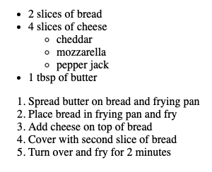

The first part of this challenge is to make the first 2 tests pass by:

1. Creating an unordered list
2. Nesting each grilled cheese ingredient as a list item wrapped in <li> tags

Open index.html in your browser.

Let's say we wanted to list out the ingredients required for making a grilled cheese sandwich. The ingredients are: 2 slices of bread, 4 slices of cheese, 1 tbsp of butter.

For the first part of this challenge, in index.html, create an unordered list that displays these ingredients. Run npm test to see if you can pass the first test. If you've done things correctly, you'll now be passing the first test, but there are more tests to pass! We now need to turn our attention to the next test.

Okay, now, lets say we wanted to make our grilled cheese a little more exciting and add a couple of cheeses, cheddar, mozzarella, and pepper jack.

To pass the second test, **inside** the li with 4 slices of cheese, add a **nested** unordered list that lists out the three types of cheese.

After editing your index.html file, go back to the browser and refresh the page you opened earlier. You should see something like this if you've set up your lists correctly:

* 2 slices of bread
* 4 slices of cheese
  + cheddar
  + mozzarella
  + pepper jack
* 1 tbsp of butter

Run npm test again. If your first two tests are passing, great! It's time to talk about another type of list!

**Identify the Ordered List Tag**

Unordered lists are great for organizing related content where it doesn't matter what goes first, like in our grilled cheese ingredients. In situations where we *want* items to be displayed in a specific, numbered order, we will want to use the *ordered list* tag, which is written as <ol> instead of <ul>. Both use <li> tags inside, but this time, <ol> will display a numbered list instead of bullets. If say, we wanted to write a *ranked* list of favorite foods, it might look like:

<h3>Top 5 Favorite Foods</h3>

<ol>

<li>Grilled Cheese</li>

<li>Sushi</li>

<li>Cheese and crackers</li>

<li>Cheese soup</li>

<li>Nacho Cheese French Fries</li>

</ol>

**Top Tip:** Feel free to test this out by adding it to index.html, saving and refreshing the tab where the file is open. Now, Grilled Cheese will be displayed as 1. Grilled Cheese as the #1 food (where it belongs).

Once you've got a feel for how this ordered list looks in HTML and how it's displayed in the browser, delete the example code from your index.html file so you can create a new one from scratch for the next deliverable.

Nested ordered lists work the same as unordered, but instead of hollow and square bullets, each nested list will still display numbers.

**Note:** To create a nested list, you *must* provide the ol or ul wrapper. Otherwise, an li inside another li will just be displayed as two items at the same level.

**Create Ordered Lists**

To complete the challenge write the necessary HTML to pass the final test:

* Create an ordered list with each step for creating grilled cheese as a list item wrapped in <li> tags

Okay, so we've got our grilled cheese ingredients, but what about the steps required to make a grilled cheese? Steps to a recipe need to be in order, otherwise we may end up with burnt cheese covered in bread and topped with a square of butter. The steps to making a basic grilled cheese would be: Spread butter on bread and frying pan, Place bread in frying pan and fry, Add cheese on top of bread, Cover with second slice of bread, Turn over and fry for 2 minutes.

After editing your index.html file, go back to the browser and refresh the page you opened earlier. Your newly added list should look like this:

1. Spread butter on bread and frying pan
2. Place bread in frying pan and fry
3. Add cheese on top of bread
4. Cover with second slice of bread
5. Turn over and fry for 2 minutes

Once you've written an ordered list that displays these 5 steps correctly, run npm test to see the tests pass.

**Saving Your Work Remotely**

Currently, the work you've done on this assignment is only on your local machine. To preserve work on your GitHub fork, you will need to stage the changes you've made, commit them, and push the commit up to GitHub. Use the following commands to do this:

$ git add .

$ git commit -m "Completed assignment"

$ git push

If you visit your fork on GitHub, you should now see that *you've* made the most recent commit, and your solution will be present in the files.

**Conclusion**

Lists in HTML are very useful for organizing related content, and are really the only way to indicate that content is related with basic HTML. Using unordered lists ends up being very useful for more than just listing favorite foods and ingredients. Its possible, for instance, to use list elements to organize navigation links - with styling, we make the content look however we want: remove the bullets, make them line up horizontally, but in our HTML they will still be organized and easy to read.

[Previous](https://moringa.instructure.com/courses/318/modules/items/59166)[Next](https://moringa.instructure.com/courses/318/modules/items/59168)

HTML Tables

* **Due** No Due Date

* **Points** 1

* **Submitting** a website url

**Learning Goals**

* Recognize basic HTML table elements
* Create HTML tables

**Introduction**

In HTML, we can create lists of related content using unordered and ordered lists, and they will display line by line in the order we put them in. Sometimes as web developers, though, we need to display more complex data. For instance, imagine you are working with a financial company and need to display a collection of transactions, each with a title, value, time, and category. Or, imagine that you've been hired by a marketing company and need to display a list of the [most popular Instagram accountsLinks to an external site.](https://en.wikipedia.org/wiki/List_of_most-followed_Instagram_accounts), each with their username, the owner of the account, and the number of followers. For sets of data like this, with many separate components, the best way to display would be to put the data into a *table*.

HTML has a built in way to display tables! In this lesson, we will be reviewing how tables work and how to make our own.

**Getting Started**

Fork and clone this lesson into your local environment. Navigate into its directory in the terminal, then run code . to open the files in Visual Studio Code. Finally, run npm install to install the lab's dependencies.

**Recognize Basic HTML Table Elements**

**The Table Tag: <table>**

The first thing we need in order to create a table is to write opening and closing <table> tags.

<table></table>

This tells our browser to interpret anything inside as part of the table. What makes up a table, exactly? A table has rows and columns, which together create individual cells, as well as headers to label what each column is for.

In HTML, we define these table components using individual elements that we nest inside our table tags.

**The Table Row Tag: <tr>**

It's important to note: order really matters when building a table in HTML! We're trying to display a two-dimensional table, but browsers interpret HTML *line by line*. For this reason, HTML tables were designed so that there is no tag for *columns*, only *rows*. If you were creating a table with 5 rows and 5 columns, in designing the table, we would actually have to create 5 *rows*, each with 5 individual *cells* inside. When displayed, the cells in each row will line up to *look* like columns.

Table rows always come first. To make a row inside our table, we use the *table row* tag, <tr>. So if we wanted to have four rows in our table, including a row of headers, setting up the rows it would look like this:

<table>

<tr></tr>

<tr></tr>

<tr></tr>

<tr></tr>

</table>

Any content we want in a row would go inside that particular <tr>.

**The Table Header Tag: <th>**

Tables generally start with a row of headers to label each column, so the first tr tag we write will be dedicated to these headers.

To create headers, we use <th>, the *table header* tag. Let's say we were creating a list of guests to a party. The first column might have a header called 'Name' for the guest's name, the second, the guest's 'Phone Number', and the third, what the guest is 'Bringing' to the party.

These headers need to go in the first row, so that may look something like:

<table>

<tr>

<th>Name</th>

<th>Phone Number</th>

<th>Bringing</th>

</tr>

<tr></tr>

<tr></tr>

<tr></tr>

</table>

Even though we write the HTML from top down, we would see these headers in bold and lined up *left to right*. We can open up index.html right now to take a look to confirm.

This first row is almost always the only place where we use the th tag.

**The Table Data Tag: <td>**

In the second row, we can start putting in our data. Here, we want to use the *table data* tag, <td> instead of using the *table header* tag. The <td> tag represents one table cell. So, for our party table, we can add in some names, phone numbers and items for guests to bring. An example row would look like the following:

<tr>

<td>Daniel</td>

<td>845-282-4000</td>

<td>Guacamole</td>

</tr>

As long as each bit of data in a <td> is in the *same position* as the corresponding <th> in the first row, it will show up in that column.

Repeating this structure, if we wanted to include 3 guests for our party, our entire table would look like the following:

<table>

<tr>

<th>Name</th>

<th>Phone Number</th>

<th>Bringing</th>

</tr>

<tr>

<td>Daniel</td>

<td>718-555-1212</td>

<td>Guacamole</td>

</tr>

<tr>

<td>Rachel</td>

<td>718-555-1212</td>

<td>Chips</td>

</tr>

<tr>

<td>Terrance</td>

<td>914-555-1212</td>

<td>Salsa</td>

</tr>

</table>

Paste this into index.html and take a look at how it is displayed in browser. You'll see we've got a table with 4 rows and 3 columns! Each "column" of content expands to fit the width of the content. It should look something like this:

| **Name** | **Phone Number** | **Bringing** |
| --- | --- | --- |
| Daniel | 718-555-1212 | Guacamole |
| Rachel | 718-555-1212 | Chips |
| Terrance | 914-555-1212 | Salsa |

**Create HTML Tables**

Okay, now its time to put what we've learned to the test. For this challenge, your task is to recreate a table using the following data:

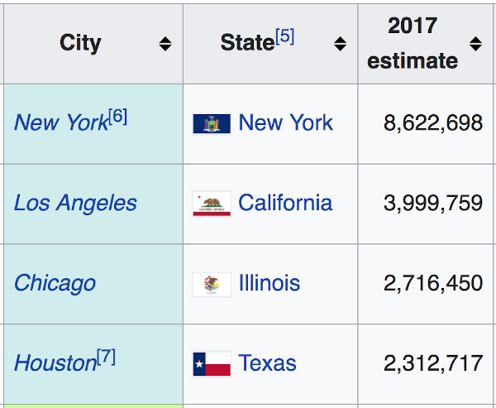

The above table shows total population of the 4 biggest cities in the US. We can see there are 3 headers, "City", "State", and "2017 estimate", and data for each of the four cities.

To complete this task, follow the order of table creation we discussed earlier:

1. Create a table, and place rows inside,
2. Dedicate the first row to just headers
3. Add in the data in the appropriate order so that each city name falls under the "City" column, each state is under "State", etc...

Run npm test to test your work and see your progress. The tests also include the exact population numbers, so feel free to copy them from the errors!

**Saving Your Work Remotely**

Currently, the work you've done on this assignment is only on your local machine. To preserve work on your GitHub fork, you will need to stage the changes you've made, commit them, and push the commit up to GitHub. Use the following commands to do this:

$ git add .

$ git commit -m "Completed assignment"

$ git push

If you visit your fork on GitHub, you should now see that *you've* made the most recent commit, and your solution will be present in the files.

**Conclusion**

So, with table, tr, th and td, we are able to turn line by line HTML into a table with rows and columns! It may seem counterintuitive at first to list out row content separately, but with this, you can represent all sorts of data!

[Previous](https://moringa.instructure.com/courses/318/modules/items/59167)[Next](https://moringa.instructure.com/courses/318/modules/items/59169)

HTML Images

* **Due** No Due Date

* **Points** 1

* **Submitting** a website url

**Learning Goals**

* Recognize the img tag
* Use img tag attributes
* Create images

**Introduction**

Images are absolutely critical to making appealing and engaging websites. Can you imagine the web without them? No cat memes. No animated dancing bananas! No *Instagram*, at all. The internet would be a pretty boring and sad place!



In this lesson, we will be discussing how to include images in your HTML, along with some important attributes of the tag. With images, you can make your web pages much more engaging and visually appealing.

**Getting Started**

Fork and clone this lesson into your local environment. Navigate into its directory in the terminal, then run code . to open the files in Visual Studio Code. Finally, run npm install to install the lab's dependencies.

**Recognize the img Tag**

Images are inserted into HTML using the img tag. The tag can display a variety of image types, including animated GIFs, bitmaps and vector graphics, though most often, the images we see on the internet are JPEG and PNG files.

The img tag is *self closing*, meaning it doesn't wrap around content or text. Instead, the relevant information is stored in attributes within the tag itself.

There are two main attributes, src, the *source* of the image, and alt, the *alternate* text.

**Use the img Tag Attributes**

**The Image Source Attribute**

The src attribute provides the relative path or URL to the image file we want to display. The image file can be local, say, for instance, if you're publishing a website and have a local stored in a folder, your source may look like this:

<img src="../images/my\_company\_logo.png" />

However, its very common, even when publishing your own websites, to have images hosted somewhere else on the internet. In these situations, we need to provide a full URL as the source:

<img src="https://i.imgur.com/H1qsYEl.png" />

The src attribute is always necessary, as without it, the img tag would have nothing to display.

**The Image Alt Attribute**

The alt attribute contains text relevant to the image we're displaying, and will appear in its place if the image fails to load.

While it isn't required, it is **highly recommended** that every image includes an alt attribute. The alt text is important for screen readers for the visually impaired, as the text will be read out loud to the site visitor. It is also nice to provide some sort of message to a website visitor if the image fails to load, especially if the image is relevant to the rest of the content. Alt text on a failed image will appear along with a small 'broken image' icon:



To include an alt attribute, add it in along with the src attribute:

<img

src="https://i.imgur.com/H1qsYEl.png"

alt="comedic crow gets wholesome support"

/>

**Note** When an HTML element gets too long for one line in your text editor, it's appropriate to separate out each attribute on its own line as we've done above. This helps make your HTML code more readable.

**The Image Title Attribute**

One additional attribute that can be useful is the title. Content added to this attribute will display when we hover over the image with our mouse. If we were creating an img tag with src, alt and title for a company logo, it might look something like this:

<img

src="../images/my\_company\_logo.png"

alt="my company name"

title="We're here to help you!"

/>

When a visitor to your company site hovers over the logo, they'll see a message appear saying 'We're here to help you!'

The title attribute isn't necessary and is often left out, but can be a nice detail to include.

**Create Images**

Its time to practice creating some images! For this challenge, feel free to use any images you'd like - the tests are looking for the correct tag and attributes, not the content. If you're not sure what to use, feel free to use the following URL as your source:

https://s3.amazonaws.com/ironboard-learn/lion.jpg



Your challenge is to write *three* image tags:

* The first should have *just* a *source* attribute
* The second should include an alt text, in addition to a source
* The third should have both an alt and source attribute, as well as a *title* attribute

Run npm test and read the tests as you go.

**Saving Your Work Remotely**

Currently, the work you've done on this assignment is only on your local machine. To preserve work on your GitHub fork, you will need to stage the changes you've made, commit them, and push the commit up to GitHub. Use the following commands to do this:

$ git add .

$ git commit -m "Completed assignment"

$ git push

If you visit your fork on GitHub, you should now see that *you've* made the most recent commit, and your solution will be present in the files.

**Conclusion**

With images, we can fill our web pages with visual content in addition to text. Brand logos, animated instructional guides, personal artwork and photography, or pictures of you and your friends - you now have the ability to create visually appealing content of *any type!*

[Previous](https://moringa.instructure.com/courses/318/modules/items/59168)[Next](https://moringa.instructure.com/courses/318/modules/items/59170)

**HTML Validation**

**Learning Goals**

* Identify W3C organization
* Validate sample HTML
* Identify HTML errors

**Introduction**

You have written a few HTML pages by now. Did you accidentally break nesting and put emphasis on a whole page? Or did you type <he> instead of <h3>? How can we guard HTML? Many editors try to catch errors for us, and most browsers are pretty good at guessing what you meant. But what happens when Windows Edge guesses differently than Google Chrome? How can we be certain that our HTML meets standards and is error free? Luckily, the W3C – the people who define the tags of HTML – have a validation service we can use. We'll explain the W3C and their validator in this lesson.

**Identify W3C organization**

The World Wide Web Consortium (W3C) is an international community that develops open standards to ensure the long-term growth of the web. It operates under a strict [code of ethics and professional conductLinks to an external site.](https://www.w3.org/Consortium/cepc/) and provides many [free toolsLinks to an external site.](https://www.w3.org/developers/tools/) for developers.

**Validate sample HTML**

Take a look at this file: [example\_code.htmlLinks to an external site.](https://curriculum-content.s3.amazonaws.com/web-development/html-validation/example_code.html" \t "_blank) in a new tab. We'll call this the **viewing tab**. It looks relatively OK, right? There's some oddness happening with the list at the bottom (we might not have wanted everything hyperlinked), and there's an odd bullet point with no content, but everything else looks pretty good.

Now let's try validating the code to identify where we went wrong.

1. In your **viewing tab**, navigate View → Developer → View Source *or* press Command-Option-U. This will give you the "Source View" of the document
2. Select the whole of the HTML contents in the file, and copy them
3. In your web browser, open a new tab to [W3C's HTML ValidatorLinks to an external site.](https://validator.w3.org/#validate_by_input)
4. If not already selected, select the tab that says "Validate by Direct Input"
5. Paste all of your copied HTML in the text box labeled "Enter the Markup to validate:"
6. Click the button labeled "Check"

As you scroll down the page, you should see a list of errors, or invalid HTML.

**What is HTML Validation?**

Like all other programming languages, HTML can contain all kinds of different errors. These can range from missing angle brackets to wrong or missing opening or closing tags, unnecessary or missing attributes, and many other issues. Our web browsers are pretty good at filling in the missing pieces but we can't always count on it being the same experience with every one. Tools like W3C's HTML Validator can catch these errors and prevent our user from having a poor experience.

**Identifying HTML Errors**

Now that we have a page full of HTML validation errors, how do we start fixing them? There are several parts of the error message that will help us parse the error, and figure out exactly where it is and what we can do to fix it.

**Error Description**

The first line of the error is our error description. This is a narrative that gives us a little bit more information about our error.

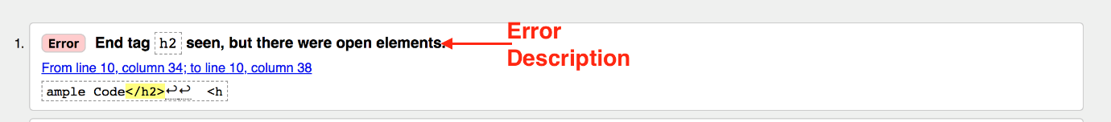

In this case, it's saying that there was an ending </h2> tag, but there was a different opening tag that came before it.

**Error Location**

The second and third lines of this error give us the exact location of the error, as well as a highlighted snippet of our HTML to help us exactly locate where the error is.

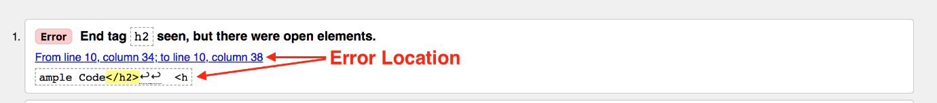

In this case, it's letting us know that our error is on line 10, from column 34-38. Line numbers will become very important in troubleshooting errors, in JavaScript and CSS as well as HTML. These error messages can serve as a road map to us, and help us troubleshoot much more efficiently.

**A Valid HTML Experience**

Now, let's see what a valid HTML file returns.

1. Open the [example\_code\_passing\_validation.htmlLinks to an external site.](https://curriculum-content.s3.amazonaws.com/web-development/html-validation/example_code_passing_validation.html" \t "_blank) file in a new tab. This will now be our new **viewing tab**
2. In your **viewing tab**, navigate View → Developer → View Source *or* press Command-Option-U. This will give you the "Source View" of the document
3. Select the whole of the HTML contents in the file, and copy them
4. In your web browser, navigate to [W3C's HTML ValidatorLinks to an external site.](https://validator.w3.org/#validate_by_input) in a new tab
5. If not already selected, select the tab that says "Validate by Direct Input"
6. Paste all of your copied HTML in the text box labeled "Enter the Markup to validate:"
7. Click the button labeled "Check"

You should see a green bar denoting that there are no errors or warnings to show.



**Resources**

* [W3CLinks to an external site.](https://www.w3.org/)
* [HTML Validation ToolLinks to an external site.](https://validator.w3.org/)
* [Why Validate?Links to an external site.](https://validator.w3.org/docs/why.html)

[Previous](https://moringa.instructure.com/courses/318/modules/items/59169)[Next](https://moringa.instructure.com/courses/318/modules/items/59171)

**Expanding Your HTML Vocabulary via MDN**

**Learning Goals**

* Identify the Mozilla Foundation and MDN
* Navigate the MDN Reference Guide

**Introduction**

Because of the pace of change in web technologies, it often feels like as soon as you learn something it's already obsolete. How can a developer stay up-to-date? Developers need to be able to reference the latest documentation in a just-in-time fashion.

When you have a question, you should consult the best source, take what you need, and use it. The purpose of this README is to help you get oriented with a popular source of HTML documentation, the [Mozilla Developer Network (MDN)Links to an external site.](https://developer.mozilla.org/en-US/docs/Web/HTML/Element).

**Identify the Mozilla Foundation and MDN**

The Mozilla Foundation is an open-source company that has a long history with browsers and browser technology.

Mozilla is a reliable reference for the latest HTML tags. There are many other sites online that exist to discuss these tags, but when you want a thorough explanation of a tag, Mozilla is often a great choice.

There are some drawbacks in using MDN. Because Mozilla is so trusted, their information tends to be ... *exhaustive*. Because it's so *ahem* thorough, it can sometimes be hard to digest. Their information tends to be for *reference*, not *tutorial* purposes.

Drawbacks aside, MDN is a good solid starting place for research and it can take you from "Does something like this exist?" to "Now I know that this thing exists, maybe I can find a tutorial!"

**Navigate the MDN Reference Guide**

The [MDN HTML Reference GuideLinks to an external site.](https://developer.mozilla.org/en-US/docs/Web/HTML/Element) is a list of HTML tags grouped together by their functions. These sections are not entirely "human readable," which makes it a bit difficult to understand where to start looking. Some of the headings are very technical-sounding.

To help you find what you need in this listing, we've created this helpful table to help you convert **between** MDN-ese and the HTML terms you have learned. We've also listed only the MDN content sections that you're most likely to use:

| **MDN Section Title** | **Human-Friendly Section Title** | **Summary** |
| --- | --- | --- |
| Main Root | The html tag | *The html tag and that's it!* |
| Document metadata | Website data that goes in the head tag | *Metadata contains information about the page. Information about styles, scripts and data to help software (search engines, browsers, etc.) use and render the page.* |
| Sectioning Root | The body tag | *The body tag and that's it!* |
| Content sectioning | Headings, titles, divs, sections, footers, etc. | *Content sectioning elements allow you to organize the document content into logical pieces.* |
| Text content | Formatting for text: list items, horizontal rules, figures listings for under images | *Use HTML text content elements to organize blocks or sections of content placed between the opening and closing body tags.* |
| Inline text semantics | Citation, emphasis, underlines, etc. | *Use the HTML inline text semantics to define the meaning, structure, or style of a word, line, or any arbitrary piece of text.* |
| Image and multimedia | Adding pictures and media! | *HTML supports various multimedia resources such as images, audio, and video.* |
| Embedded content | Advanced: Using material hosted elsewhere on other servers, iframe is the biggie here | *In addition to regular multimedia content, HTML can include a variety of other content, even if it's not always easy to interact with.* |
| Scripting | Advanced: JavaScript and Drawing Support (Vector Graphics) | *In order to create dynamic content and Web applications, HTML supports the use of scripting languages, most prominently JavaScript. Certain elements support this capability.* |
| Table content | Tables | *Tables* |
| Forms | Advanced: Tags for building forms for sign-up or login, for example | *HTML provides a number of elements that can be used together to create forms which the user can fill out and submit to the Web site or application. There's a great deal of further information about this available in the HTML forms guide.* |

**Conclusion**

As developers, we will often feel uncomfortable with the fact that the technologies we depend on are always growing and changing. With authoritative guides like [MDNLinks to an external site.](https://developer.mozilla.org/en-US/docs/Web/HTML/Element" \t "_blank), we have found out that we can learn just the little bit we need as we need it.

**Researching HTML Elements**

**Learning Goals**

* Use search engines as a resource to find information
* Identify relevant resources
* Compare multiple resources to find the best source

**Introduction**

When writing HTML you might encounter tags that are new to you. How are we going to level-up? When searching for technical help, we have to be careful about which sources we trust. This is a skill you will build over time, but we'll model some good practices in this README.

**Use Search Engines as a Resource to Find Information**

Let's say in your research, you come across an unfamiliar HTML element like <samp>. We can google samp html element, and we will find an endless list of results to choose from. Sometimes resources can be outdated, biased, or inaccurate. It's important to filter through the results to find the best fit.

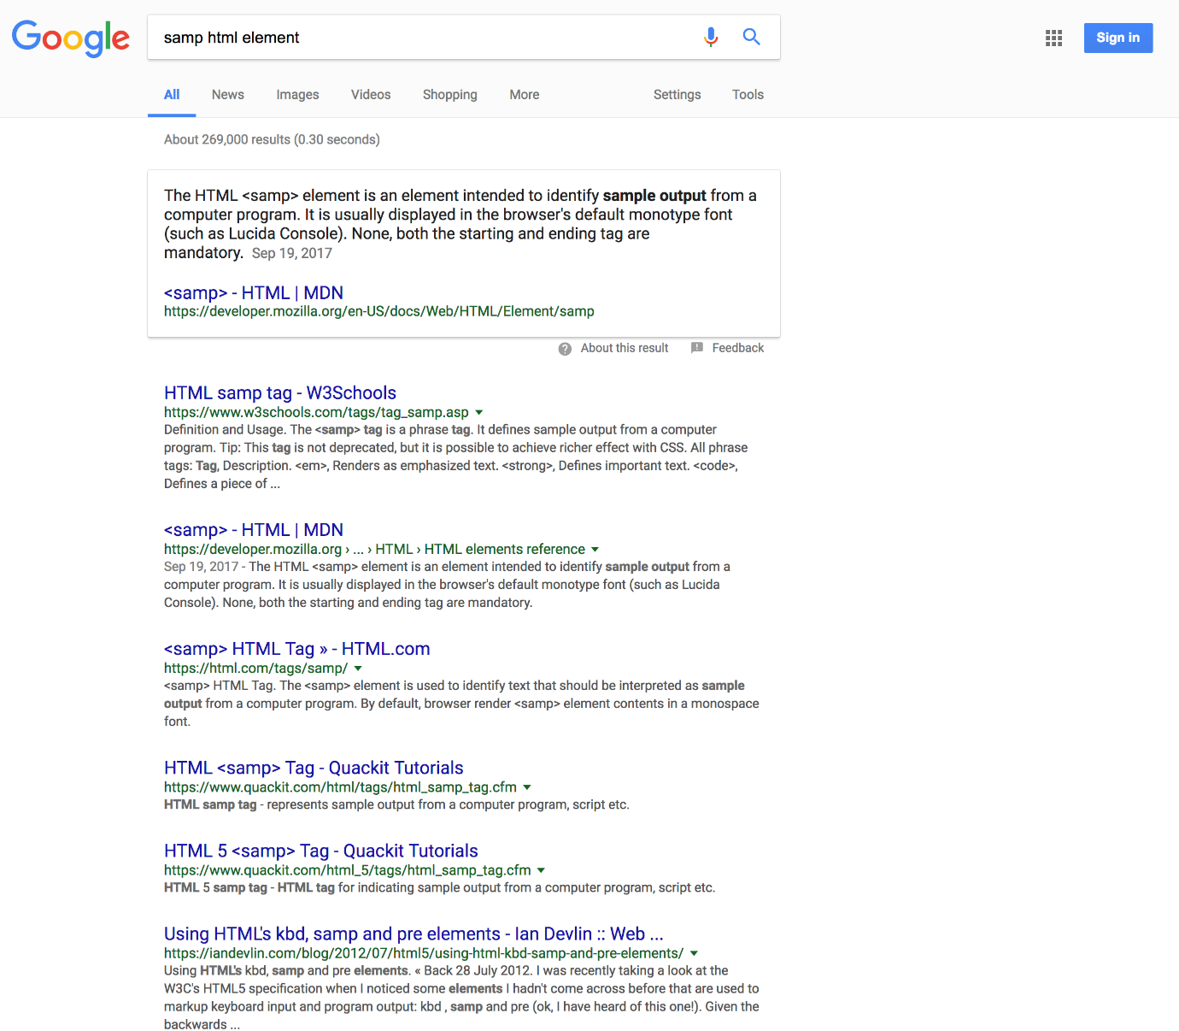

**Identify Relevant Resources**

Your instinct might be to open the first result. You should be pickier. Sometimes the result has "gamed" the search engine and unfairly influenced the ranking. We recommend that you open the top **five** results and review them critically.

We also recommend that you trust sites that are affiliated with building or defining the technologies more than blogs or other resources. In the HTML world, the Mozilla Developer Network (MDN) is an extremely trustworthy site. In fact, it's likely the best HTML, JS and CSS documentation source on the internet.

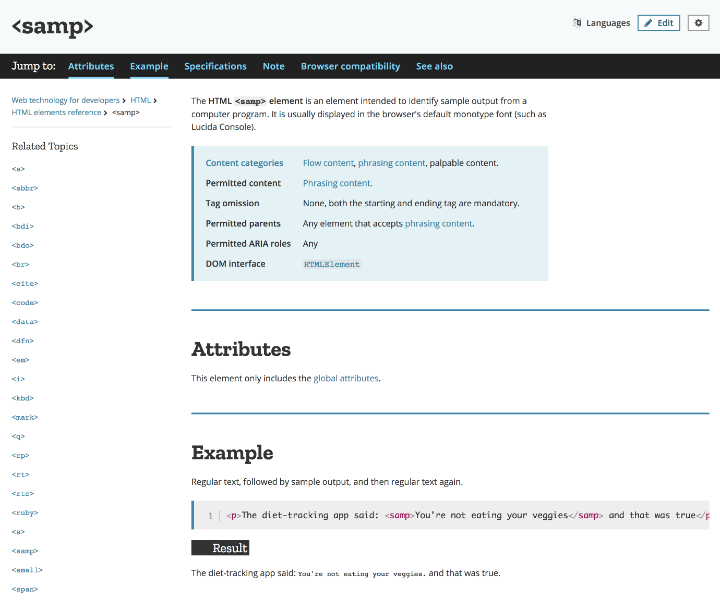

**Compare Multiple Resources to Find the Best Source**

If we go back to the search results, you'll see that the first result, in this case, is W3schools. A site, like W3schools, for example, can be used as an additional resource for garnering understanding. It even includes interactive examples, creating a sandbox environment for experimentation.

In this case, between MDN and W3schools, you should get a good sense of how to use the <samp> element.

**Conclusion**

The web is a constantly evolving entity. As we build more ambitious products or learn from our collective needs and mistakes, the industry will continually update the HTML specifications.

Researching referencing documentation can be scary at first, but it's a primary skill for developers. Don't be afraid to practice technical searches. It's a *skill* that you will get better at with practice.

Most importantly, don't feel like *not knowing everything by heart* means you can't be a developer. The greatest developers we know are constantly admitting what they don't know, finding the latest news, using the answer they found and moving on.

HTML Issue Bot 9000

* **Due** No Due Date

* **Points** 1

* **Submitting** a website url

**Learning Goals**

1. Demonstrate writing valid HTML

**Introduction**

Let's practice using the W3C's HTML Validator!

**Demonstrate Writing Valid HTML**

In this lab we'll use the W3C Validator to make our invalid HTML happy! You might need to change how you work this problem depending on your work environment. Either way you'll learn to fix invalid HTML.

**Getting Started**

Fork and clone this lesson into your local environment. Navigate into its directory in the terminal, then run code . to open the files in Visual Studio Code. Finally, run npm install to install the lab's dependencies.

**Steps**

1. Open index.html in a browser. See how it, well, doesn't look *quite* right?
2. Open index.html in your text editor
3. Visit the W3C validator at: [http://validator.w3.org/#validate\_by\_inputLinks to an external site.](http://validator.w3.org/#validate_by_input)
4. Copy the code from index.html and paste it into the text area
5. Click the large "Check" button
6. Use the error messages to correct the code your copy of index.html
7. Repeat steps 3-6 until the Html Validator reports: "Document checking completed. No errors or warnings to show."
8. Not only is the document now W3C-valid, it no longer looks weird

**Wrapping Up**

When your document is valid, go to the terminal and type npm test. Since the goal of this assignment is to practce verifying the HTML structure via W3C, the test in this lab is only checking that an index.html file exists.

**Resources**

* [W3C HTML Validator - Validate Direct InputLinks to an external site.](http://validator.w3.org/#validate_by_input)

**Using Your Browser's Developer Tools**

**Learning Goals**

* Examine the developer tools
* Use the developer tools to locate and inspect elements
* Use the developer tools to edit HTML

**Introduction**

By now, you're pretty familiar with HTML structural elements, and how they relate to each other on the page. You might even feel pretty comfortable writing your own valid HTML. But much of the time as developers, we'll be jumping in on projects that are already in progress. We'll need a way to view existing HTML and CSS, and potentially a way to play around with elements on live pages to see how we might potentially adjust things. Luckily for us, most browsers have those kinds of tools already built in, called developer tools, or dev tools for short. In this lesson, we'll look at the dev tools on [Google ChromeLinks to an external site.](https://www.google.com/chrome/).

**Examine the Developer Tools**

The Developer tools that browsers provide you are a great way to experiment with HTML and CSS, and immediately see how those changes are rendered in the browser.

For this lesson, please open the [Wikipedia page for Alan TuringLinks to an external site.](https://en.wikipedia.org/wiki/Alan_Turing) in Chrome.

Once the page is open, right click on the title of the page — the header containing his name. You should get a list of options. We want to click on the one that says Inspect. This is going to bring up a window at the bottom of the page that contains all of the HTML that makes up the Wikipedia page.

**Use the Developer Tools to Locate and Inspect Elements**

If you hover over elements, you should see different colored boxes appear over different parts of the page. We're going to hover over the HTML until we find the section that contains the title of the page ("Alan Turing"). It should look something like this:

<h1 id="firstHeading" class="firstHeading">...</h1>

**Use the Developer Tools to Edit HTML**

There should be a drop down arrow next to the first <h1 ...> If you don't already see the text nested under that <h1>, click on the arrow to expose it. Right click that text and select Edit as HTML.

A new window will pop up in Dev Tools where we can actually go in and type. Try deleting "Alan Turing" and replacing it with "Puppies Puppies Puppies." Once you're done, just click outside of the text window, and take a look back at the header in the browser. It should now say "Puppies Puppies Puppies."

If you refresh the page, your text will disappear. We're just editing HTML in our own web browser, not on Wikipedia's web server. Feel free to scroll around on the page and play with all sorts of different HTML elements and see what happens.

**Editing Images**

Now, right click on Alan Turing's picture and choose "Inspect". Right click on the image tag in the HTML and again select Edit as HTML. Let's replace the entire <img> tag with another image from a website. For example, you might change it to this:

<img

src="http://images2.fanpop.com/image/photos/9400000/Aaaaaawwwwwwwwww-Sweet-puppies-9415255-1600-1200.jpg"

alt="Puppies"

/>

Your puppy image should now be displaying on the page, but it's pretty big. Let's add an attribute to our <img> tag to set the image's size. It should look like this:

<img

src="http://images2.fanpop.com/image/photos/9400000/Aaaaaawwwwwwwwww-Sweet-puppies-9415255-1600-1200.jpg"

width="200"

alt="Puppies"

/>

This attribute sets the width of the image to 200px and adjusts the height accordingly. Much better!

Feel free to play with other HTML elements and watch things change on the page.

**Bonus**

If you want to attempt to change any of the styles of the page, take a look at the right-hand column. CSS, which stands for Cascading Style Sheets, manages all the styles of your page (think background color, font size, placement of different items on the page, etc).

Feel free to play around, check and uncheck boxes, change colors, change pixels. It's okay if you "mess things up". Just refresh the browser and it will all go back to how it was!

[Previous](https://moringa.instructure.com/courses/318/modules/items/59173)[Next](https://moringa.instructure.com/courses/318/modules/items/59175)

HTML Album Cover

* **Due** No Due Date

* **Points** 1

* **Submitting** a website url

**Learning Goals**

* Use common HTML tags to produce a webpage based on a mock-up

**Introduction**

Learning all the individual pieces that make up a web page is a necessary first step in the process of learning HTML, but one of the best ways to solidify the concepts we've learned is to apply concepts together. In this lab, your task will be to update index.html based on commented notes in the file, using what we've learned about text formatting and displaying images.

**Getting Started**

Fork and clone this lesson into your local environment. Navigate into its directory in the terminal, then run code . to open the files in Visual Studio Code. Finally, run npm install to install the lab's dependencies.

**Apply Header, Paragraph, Image and Span Tags**

Pharrell isn't quite happy, he needs some help coding the album cover for his hit song "Happy." His dev chops aren't quite as skilled as yours, so he's hired you to take care of business.

Pharrell did provide us with a mock-up of what he would like to see for the design of the album cover:



In the industry, front-end developers are typically given specs just like this from the product team and then asked to write the code to make a website look just like the spec. Today, you're the developer and Pharrell is the product team.

**Use SOURCE.md**

Pharrell has provided us with the text for the album and all the legal mumbo-jumbo to give credit where credit is due. You can find that text in SOURCE.md. Again, this is a typical industry standard workflow, where the developers are given a copy for the site from the product team.

Each line of text in this file corresponds to a note in index.html that will indicate where you'll need to add this information. It will be up to you to pick which HTML tags to use.

**Deliverables**

Write your code in index.html. Your job is to make sure the text from SOURCE.md makes it into index.html surrounded by the appropriate HTML tags.

The files you need are provided in the 'images' folder, but you'll have to write the correct URL paths (like http://..../image-name) in order for them to display correctly.

You may not have encountered the span tag before, so if you are curious, take a moment to [read up on some reference materialLinks to an external site.](https://www.w3schools.com/tags/tag_span.asp) to better understand its use.

Open index.html in a separate browser tab to see your progress on the Album Cover as you build it.

Run npm test to make sure you've met all the deliverables and passed the tests.

**Saving Your Work Remotely**

Currently, the work you've done on this assignment is only on your local machine. To preserve work on your GitHub fork, you will need to stage the changes you've made, commit them, and push the commit up to GitHub. Use the following commands to do this:

$ git add .

$ git commit -m "Completed assignment"

$ git push

If you visit your fork on GitHub, you should now see that *you've* made the most recent commit, and your solution will be present in the files.

**Conclusion**

A lot of the formatting in this lab is done using CSS, or Cascading Style Sheets, a language that defines styling for HTML. Before we can get to more elaborate styling, though, it is important to have a strong understanding of HTML fundamentals.

In this lab, we've tested that understanding by having you practice applying headers, image, and paragraphs. Completing this lab means that you have a solid foundation that we can build upon as we continue to learn about web development.

*Clap along if you feel* you're getting the hang of HTML!

[Previous](https://moringa.instructure.com/courses/318/modules/items/59174)[Next](https://moringa.instructure.com/courses/318/modules/items/59176)

Riyadh Blog

* **Due** No Due Date

* **Points** 1

* **Submitting** a website url

**Learning Goals**

1. Create an HTML structure for an existing mockup

**Introduction**

Web developers are often asked to work from a mockup of a potential webpage, generally referred to as either a mockup or comp. In this lab, you'll be asked to use a mockup image, source text and images, and create an HTML structure that mirrors the mockup image.

**Getting Started**

Fork and clone this lesson into your local environment. Navigate into its directory in the terminal, then run code . to open the files in Visual Studio Code. Finally, run npm install to install the lab's dependencies.

**Create an HTML Structure for an Existing Mockup**

**Process**

In the index.html file, use the comments in the code to place the content from SOURCE.md in the proper locations. The image file [MOCKUP.jpgLinks to an external site.](https://s3.amazonaws.com/learn-verified/RIYADH-MOCKUP.jpg" \t "_blank) can be used as a reference to build the index.html page as it appears.

Open index.html in a separate browser tab to see your progress as you work. Run npm test as you go to see test results.

**Bonus**

Use CSS in the style.css file in the css folder to change different aspects about your page such as:

* font color
* font size
* font family
* change the background image to a color
* change the background color to a gradient

You can also try modifying these styles on-the-fly by modifying them with the[developer toolsLinks to an external site.](https://www.youtube.com/watch?v=q3mWDijP_8w)[](https://www.youtube.com/watch?v=q3mWDijP_8w)of your [browserLinks to an external site.](http://www.sitepoint.com/edit-source-files-in-chrome/" \t "_blank).

You might think: "BUT I DON'T KNOW CSS" (*very well* or *at all*). Developers *constantly* encounter this feeling. Since developers are constantly learning, we try to keep the commands as simple as possible. You might know more than you think! What happens if you change red to green? What do you expect? How would you validate your guess? Developers usually call this process "trying stuff" or "messing around" or "playing with stuff." While all those phrases sound like a joke, what they mean to say is that they're using the Scientific Method to validate their guesses into building a model.

It's possibly the most powerful learning technique possible. Toddlers and puppies are amazing at it!

**Saving Your Work Remotely**

Currently, the work you've done on this assignment is only on your local machine. To preserve work on your GitHub fork, you will need to stage the changes you've made, commit them, and push the commit up to GitHub. Use the following commands to do this:

$ git add .

$ git commit -m "Completed assignment"

$ git push

If you visit your fork on GitHub, you should now see that *you've* made the most recent commit, and your solution will be present in the files.

**Intro to CSS**

**Learning Goals**

* Identify the differences between HTML and CSS
* List the basic characteristics of CSS
* Declare CSS properties and values

**Introduction**

Browsers combine the content (HTML) and presentation (CSS) layers to display web pages. CSS — Cascading Style Sheets — is the language we use for styling web pages.

CSS instructions live apart from the HTML elements and have a different look and feel ("syntax"). CSS directives give web pages their specific appearance. If you have ever been impressed by how a website can be displayed on a desktop browser while the same content looks great on a mobile device, you have CSS to thank for it!

One of the most amazing displays of the power of CSS is the [CSS Zen GardenLinks to an external site.](http://www.csszengarden.com/) where people take the *exact same* HTML page and use CSS to create *wildly* different pages. Take a look!

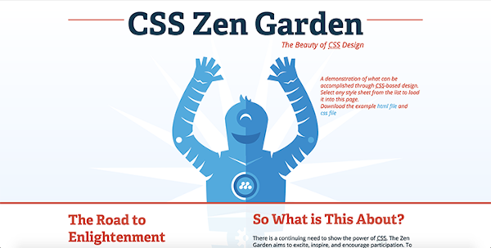 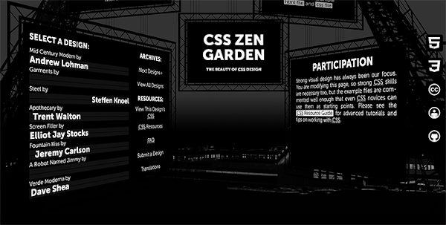 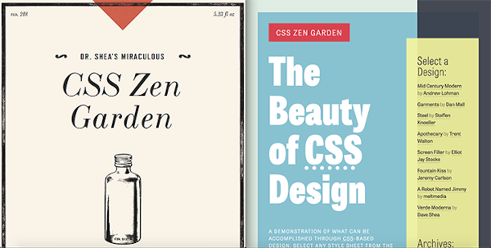

Like we said: all the difference between these images is created by CSS! Astounding, right!?

We know now what CSS is and its purpose, so how does it differ from HTML and how can we use it?

**Identify the Differences Between HTML and CSS**

HTML and CSS play two different roles. When we write HTML, we focus on structure, hierarchy, and meaning — the "marking-up" of content. Questions in the mind of an HTML author are:

* Is it best to list these members' names with numbers, or bullets?
* Does this menu belong in the navigation in the header?
* Should this additional reference be an aside, or a separate section?

These questions deal with structure, hierarchy, and meaning, which are concerns of the content layer (HTML).

When defining the presentation layer (CSS), here are the questions we ask ourselves:

* Do we want the header menu to be stationary, or does it scroll with the browser window?
* How do we want the content to display inside of a container? For example, does it fill the whole area, edge-to-edge? Is there white space around the content and/or the container?
* How large should an H1 be relative to an H2? What about an H3?
* What properties should links have? Underline or no underline? Which color for the normal state versus the hover state? Should the visited link state be different?
* How should the content appear when on a desktop machine versus a mobile device?

As you ask yourself these questions, your focus is on the *aesthetic* quality of the page. For each bit of *content* we can define a *presentation rule* that will change the way the HTML is displayed.

**List the Basic Characteristics of CSS**

For each *presentation rule*, there are 3 things to keep in mind:

1. What is the specific HTML we want to style?
2. What are the qualities we want to modify (e.g. the properties of text in a paragraph)?
3. *How* do we want to modify the qualities of the element (e.g. font family, font color, font size, line height, letter spacing etc.)?

Once you've decided what to modify and how, we can start writing CSS rules.

CSS selectors are a way of declaring which HTML elements you wish to style. Selectors can appear a few different ways:

* The type of HTML element(h1, p, div, etc.)
* The value of an element's id or class (<p id='idvalue'></p>, <p class='classname'></p>)
* The value of an element's attributes (value="hello")
* The element's relationship with surrounding elements (a p within an element with class of .infobox)

For example if you want the body of the page to have a black background, your selector syntax may be html or body. For anchors, your selector would be a. A few more examples are listed below:

/\*

The CSS comment syntax is text between "slash-star" and "star-slash"

\*/

/\*

selects all anchor tag elements in the document (e.g. <a href="page-link.html">Page Link</a>)

\*/

a {

}

/\*

selects all headers of type h3 in the document (e.g. <h3>Type selectors</h3>)

\*/

h3 {

}

/\*

selects all paragraph elements in the document (e.g. <p>Type selectors are used

to...</p>)

\*/

p {

}

[Type selectors documentationLinks to an external site.](https://developer.mozilla.org/en-US/docs/Web/CSS/Type_selectors)

The element type class is a commonly used selector. Class selectors are used to **select all elements that share a given class name**. The class selector syntax is: .classname. Prefix the class name with a '.'(period).

/\*

select all elements that have the 'important-topic' classname (e.g. <h1 class='important-topic'>

and <h1 class='important-topic'>)

\*/

.important-topic {

}

/\*

select all elements that have the 'helpful-hint' classname (e.g. <p class='helpful-hint'>

and <p class='helpful-hint'>)

\*/

.helpful-hint {

}

You can also use the id selector to style elements. However, **there should be only one element with a given id** in an HTML document. This can make styling with the ID selector ideal for one-off styles. The id selector syntax is: #idvalue. Prefix the id attribute of an element with a # (which is called "octothorp," "pound sign", or "hashtag").

/\*

selects the HTML element with the id 'main-header' (e.g. <h1 id='main-header'>)

\*/

#main-header {

}

/\*

selects the HTML element with the id 'welcome-message' (e.g. <p id='welcome-message'>)

\*/

#welcome-message {

}

[id selectors documentationLinks to an external site.](https://developer.mozilla.org/en-US/docs/Web/CSS/ID_selectors)

**Declare CSS Properties and Values**

Each element has a list of qualities that can be styled. CSS "property" names identify those qualities. For text styling, examples of property names include text color, text-align and line-height.

CSS Property Values are directly related to property names. If we are working with the color property, the value could be a named color such as red, or #660000. Some properties have their values set with words, others with numbers, and some can take both.

A CSS property name with a CSS property value is a **CSS declaration**. To apply a CSS declaration like color: blue to a specific HTML element, you need to combine your CSS declaration with a CSS selector. The association between one or more CSS declarations and a CSS selector is called a **CSS declaration block**. CSS declarations (one or more) that applied to a specific selector are wrapped by curly braces ({ }). Each declaration inside a declaration block **must** be separated by a semi-colon (;).

Below is a sample CSS declaration block.

selector {

color: blue;

}

/\*

This is a css declaration for a selector

'color' is a property name and 'blue' is a css property value

!!!!! CSS declarations must end with a semi-colon (;) !!!!!

\*/

Let's write a more complete example declaration block.

/\*

The CSS declaration block below:

\* Will apply to all `h1` elements

\* Will change the text color to blue

\* Will set the font family to Georgia

\*/

h1 {

color: blue;

font-family: Georgia;

}

**Conclusion**

With the combination of HTML and CSS, you are able to define content, structure, and style to websites. Using a CSS selector like h1 or p paired with a declaration block, you will change the display of that element. Declaration blocks are collections of CSS properties and values.

**Resources**

* [Mozilla Developer Network: Introduction to CSSLinks to an external site.](https://developer.mozilla.org/en-US/docs/Learn/CSS/Introduction_to_CSS)

Introduction to CSS Lab

* **Due** No Due Date

* **Points** 1

* **Submitting** a website url

**Learning Goals**

* Import a CSS file in our HTML
* Implement CSS declarations

**Introduction**

HTML's role in our websites is to provide structure, content, and link resources (e.g. CSS files). Its role in describing the style ("presentation") of content is minimal. HTML's ability to style is pretty much limited to "pretty good" defaults.

In order to further customize the style, appearance, and interactive behavior of our websites, we turn to Cascading Style Sheets, or CSS. In this lab, we will work on implementing CSS declarations in our HTML.

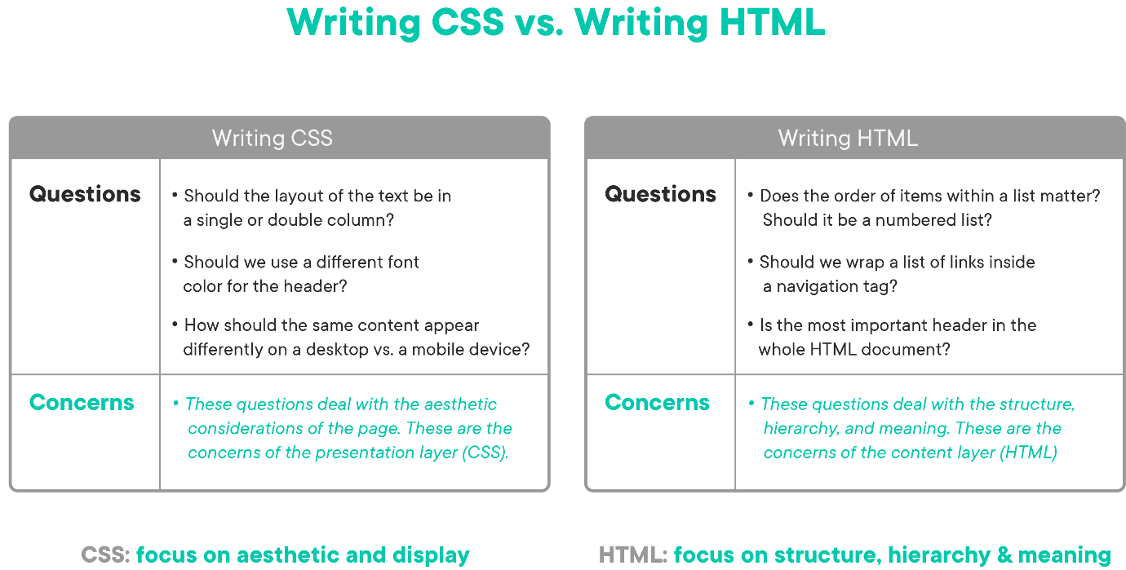

**Getting Started**

Fork and clone this lesson into your local environment. Navigate into its directory in the terminal, then run code . to open the files in Visual Studio Code. Finally, run npm install to install the lab's dependencies.

**Import a CSS File in Our HTML**

First things first: we need to make sure our HTML is loading our style sheet.

We have two options:

1. Write CSS rules inside of a <style> tag ("internal CSS"), which tells HTML "Hey, I want to define some CSS styling here
2. Write CSS rules in an external file that is specified with the <link> tag ("external CSS").

In our case, we want to provide a link to our style sheet, instead of writing all of our CSS code directly in the <style> tag. This allows us to only have to write styles for the entire site once, instead of repeating every <style> element on every page. A common workflow is to see developers work on CSS inside of the <style> tag until their styling is done. At that point they move it to their external file and remove the <style> element from the HTML page. Feel free to try it out!

In index.html, provide a <link> tag which correctly sources the CSS file located in this directory. The <link> tag will link to our file with an href attribute, like so:

<link rel="stylesheet" href="relative path to CSS file" />

The href attribute should point to the file style.css which is located in this directory using a *relative path*. The rel attribute is used to note that the file which is being linked has a **rel**ation of being a "stylesheet."

Now, what is a relative path? You could write href="style.css" and the content of style.css would change your index.html file. But we want to teach you to require external resources (like CSS or JavaScript) by using *relative paths*. Relative paths make it *crystal clear* which file is being used. Relative paths start with ./ which means "from the directory I am currently in." So, when we use link to associate with a style sheet and we write href="./style.css" we're saying: "From the directory in which I, the index.html file live, look for a file called style.css and use it. This pattern will help you and other developers remove any possible confusion.

<link rel="stylesheet" href="relative path to CSS file" />

Links to style sheets should go at the end of the <head> section! Make sure you provide a *relative* path to the style sheet. Hint: Open index.html in the browser. You can test whether your link is working or not by the color of your headline. If it's red, it's working! If it's black, keep going - you'll get it.

**Implement CSS Declarations**

Now, we are going to create some CSS declarations and add styling to our document! First, open index.html in the browser to get a good idea of what [our un-styled pageLinks to an external site.](https://curriculum-content.s3.amazonaws.com/web-development/unstyled-codepen.jpeg) page looks like.

What we would really like is [something a little more jazzed upLinks to an external site.](https://curriculum-content.s3.amazonaws.com/web-development/styled-intro-to-css.png)! Let's work towards that. Set the following *properties* to specific *values*. Make sure to, after each update, look at index.html in the browser to see how it has changed:

* Set the background of the <body> element (whole document) to #00b3e6 (light blue)
* Set the <div> elements:
  + width to 700px
  + margin to auto (centers our element)
  + font-family to "Helvetica Neue"
  + background to white
  + padding to 30px (creates an invisible space around the element)
* Set the element with the id of #main-header to a font-size of 22px
* Set the elements with the class of .perspective-questions to a font-style of italic

Run npm test to test your work.

**Saving Your Work Remotely**

Currently, the work you've done on this assignment is only on your local machine. To preserve work on your GitHub fork, you will need to stage the changes you've made, commit them, and push the commit up to GitHub. Use the following commands to do this:

$ git add .

$ git commit -m "Completed assignment"

$ git push

If you visit your fork on GitHub, you should now see that *you've* made the most recent commit, and your solution will be present in the files.

**Conclusion**

CSS allows us to easily separate our 'styling' logic into separate files that follow the 'cascading' rule set. This enables us to keep our HTML clean and simple to read, without sacrificing the customization that we have come to expect on websites.

**Resources**

* [W3 Introduction to CSSLinks to an external site.](https://www.w3schools.com/Css/css_intro.asp)

[Previous](https://moringa.instructure.com/courses/318/modules/items/59178)[Next](https://moringa.instructure.com/courses/318/modules/items/59180)

**CSS Fundamentals**

**Learning Goals**

* Identify CSS syntax
* Identify CSS use formats
* Implement various types of CSS selectors
* Implement various types of color values in CSS
* Identify and implement CSS comments

**Introduction**

In this lesson, we'll build on the basics we've learned. We'll learn to select elements based on HTML attributes, we'll learn to apply colors, and we'll learn how to comment our CSS.

**Identify CSS Syntax**

Before we turn to the various ways we can extend CSS rules, let's go over the foundational syntax CSS uses.

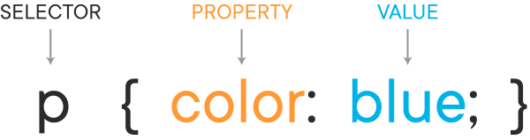

We create a CSS rule by defining the selector, which matches the HTML element we want to style. Inside the curly braces we declare the properties we want to change and, after the colon, we set the value we want to change that property to. Each property is written in the following form: property name, colon, the value for that property and a semicolon.

In the example above, we are selecting the p element and displaying its color as blue.

**Identify CSS Use Formats**

How do we "apply" CSS to an HTML page? By using one of three CSS use formats: inline, internal (or embedded) and external.

Inline includes the styles directly into the HTML element with the style attribute.

<p style="color: blue;"></p>

While you might see this sort of styling in something like the code for an HTML email, this is generally not the best practice for two reasons. The primary reason is because it only affects that single element. If we want all paragraph elements on our page to appear blue, we would have to add that attribute to every element individually, which is inefficient and difficult to maintain into the future. That brings us to the second reason to avoid inline CSS: it breaks our principle of separation of content and presentation.

Internal CSS is inside of style tags in the HTML document's head section.

<!DOCTYPE html>

<html>

<head>

<style>

p {

color: blue;

}

</style>

</head>

<body>

<p>This is a paragraph.</p>

</body>

</html>

This rule will display all paragraphs in this document as blue, which is a step up in scope from the inline styles that only apply to single elements. But this CSS will only apply to the single document. Other paragraph elements on other pages in the same website will be unaffected.

If we want our CSS to carry across various pages, we can use an external style sheet. This is a separate CSS file that we link in the head of HTML documents.

<!DOCTYPE html>

<html>

<head>

<link rel="stylesheet" href="styles.css" />

</head>

<body>

<p>This is a paragraph.</p>

</body>

</html>

With the link tag, we can use the relation attribute to define the target as a style sheet and the link source our CSS file that contains all the CSS we want to use on our site. This is by far the easiest way to link CSS to HTML and apply styles across all of our pages.

**Implement Various Types of CSS Selectors**

CSS gives us a wide range of ways that we can select elements on the page. Some of these you will use more than others, but it's a good idea to know them all so you can choose the right one when you need it.

**ID and Class Selectors**

ID selectors target all elements with a specific ID attribute value. The way we specify an ID selector in a CSS rule is to follow the element name with a hash symbol and then the ID attribute value we want to match. In this case, the browser will look for a p element with the ID attribute "introduction" and apply the CSS to that element.

p#introduction {

color: blue;

}

<p id="introduction">I'm blue</p>

ID selectors are useful when you want to give a single element on the page a unique identity and set it apart from everything else.

Class selectors target all elements with a class attribute value matching the selector name. We specify a class selector using the period symbol followed by the name value.

p.alert {

color: red;

}

<p class="alert">I'm red</p>

The difference between IDs and classes is that IDs are meant for one element on the page that has a unique identity where class selectors are meant to be spread throughout the page across multiple elements.

**Compound Selectors**

Compound selectors let us apply the same CSS rules to multiple elements at once. If we want to make both h2 and h3 elements display green, we use both as selectors, separated with a comma.

h2,

h3 {

color: green;

}

<h2>I'm green</h2>

<h3>I'm green too</h3>

<h4>I'm not green</h4>

This eliminates the need to rewrite a new CSS rule containing the same styles for different elements.

**Descendant Selectors**

Descendant selectors target elements that are descendants of the matching selector name. A descendant selector is indicated by a space in between one selector and another selector.

article p {

color: blue;

}

In this case, *only* p elements within the article element will receive the styling.

<article>

<p>I'm blue</p>

</article>

<p>I'm not blue</p>

ID, class, compound and descendant selectors are the kind of selectors you will probably use in your CSS on a regular basis. From this point on, we get into more advanced selectors. They are often not as necessary as the previous ones, but they can accomplish some powerful operations.

**Child Selectors**

The child selector targets all elements that are the immediate children of a specified element.

article > p {

color: blue;

}

Only p tags exactly one level down from article will display as blue. If there are p tags within an aside element within the article element, they will not receive the same instructions.

<article>

<p>I'm blue</p>

</article>

<article>

<aside>

<p>I'm not blue</p>

</aside>

</article>

**Adjacent Sibling Selector**

The adjacent sibling selector targets elements that appear directly after the matching selector name. We indicate it using a plus symbol.

h3 + p {

color: blue;

}

Here the adjacent sibling selector will style the paragraph directly following an h3 element but not paragraphs that come after the first.

<h3>Header</h3>

<p>I'm blue</p>

<p>I'm not blue</p>

**General Sibling Selector**

The general sibling selector (sometimes called the preceded selector) will style all matched elements after the preceding selector name.

h3 ~ p {

color: red;

}

With this general sibling selector, all paragraph elements that come after the h3 will receive the styling.

<h3>Header</h3>

<p>I'm red</p>

<p>I'm red</p>

**Universal**

The universal selector matches any elements and will apply to elements that are not targeted by other rules. It's indicated by the star symbol.

\* {

color: yellow;

}

In this case, this is going to set the color of the text yellow for any element that hasn't had its color property specified elsewhere.

<h2>I'm yellow</h2>

<p>I'm yellow</p>

<div>I'm yellow</div>

**Attribute Selectors**

The attribute selector can target elements with a particular attribute. We can also define exactly which attribute we want to match.

input[type="text"] {

width: 200px;

}

Here we want to find input elements, but only those with a type value that matches "text." For those elements that fit the requirements, the browser will then apply the width we want. There are many different ways to use this type of selector with various combinations of operations and attribute values so you can refer to the resources to explore them all.

<input type="text" value="I'm 200px" />

<input type="submit" value="I'm not 200px" />

**Pseudo-class Selectors**

Pseudo-class selectors target elements based on a particular state of an element or relationship to other elements. The way we signify a pseudo class selector is with the colon symbol.

a:link {

color: blue;

}

a:visited {

color: purple;

}

These two link examples reflect the way links that are both unvisited and visited will be displayed differently. If the link is unvisited, it will show as blue. If it has been visited, it will show up purple. Pseudo-class selectors, like attribute selectors, have a lot of aspects so you can explore them more in other resources.

<a href="https://developer.mozilla.org/en-US/docs/Web/CSS/Pseudo-classes">

I'm blue before you click, and purple after

</a>

**Implement Various Types of Color Values in CSS**

We've been using color names in our examples to keep it simple, but only a handful of color names are recognized by all browsers. When writing CSS, we'll be better off to use different ways of defining our colors.

**Hexadecimal Color Values**

Most often developers use a set of numbers called hexadecimal, which represents a wide range of colors. Hex colors begin with # and are followed by, generally, 6 numbers, but some of these numbers are actually letters. The lowest single digit number in hex is 0 and the highest single digit number is f. This table might help to visualize what we mean by this.

Decimal Numbers: 0, 1, 2, 3, 4, 5, 6, 7, 8, 9, 10, 11, 12, 13, 14, 15, 16

Hexadecimal Numbers: 0, 1, 2, 3, 4, 5, 6, 7, 8, 9, a, b, c, d, e, f, 10

Hex colors work by creating Red, Green, Blue (RGB) values. Traditional RGB colors are on a scale of 0 to 255 for each of the three colors in the spectrum. #000000 translates to black since 0 reds, 0 green, 0 blues represents the absence of all colors and #ffffff makes white since 255 reds, 255 greens, and 255 blues equal the maximum of each of the colors.

Hex colors can be shortened to just three numbers when each RGB value is the same for each digit. So #111111 can be written as #111.

**RGB Color Values**

We can also work directly with RGB values.

p {

color: rgb(255, 255, 255);

}

Here we've set our p elements to the color white, the maximum of all RGB values (255).

You can also add an extra channel to your RGB color by setting an "a" value, which represents opacity.

p {

color: rgba(0, 0, 255, 0.5);

}

This example will show up as blue, with 50% opacity so the element will have a somewhat transparent color.

**Identify and Implement CSS Comments**

Sometimes developers want to put into their code information that helps other humans understand what the code is doing but without bothering the browser. We do this with comments, and CSS has its own way to mark up comments.

p.alert {

color: #ff0000; /\* Alert text displays red \*/

}

Everything in between the /\* \*/ is a CSS comment. The browser will not pay attention to these comments, but they can be useful for us to add explanations or reminders alongside our CSS code.

**Conclusion**

We reviewed the specifics of CSS syntax and covered the different ways we can connect CSS to HTML. We ran through the various types of CSS selectors, including IDs, classes, compound, child, adjacent sibling, general sibling, universal, attribute and pseudo-classes. We also took a look at the various ways to express colors, from standard color names to hexadecimal and RGB values. Lastly, we identified how to read and write CSS comments.

**Resources**

* [MDN: CSS Tutorials for BeginnersLinks to an external site.](https://developer.mozilla.org/en-US/docs/Web/Guide/CSS/Getting_started)
* [MDN: CSS Property ReferenceLinks to an external site.](https://developer.mozilla.org/en-US/docs/Web/CSS/Reference)
* [MDN: CSS InheritanceLinks to an external site.](https://developer.mozilla.org/en-US/docs/Web/CSS/inheritance)
* [Tuts Plus: 30 CSS selectors to MemorizeLinks to an external site.](https://code.tutsplus.com/tutorials/the-30-css-selectors-you-must-memorize--net-16048)
* [CSS Tricks: Learn More Pseudo SelectorsLinks to an external site.](http://css-tricks.com/pseudo-class-selectors/)
* [MDN: Using Web FontsLinks to an external site.](https://developer.mozilla.org/en-US/docs/Learn/CSS/Styling_text/Web_fonts)
* [Shay Howe: CSS Performance & Organization, Best PracticesLinks to an external site.](http://learn.shayhowe.com/advanced-html-css/performance-organization/)
* [Adobe Color ToolLinks to an external site.](https://color.adobe.com/create/color-wheel/)
* [CSS ValidatorLinks to an external site.](http://jigsaw.w3.org/css-validator/)
* [CSS Diner GameLinks to an external site.](http://flukeout.github.io/)
* [CSS Tricks: Hue, Saturation and LightnessLinks to an external site.](https://css-tricks.com/yay-for-hsla/)

[Previous](https://moringa.instructure.com/courses/318/modules/items/59179)[Next](https://moringa.instructure.com/courses/318/modules/items/59181)

CSS Fundamentals Lab

* **Due** No Due Date

* **Points** 1

* **Submitting** a website url

**Learning Goals**

* Link an external CSS file
* Write CSS rules to style HTML

**Introduction**

In this lab, we will be adding style to our index.html page by linking an external CSS file. If you open index.html in the browser (by either opening the file with Google Chrome or running httpserver on the Learn IDE), you will see basic HTML that has been provided. The website emulates a basic Real Estate website (the links on it have been disabled, we will be working with only the basic index.html landing page).

As you can see, our basic page is rather lackluster. This is where you come in! You will be adding CSS, using selectors, to jazz the page up. All of our CSS should be written in style.css.

**Getting Started**

Fork and clone this lesson into your local environment. Navigate into its directory in the terminal, then run code . to open the files in Visual Studio Code. Finally, run npm install to install the lab's dependencies. Run npm test as you work through this assignment to see your progress.

**Link an External CSS File**

As usual, we need to make sure our HTML is loading our style sheet.

We have two options:

1. Write CSS rules inside of a <style> tag ("internal CSS"), which tells HTML "Hey, I want to define some CSS styling here"
2. Write CSS rules in an external file that is specified with the <link> tag ("external CSS").

In our case, we want to provide a link to our style sheet, instead of writing all of our CSS code directly in the <style> tag. This allows us to only have to write styles for the entire site once, instead of repeating every <style> element on every page. A common workflow is to see developers work on CSS inside of the <style> tag until their styling is done. At that point, they move it to their external file and remove the <style> element from the HTML page. Feel free to try it out!

In index.html, provide a <link> tag which correctly sources the CSS file located in this directory. The <link> tag will link to our file with an href attribute, like so:

<link rel="stylesheet" href="relative path to CSS file" />

Links to style sheets should go at the end of the <head> section! Make sure you provide a *relative* path to the style sheet.

Now, what is a relative path? You could write href="style.css" and the content of style.css would change your index.html file. But we want to teach you to require external resources (like CSS or JavaScript) by using *relative paths*. Relative paths make it *crystal clear* which file is being used. Relative paths start with ./ which means "from the directory I am currently in." So, when we use link to associate with a style sheet and we write href="./style.css" we're saying: "From the directory in which I, the index.html file live, look for a file called style.css and use it." This pattern will help you and other developers remove any possible confusion.

Hint: Try adding the following temporarily to your style.css file to test if your linked CSS is working:

h1 {

color: red;

}

If you see your <h1> change to red, you've linked your style sheet correctly! Don't forget to delete it once you have your link working.

**Write CSS Rules to Style HTML**

For this exercise, we are going to be transforming our base HTML into a more exciting version using CSS.

It is important to note that there are *many* ways to go about transforming the HTML with CSS to match the end product. For this lesson, we will provide you with general guidance in *one way* of getting to the desired view by adding to the style.css. Ultimately, the goal is to have your website look like the finished product whatever way works the best for you.

**Note:** If you are having trouble finding the specific CSS property you need to get a specific visual outcome, use your Google skills with queries such as: "CSS center text within div".

In following the guidelines, you should be referencing the index.html to find the appropriate tags/IDs that we will use as selectors in our style.css file. Don't forget: you can use the Chrome Inspector Tool (cmd + shift + C on Mac) to inspect specific elements of the DOM (and make trial changes to their CSS) in the browser.

**What We Have**

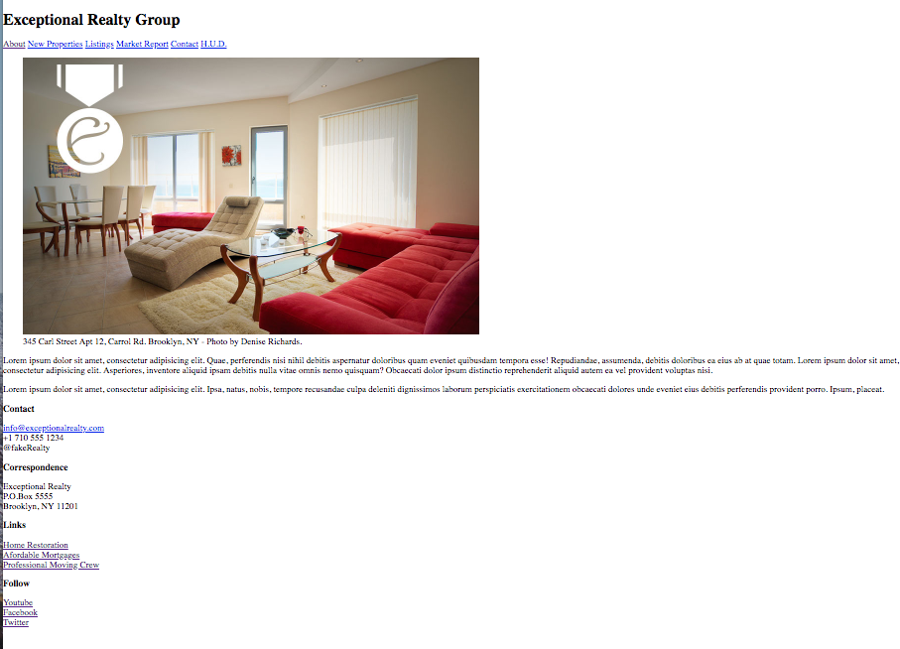

**What We Want**



**Deliverables**

* **Update the header**: the text is a little wonky being aligned on the left like that. Provide a property that aligns it in the center instead.
* **Center our image**: We only have one image on the page and we would like it centered!
* **Jazz up our navigation links**: Let's center all of our nav links as well. Give all of the <a> tags within our navbar padding of 10px on their left and right sides. In addition, change their background color to something of your choosing. We chose grey!
* **Our image caption needs work**: Let's shrink that font size down and make sure it is centered.
* **Update the text block**: Wouldn't it look nicer if our text was centered as well? Our image is about 900px wide, so let's give all our <p>s within #featured-property a hard width of 800px and center the text in there. Be sure to keep a little vertical space around the <p>s.
* **Make our #details section horizontal**: The details section could go nicely as a footer to the page, instead of a vertical list. To do this, make each of the <div>s float to the left.
* **As a finishing touch**: Let's clean up the <div>s at the bottom of the page. All of them should have the same background color, centered text, and occupy 25% of the width of the bottom row (since we have 4 divs).

**Saving Your Work Remotely**

Currently, the work you've done on this assignment is only on your local machine. To preserve work on your GitHub fork, you will need to stage the changes you've made, commit them, and push the commit up to GitHub. Use the following commands to do this:

$ git add .

$ git commit -m "Completed assignment"

$ git push

If you visit your fork on GitHub, you should now see that *you've* made the most recent commit, and your solution will be present in the files.

**Conclusion**

CSS allows many avenues to the same goal. The important takeaway is to experiment and become familiar with the commonly used rules. This will enable you to identify what properties will get you to which end result the quickest.

You will find that even years into your career as a front end developer, you will be referencing basic CSS documentation. *This is to be expected!* To be comfortable quickly finding the property/value you are looking for online is the most important skill set you can develop right now. Memorization is for machines, adaptation is for humans!

[Previous](https://moringa.instructure.com/courses/318/modules/items/59180)[Next](https://moringa.instructure.com/courses/318/modules/items/59182)

CSS Validation Lab: Issue Bot 9000

* **Due** No Due Date

* **Points** 1

* **Submitting** a website url

**Learning Goals**

* Change invalid CSS to valid CSS

**Introduction**

Although today's browsers are becoming more capable of handing errors in CSS, some errors are not always caught gracefully. This variable can make it extremely difficult to apply style or layout consistently. What can be done to quickly scan our CSS documents for issues? Let's practice using the W3C's CSS Validator!

**Getting Started**

Fork and clone this lesson into your local environment. Navigate into its directory in the terminal, then run code . to open the files in Visual Studio Code. Finally, run npm install to install the lab's dependencies. Run npm test to as you go to see your test progress.

**Change Invalid CSS to Valid CSS**

In this lesson, we will be taking the invalid CSS in css/style.css and changing it to valid.

1. Open index.html in your browser. Notice how our styles don't look quite right?
2. Open css/style.css in your text editor.
3. Visit the W3C CSS validator [http://jigsaw.w3.org/css-validator/#validate\_by\_inputLinks to an external site.](http://jigsaw.w3.org/css-validator/#validate_by_input). If not already selected, click on the tab labeled "By direct input".
4. Copy the code from css/style.css and paste it into the text area. Click the "Check" button.
5. Use the error messages to correct the CSS.
6. Repeat steps 3-5 until your readout states "Congratulations! No Error Found.".

Remember to check your progress in index.html in your browser!

**Saving Your Work Remotely**

Currently, the work you've done on this assignment is only on your local machine. To preserve work on your GitHub fork, you will need to stage the changes you've made, commit them, and push the commit up to GitHub. Use the following commands to do this:

$ git add .

$ git commit -m "Completed assignment"

$ git push

If you visit your fork on GitHub, you should now see that *you've* made the most recent commit, and your solution will be present in the files.

**Conclusion**

With a CSS validator, you can work your way through cleaning up errors in a CSS document and reduce the likelihood of display errors across platforms. Using the W3C CSS validator will help you quickly and efficiently troubleshoot your CSS.

**Resources**

* [W3C CSS Validator - Validate Direct InputLinks to an external site.](http://jigsaw.w3.org/css-validator/#validate_by_input)

My Little Rainbow

* **Due** No Due Date

* **Points** 1

* **Submitting** a website url

**Learning Goals**

* Review HTML basics
* Review CSS basics
* Specify hexadecimal color values with CSS

**Introduction**

In this lab, we're going to make a rainbow with HTML <div> elements. And while we do it we're going to learn about HTML elements, CSS styling, CSS selectors, how color works in CSS and importing style sheets.

Before we start, here's some basic info about HTML and CSS. Skip to [Make a Rainbow](https://moringa.instructure.com/courses/318/assignments/27792?module_item_id=59183#make-a-rainbow) if you feel comfortable enough with HTML and CSS.

**Getting Started**

Fork and clone this lesson into your local environment. Navigate into its directory in the terminal, then run code . to open the files in Visual Studio Code. Finally, run npm install to install the lab's dependencies. Run npm test as you work to see your test progress.

**Review HTML Basics**

Hyper Text Markup Language, or HTML, is a way to structure a document with different parts. Each section of content is *marked* by elements (using tags). Each element has its own special meaning that the browser uses to *render* the HTML document. Use this [cheat sheetLinks to an external site.](https://htmlcheatsheet.com/) on HTML elements for guidance.

**Elements**

* All begin with < and end with >, e.g., <div> (this last part is a tag).
* Most have an opening tag such as <div> and a closing tag </div>.
  + The / indicates to the browser that that tag is a closing tag.
  + The element is everything between the tags and the tags themselves.
* Some tags are self-closing like the line break element <br>.
* Elements can have IDs and classes to aid the browser in finding specific tags.
  + Must begin with a letter A-Z or a-z.
  + Can be followed by: letters (A-Za-z), digits (0-9), hyphens (-), and underscores (\_).
  + IDs **can** only be used once per page. E.g.: <div id="this-special-div"></div>.
  + Classes can be used as many times as you want. E.g.: <div class="a-less-special-div"></div>.
* Elements nested inside other elements are called children.
  + Children inherit attributes from their parents.
  + Don't nest everything.
* Elements next to one another are siblings.
  + Siblings do not inherit from one another but are important for selecting in CSS.

Here is an example of element relations:

<div>

<!-- the parent element -->

<p></p>

<!-- the first sibling element/the first child-->

<p></p>

<!-- the second sibling element/the second child -->

</div>

**Review CSS Basics**

Cascading Style Sheets, or CSS, is a language created to style HTML documents by telling the browser how specific elements should look. CSS does this by selecting elements based on their tag, ids, classes, or all of the above. The reason for CSS is the separation of concerns. We want HTML to focus on the structure and meaning of our content. We let CSS worry about how to make that information appear clear and engaging.

**CSS selectors**

* They select elements to assign them styles.
* \* (wildcard) selects every element.
* An element, such as div, will select all elements of that type.
* They select an id like #some-id
* Classes are selected like this .some-class
* To select all children elements of a parent do something like this div p
* To select multiple different elements separate them by commas like this div, p, a

Here's an example of CSS styling:

\* {

color: red; /\* color in CSS refers to font color \*/

} /\* all elements will have red font \*/

**Make a CSS Rainbow**

In the directory, you'll see three files: index.html, main.css, and this file, README.md. Open index.html.

If everything is working correctly, you should see a white page.

Good job!

**Making the Divs Visible**

If you look at the file in your text editor or use the inspector, you'll see that the basic HTML structure is present in index.html. So why can't we see anything?

Well, divs are *structural* elements. They're used to *invisibly* group other visible elements together. But the style sheet that would tell our divs to do something a little different hasn't been linked yet!

Let's fix this by adding the style sheet to the head:

<head>

...

<link rel="stylesheet" type="text/css" href="main.css" />

...

</head>

Link is a self-closing tag that will create a relative path with the href attribute. A relative path means the browser knows that the main.css file is in the same place as index.html. The head is a hidden part of the page that tells the browser where to find any other files it needs to display the page correctly, the title for the tab, and any other possible important information.

Now if you refresh the index.html page in your browser you should see a perfectly [GothLinks to an external site.](https://en.wikipedia.org/wiki/Goth_subculture) solid-black rainbow.

We got the basic outline because in the main.css all the div elements were selected and given a border whose color is #000, "black." While we could set color: red;, we will have more colors available if we define colors without words.

Instead of red, green, or the exotic tomato, professionals prefer a set of numbers with a base pair of 16 rather than a base pair of 10 like we use every day. These numbers are called "hexadecimal" and we can use them to make a wide range of colors.

**Some Stuff You Should Know About Hex Colors (and Web Colors in General)**

Hex colors begin with # and are followed by, generally, 6 numbers, but some of these numbers are actually letters. The lowest single digit number in hex is 0 and the highest single digit number is f. This table might help to visualize what we mean by this.

Decimal Numbers: 0, 1, 2, 3, 4, 5, 6, 7, 8, 9, 10, 11, 12, 13, 14, 15, 16

Hexadecimal Numbers: 0, 1, 2, 3, 4, 5, 6, 7, 8, 9, a, b, c, d, e, f, 10

Hex colors work by creating Red, Green, Blue (RGB) values. Traditional RGB colors are on a scale of 0 to 255 for each of the three colors in the spectrum. Hex colors are considered true colors since they can represent ~16 million colors—but your eye can only see 10 million of those. So #000000 translates to black since 0 reds, 0 green, 0 blues represents the absence of all colors, and #ffffff makes white since 255 reds, 255 greens, and 255 blues is the maximum of each of the colors.

Hex colors can be shortened to just three numbers when each RGB value is the same for each digit. So #11dd99 can be written as #1d9.

**Coloring the Rainbow**

To get ROYGBIV onto our rainbow we'll need seven hex colors. Red: #f00; Orange: #ffa500; Yellow: #ff0; Green: #00bc3f; Blue: #06f; Indigo: #8a2be2; Violet: #d300c9

All we have to do next is select each div individually and apply each of those colors. That is a perfect use for ids since they're meant to style one specific element only. We need to add an id for each div so a logical name for each div would be the color that they have to be. It could be something random, but good names make for semantic code. So let's give the outermost div the id red.

<div id="red">...</div>

To give that id some CSS attributes we'll go into main.css, select the id, and mark its color as red.

#red {

/\* this selects any elements with the red id \*/

border-top-color: #f00;

}

To make sure the rainbow isn't so monochromatic you now need to repeat the above steps with the final six colors, and when you do you should have [a complete, colorful rainbowLinks to an external site.](http://i0.kym-cdn.com/photos/images/original/000/118/087/2468904593_6a7c692ab6.jpg).

**Moving On**

When you're done with this lab type npm test to confirm you've passed all the tests.

**Saving Your Work Remotely**

Currently, the work you've done on this assignment is only on your local machine. To preserve work on your GitHub fork, you will need to stage the changes you've made, commit them, and push the commit up to GitHub. Use the following commands to do this:

$ git add .

$ git commit -m "Completed assignment"

$ git push

If you visit your fork on GitHub, you should now see that *you've* made the most recent commit, and your solution will be present in the files.

**Conclusion**

After we reviewed HTML and CSS basics, we moved on to create an HTML rainbow. We linked our style sheet to our HTML page and added ids to our HTML elements. We then created CSS rules, using hexadecimal color values, for those elements to display all the colors on our completed HTML page.

[Previous](https://moringa.instructure.com/courses/318/modules/items/59182)[Next](https://moringa.instructure.com/courses/318/modules/items/59184)

CSS Kitten Wheelbarrow

* **Due** No Due Date

* **Points** 1

* **Submitting** a website url

**Learning Goals**

* Position elements absolutely
* Practice using CSS selectors

**Introduction**

Oh no! All of our kittens have escaped from the wheelbarrow and we need to get them back in. Help collect all the kittens and put them into the wheelbarrow using CSS selectors and absolute positioning.

**Getting Started**

Fork and clone this lesson into your local environment. Navigate into its directory in the terminal, then run code . to open the files in Visual Studio Code. Finally, run npm install to install the lab's dependencies.

**Position Elements Absolutely**

There are a few different ways we can use CSS to position elements in our web pages. *Absolute* positioning means placing the element in its containing element in a certain location that will stay the same no matter where other elements are placed. We can use absolute positioning to specify *exactly* where in the document layout we want an element to be placed:

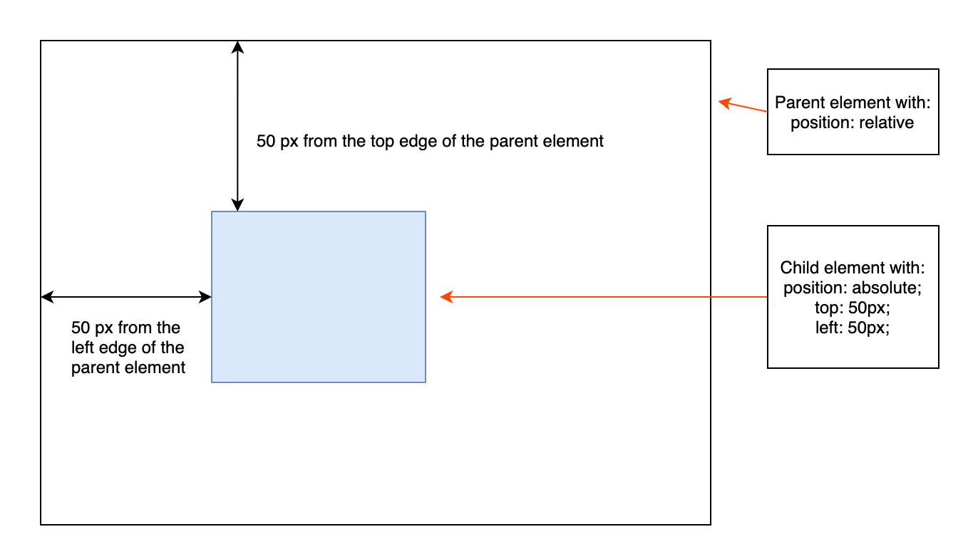

Here's an example of what absolute positioning looks like in CSS:

.parent-element {

position: relative;

}

.child-element {

position: absolute;

top: 50px;

left: 50px;

}

**Note** When using position: absolute, the browser calculates the position using top/left from the closest parent element that has a position specified — that's why in the example, we're specifying position: relative for the parent element. Check out the resources on positioning for more info on this if you're interested!

For this lab, we've done the work of calculating the absolute positions and creating CSS rules for a bunch of different kitten image elements. It's your job to use CSS selectors to apply the correct positioning to each of these elements.

To get started with this lab, open the index.html file in the browser. Use the comments in css/place-kitty.css to write the correct selectors to move each kitty into the wheelbarrow.

**Saving Your Work Remotely**

Currently, the work you've done on this assignment is only on your local machine. To preserve work on your GitHub fork, you will need to stage the changes you've made, commit them, and push the commit up to GitHub. Use the following commands to do this:

$ git add .

$ git commit -m "Completed assignment"

$ git push

If you visit your fork on GitHub, you should now see that *you've* made the most recent commit, and your solution will be present in the files.

**Conclusion**

Nice work getting practice with more CSS selectors, and learning about absolute positioning along the way! Now that you've seen absolute positioning in action, you'll have a better sense of when you might need to use it to build more complex CSS layouts in the future.

**Resources**

* [Mozilla Developer Network: CSS SelectorsLinks to an external site.](https://developer.mozilla.org/en-US/docs/Learn/CSS/Building_blocks/Selectors)
* [W3 CSS Selector ReferenceLinks to an external site.](https://www.w3schools.com/cssref/css_selectors.asp)
* [Mozilla Developer Network: PositioningLinks to an external site.](https://developer.mozilla.org/en-US/docs/Learn/CSS/CSS_layout/Positioning)

CSS Graffiti Override Lab

* **Due** No Due Date

* **Points** 1

* **Submitting** a website url

**Learning Goals**

* Use the browser developer tools
* Override existing styles

**Introduction**

Imagine that you are walking down the street, and you notice that there's a mural that has been painted over with various graffiti tags. In reality, cleaning this up could be a challenging feat; however, in CSS, you have the power to manipulate the DOM with just a line or two of code and to restore the mural to its original look! In this lab, we've created a virtual wall. Using only CSS, how can you remove the unsightly tags?

**Getting Started**

Fork and clone this lesson into your local environment. Navigate into its directory in the terminal, then run code . to open the files in Visual Studio Code. Finally, run npm install to install the lab's dependencies. Run npm test as you go to see your test progress.

**Use the Browser Developer Tools**

Assuming you have opened the index file in Chrome, open the [dev toolsLinks to an external site.](http://discover-devtools.codeschool.com/). You can quickly access Chrome dev tools with the keyboard shortcut Cmd+Option+i on a Mac, or by right/control-clicking anywhere in the window and selecting inspect.

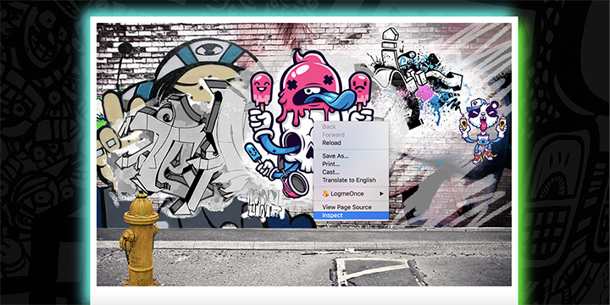

Inspect the elements of the graffiti wall in the dev tools by hovering over and clicking on nested elements. Take a close look at what's made available to you in the dev tools pane. You can see which style sheets specific style declarations live in, as well as create new styles on the fly. Now, make note of the CSS styles used to add graffiti tags (as background images) to the wall.

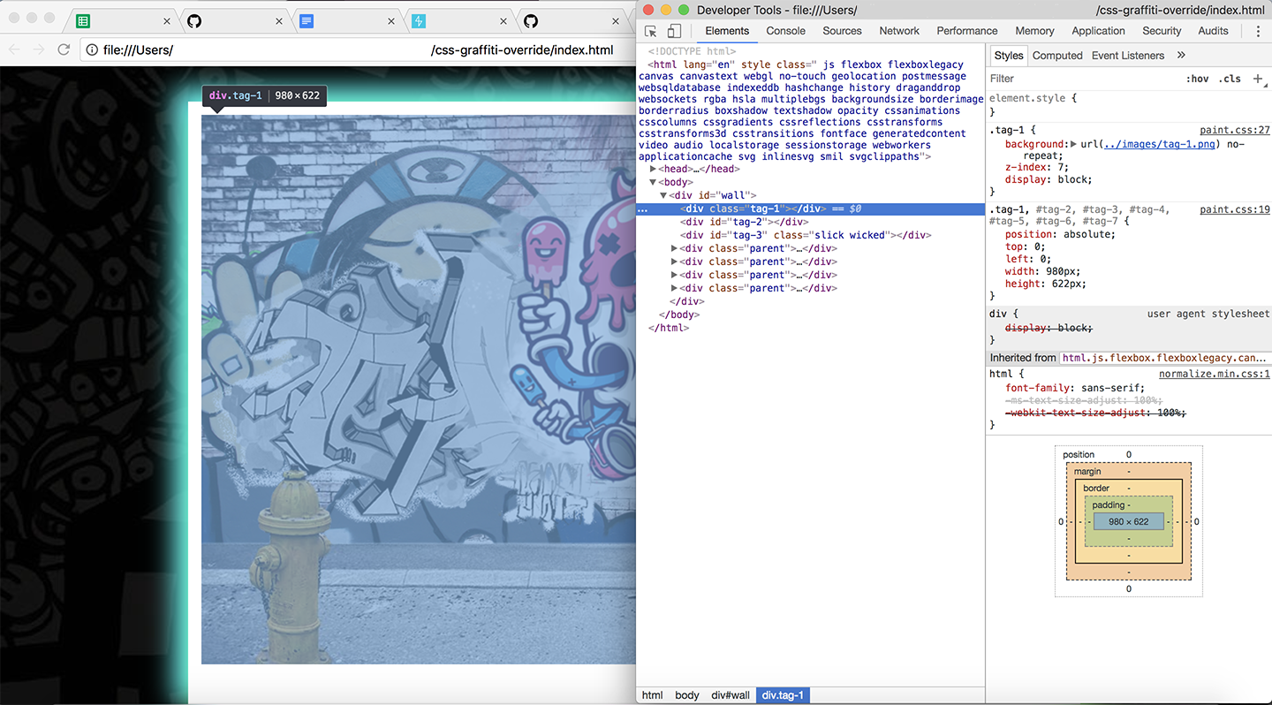

**Override Existing Styles**

In the file css/cleanup.css, write selectors that have more specificity (authority) than those that are showing the graffiti tags. You can test out writing classes in dev tools by clicking the + in the top right-hand corner of the pane. You can also click the sources tab and select css/cleanup.css in the dev tools pane. This allows you to edit the CSS file directly. It *won't* save your edits, but it will give a live update of changes so that it's easier to manipulate the DOM without refreshing the page. From there, you can copy and paste your working changes into the file.

To remove the tags, use the CSS declaration display:none;. It will change the elements' previous display property value from display: block to display: none, which will hide that graffiti.

For example, for "tag-1" the developer tools reveal that the style applying the graffiti here is:

.tag-1 {

background: url(../images/tag-1.png) no-repeat;

z-index: 7;

display: block;

}

You'll need to override this by setting its display to display: none; instead. We can do this by writing a selector statement that is more specific such as:

#wall .tag-1 {

display: none;

}

This selects elements with a class of "tag-1" that happen to also be inside an element with an id of "wall". This is more specific, and therefore will override the previous statement and hide the graffiti. For more info on how specificity in CSS works take a look at: [Smashing Magazines What You Need to Know About CSS SpecificityLinks to an external site.](http://www.smashingmagazine.com/2007/07/27/css-specificity-things-you-should-know/). You can also take advantage of a [Specificity CalculatorLinks to an external site.](https://specificity.keegan.st/) to assist with finding and understanding options for overriding styles.

**Do not use the CSS !important value**! It is considered a bad practice and should be used sparingly, in very specific edge-cases. For this lab, avoid adding inline or embedded CSS to the index.html file, or any additional class or id attributes to the index.html file either. This will make it more challenging as you will have to write CSS that is more specific based on the existing markup.

**Moving On**

When you're ready to leave this lab, run npm test from the command line to confirm you've passed all tests.

**Saving Your Work Remotely**

Currently, the work you've done on this assignment is only on your local machine. To preserve work on your GitHub fork, you will need to stage the changes you've made, commit them, and push the commit up to GitHub. Use the following commands to do this:

$ git add .

$ git commit -m "Completed assignment"

$ git push

If you visit your fork on GitHub, you should now see that *you've* made the most recent commit, and your solution will be present in the files.

**Conclusion**

With the dev tools and resources on CSS specificity rules, work your way through all seven graffiti pictures until the wall is fully clean. In your experimentation, you will find that there are many ways to manipulate and override the DOM. This will become a common practice as you build out more complex websites or work with cloud-hosted third-party resources where you may not have direct access to the style sheet.

**Resources**

* [Smashing Magazine - CSS SpecificityLinks to an external site.](http://www.smashingmagazine.com/2007/07/27/css-specificity-things-you-should-know/)
* [CSS Tricks - CSS SpecificityLinks to an external site.](http://css-tricks.com/specifics-on-css-specificity/)
* [Specificity CalculatorLinks to an external site.](https://specificity.keegan.st/)

[Previous](https://moringa.instructure.com/courses/318/modules/items/59184)[Next](https://moringa.instructure.com/courses/318/modules/items/59186)

**Introduction to Programming as Conversation**

**Introduction**

Welcome! In this module, we’re going to start learning how to program in JavaScript.

It will be a long process and you will have moments of elation, excitement and, sometimes, frustration. But we *promise* you, learning to think in the disciplined way that programming teaches will change your life for the better.

**Programming as Conversation**

Our method for teaching programming starts from a different place than you might expect. If you've ever looked at a programming tutorial or book you might be expecting lectures on how to convert decimal numbers to binary numbers, data types, variables, or something like that. We've designed our curriculum to *not* do that.

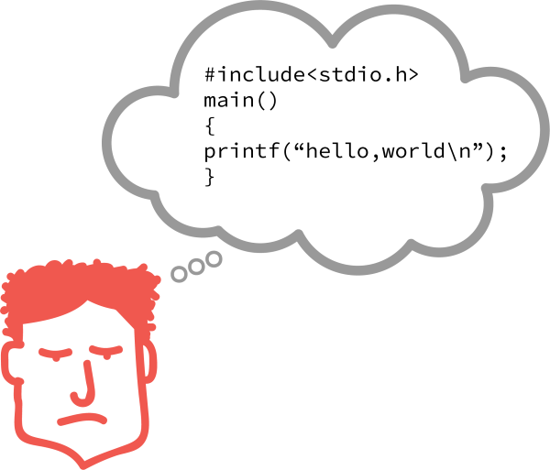

We think there's a different, and better, way: we start instead by thinking deeply about having *conversations*.

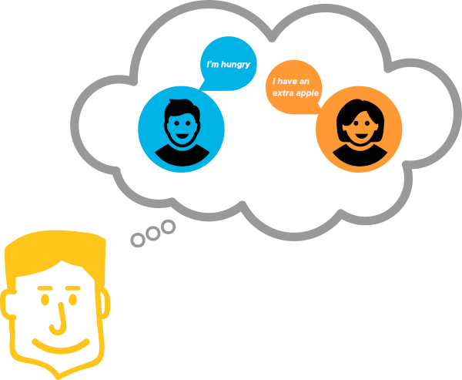

Many of the ideas we’ll share in this module ask you to reflect on "when you learned to talk" or "when you’re talking with a friend." We call this "programming as conversation" and it gets you to think about *communicating* instead of "memorizing strange programmer words, facts, and symbols." You'll learn those strange words and symbols eventually, of course, but you'll see them as part of the act of communication, something you find natural right now.

**Programming is About Communication**



At its heart, programming is about communicating strategies for solving problems. You:

* Document these strategies for yourself
* Communicate these documented strategies to others
* And then, lastly, ask a computer to run these strategies *very fast*

A "program" then is actually a strategy for solving a problem that people use to communicate with one another *as well as* give to a machine.

A recipe for a fancy dish is a good comparison: you **document** the ingredients and preparation for yourself using human language. You can then **communicate** that plan for food preparation by sharing the recipe with a friend.

**Programs are Written in Notation**

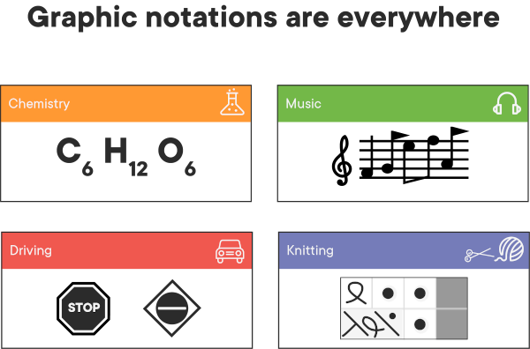

Even in recipes, we commonly use special *notation* like 3g for "3 grams" or ½C. for "½ Imperial Cup." In recipes, we usually use *notation* to save time so our wrists don't get tired. But with computers, we have to communicate using notation. Human language is often vague and imprecise and computers are *terrible* about handling unclear directions. To help prevent communication breakdowns, we converse with them using a special notation. The "special notation" is the programming language's rules or "syntax."

**DEFINITION** Notation: A specialized vocabulary or system of symbols for communication. **Examples** Musical notation, arithmetic symbols, chemistry symbols, traffic signs, or knitting patterns.

**Programming Defined**

Let's propose a definition of programming:

**DEFINITION** Programming: The act of creating programs, documents written in a notation system that can be understood by other humans *as well as* computers.

**Programming Language Defined**

**DEFINITION** Programming Language: A programming language defines the rules of notation ("syntax") that are required for it to ask the computer to do work on your behalf.

When programmers say "I prefer Ruby to JavaScript" they're saying "I like the notation system that Ruby uses for expressing problems and their solutions." It's a lot like why some people like to play one instrument over another. In your heart you might *feel* like a bassoonist, tuba player, or pianist — but all those instruments play a Middle-C note at the same frequency. Programming languages are similar: while their notation varies, they all ask the chips inside the computer to do the same work at the end of the day.

As such, a lot of the "fashion parade" of "what's hot" in the technical scene is just fashion. The really important thing to learn is: "What kind of problems or solutions does this language make easier to express?"

**We Converse With Computers**

One of the most essential ways of communicating, that we've all practiced thousands of times, is a *conversation*. "Conversation" comes from the Latin words meaning "by taking turns." In conversation, we "take turns" *expressing* ourselves.

A unit of "ideas" is an *expression*. When a listener hears an *expression* they interpret the words and symbols and sounds in the *expression* into a *meaning*. We call the work they're doing *evaluation*. The result of *evaluation* for a human is "understanding." Computers show their understanding by returning the result of that evaluation. That value is called a *return* value.

Consider this diagram:

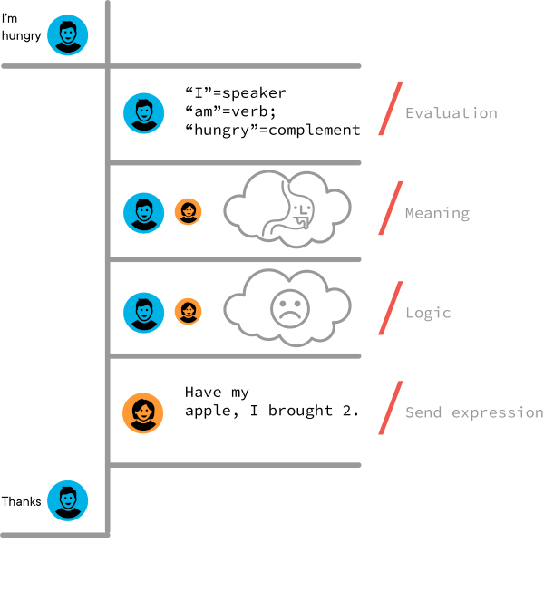

In the next lessons, we're going to see how JavaScript acts as a "listener" in a conversation. When given an *expression*, JavaScript will *evaluate* it and, like a good friend, give you a reaction about *how* it evaluated your expression. In the programming world, we call responses from the programming language a *return value*.

***When expressions are evaluated, they return something***

Sometimes our expressions might not make sense to JavaScript, just like sometimes our conversations with friends don't *quite* make sense to them.

Work, you stupid machine is not part of the valid notation of JavaScript. Below, we've embedded a tool that can read JavaScript. To see what happens when JavaScript tries to evaluate the expression, press the play button at the top.

Here we've broken the rules of the notation system. This is known as a *syntax error*. Computers require us to honor *their* ***limited*** vocabulary. Syntax errors are prompts from the programming language to help steer *our* communication to be more precise.

When we follow the rules and adhere to the syntax, JavaScript will return something to us:

Sometimes, we might get something unexpected:

But we'll get *something* in return.

**Conclusion**

Congratulations! You've finished your first lesson in thinking about programming as a conversation. As you might guess, *expressions* are important because they're how we "push" ideas to computers and other programmers. We're going to spend the remainder of this module learning to build expressions and understanding how JavaScript will *evaluate* them. Make sure you've integrated the vocabulary words of "expression," "evaluation," and "return value" before moving on.

**Expressions in JavaScript**

**Learning Goals**

* Define "Expression"
* Define "Evaluation"
* Expression and Evaluation with JavaScript
* Identify the Parts of an Expression
* Identify Core Operators in JavaScript

**Introduction**

Previously, we saw a tool that allowed us to have a conversation with JavaScript. This tool is known as a REPL, short for [Read Evaluate Print LoopLinks to an external site.](https://en.wikipedia.org/wiki/Read%E2%80%93eval%E2%80%93print_loop). Code written in the top box will be read and evaluated. The response, whatever is returned, will appear in the bottom box. For example, below we have a REPL with a math equation, 10 + 10, prewritten inside. If you click the button with the play symbol ▶ above the equation, you should see 20 appear in the bottom box.

**Note:** We encourage you to experiment with this and other code examples provided in the REPL. In order to do so, you will need to click "open in repl.it" in the upper right corner of the REPL window, which will open it in a new browser tab. You will also need to create a free account. Once you've done that, you will be able to fork the REPL to your account and make changes to try things out.

Conversations, we've seen, are the things that result when two individuals — be they human or machine — communicate *expressions* to one another.

We've been imprecise in defining "expression" while we were getting the hang of it. Let's propose formal definitions for *expression* and *evaluation*.

**Define "Expression"**

An expression in a programming language is like a sentence in a spoken language.

Some sentences are simple: "He wept." Some sentences are complex: "I sing of weapons and a man, an outcast of Troy who was driven to the shores of Italy..."

Some expressions are simple: 2. Some expressions are complex 1 + 2. Some expressions are *really* complex: 10 + (3 \* ( (-1) \*\* 3) + 2) / 18.

**Definition**: Expression: A combination of information, called *data*, and *symbols* indicating how to combine *data*, called *operators*.

**Define "Evaluation"**

*Evaluation* is the process of interpreting an expression, according to rules, to produce a return value.

**Expression and Evaluation with JavaScript**

These definitions should align with your experience of having a conversation with REPLs so far. Think about 255 / 5. Which parts of the expression are *data*? Which parts are *operators*?

**Pro-tip**: Think it through yourself. Which is a given thing (*data*) and which parts tell you how to combine things (*operators*)? When reading technical documents you can't simply read the answers, you ***have to think along*** in order to learn. Active participation tells your brain that this stuff is important!

**Identify the Parts of an Expression**

The *data* are: 255 and 5

The *operator*: is /

In this example, there is only one operator. It's certainly possible for expressions to have multiple operators like 100 + 10 - 3. In this example, the *operators* are + and -.

**Identify Core Operators in JavaScript**

Here's a table of other operators and their operations. While some of the symbols used are different from their mathematical counterparts, the operations work in the familiar way.

| **Operator** | **Operation** | **Note** |
| --- | --- | --- |
| + | Addition |  |
| - | Subtraction |  |
| \* | Multiplication | We use \* instead of × because it looks like x-the-letter |
| / | Division | We use / instead of ÷ because that's not on a keyboard |
| \*\* | Exponentiation | We use \*\* instead of ^ because ^ means something else in programming languages |
| () | Association | Expressions inside of () get evaluated earlier |

**Conclusion**

In the next few lessons, we're going to introduce the **Essential Three Expressions**:

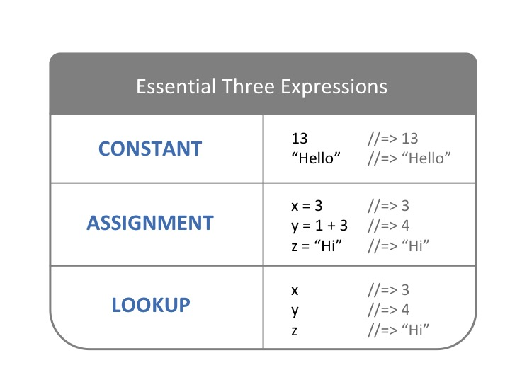

1. The constant expression
2. The assignment expression (variable assignment)
3. The variable lookup expression

***All expressions, which are the core of every programming language, are built on these Essential Three Expressions.***

**Resources**

* MDN
  + [ExpressionsLinks to an external site.](https://developer.mozilla.org/en-US/docs/Web/JavaScript/Guide/Expressions_and_Operators#Expressions)
* [Read-evaluate-print loopLinks to an external site.](https://en.wikipedia.org/wiki/Read%E2%80%93eval%E2%80%93print_loop)

**The Constant Expression**

**Learning Goals**

* Identify the *constant expression*
* Explain how the *constant expression* stops evaluation

**Introduction**

Lets repeat our definition of *expression*

**Definition**: Expression: A combination of information, called *data*, and *symbols* indicating how to combine *data*, called *operators*.

What if we were to make an expression that had no *operators*? What if it only had *data*. For example, what if we just pass 9000 into a REPL:

In response, we get 9000. This type of expression is known as the *constant expression* and it's very important, although very boring.

It's boring because it doesn't *do* anything except be itself. But it's important because it confirms that JavaScript knows when to stop applying operations. It tells JavaScript to *stop*, you have an answer.

**Explain How the *Constant Expression* Stops Evaluation**

Let's consider a simple arithmetic expression. Keep in mind we apply operators in "[PEMDASLinks to an external site.](https://en.wikipedia.org/wiki/Order_of_operations" \t "_blank)" order: parenthesis, exponents, multiplication, division, addition, subtraction.

We'll start with the expression:

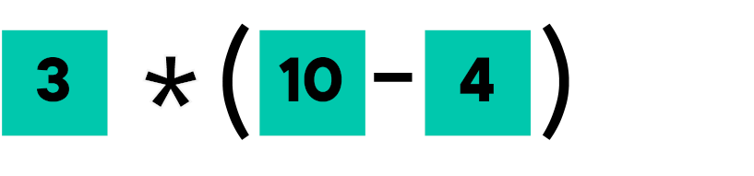

JavaScript's mission is to find a constant piece of data or a *constant expression*. Because of (), it goes there first. The (10 - 4) is clearly **not** a constant expression because of the - operator's presence. JavaScript makes a "tree" of the two sides of the operator (-) and then looks on each side to see whether those sides are *constant expressions* i.e. "plain old data."

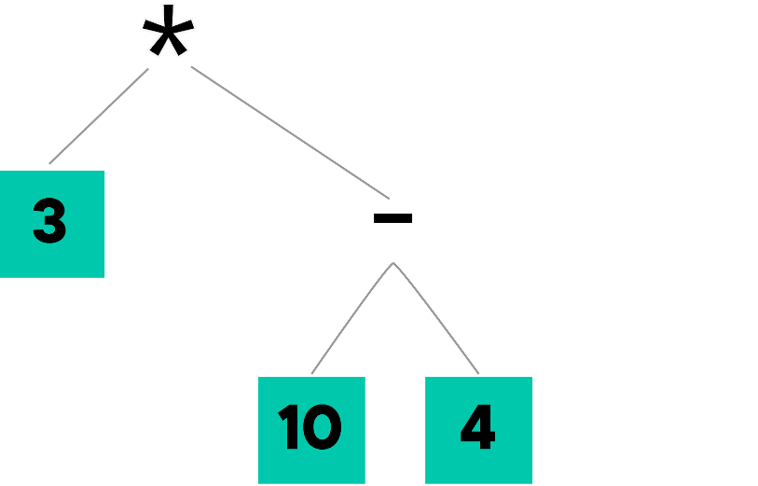

Since both 4 and 10 are plain old data, it can apply - to them and produce 6 — a *constant expression*.

So what JavaScript now sees looks like this:

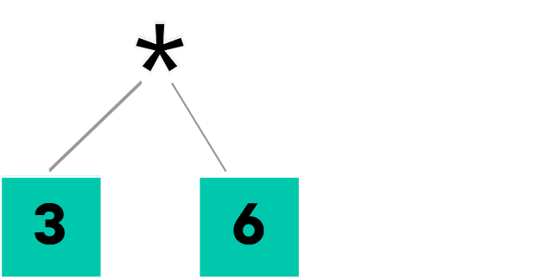

Here again, JavaScript checks both sides of the operator \* and, because both sides are now *constant expressions*, applies the \* to 3 and 6 and creates a new *constant expression*, the answer (or "return value"):



Whew! Fortunately, JavaScript does *all this work* of building a tree of operators and returning a value very quickly!

The *constant expression* is *always* the last expression in a complex expression. It's how JavaScript knows it has *data* that it can work with and that no other operations need to be applied.

**Table Explanation**

Another way of looking at this process might be to look at a table. We'll repeat all the same things we just showed graphically, but if a table makes more sense for you, then you'll like this one better!

This is an important strategy when learning to program: if you like thinking in code, try out the code; if you prefer diagrams, draw a diagram; if tables make more sense to you, build a table. An important part of learning to be a technologist is learning to build the tools that will help you learn.

| **Expression** | **Has Operators?** | **Operators** | **Are we done?** | **Next Step** |
| --- | --- | --- | --- | --- |
| 3\*(10-4) | YES | \*, () | NO | Zoom in on new sub-expression in () because of PEMDAS |
| (10-4) | YES | - | NO | Evaluate sub-expressions |
| 10 | NO | NONE | YES | Zoom in on expression 10. Constant expression! Return the value of the constant, we're done! |
| 4 | NO | NONE | YES | Zoom in on expression 4. Constant expression! Return the value of the constant, we're done! |
| (10-4) | YES | - | NO | Replace ( 10 - 4 ) with application of - to 10 and 4 making 6 |
| 3\*6 | YES | \* | NO | Zoom out and replace the sub-expression with its value we just determined |
| 3 | NO | NONE | YES | Zoom in on expression 3. Constant expression! Return the value of the constant, we're done! |
| 6 | NO | NONE | YES | Zoom in on expression 6. Constant expression! Return the value of the constant, we're done! |
| 3\*6 | YES | \* | NO | Apply \* to 3 and 6 making 18 |
| 18 | NO | NONE | YES | Constant expression! Return the value of the constant, we're done! |

**Conclusion**

While the *constant expression* might seem dull, it lets us (and JavaScript) know when expression evaluation is done *and* establishes a groundwork for all the following expressions. The first rule of Aristotle's logic is A is A; the constant expression provides a similar "foundation" for programming.

**Resources**

* [Order of Operations: PEMDASLinks to an external site.](https://www.mathsisfun.com/operation-order-pemdas.html)

[Previous](https://moringa.instructure.com/courses/318/modules/items/59189)[Next](https://moringa.instructure.com/courses/318/modules/items/59191)

**The Assignment Expression**

**Learning Goals**

* Define the *Assignment Expression*
* Define Mutability / Immutability
* Learn what the Return Value of an *Assignment Expression* is

**Introduction**

So you've seen the first of our **essential three expressions**, the *constant expression*, which gives JavaScript some constant facts about the world: 2 is 2, 3 is 3, etc...

It's really useful to associate an *expression's evaluated result* with a 'name'. We call those names that we associate with the *expression's* result, *variable names* or, commonly, just *variables*. The process of bonding an expression to a variable is called *assigning a variable*. Programmers also say that "the variable name 'points to' the expression that was assigned to it."

A helpful metaphor here is that it's like adding a new entry to a dictionary: aFunNumber's definition is 3 \* (10 - 4) or myBirthYear's is 1989. Or you can think about a variable name as a label you put on a box. Using this metaphor, the box labeled aFunNumber contains the value 3 \* (10 - 4), and the box labeled myBirthYear contains the value 1989.

We create the association between a variable name and a value by using the second of our **essential three expressions**: the *assignment expression*.

**Define the *Assignment Expression***

In JavaScript, the assignment expression is like so:

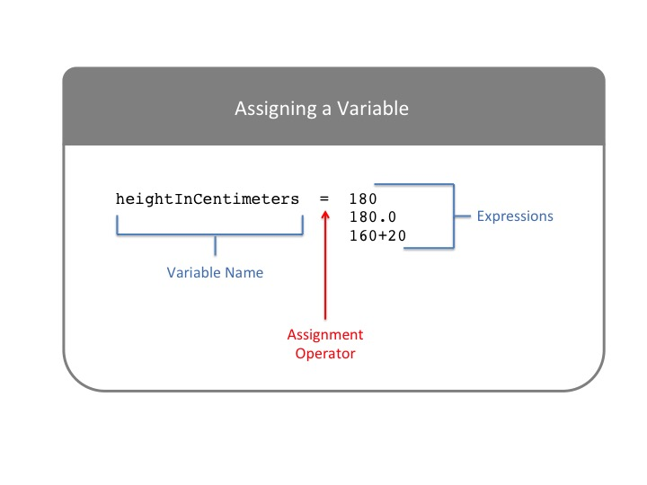

Here are some examples:

aFunNumber = 3 \* (10 - 4);

myBirthYear = 1989;

Variable names are most often descriptions of what their assigned expressions *mean*. In JavaScript, when a variable name is made of multiple words, every word after the first is capitalized. This is referred to as *camelCase* and although it isn't strictly required, it is a common convention in JavaScript.

**Note**: In JavaScript, it's *optional* to include a semi-colon at the end of each line. You may encounter JavaScript expressions written both ways.

While you *can include* numbers and some symbols in variable names, let's keep things simple for the moment and just use camelCased letters.

Consider the following expression:

maximumSpeed;

Run this alone in a REPL, and we get an error:

ReferenceError: maximumSpeed is not defined

...followed by many lines starting with at.... Here, JavaScript, by default, doesn't know anything about maximumSpeed.

When we define a variable using the "assignment expression" we add something new to JavaScript.

Notice that maximumSpeed = 9000, the assignment expression, evaluates to 9000 when run. Once maximumSpeed is defined, JavaScript will know what it is. (We'll look at this more closely in the next lesson.)

***SUPER-IMPORTANT***: In the assignment expression = means "assignment". It does not mean "what's on the left of the = is equal to what's on the right." In math courses, we use = to say that the expressions on either side of the = are the same. JavaScript uses == and === for that purpose. It's very common — and very confusing — for beginners to have bugs where they confuse = for == or ===.

**Define Mutability / Immutability**

A variable is said to be "mutable." That means the value that the name "points to" can be changed during the running of the program. Being able to change the value a variable points to is very important. For example, if we need to do something 10 times, we need a variable to keep track of how many times the thing happens. That variable will need to change: its value will need to increase by 1 each time. Here's "mutability" in action:

Many years ago my height in centimeters was:

heightInCentimeters = 50;

But today it is:

heightInCentimeters = 180;

We can try these out in REPL:

Sometimes, we might want to make a variable's value permanent. We might want to say "hey, this value should not change." We want to say that the value is *immutable*, the opposite of *mutable*. We do this by writing a **constant** (not the same as the constant expression we discussed previously). We'll go into more detail on constants in the next part of this course.

**Return Value of an *Assignment Expression***

The return value of an *assignment expression* is the evaluated result of the expression to the right of the =.

recurringExpressionValue = 3 \* (10 - 4);

// 18

Pay attention here: the return value of the assignment expression ***IS NOT THE SAME THING*** as getting the value out of the variable name. We'll learn to get the value "back out of a variable" in the next lesson. What JavaScript is saying is that the assignment expression's return value is the value of the expression to the right of the =.

**Note**: The syntax underneath recurringExpressionValue indicates what this expression evaluates to; in this case, it's the number 18. Any line that starts with // in JavaScript is a "comment": it's code that is ignored by the JavaScript engine, but can be used to indicate something to other developers looking at your code.

**Conclusion**

Think about a baby who has never spoken before. Before it stands a parent saying their name over and over (...and over) again.

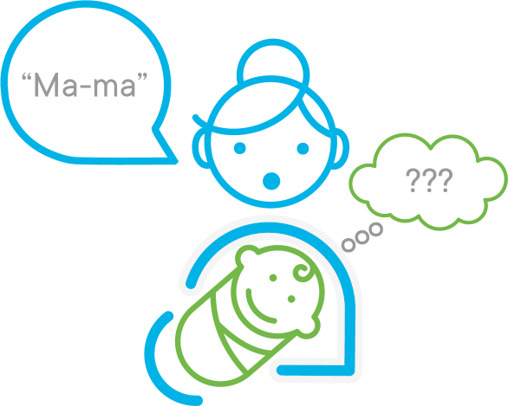

They wave towards their bodies and say their names again and again. What the parent is trying to do is teach the baby to assign their face to the variable name "Mama" or "Dada." But to the baby, this means nothing.

While neither the baby or the (average) adult is aware of it, they're trying to teach the baby the second of the *three essential expressions*: the assignment expression. Then, one magical day, it clicks for the baby. It performs an assignment in its precious little head:

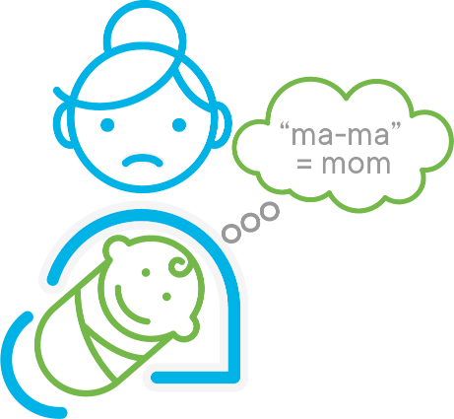

Unfortunately, Mom is still sad; she doesn't have any *proof* that the assignment was successful. For that to work, the baby will need to prove that it can "look up" the variable assignment of who "ma-ma" points to. The baby will need to learn the last of our *essential expressions*: the variable lookup expression!

**The Variable Lookup Expression**

**Learning Goals**

* Define the Variable Lookup Expression

**Introduction**

The final of our *essential three* expressions is the variable lookup expression. Like the *constant expression*, it is boring yet profound. Once we've assigned a value to a *variable name* using the *assignment expression*, we can use the *variable lookup expression* to retrieve that value. Using our metaphors from the previous lesson, it looks up the variable's definition in the dictionary, or "shakes out" the value that was put in the labeled box.

**Define the Variable Lookup Expression**

To look up the value in a variable we simply type the variable's name in.

// Assignment expression that returns 32

age = 32;

// Type in the assigned name

age;

In return, we get 32.

That's it. The values we associate with the assignment expression can be retrieved by simply typing the variable's name.

**Variable Lookup as Conversation**

In the previous lesson, we talked about a parent and a baby. A parent repeats their name hundreds of times to get the baby to assign their face to the variable ma-ma. When the baby first sees that face again and says "ma-ma!" the parent has successfully taught the child "variable lookup." Although there are no pages in baby journals for "Baby's First Variable Lookup."



If you think about it, most of childhood education until early elementary school is giving them thousands of assignment expressions so they can participate in the world: "Red," "one," "eleven," "far."

Consider this scenario. Look for the *essential three* expressions in here.

Parent: See the doggie? That's a doggie.

Child: Doggie?

Parent: That's right, that's a doggie. Doggies say "Woof-woof!"

Child: Doggie?

Parent: Right. Doggie.

*Some time later*...

Child: Doggie!

Parent: That's right. Doggie!

Let's compare teaching a baby a four-legged animal's name and teaching JavaScript that a is 4.

| **Expression** | **Real-Life Conversation** | **JavaScript Conversation** |
| --- | --- | --- |
| Constant Expression | Parent points to the doggie | 4 (evaluates to 4) |
| Assignment Expression | Parent teaches child that "Doggie" = Puppy picture | a = 4 (evaluates to 4) |
| Variable Lookup | Child sees the dog and says "Doggie!" | a (evaluates to 4) |

**Conclusion**

Now that the *essential three* expressions are under your control, we're going to start rapidly building up the richness of things you can do using expressions. Whole programming languages are built around executing through evaluating expressions! Languages that work this way are called "functional languages" and they are some of the first programming languages ever created.

**JavaScript Variables**

**Learning Goals**

* Define what a variable is
* Variable names in JavaScript
* Initializing variables in JavaScript
* Retrieving and changing the value of variables
* Identify when to use const, let, and var for declaring variables

**Introduction**

In an earlier lesson, we talked about using the *assignment expression* to save information into a variable. "Saving" to a variable allows us to *store* a result so we can use it again later. Storing calculations to *temporary storage places* is the heart of making efficient programs. It's a simple idea that has powerful consequences.

**What is a Variable?**

A variable is a container in which we can store values for later retrieval.

Imagine a box that can hold any type of data: a number, a string, etc. We take some data that we want to store, place it inside the box, and hand the box off to the JavaScript engine, which stores it in memory. All done! Our data is safely cached until we need to access it again.



But wait! When we ask for the data back, how will the JavaScript engine know *which* box to retrieve? We need to assign a name to our variable — a label for our box — so that we can use the *variable lookup expression* to tell the engine exactly which piece of stored data we want to access.

**Variable Names in JavaScript**

Variable names in JavaScript can sometimes be complicated, but if you follow these three rules you'll be fine:

* Start every variable name with a lowercase letter. Variable names starting with a number are not valid.
* Don't use spaces. If a variable name consists of multiple words, camelCaseYourVariableNames (see the camel humps?) instead of snake\_casing\_them (think of the underscore as a snake that swallowed the words).
* Don't use JavaScript [reserved wordsLinks to an external site.](https://developer.mozilla.org/en-US/docs/Web/JavaScript/Reference/Lexical_grammar#Reserved_keywords_as_of_ECMAScript_2015) or [future reserved wordsLinks to an external site.](https://developer.mozilla.org/en-US/docs/Web/JavaScript/Reference/Lexical_grammar#Future_reserved_keywords).

It's important to note that case matters, so javaScript, javascript, JavaScript, and JAVASCRIPT are four different variables.

**Initializing Variables in JavaScript**

Initializing variables in JavaScript is really a two-step process: first, we *declare* the variable, then we *assign a value* to it.

To declare the variable, we use either the let or const reserved word. (And, in fact, there's a third option as well: var. We'll talk about when to use each a bit later in this lesson. For now, just know that when you see const, let, or var, those are reserved words that are used to declare a variable.)

let pi;

//=> undefined

The JavaScript engine sets aside a chunk of memory to store the declared variable. Then, we assign a value to that variable using the *assignment expression*:

pi = 3.14159;

//=> 3.14159

We can make our code a bit more efficient by packaging both initialization steps — declaration and assignment — in a single line of code:

let pi = 3.14159;

//=> undefined

You will encounter cases later on where it makes sense to declare a variable without immediately assigning a value to it, but combining the two steps will work most of the time.

**Retrieving and Changing the Value of Variables**

Say we've declared a variable pi and set its value:

let pi = 3.14159;

To retrieve the value of pi, we use the *variable lookup expression*, i.e., we simply type in its name:

pi;

//=> 3.14159

If we want to change (reassign) that value, we use the *assignment expression*:

pi;

//=> 3.14159

pi = 3.14;

pi;

//=> 3.14;

**Identify When to Use const, let, and var for Declaring Variables**

In the past, var was the only option available in JavaScript for declaring variables. Then, in 2015, the language underwent a major revision that, among many other changes, added two new options: const and let.

**NOTE:** Delving into the history of JavaScript and the many changes and improvements that were made to it in 2015 is outside the scope of this lesson. However, as you're learning to code in JavaScript you may see references to ECMAScript 2015, ES2015, or ES6. These terms are interchangeable and refer to that major revision. (ECMAScript is the "official" name of JavaScript.) There are some resources listed at the end of this lesson if you're interested in learning more about ES2015 and the history of JavaScript.

The addition of const and let was in response to significant problems that the use of var can cause. In particular, it can create scope issues (which is a whole other topic that you'll learn about later) that lead to unpredictable and difficult to diagnose bugs in your code. You will likely see var used a lot in legacy code and older StackOverflow posts, so it's important to be familiar with it. ***However, there is no good reason to use var to declare variables in your own code, and good reasons not to***.

**let**

The main advantage of using let for declaring a variable is that, unlike var, it will throw an error if you try to declare the same variable a second time:

let pi = 3.14159;

//=> undefined

let pi = "the ratio between a circle's circumference and diameter";

//=> Uncaught SyntaxError: Identifier 'pi' has already been declared

Why is this a good thing? Well, you can imagine how easy it could be, especially in a lengthy program, to accidentally reuse a variable name. Doing so can cause unpredictable behavior because the value associated with the variable in one part of the program may be changed by code in a different part of the program. These types of problems can be very difficult to track down and debug. Using let to declare your variables will reduce the likelihood of introducing such errors into your code.

While we can't *redeclare* a variable that is declared using let, we can still *reassign* its value:

let pi = 3.14159;

//=> undefined

pi = "the ratio between a circle's circumference and diameter";

//=> "the ratio between a circle's circumference and diameter"

pi;

//=> "the ratio between a circle's circumference and diameter"

**const**

The const reserved word should be your go-to option for declaring variables in JavaScript. When you declare a variable with const, not only can it not be redeclared but it also ***cannot be reassigned***.

const pi = 3.14159;

//=> undefined

pi = 2.71828;

//=> Uncaught TypeError: Assignment to constant variable.

When you (or another developer) sees that pi has been declared with const, you immediately know that the variable points to the same value every other time it's referenced in the program. For variables declared with let (or var), you cannot be so sure and will have to keep track of how those variables change throughout the program. The extra information provided by const is valuable, and it comes at no extra cost to you! Just use const whenever possible and reap the benefits.

**Note**: With let, it's possible to declare a variable without assigning a value:

let pi;

//=> undefined

pi = 3.14159;

//=> 3.14159

However, because const doesn't allow reassignment after the variable is initialized, we **must** assign a value right away:

const pi;

//=> Uncaught SyntaxError: Missing initializer in const declaration

const pi = 3.14159;

//=> undefined

As your JavaScript powers increase with experience, you'll develop a more nuanced understanding of what to use where. However, for now, this is a good rule of thumb:

* ***Use var...*** never.
* ***Use let...*** when you know the value of a variable will change. For example, a counter variable that starts at 0 and is subsequently incremented to 1, 2, 3, and so on. In the lessons on looping and iteration in JavaScript, let will have its moment in the spotlight.
* ***Use const...*** for *every* other variable.

Best practice is to always declare variables with const and then, if you later realize that the value has to change over the course of your program, circle back to change it to let.

**Conclusion**

We covered what a variable is, how to initialize and retrieve it, and how to assign or reassign its value. We also looked at best practices for naming variables and for when to use let, const, and var.

**Resources**

* [MDN — Language basics crash course: VariablesLinks to an external site.](https://developer.mozilla.org/en-US/docs/Learn/Getting_started_with_the_web/JavaScript_basics#Variables)
* [MDN — letLinks to an external site.](https://developer.mozilla.org/en-US/docs/Web/JavaScript/Reference/Statements/let)
* [MDN — constLinks to an external site.](https://developer.mozilla.org/en-US/docs/Web/JavaScript/Reference/Statements/const)
* [MDN — varLinks to an external site.](https://developer.mozilla.org/en-US/docs/Web/JavaScript/Reference/Statements/var)
* [JavaScript ES6+: var, let, or const?Links to an external site.](https://medium.com/javascript-scene/javascript-es6-var-let-or-const-ba58b8dcde75)
* [W3C - A Short History of JavaScriptLinks to an external site.](https://en.wikipedia.org/wiki/JavaScript#History)
* [Wikipedia - ECMAScript: VersionsLinks to an external site.](https://en.wikipedia.org/wiki/ECMAScript#Versions)

**JavaScript Data Types**

**Learning Goals**

1. Define a data type
2. Demonstrate basic type checking with the typeof operator
3. Identify JavaScript's seven basic data types
4. Describe interactions between data of various types in JavaScript

**Introduction**

Did you ever hear this song from educational TV?

One of these things is not like the others.

One of these things doesn't belong.

Can you tell which thing is not like the other by the time

I finish this song?

What this song is asking the young viewer to engage in is a pretty powerful behavior: *abstraction*. It's looking at several *concrete* examples and finding some sort of "ideal" that the *concrete* examples all have in common and using that as a rule to find something that doesn't *quite* fit.

Doing this is one of the most profound problems in philosophy and human development. No less an authority than Aristotle wrote a [whole bookLinks to an external site.](https://plato.stanford.edu/entries/aristotle-categories/) on it and how humans do it (one of the essential reasons why he [differsLinks to an external site.](https://www.diffen.com/difference/Aristotle_vs_Plato" \t "_blank) from his teacher, Plato).

Who knew JavaScript would lead us to ancient Greece as well as "Sesame Street?"

In JavaScript, *concrete* instances of data can be categorized into *abstract* names called "data types" or, more simply, "types."

**What Is a Data Type?**

***Everything in JavaScript is data*** except:

1. **Operators**: +, !, <=, etc.
2. **Reserved words**: function, for, debugger, etc.

Every piece of data falls into one of JavaScript's seven data types: numbers, strings, booleans, symbols, objects, null, and undefined.

**Basic Type Checking Using the typeof Operator**

Throughout this lesson, we'll use the typeof operator to give us an idea of what data types we're dealing with. typeof accepts one argument, the piece of data that we'd like to know the *type of*.

**NOTE** typeof is an operator, just like + or !. We get used to operators being only one character, but JavaScript (and many other languages) have operators with ***more than one*** character. Because it's an operator, **we don't need parentheses with typeof**. That said, JavaScript also supports () after typeof, but it's commonly not done.

**Identify JavaScript's Seven Basic Data Types**

**Numbers**

Some programming languages divide numbers up into integers, decimals, doubles, floats, and so on. They do this so that they can have higher *precision* in their calculations. In a banking application or airplane wing engineering application we want our interest rate or the curve of the wing to be ***as accurate as possible***. For good reason: we want to make sure we get paid or have a safe plane! When JavaScript was created, this level of precision was not thought to be a thing that would be needed, so JavaScript only has a single, all-encompassing number type:

typeof 42;

//=> "number"

typeof 3.141592653589793;

//=> "number"

typeof 5e-324;

//=> "number"

typeof -Infinity;

//=> "number"

**Think About This:** As JavaScript has become a language for the back end as well as the front end, its imprecision around numbers keeps it from entering many banking or engineering applications where precision is vital.

**Strings**

Strings are how we represent text in JavaScript. A string consists of a matching pair of 'single quotes', "double quotes", or `backticks` with zero or more characters in between:

typeof "I am a string.";

//=> "string"

typeof "Me too!";

//=> "string"

typeof `Me three!`;

//=> "string"

Even empty strings are strings:

typeof "";

//=> "string"

**Booleans**

A boolean can only be one of two possible values: true or false. Booleans play a big role in if statements and looping in JavaScript.

typeof true;

//=> "boolean"

typeof false;

//=> "boolean"

**Objects**

A JavaScript object, unlike the types we've looked at so far, is a *collection* of data rather than a single value. An object consists of a list of properties, wrapped in curly braces {} and separated by commas. Each property in the list consists of a name — also known as a key — which points to a value: "name": "JavaScript". The example below has four properties, with the names (or keys) "name", "createdBy", "firstReleased", and "isAwesome":

const js = {

name: "JavaScript",

createdBy: {

firstName: "Brendan",

lastName: "Eich",

},

firstReleased: 1995,

isAwesome: true,

};

typeof {};

//=> "object"

A dictionary is a good metaphor here: an object is a collection of terms (the names or keys) and their definitions (the values). In fact, the programming language Python has a similar data type which is called a dictionary.

Note that objects' properties can point to values of any data type. In the example above, the properties have values of four different types: a string, a number, a boolean, and another object!

**Arrays**

An array is just a list of values enclosed in square brackets: ["Byron", "Cubby", "Boo Radley", "Luca"]. As with objects, the values can be of any data type. In fact, from JavaScript's perspective, arrays are just special cases of objects. We can see that if we check the data type of our array:

const dogs = ["Byron", "Cubby", "Boo Radley", "Luca"];

typeof dogs;

//=> "object"

This may seem strange at first, but will make more sense as we learn more about objects and arrays in future lessons.

**null**

The null data type represents an intentionally absent object. For example, if a piece of code returns an object when it successfully executes, we could have it return null in the event of an error. Confusingly, the typeof operator returns "object" when called with null:

typeof null;

//=> "object"

**undefined**

The bane of many JS developers, undefined is a bit of a misnomer. Instead of 'not defined,' it actually means something more like 'not yet assigned a value.'

typeof undefined;

//=> "undefined"

let unassignedVariable;

typeof unassignedVariable;

//=> "undefined"

unassignedVariable = "";

typeof unassignedVariable;

//=> "string"

Any variable declared but not defined will be undefined until a value is assigned.

***Top Tip***: When writing JavaScript code, it's good practice to ***never*** set a variable equal to undefined. Variables will be undefined until we explicitly assign a value, so encountering an undefined variable is a strong signal that the variable was declared but not assigned prior to the reference. That's valuable information that we can use while debugging, and it comes at no additional cost to us.

**Symbols**

Symbols are a relatively new data type (introduced in ES2015) that's primarily used as an alternative way to add properties to objects. Don't worry about symbols for now.

**Primitive Types**

Six of the seven JavaScript data types — everything except object — are **primitive**. All this means is that they represent *single* values, such as 7 or "hello" or false, instead of a collection of values.

**How Different JavaScript Data Types Interact**

Every programming language has its own rules governing the ways in which we can operate on data of a given type. For example, it's rather uncontroversial that numbers can be subtracted from other numbers...

3 - 2;

//=> 1

...and that strings can be added to other strings:

"Hello" + ", " + `world!`;

//=> "Hello, world!"

But what happens if you mix them?

Some programming languages, such as Python, are strict about how data of different types can interact, and they will refuse to compile a program that blends types. Well, that's rather strict.

Other languages, such as Ruby, will attempt to handle the interaction by converting one of the data types so all data is of the same type. For example, instead of throwing an error when an integer (3) is added to a floating-point number (0.14159), Ruby will simply convert the integer into a floating-point number and correctly calculate the sum:

3 + 0.14159

#=> 3.14159

Ruby throws errors when some stranger cases come up:

"THX-" + 1138

#=> TypeError: no implicit conversion of Fixnum into String

That seems pretty reasonable: Ruby won't make the Integer, 1138, into a String without being directly told that you want it to be a String (same as Python's rule).

That seems like a good baseline. JavaScript, on the other hand, is a little *too* nice when handling conflicting data types. **No matter what weird combination of types you give it, JavaScript won't throw an error and will return *something* (though that *something* might make no sense at all).**

Sometimes it makes *some* sense:

"High " + 5 + "!";

//=> "High 5!"

...and sometimes it's downright [comicalLinks to an external site.](https://www.destroyallsoftware.com/talks/wat" \t "_blank):

null \*\* 2; // null to the power of 2

//=> 0

undefined \*\* null; // undefined to the power of null

//=> 1

{

}

+{}; // empty object plus empty object

//=> "[object Object][object Object]" <-- That's a string!

Why JavaScript returns a string when we ask it to add two empty objects is anyone's guess, but its heart is in the right place. The language always tries to bend over backwards for us, returning actionable data instead of throwing errors. However, JavaScript's eagerness occasionally results in data type issues that surprise novice and expert programmers alike.

Try to follow along with what's happening here:

1 + 2 + 3 + 4 + 5;

//=> 15

"1" + 2 + 3 + 4 + 5;

//=> "12345"

1 + "2" + 3 + 4 + 5;

//=> "12345"

1 + 2 + "3" + 4 + 5;

//=> "3345"

1 + 2 + 3 + "4" + 5;

//=> "645"

1 + 2 + 3 + 4 + "5";

//=> "105"

As long as we are only adding numbers to other numbers, JavaScript performs the expected addition. However, as soon as we throw a string in the mix, we stop adding and start concatenating everything together into a string. Let's take a look at an example to see how this works:

1 + 2 + "3" + 4 + 5;

//=> "3345"

First, we add the numbers 1and 2 together to get 3 (a number). We then ask JavaScript to add 3 (a number) to "3" (a string). JavaScript can't perform addition with a string, so it decides to concatenate the two operands instead, resulting in "33" (a string). The next operation, "33" + 4, is also between a string and a number, and JavaScript once again concatenates, giving us the result of "334" (a string). In the final operation, we're adding "334" with 5 (a number). Again, JavaScript concatenates, giving the final result of "3345".

You'll encounter a lot of these weird data type behaviors throughout your JavaScript programming, but fear not: they'll trip you up less and less often as you gain experience.

**Conclusion**

In this lesson we've learned about data types, which are abstractions used to categorize pieces of information, or data. JavaScript defines seven different types: numbers, strings, booleans, symbols, objects, null, and undefined.

**Resources**

* [MDN — JavaScript data types and data structuresLinks to an external site.](https://developer.mozilla.org/en-US/docs/Web/JavaScript/Data_structures)
* [Destroy All Software — TypesLinks to an external site.](https://www.destroyallsoftware.com/compendium/types?share_key=baf6b67369843fa2) – A cross-language examination of type in various languages
* [Destroy All Software — WatLinks to an external site.](https://www.destroyallsoftware.com/talks/wat) – A beloved ***and hilarious*** talk in which JavaScript's friendliness when mixing types is discussed at a feverish pace – with awesome slides

[Previous](https://moringa.instructure.com/courses/318/modules/items/59193)[Next](https://moringa.instructure.com/courses/318/modules/items/59195)

**Working With Strings**

**Learning Goals**

* Recognize how to declare a String
* Define *interpolation*
* Explain how different quote characters allow flexibility
* Join Strings using +

**Introduction**

Thus far in programming as conversation, we've used numbers as data most of the time. Numbers are great because they reach across languages and cultures. But there are times when we need our programs to return information in the form of text. In this lesson, we'll learn more about using text (i.e. Strings) in our JavaScript expressions.

**Recognize How to Declare a String**

We declare Strings most often by enclosing our text in double quotes:

const greeting = "Hello, folks";

The letters inside of a String are often called "characters."

The pair of matching "s are called "String delimiters" because they form a boundary or *limit* around the characters that make up the String.

We can also declare Strings by putting the characters in single quotes:

const greeting = 'Hello, folks';

or backticks:

const greeting = `Hello, folks`;

Single quotes and double quotes can be used interchangeably in JavaScript — they are treated the same. Using backticks to enclose a string, however, brings some additional capabilities. A string enclosed in backticks forms a [template literalLinks to an external site.](https://developer.mozilla.org/en-US/docs/Web/JavaScript/Reference/Template_literals), which allows you to *interpolate* data into the String.

**Define *interpolation***

String *interpolation* is the process of injecting the value of an expression (often, but not necessarily, the *variable lookup expression*) into a String. You wrap the expression inside the *interpolation operator* which lets JavaScript know that it should interpret the value of the expression, convert it to a String if necessary, and insert it into the containing String where the *interpolation operator* appeared.

The *interpolation operator* looks like this: ${}. When it appears in a backtick-delimited String, the return value of the expression inside the operator is "plugged in" to the containing String.

In a single or double-quoted String there is no interpolation possible. JavaScript would not interpret the value inside the ${}; instead, it would create a literal string containing the operator and whatever expression is inside it.

const barkCount = 3;

const backtick = `Byron barks ${barkCount} times`; //=> "Byron barks 3 times"

const singleQuote = 'Byron barks ${barkCount} times'; //=> "Byron barks ${barkCount} times"

const doubleQuote = "Byron barks ${barkCount} times"; //=> "Byron barks ${barkCount} times"

The expression inside the ${} does not need to be a variable lookup. Any expression, i.e., any statement that returns a value, can be used:

const byron = `Byron is ${2 + 3} years old`; //=> "Byron is 5 years old"

Here JavaScript knows to interpret the value inside the interpolation operator because the string is enclosed in backticks. It evaluates the expression (2 + 3 yields the value 5), turns the result into a string and inserts it in place.

**Explain How Different Quote Characters Allow Flexibility**

What if you needed to store some *dialog* as a String:

In the book it would look like:

"Wait," said Jo, "Do not go without me!"

If we want to create a string containing this text, we might try wrapping the whole thing in quotes, like this:

""Wait," said Jo, "Do not go without me!""

However, because " is the String delimiter, JavaScript would get confused. It would attempt to end the String right before the W as the two "s "delimit" the String. Not what we wanted.

To fix this, we can use single quotes as our delimiter instead:

const littleWomanEsque = '"Wait," said Jo, "Do not go without me!"';

Because the opening delimiter of the String was ', JavaScript will "close" the String at the next ' — at the very end. Inside of the single quotes, the " loses its meaning of "here's a String" and, instead, is just a plain literal, letter-like character ".

But oh my goodness, what if the speaker said Don't instead of Do not. That would break our String *again* as JavaScript attempted to use the ' inside Don't as the closing delimiter.

Sometimes we need to tell JavaScript, "Don't use this ' or " as a String delimiter. To do this we need *escaping*.

We can "escape" the power of " or ' to close a String by putting a \ in front of it:

const littleWomanEsque = '"Wait," said Jo, "Don\'t go without me!"';

Without the backslash, JavaScript would interpret the apostrophe inside "Don't" as the end of the string, and we'd end up with a mess. ***BUT*** since there is a \ immediately before the second ' (the apostrophe), thus *escaping* it, JavaScript says "Oh you mean to use this as a character, not as a String delimiter. I'll find the next unescaped '."

It doesn't find an unescaped ' until the very end, just like we want.

**Join Strings using +**

We already know that we can use + as an arithmetical operator to add two Numbers together. But we can also use it as a String operator: when placed between two Strings, it joins them and returns a ***new*** String.

You may want to follow along with the examples in [repl.itLinks to an external site.](https://repl.it/languages/javascript" \t "_blank).

const firstName = "Byronius";

const clanName = "Karbitus";

const commonName = "Maris";

let fullName;

// With +

fullName = firstName + " " + clanName + " " + commonName; //=> "Byronius Karbitus Maris"

// Or, with interpolation

fullName = `${firstName} ${clanName} ${commonName}`; //=> "Byronius Karbitus Maris"

// Keep in mind it returns a \_new\_ String; therefore:

firstName; //=> "Byronius"

clanName; //=> "Karbitus"

commonName; //=> "Maris"

fullName; //=> "Byronius Karbitus Maris"

**A Warning About Mixing Data Types**

Recall from the lesson on data types that JavaScript, unlike some other programming languages, will bend over backwards to return a value instead of throwing a type error. This means that the following will work in JavaScript:

const fact = "Byron is "; // fact is of type `String`

const tail = " years old"; // tail is of type `String`

const age = 5; // age is of type `Number`

fact + age + tail; //=> "Byron is 5 years old"

If we were to try this in Ruby or Python, we would get an error, but JavaScript returns what it *thinks* we meant to do. While in this case this seems pretty reasonable, there are times when JavaScript's behavior will yield unexpected results. For this reason, best practice is **not** to depend on JavaScript to handle mixed data types in this way. A better way to handle this situation is by using interpolation instead:

const fact = "Byron is";

const tail = "years old";

const age = 5;

`${fact} ${age} ${tail}`; //=> "Byron is 5 years old"

Here, by using backticks and the interpolation operator, we are explicitly telling JavaScript to *interpret* the expression inside the ${}, convert it to a string (if necessary), and insert it into our String.

Another alternative is to use JavaScript's toString() method:

const fact = "Byron is "; // fact is of type `String`

const tail = " years old"; // tail is of type `String`

const age = 5; // age is of type `Number`

fact + age.toString() + tail; //=> "Byron is 5 years old"

**When to Use + vs. ${}**

The choice of whether to use + or interpolation is, to a certain extent, a matter of personal preference — you can accomplish what you need to using either method. That said, however, JavaScript programmers tend to use interpolation more often than +. As you gain experience working with strings, you may find that using interpolation results in cleaner code that's easier to read. As a general rule, if the string you're constructing is simple and short, using + may be cleaner but you may want to consider using interpolation with more complex strings.

**Conclusion**

In this lesson, we learned how to declare Strings, how to interpolate the value of expressions into Strings, how to use different quote delimiters and escaping to create more complicated Strings, and a couple different methods for joining Strings.

[Previous](https://moringa.instructure.com/courses/318/modules/items/59194)[Next](https://moringa.instructure.com/courses/318/modules/items/59196)

**Boolean Expressions**

**Learning Goals**

* Explain What a Boolean Expression Is
* Describe Truthy and Falsey Values in JavaScript

**Introduction**

Quite commonly in our computer programs, we want to execute code *conditionally*, i.e., if some condition is true (or false). For example:

* *If* the user has entered the correct login credentials, *then* log them into our web app
* *If* there isn't enough money in the user's account to execute the transfer, *then* send them an error message

In the following lessons, we will learn about operators we can use to construct those conditional statements. Before we get to that, however, we need to understand *boolean expressions* and the concepts of *truthy-ness* and *falsey-ness*.

**Explain What a Boolean Expressions Is**

We have learned that *expressions* are code statements that return a value: the *constant expression* returns the value of the constant, the *assignment expression* returns the value that is assigned, and the *variable lookup expression* returns the value of a variable. We have also learned that JavaScript has a Boolean data type that has only two values: true or false. As you might expect, therefore, a *Boolean expression* is an expression that returns either true or false.

**Describe the Difference Between Truthy and Falsey Values**

All values in Javascript, of any data type (String, Number, etc.), are treated as either *truthy* or *falsey*. The following values are **falsey**:

* false
* null
* undefined
* 0
* NaN
* An empty string ("", '')

***Every other value is truthy***.

To check whether a value is truthy or falsey, we can pass it to the global Boolean object, which converts the value into its boolean equivalent. You may want to try these out yourself in [repl.itLinks to an external site.](https://repl.it/languages/javascript" \t "_blank).

Boolean(false);

// => false

Boolean(null);

// => false

Boolean(undefined);

// => false

Boolean(0);

// => false

Boolean(NaN);

// => false

Boolean("");

// => false

Boolean(true);

// => true

Boolean(42);

// => true

Boolean("Hello, world!");

// => true

Don't worry if this seems a little theoretical at this point. We will learn how this information is used in constructing Boolean expressions in the following lessons.

**Conclusion**

In this lesson, we've learned what a *Boolean expression* is. We've also learned which values in JavaScript are considered *truthy* and which are considered *falsey*. With these understandings, we are now ready to learn how to construct Boolean expressions that return true or false.

**Resources**

* MDN
  + [TruthyLinks to an external site.](https://developer.mozilla.org/en-US/docs/Glossary/Truthy) and [falseyLinks to an external site.](https://developer.mozilla.org/en-US/docs/Glossary/Falsy" \t "_blank)

[Previous](https://moringa.instructure.com/courses/318/modules/items/59195)[Next](https://moringa.instructure.com/courses/318/modules/items/59197)

**Comparisons in JavaScript**

**Learning Goals**

* Identify equality operators
* Compare numbers using relational operators

**Introduction**

Now that we know what *Boolean expressions* are we'll start learning how to create them. In this lesson we'll learn about comparison operators, which enable us to check to see if a value is what we're expecting. Follow along with the examples below in [repl.itLinks to an external site.](https://repl.it/languages/javascript" \t "_blank).

**Note:** JavaScript includes both *strict* and *loose* comparison operators. When writing JavaScript, you should strongly prefer the **strict** operators.

The reason for this is the loose operators will return true even if the data types aren't the same, which can result in unexpected behavior and bugs that can be difficult to track down. Even if you find you need to compare two values of different data types, you should avoid using loose operators. You will be better off converting the data type of one of the variables so they have the same type, then comparing them using a strict operator.

**Identify equality operators**

JavaScript includes four equality operators:

* **strict equality operator** (===)
* **strict inequality operator** (!==)
* **loose equality operator** (==)
* **loose inequality operator** (!=)

These operators allow us to compare values and determine whether they are the same.

**Strict Equality Operator === and Strict Inequality Operator !==**

The **strict equality operator** returns true if two values are equal *without performing type conversions*. Even if the values on both sides of the operator look similar (e.g., '42' === 42), the === operator will only return true if the data types also match:

42 === 42;

// => true

42 === "42";

// => false

true === 1;

// => false

"0" === false;

// => false

null === undefined;

// => false

" " === 0;

// => false

This is logical and accurate!

The **strict inequality operator** returns true if two values are *not* equal *without* performing type conversions:

9000 !== 9001

// => true

9001 !== '9001'

// => true

[] !== ''

// => true

***You should prefer === and !== for comparisons***.

**Loose Equality Operator == and Loose Inequality Operator !=**

The **loose equality operator** returns true if two values are equal:

42 == 42;

// => true

However, it will *also* return true if it can perform a type conversion (e.g., changing the string '42' into the number 42) that makes the two values equal:

42 == "42";

// => true

true == 1;

// => true

"0" == false;

// => true

null == undefined;

// => true

" " == 0;

// => true

The **loose inequality operator** is the opposite of ==. It returns true if two values are *not* equal, performing type conversions as necessary:

9000 != 9001

// => true

9001 != '9001'

// => false

[] != ''

// => false

This is confusing and inaccurate! It makes no sense that the string '0' is equal to the boolean false or that null and undefined — two **completely different** data types — are equivalent.

***You should prefer === and !== for comparisons***. There are [a lot of rulesLinks to an external site.](https://dorey.github.io/JavaScript-Equality-Table/) that JavaScript follows when performing type coercion using the == operator, and it's not worth keeping track of them all.

**Compare Numbers with Relational Operators**

JavaScript includes four relational operators:

* **greater than** (>)
* **greater than or equals** (>=)
* **less than** (<)
* **less than or equals** (<=)

The behavior of these operators is consistent with the meaning of the corresponding symbols in mathematics:

88 > 9;

// => true

88 >= 88;

// => true

88 < 9;

// => false

However, beware of type conversion when comparing non-numbers against numbers. For instance, when a string is compared with a number, the JavaScript engine tries to convert the string to a number:

88 > "9";

// => true

If the engine can't convert the string into a number, the comparison will always return false:

88 >= "hello";

// => false

88 <= "hello";

// => false

Strings are compared with other strings lexicographically, meaning character-by-character from left-to-right. The following returns false because the Unicode value of 8, the first character in 88, is less than the Unicode value of 9.

"88" > "9";

// => false

If you aren't sure what data type you are going to be receiving, but you still need to compare them, make sure that you tell JavaScript to [convert the string to a number firstLinks to an external site.](https://gomakethings.com/converting-strings-to-numbers-with-vanilla-javascript/), and then compare.

**Top Tip**: Stick to comparing *numerical* values with the relational operators and you'll be golden.

**Conclusion**

JavaScript contains both equality and relational operators that we can use in writing code to compare two values. The resulting statements are *Boolean expressions* — they always return true or false.

Make sure you're using the strict equality operators whenever possible, and only comparing numerical values using the relational operators, and you'll avoid annoying errors that can be time consuming to troubleshoot!

**Resources**

* MDN
  + [Comparison operatorsLinks to an external site.](https://developer.mozilla.org/en-US/docs/Web/JavaScript/Reference/Operators/Comparison_Operators)
  + [Equality comparisons and samenessLinks to an external site.](https://developer.mozilla.org/en-US/docs/Web/JavaScript/Equality_comparisons_and_sameness)
* [JavaScript Equality TableLinks to an external site.](https://dorey.github.io/JavaScript-Equality-Table/)
* [freeCodeCamp Forum — JavaScript Comparison OperatorsLinks to an external site.](https://forum.freecodecamp.org/t/javascript-comparison-operators/14660)

[Previous](https://moringa.instructure.com/courses/318/modules/items/59196)[Next](https://moringa.instructure.com/courses/318/modules/items/59198)

**Logical Operators**

**Learning Goals**

* Describe how to use ! to negate an expression
* Describe how to convert an expression to a Boolean using !!
* Define the && and || operators
* Describe how to link conditions using the && and || operators
* Practice What We Learned

**Introduction**

In this lesson, we will continue to expand our toolset for creating Boolean expressions by learning about logical operators. Using JavaScript's three logical operators, NOT (!), AND (&&), and OR (||), we'll learn how to negate and combine expressions. These operators, in combination with the equality and relational operators we learned earlier, will enable us to create more complex and sophisticated Boolean expressions.

**Describe How to Use ! to Negate an Expression**

**! NOT**

In an earlier lesson, we learned about truthy and falsey values in JavaScript. The logical NOT operator (!), also called the *bang operator*, operates on an expression, returning the opposite of the expression's truthiness. If x resolves to a truthy value, !x returns false. If x is falsey, !x returns true:

If you click the Run button you'll see the bang operator in action, returning the reverse of truthyValue's truthiness. Then modify the code on line 4 to verify that it works for the falsey value as well.

**Reminder:** Recall that you will need to click "open in repl.it" in the upper right corner of the REPL window to open it in a new browser tab, then sign in to your repl.it account before you can fork the code and modify it.

**Describe How to Convert an Expression to a Boolean Using !!**

In an earlier lesson, we passed values into the Boolean() *constructor function* to check their truthiness. We'll learn all about constructor functions later in the course; for now, just think of Boolean() as a function that takes in some input, *constructs* a new Boolean from that input, and outputs the newly constructed Boolean.

As a shorter way to convert any value into a Boolean, we can use two NOT operators:

The JavaScript engine reads from left to right: it sees the first ! and looks to the right to check what we're asking it to invert (!truthyValue). It then sees the second ! and looks to the right *again*, this time finding our truthyValue variable. At this point, the engine resolves truthyValue to "This value is truthy.", which (as it tells us) is truthy. It then executes the inner ! operator on it. !truthyValue returns false, so instead of !!truthyValue JavaScript is now evaluating !false. Executing the outer ! operator on false returns true.

Try inverting various values in the REPL above to get a feel for the NOT operator. See what happens when you stack a ton of them: !!!!!!!!!truthyValue.

**Note:** You can edit line 3 in index.js *or* add lines of code below the current code. If you add lines, when you click the Run button, the value returned in the console tab will be the return value of the *last expression evaluated*.

On to the next!

**Define the && and || Operators**

**&& (AND)**

The logical AND (&&) operator takes two expressions:

expression1 && expression2;

The return value of the && operator is always **one of the two expressions**. If the first expression is falsey, && returns the value of the first expression. If the first expression is truthy, && returns the value of the second expression.

Again, if the first expression is falsey, && returns that value and exits *without ever checking the second expression*:

false && "Anything";

// => false

// 4 \* 0 returns 0, which is falsey

4 \* 0 && "Anything";

// => 0

If the first expression is truthy, && then returns whatever the second expression evaluates to:

true && false;

// => false

1 + 1 && "Whatever";

// => "Whatever"

"The truthiest of truthy strings" && 9 \* 9;

// => 81

There are three different ways the && operator can be evaluated:

| **Left side** | **Right side** | **Return value** | **Truthiness of return value** |
| --- | --- | --- | --- |
| Falsey | Doesn't matter | Left side | Falsey |
| Truthy | Falsey | Right side | Falsey |
| Truthy | Truthy | Right side | Truthy |

1. If the left-side expression is falsey, the right-side expression doesn't matter at all. The && operator returns the left side's falsey value and finishes.
2. If the left-side expression is truthy, the && operator returns the right side's value (whether it's truthy or falsey) and finishes.

What this means is that the return value of the expression will be truthy if the values on either side of the && are *both* truthy, and falsey otherwise.

If you're feeling a little confused, that's ok. This is one of those concepts that's a bit hard to understand unless you've played around with it in code. You will have an opportunity to practice at the end of the lesson.

**|| (OR)**

The logical OR (||) operator also takes two expressions:

expression1 || expression2;

As with &&, the return value of the || operator is always **one of the two expressions**. If the first expression is truthy, || returns the value of the first expression. If the first expression is falsey, || returns the value of the second expression.

If the first expression is truthy, that value is immediately returned and the second expression is never evaluated:

true || "Whatever";

// => true

1 + 1 || "Whatever";

// => 2

If the first expression is falsey, || returns whatever the second expression evaluates to:

false || "Whatever";

// => "Whatever"

1 === 2 || 8 \* 8;

// => 64

"" || "Not " + "an " + "empty " + "string";

// => "Not an empty string"

There are three different ways the || operator can be evaluated:

| **Left side** | **Right side** | **Return value** | **Truthiness of return value** |
| --- | --- | --- | --- |
| Truthy | Doesn't matter | Left side | Truthy |
| Falsey | Truthy | Right side | Truthy |
| Falsey | Falsey | Right side | Falsey |

1. If the left-side expression is truthy, the right-side expression doesn't matter at all. The || operator returns the left side's truthy value and completes.
2. If the left-side expression is falsey, the || operator returns the right side's value (regardless of whether it's truthy or falsey) and completes.

What this means is that the return value of the expression will be truthy if *one or both* of the values on either side of the || are truthy, and falsey otherwise.

**Practicing What We've Learned**

The REPL below contains a number of expressions that use the logical operators we've learned about in this lesson:

Before we get to that, however...

**A Note About Comments in Code**

Note that most of the lines in the REPL currently have the characters // at the front. The // is used in JavaScript to 'comment out' lines of code. Any line in your code that has // at the front will *not be interpreted* by the JavaScript engine. This enables us to do two things: 1) include text (i.e., messages meant for humans) in our code files without JavaScript throwing an error, and 2) *temporarily* keep lines of code from being interpreted; this second use can be especially handy when debugging code.

Try removing the // at the beginning of line 1 and clicking the Run button. Not surprisingly, JavaScript doesn't know what to do with that line of 'code'. The // enables programmers to include messages to other programmers — or to their own future selves — for documentation or clarification purposes. Don't forget to re-comment out line 1 before you move on.

**Instructions**

Okay, let's get some practice with logical operators. Take a look at line 4 in the REPL (the only un-commented out line). What do you think the expression will return? Think it through and come up with an answer, then click Run to check whether you're right. When you're done with the first expression, work your way down, un-commenting out each expression in turn. Be sure you think each example through and figure out your answer before clicking Run.

If you're having difficulty with the examples, try following this procedure:

1. Evaluate each side of the operator individually: what is the *return value* of each individual expression, and what is the *truthiness* of each of those values?
2. Find the corresponding row in the appropriate table above and refer to the 'Return value' column to determine the return value of the full expression.

Finally, once you're done with the provided expressions, experiment with some examples of your own to cement your understanding.

**Conclusion**

In the last few lessons, we've been introduced to powerful tools for creating Boolean expressions: comparison operators (equality and relational) and logical operators. With these tools, we can construct very sophisticated expressions. A bit later in the course, we will learn how to use these expressions to execute code conditionally, which will enable us to implement powerful logic in our programs.

**Resources**

* [MDNLinks to an external site.](https://developer.mozilla.org/en-US/)
* [Logical operatorsLinks to an external site.](https://developer.mozilla.org/en-US/docs/Web/JavaScript/Reference/Operators/Logical_Operators)
* [Review of conditionals, comparisons, and logical operatorsLinks to an external site.](https://developer.mozilla.org/en-US/docs/Learn/JavaScript/Building_blocks/conditionals)

**Programming with Expressions**

**Learning Goals**

* Identify the Ternary Expression
* Write a program with conditional logic using expressions

**Introduction**

You've traveled quite a road! You started, from a conversational perspective, mute and unable to interact, and now you can converse with JavaScript.

As conversationalists with computers, we are now able to construct complex, sophisticated *expressions*. But so far our expressions have followed a single track: *evaluate* this one single expression, or line of thought. It's like a world of absolute certainty in every statement: "My outfit today: rain boots" or "My outfit today: sun hat." In real life, however, we sometimes need to base our decisions on a test of some sort. "**IF** it's raining: rain boots... **OTHERWISE**: sun hat." This means that *complexity* is entering our expressions; we *need* that complexity so that we can express our problem-solving strategies in code.

We will now learn how to write an expression that expresses "conditional thinking" or "if-then" logic. It's called the **ternary expression**. It's an expression that takes a Boolean value or expression and returns one of two values, depending on the truth-status of that first expression.

**Identify the Ternary Expression**

The ternary expression looks like this:

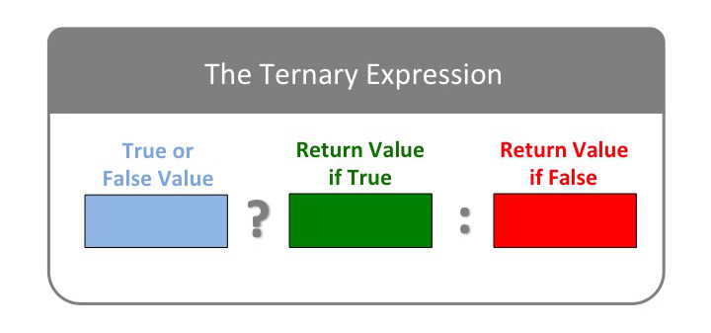

Or, in code:

booleanExpression ? "thingToReturnIfTrue" : "thingToReturnIfFalse";

If the expression in the first position evaluates to a truthy value, then the return value of the ternary expression is whatever is in the second position; here, "thingToReturnIfTrue". If the expression in the first position is falsey, however, whatever is in the last position is returned; here, "thingToReturnIfFalse".

Let's try an example:

The expression in the first position evaluates to true, so the ternary expression returns the value after the question mark, "rain boots". Try changing the variable likelyToRain with the *assignment expression* from true to false. Then run the ternary expression again. The return value of our ternary expression should now be sun hat.

We now have the ability to express conditional logic. You should try writing several ternary expressions yourself in the REPL to make sure you've gotten the hang of things.

**LEARNING TIP**: Developers learn their craft by making slight experiments to given code: be sure you're adopting that habit now.

**Moving Beyond Boolean Values**

Above we had a variable, likelyToRain, in which the literal Boolean value true was stored and we used that as our Boolean expression in our ternary. But we can, in fact, use *any* Boolean expression, not just literal Boolean values. Specifically, we can use the comparison operators and logical operators that we learned about in the previous lessons to construct our expression.

Let's look at an example:

Here we see we can make a decision based on a *comparison*. *If* the chance of rain is greater than 30%, we know we should take our rain boots; *otherwise* we'll grab our sun hat. Try different values for rainPercentage and see what happens.

With this understanding of ternary expressions, we are now ready to write a program using expressions.

**Write a Program with Conditional Logic Using Expressions**

Guess what? We've already done this! [According to WikipediaLinks to an external site.](https://en.wikipedia.org/wiki/Computer_program), a program is "a collection of instructions that can be executed by a computer to perform a specific task." The ternary (set of instructions) we looked at above is an *expression* that performs the task of *evaluating a condition* and, based on the results, *returning a value*. But of course we can expand on this, making our conditions more sophisticated and our return values more informative:

Now we have three variables and we're using them not only to construct ternary expressions but also to output a more informative message. Try experimenting with the values of the variables and see how it affects the return value.

Let's take a closer look at the code:

//Input values: we could easily imagine asking a user for these values.

const name = "Byron the Poodle";

const probabilityOfRain = 0.2;

const temperatureInC = 26;

`Hello, ${name}, with a rain chance of ${

probabilityOfRain \* 100

}% and a temperature of ${temperatureInC}C we recommend that you ` +

(rainPercentage > 0.3 ? "take an umbrella" : "enjoy this rain-free day") +

`${

temperatureInC >= 26

? " and watch out for heatstroke."

: " and bask in this fine weather."

}`;

Although this code works — JavaScript knows what we want it to do — that doesn't make it good code. Recall that programming is *conversation*, not just with the JavaScript engine but *also* with other programmers or ourselves in the future. How easy is it to read the line of code that defines our return value? How much work does it take to figure out how it works? Writing good code means writing code that not only works but is also as clean and readable as we can make it.

Let's do some *refactoring*.

We have learned that, in assigning values to variables, we can use constant values:

const name = "Byron the Poodle";

Or values evaluated from an expression:

const rainPercentage = 0.2 \* 100;

We can also include variables as part of the evaluated expression:

const rainPercentage = probabilityOfRain \* 100;

In fact, ***you can assign virtually any expression as the value of a variable***, including *comparison* expressions. So to start, let's use our new rainPercentage variable and also create a couple of appropriately named variables to store the conditions we're checking in our ternary statements. The condition rainPercentage > 0.3 is basically checking whether it's likely to rain, while the condition temperatureInC >= 26 is checking whether it's hot enough that we should stay out of the sun. Once we've created the variables we can then use them in our ternary statements:

const name = "Byron the Poodle";

const probabilityOfRain = 0.2;

const temperatureInC = 26;

const likelyToRain = probabilityOfRain > 0.3;

const sunIsDangerous = temperatureInC >= 26;

const rainPercentage = probabilityOfRain \* 100;

`Hello, ${name}, with a rain chance of ${rainPercentage}% and a temperature of ${temperatureInC}C we recommend that you ` +

(likelyToRain ? "take an umbrella" : "enjoy this rain-free day") +

`${

sunIsDangerous

? " and watch out for heatstroke!"

: " and bask in this fine weather."

}`;

This is already a bit easier to read: we've moved the math and some of the logic out of our return value; we've also used meaningful variable names that make it clearer how we're using our conditions and, by extension, what the ternary expressions are doing. But we can do better.

We mentioned above that we can assign virtually any expression as the value of a variable; this includes *ternary expressions*.

A ternary expression returns a value, just like any other expression; the value it returns is what is assigned to the variable. You can write ternary expressions on one line, like this:

const advice = raining ? "take an umbrella" : "enjoy this rain-free day";

Or on multiple, like this:

const rainAdvice = likelyToRain

? "take an umbrella"

: "enjoy this rain-free day";

const sunAdvice = sunIsDangerous

? "and watch out for heatstroke"

: "and bask in this fine weather";

Let's update our code, implementing this improvement:

const name = "Byron the Poodle";

const probabilityOfRain = 0.2;

const temperatureInC = 26;

const likelyToRain = probabilityOfRain > 0.3;

const sunIsDangerous = temperatureInC >= 26;

const rainPercentage = probabilityOfRain \* 100;

const rainAdvice = likelyToRain

? "take an umbrella"

: "enjoy this rain-free day";

const sunAdvice = sunIsDangerous

? " and watch out for heatstroke"

: " and bask in this fine weather";

`Hello, ${name}, with a rain chance of ${rainPercentage}% and a temperature of ${temperatureInC}C we recommend that you ` +

rainAdvice +

sunAdvice;

Much better! But there are still some improvements we can make. For one thing, it looks a little strange that we're using both interpolation and the + operator; let's fix that. And, while we're at it, we can take the " and" and the punctuation out of the sunAdvice ternary and incorporate them into our return value instead. This not only improves the readability of our return message, it also makes our code more flexible: if we decide to reverse the order of rainAdvice and sunAdvice in our message, or to add a third piece of advice, we don't need to go back and edit the values returned by the ternary.

Once we've done all that, the code defining our return value is much easier to read: it no longer includes a jumble of mathematical, comparison, and ternary expressions. Furthermore, by using meaningful variable names, we've made it clear what the final message will consist of:

Nice!

One final note before we move on. In the example above, we used simple Strings as the return values in our ternary expressions. But we can use any data type here — numbers, Booleans, objects, etc. And, of course, we can also use more complex expressions. Let's look at an example:

const first = 2;

const second = 1;

const problem = 99;

const luckyNumber = first > second ? (problem - 1) / 2 : problem / 3;

luckyNumber; //=> ??? (Test it out yourself!)

What's the value of luckyNumber? Step through the expressions to make sure you understand what happens step by step.

The ternary expression enables us to make a leap upward in the complexity of our expression-writing. An important thing to remember is that a ternary is an expression that, itself, is made up of three "inner" expressions.

**NOTE**: Those familiar with programming languages might be wondering, why not use if/else statements. We'll work our way up to them, but for now we have the ability to implement simple conditional decisions in one line of code!

**Conclusion**

Congratulations, you've learned the art of conversing with JavaScript at a basic level. You should be proud of this accomplishment. Learning any programming language generally follows these same steps. It's a proven general structure for finding your bearings in a programming language. Feel free to return to it.

As you build code in future lessons, be sure to try to make tiny changes and make sure the code still works. Flatiron School has learned that the students who are most successful in our programs are those who make the most "small hops" away from the given content to make the content their own. Programmers usually call this "playing with the code." Try swapping out a conditional expression, nesting a ternary within a ternary, turning a conditional from < to <=, etc. As you move on, make sure you continue to play with all the skills you've learned so far. If you need help making those "small hops" be sure to work with your community via Slack. You won't regret the investment.

By the way, doing this exact work is how most programmers orient themselves to a new language. Having the skill of getting started in a new language is a rocket booster for your career.

But to take your skills to the next level, you need to learn a new type of construction: a statement. Unlike an expression which always returns a value, statements are used to help choose which expressions to evaluate or to do repetitive tasks. That's Programming as Conversation Part II: Statements. Take a virtual high-five from us! You've come a long way!

**Resources**

* MDN
  + [Conditional (ternary) operatorLinks to an external site.](https://developer.mozilla.org/en-US/docs/Web/JavaScript/Reference/Operators/Conditional_Operator)

**Programming as Conversation 2: Introduction**

**Learning Goals**

* Define a statement versus an expression
* Understand the Default Execution Order
* Identify two core categories of code statements
* Provide an example of selection statement
* Provide an example of repetition statement

**Introduction**

Welcome to Programming as Conversation, Part 2! In this module, we'll be enriching the kinds of conversations we have with JavaScript. In Part 1, we learned to recognize *expressions* and saw that the data and operations they are comprised of are *evaluated* to produce a result or "return value." We also learned three important expressions: the constant expression, the assignment expression, and the variable lookup expression. In this next module, we'll see that evaluations of expressions, while powerful, need *statements* to control when (sequence), whether (selection), and how many times (repetition) they are *evaluated*. Code of this type is called a "statement."

We can see a parallel between expressions and statements with how children *first* learn to speak and how they enrich their communication with time. Learning to talk is a gigantic achievement. It's a much-loved moment for parents when a child learns to communicate through words instead of screaming fits. In this early phase, however, some of their statements lack politeness and sensitivity.

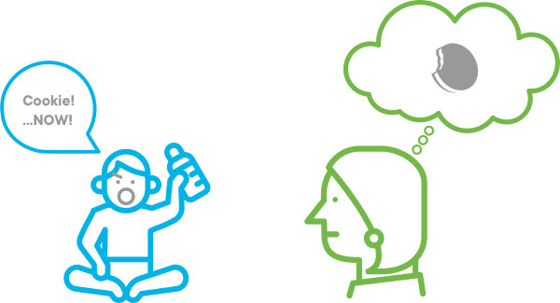

Part of growing in their ability to converse is learning to wrap their desires in politeness and consideration for the listener. "Would you mind giving me a cookie?" and "Would you care to join me for a cookie?" both express the same desire as our "rougher" example above, but show maturity.

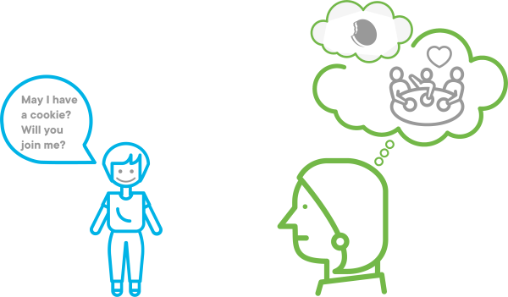

The same is true in code: we can do a great amount of work using just *expressions*. However, *mature* "speakers" of code learn to wrap their *expressions* in other *decisions* and *context*. This ensures not only that the right thing happens, ***but also*** that others can understand the code easily. Learning to "wrap" expressions in reader-friendly context will continue into Programming as Conversation Part 3 as well.

Let's start learning how to wrap our *expressions* in *statements* that will give us greater flexibility **and** enrich our communication.

**Define a Statement Versus an Expression**

We have learned that all JavaScript expressions have a return value. JavaScript statements, on the other hand, don't necessarily. We can think of a statement as an *instruction* for some action we want to carry out.

We've already seen one type of statement: the variable declaration. A variable declaration has no return value; this is the case regardless of whether we assign a value at the time the variable is declared:

const string = "Hello";

//=> undefined

let string2;

//=> undefined

string2 = "World";

//=> "World"

string2;

//=> "World"

A *variable declaration* is a statement, while a *variable assignment* and a *variable lookup* (as we have learned) are expressions.

**Note:** If you recall the previous lesson on data types, undefined is *technically* its own **thing** in JavaScript. However, it is used to represent a *lack* of any particular value, so we treat it as such when we say that variable declaration has no return value.

One type of statement you will encounter frequently as you learn JavaScript is a *block statement*. A block statement (also called a *code block*) consists of one or more expressions or statements wrapped inside curly brackets ({}). We will see them in action in upcoming lessons.

Some of the most commonly used statements in JavaScript and other languages allow us to alter the order in which code is evaluated, in other words, to change the *default execution order*.

**Understand the Default Execution Order**

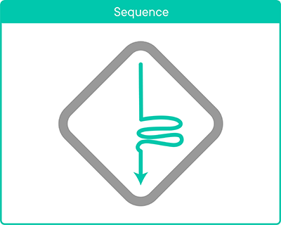

JavaScript by default will read our code according to the rules of a **default sequence** or **default flow**: "every line, top to bottom, left to right as ruled by order of operations." The "icon" above represents that rule. When you see it in the following lessons, you should immediately think about "execution order."

const result = 1 + 1;

result; //=> 2

You probably have an intuitive model of the **default sequence** since you have the general mindset that English text is read "top to bottom, left to right" and expect that to apply to code. It does! Isn't it nice when things meet our default assumptions?

This is why you intuitively grasp why JavaScript would throw an error with the following code:

result; //=> Error

const result = 1 + 1;

This error makes sense because this code is trying to do a variable lookup *before* initializing the variable that is looked up.

**Identify Two Core Categories of Code Statements**

There are two types of statements that affect whether code is executed and in what order:

* **Selection**: Given the default order (or "sequence"), can we choose to run certain lines of code and not others? How do we do so?
* **Repetition**: Given the default order (or "sequence"), can we choose to do something until a condition is met or until code has run some number of times?

**Provide An Example of Selection Statement**

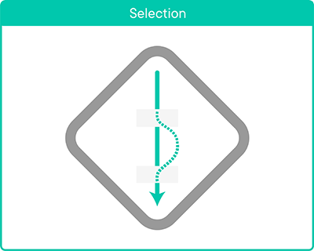

As represented in the icon above, sometimes we need to deviate from the default **sequence**. We might need to **select** a different path. There's a [poem by Robert FrostLinks to an external site.](https://www.poetryfoundation.org/poems/44272/the-road-not-taken) about it.

In this case, the traveler is JavaScript, traveling fatefully down the default sequence. We, as programmers, create a fork, a "split" in fate, and ask JavaScript to take one path (or the other, or a third, or a fourth...and so on) based on a Boolean "test" expression's return value. We ask JavaScript to *select* the path.

The first **selection** tool we'll learn is if. The if statement disrupts the "default sequence" by asking JavaScript to run a test, decide whether to follow the path, and then move back to the default sequence.

**Selection** lets us disrupt default flow by *making a choice*. JavaScript evaluates the condition in the parentheses and, if it returns true, executes the code inside the *block* (the code enclosed in {}). If favoriteNumber were assigned 0 at the time the if statement is evaluated, it would skip over the code inside the block. That's why our icon shows the default flow "hopping" from one point to another, skipping what's in the middle.

Try changing the initial value of favoriteNumber or using a different comparison operator and see what happens.

**Provide An Example of Repetition Statement**

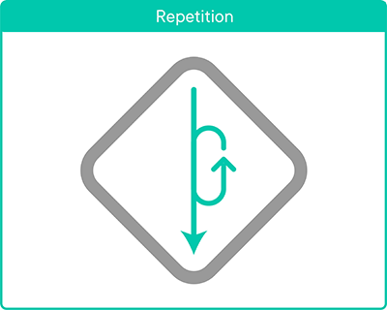

**Repetition** lets us disrupt default flow by *repeating*. The while loop, which we will introduce formally in a few lessons, means "do something while (or "as long as") some condition is true." That "something" is held inside a code block:

**Repetition** lets us disrupt default flow by marking off a set of commands that should be re-evaluated multiple times before resuming default flow. It's even possible to get into a repetition statement that you never exit. Programmers call that an "infinite loop." Most of the time, that's not a desirable situation. Our icon shows the more desirable situation of us following default sequence, then finding a block that we repeat multiple times, then returning to default sequence.

**Conclusion**

This concludes our introduction to this module. This module is like a writing class: we know how to write basic *sentences* with a simple subject and a simple verb. We're now going to try to write complete sentences with conjunctions and punctuation (like the cookie examples!). We improve our basic sentences by using SELECTION or REPETITION statements that allow us to create code that deviates from the default "flow" or SEQUENCE.

**Default Sequence and Comments**

**Learning Goals**

* Recognize the comment marker
* Add a comment to code
* 'Comment out' code

**Introduction**

As said in the introduction to this section:

JavaScript by default will read our code according to the rules of a **default sequence** or **default flow**: "every line, top to bottom, left to right as ruled by order of operations."

Using SELECTION statements we can make JavaScript "skip" over code if some Boolean *evaluation* is (or is not) true. Using REPETITION statements, we can make JavaScript "stay put" on one line and do it over and over until some Boolean *evaluation* is (or is not) true. The only way to make JavaScript "not see" a line without a Boolean *evaluation* at play is to "hide" it from JavaScript using a *comment*.

Be sure to "play along" with the examples below by keying in this code into [repl.itLinks to an external site.](https://repl.it/languages/javascript" \t "_blank). We need to build comfort with working along with the lessons.

**Recognize the Comment Marker**

We can exclude a line from the **default sequence** by starting the line with the comment marker: //. After JavaScript sees a //, it will ignore from the // to the next line.

Be careful! A comment placed in the middle of an expression can confuse JavaScript.

// Don't do this:

const sum = ( 1 //+ 1);

As a rule of thumb, try to comment out whole lines only (i.e., place the comment marker at the beginning of the line) to reduce the chances of breaking your code. While you *can* place comments within a line of code, it's best to keep things simple for now.

**Add a Comment to Code**

Comments are **primarily** used to provide references or explanations about what's going on in code.

// Perform a constant expression evaluation

3;

// Assign constant 3 to variable triangleSides

const triangleSides = 3;

Comments such as these are not particularly helpful. They're just restating what the code does. More often we add comments with motivation, or references, or blog posts, or bug reports:

// From the Three Dog Night song: "Joy to the World (Jeremiah was a Bullfrog)"

const lineOne = "Joy to the world";

const lineTwo = "All the boys and girls";

const lineThree = "Joy to the fishes in the deep blue sea";

const lineFour = "Joy to you and me";

// The '\n' inserts a new line into the string

const chorus = `${lineOne}\n${lineTwo}\n${lineThree}\n${lineFour}`;

chorus;

**A-HA! Moment**. Recall that the "return value" documentation shorthand //=> starts with a comment marker. This indicates that what's after // is not part of the code itself. That's why it's used as an "in-code" documentation convention.

**Comment Out code**

Another way to use comments is to "comment out" code, to "hide" or "mute" buggy or unused code from the **default sequence**.

With our current code:

const lineOne = "Joy to the world";

const lineTwo = "All the boys and girls";

const lineThree = "Joy to the fishes in the deep blue sea";

const lineFour = "Joy to you and me";

const chorus = `${lineOne}\n${lineTwo}\n${lineThree}\n${lineFour}`;

chorus;

**Default sequence** satisfies our expectations by returning:

Joy to the world

All the boys and girls

Joy to the fishes in the deep blue sea

Joy to you and me

Now let's "comment out" lineThree. We'll also need to modify chorus accordingly. (If you aren't sure why, try **just** commenting out lineThree in your REPL and see what happens when you run the code.) We'll comment out the current version of chorus to save it and modify a copy:

const lineOne = "Joy to the world";

const lineTwo = "All the boys and girls";

//const lineThree = "Joy to the fishes in the deep blue sea";

const lineFour = "Joy to you and me";

// const chorus = `${lineOne}\n${lineTwo}\n${lineThree}\n${lineFour}`;

const chorus = `${lineOne}\n${lineTwo}\n${lineFour}`;

chorus;

If we run this code, it returns:

Joy to the world

All the boys and girls

Joy to you and me

If we want to go back to the original version, we simply "comment back in" lineThree and the original chorus variable, and comment out or delete the modified version of chorus.

If we want to comment out *multiple* lines, we can either place the comment marker at the beginning of each line, *or* we can wrap the lines with /\* and \*/:

/\*

const lineOne = "Joy to the world";

const lineTwo = "All the boys and girls";

const lineThree = "Joy to the fishes in the deep blue sea";

\*/

const lineFour = "Joy to you and me";

lineFour;

It's common for developers to test two code paths (in effect, doing a selection statement's work by hand!) by "commenting out" and "commenting back in" code.

**Conclusion**

The **default sequence** is how JavaScript reads and executes each of the statements and commands in JavaScript code. To "hide" a line of code from being seen by the JavaScript engine, start the line with the comment marker //. We use comments to provide lightweight documentation or to hide code while we debug or test it.

[Previous](https://moringa.instructure.com/courses/318/modules/items/59201)[Next](https://moringa.instructure.com/courses/318/modules/items/59203)

**Selection with Conditionals: the if Statement**

**Learning Goals**

* Learn to use the if statement

**Introduction**

We've covered the default sequence the JavaScript engine follows when reading and executing JavaScript code. We've also learned that there are two types of statements that will enable us to change the default sequence: **selection** statements and **repetition** statements. In this lesson and the next one, we'll learn more about **selection** statements, i.e., conditionals.



**Conditional** statements enable us to execute code if a certain condition is true (or false). Some real-life examples might look like:

* if hungry → make a meal.
  + else → don't make a meal.
* if light is green → press gas pedal.
  + else → press brake pedal.
* if it's the first of the month → pay the bill.
  + else → don't pay the bill.

You might also hear this referred to as **control flow** because it helps control the flow (i.e., sequence) of an application.

JavaScript includes three structures for implementing code conditionally: *if statements*, *switch statements*, and *ternary expressions*. In this lesson, we will learn how to construct if statements.

**Learn to Use the if Statement**

To write a basic if statement, we use the following structure:

if (condition) {

// Block of code

}

It consists of the if keyword followed by the condition to be checked in parentheses. After that comes a *block statement* (more commonly called a *code block*): one or more JavaScript expressions or statements enclosed in {}. The *code block* contains the code we want to execute *if* the condition returns a truthy value:

In the code above, age is initialized to 30, so the condition (age >= 18) resolves to true. The code in the code block executes, setting the isAdult variable to true. Try making some changes — assigning different values to age; changing the conditional statement — to see what happens.

**else**

Often we want to run one block of code when the condition returns a truthy value and a *different* block of code when it returns a falsey value. To do this, we use an else clause:

Note that the else clause **does not take a condition** — if the condition for the if returns a falsey value, we want the else code block to run **no matter what**. This means that exactly one of the code blocks will *always* run.

**The Ternary Expression**

Recall that this is the exact situation where we can use a ternary expression. Here's what the code above would look like using a ternary:

Here, we assign isAdult as true if the condition returns a truthy value and as false otherwise, exactly like the version using if.

Remember that a ternary is an *expression* — it returns a *value*. What this means is that we can simplify the code above a bit and assign the *result* of the ternary directly to a variable:

const age = 26;

const isAdult = age >= 18 ? true : false;

isAdult;

//=> true

The ternary expression is evaluated and resolved to true, and that value is assigned to the variable isAdult. Try this version out in the REPL to verify that it works.

**Advanced:** What is the ternary above doing? Basically, it's saying: "when the conditional code returns true, return true, and when the conditional code returns false, return false." Sounds a bit redundant, doesn't it? When the return values are true and false as in the example above, you actually don't need to use a ternary — or an if...else — at all! This is because ***the conditional is an expression as well***. The return value of age >= 18 is a *Boolean value* (true or false), so it can be assigned directly to our isAdult variable:

const age = 6;

const isAdult = age >= 18;

isAdult;

//=> false

The ternary (or if...else) is only necessary if the desired return value is something other than a Boolean:

const age = 20;

const ageMessage = age >= 18 ? "Congratulations! You're an adult!" : "Enjoy your childhood while it lasts!";

ageMessage;

//=> "Congratulations! You're an adult!"

**Top Tip:** Be careful to not overuse the ternary expression. It's fine for slimming down a simple if...else, but be conscious of how easy your code is to understand for an outsider. Remember, you generally write code once, but it gets read (by yourself and others) **far** more than once. The ternary is often more difficult to quickly interpret than a regular old if...else, so make sure the reduction in code is worth any potential reduction in readability.

**else if**

We've discussed the case where our condition is *binary* (one code block executes if the conditional returns true and a second executes otherwise), but sometimes we need to check multiple conditions. We can handle this situation by using one or more else if clauses.

Let's say that instead of just deciding whether the passed-in age meets the criterion for isAdult, we want to add in some other examples of adulthood (in American society, at least): canWork, canEnlist, and canDrink. 16-year-olds can legally work; 18-year-olds can do what 16-year-olds can do **plus** they can enlist and they are legal adults; 21-year-olds can do what 16- and 18-year-olds can do **plus** they can drink (at the federally set minimum age).

Here's how we can handle that using else if clauses:

Any time you use an if...else if construction, **at most one code block will be executed**. As soon as one of the conditions returns a truthy value, the attached code block runs and the conditional statement ends. In the example above, we have not included an else statement so, if none of the conditions is truthy, no code blocks will be run. If we had included an else clause, exactly one code block would be run.

Try different values for age in the REPL and check the resulting values of the four variables.

**Nested if Statements**

You may have noticed that there is some redundancy in the example above: three of the four variables appear in more than one of the conditions. In this circumstance, we can streamline our code a bit by using nested conditional statements:

The first if condition checks for the "base level" of adulthood (age >= 16), and each subsequent nested if "adds on." Note that each inner if statement is nested **inside** the code block of the one before. This means that the inner if statements will only execute if the outer ones are truthy. This makes sense: if age is less than 16, we're done — there's no need to check the remaining conditions because we know they have to be false as well. Otherwise JavaScript will keep checking each subsequent condition until it either comes to one that is false or finishes running all the code blocks.

While nested ifs are more efficient than if...else ifs for handling overlapping categories, they are also more difficult to read. An if...else if construction will always work. You should consider the tradeoff of readability vs. efficiency in deciding which construction to use.

**Conclusion**

In this lesson, we've learned about one of the *selection statements* that enable us to modify the *default sequence*: the if statement. In the simplest case, the if statement consists of the if clause, a condition, and a code block to run if the condition returns true. In more complex situations, we can add one or more else if clauses or an else clause.

In the next lesson, we'll learn about another selection statement we can use to create conditional code: the switch statement.

**Resources**

* MDN
  + [Conditional statementsLinks to an external site.](https://developer.mozilla.org/en-US/docs/Web/JavaScript/Guide/Control_flow_and_error_handling#Conditional_statements)
  + [if...else statementLinks to an external site.](https://developer.mozilla.org/en-US/docs/Web/JavaScript/Reference/Statements/if...else)

**Selection with Conditional: the 'switch' Statement**

**Learning Goals**

* Learn to use the switch statement

**Introduction**

We've now learned about two of the three *selection* tools available to us in JavaScript: the if statement and the ternary expression. In this lesson, we'll learn about a third: the switch statement. The switch statement provides an alternate way of expressing conditional code that is less repetitive in cases where you want to test multiple conditions against a single value.



**Learn to Use the Switch Statement**

Let's say we have a program that includes a variable containing a person's name and we want to execute certain code depending on what that person's name is. Using an if...else if construction, that might look like this:

const name = "Alice";

let greeting;

if (name === "Alice") {

greeting = "Hello, Alice!"

} else if (name === "The White Rabbit") {

greeting = "Don't be late, White Rabbit"

} else if (name === "The Mad Hatter") {

greeting = "Welcome to the tea party, Mad Hatter"

} else if (name === "The Queen of Hearts") {

greeting = "Please don't chop off my head!"

} else {

greeting = "Whoooo are you?"

}

greeting;

//=> "Hello, Alice!"

As we can see, there's quite a bit of repetition here: we always test name and we always compare with ===. This is a pretty common selection need. It's so standard that the switch statement was created to enable us to streamline our code. Here's the switch version of the code above:

The JavaScript engine compares the value passed in to the switch statement (here, name) against each of the case values *using strict equality* (===). When a match is found, the statements nested under that case are executed. In this example, by using the switch statement, we avoid the need to repeat the if (name === \_\_\_\_\_) line for each possibility.

We can also assign the same set of statements to multiple cases:

In the above example, if the name variable matches the names of any of the dwarves, the characterType variable will be set to "dwarf".

The default and break keywords are both *optional* in switch statements, but can be useful. In more complicated statements, they become necessary to ensure the correct flow.

**default**

The default keyword is similar to the else clause in an if...else construction. It specifies a set of statements to run after all of the switch statement's cases have been checked. However, it is different from an else in that **the only time it does *not* run is if the engine hits a break in one of the case statements**. If you only want one code block in your switch statement to execute, you should always include the break keyword.

**break**

In the previous example, break is used to stop the switch statement from continuing to look at case statements once it finds a match. If we left out the break keywords, the JavaScript engine would first assign characterType to "dwarf" when it reached the "Grumpy" case (as desired), but the code would **continue to execute** and characterType would wind up being reset to "minor character." To keep that from happening, we use break to tell the JavaScript engine to stop executing the switch statement as soon as it finds a match. You will often see switch statements where break is used in every case as a way to ensure there is no unexpected behavior from multiple cases executing.

**Advanced:** Sometimes we *want* to potentially match multiple cases, and we will need to leave out break in order to do this. Let's revisit an example from the lesson on if statements:

const age = 20;

let isAdult, canWork, canEnlist, canDrink;

if (age >= 21) {

isAdult = true;

canWork = true;

canEnlist = true;

canDrink = true;

} else if (age >= 18) {

isAdult = true;

canWork = true;

canEnlist = true;

} else if (age >= 16) {

canWork = true;

}

// => true

isAdult;

// => true

canWork;

// => true

canEnlist;

// => true

canDrink;

// => undefined

We can refactor the above if...else if...else chain as a more compact, less repetitious switch statement. To make it work, we will employ a neat little trick: we'll use comparisons for our case statements instead of a simple value.

We specified true as the value to switch on. All of our cases are *comparison expressions* that return true or false. Therefore, if a comparison returns true, its statements will be run. Because we did not include any break statements, once *one* case statement matches, all subsequent statements will execute. This is what we want here: if age is greater than 21, it's also greater than 18 and 16, so we want *all* the assignments to be made.

If we set age to 20 in the above example, the first case, age >= 21, returns false and the assignment of canDrink never happens. The engine then proceeds to the next case, age >= 18, which returns true, assigning the value true to isAdult and canEnlist. Since it encounters no break statement, it then proceeds to the last case statement where canWork is set to true as well.

**Conclusion**

You now have three different tools available to you to use *selection* in JavaScript: the if statement, the ternary expression, and the switch statement. The if statement is the one you will use most often — in fact, you can *always* construct your conditional code using some combination of if, else if, and else. It may not be the most efficient way to write the code, but it will always do the trick.

As a rule of thumb, you may find it makes sense to start with if statements and, once you've got the code working, consider refactoring it to use a ternary or switch statement if they're better suited for what you need to do.

**Resources**

* MDN
  + [switch statementLinks to an external site.](https://developer.mozilla.org/en-US/docs/Web/JavaScript/Reference/Statements/switch)

**Logging in JavaScript**

**Learning Goals**

* Learn about logging in JavaScript
* Use console.log() in the development process
* Use console.log() for debugging

**Logging**

The venerable console.log() is an all-purpose logging *method*. (A **method** or a **function** is a bit of code that *does* something. We *call* them when we want them to act.) In programming, *logging* refers to the process of printing information about the program as it runs. Note that console.log() is a *development* tool; it's not something that's used in deployed code.

Let's take a look at how it works. Open up [repl.itLinks to an external site.](https://repl.it/languages/javascript" \t "_blank) and follow along.

Notice, when the REPL opens, that they've already provided an example:

console.log("Hello, world!");

If you click the Run button, you'll see the message output in the terminal.

We can log more than just a simple message. In fact, we can pass any number of messages to console.log() by separating them with commas; when printed, they'll be separated by a space:

console.log("one", "two", "three");

And we can pass other types of values to console.log(), not just strings. Give this a try:

console.log("I must have logged", 1000, "times today.");

Note that, for that first string ("I must have logged"), the comma is *after* the end quotation mark. This is because the comma is not part of the string; instead, it's how we tell JavaScript, "Hey, I'm going to give you something else!"

We can also pass *variables* to console.log():

const name = "Byron the Poodle";

console.log("Hello,", name);

In fact, we can log any *expression* — even very complex ones — using console.log().

**Using console.log() in the Development Process**

Where console.log() gets really helpful is when you use it to check that your code is functioning as you want it to. Let's revisit an example from an earlier lesson:

Let's say we want to run some tests to make sure that we have our if statement set up properly. We can do this by checking the values of the four variables for different values of age. Recall that, when we worked with this code before, we had to check each of our variables one at a time since only the value of the *last* executed expression is displayed in the REPL's terminal window. This can get pretty tedious, especially if we have a lot of variables or a lot of conditions (or both). Here's where console.log() comes in.

Let's add the following to the end of our code:

console.log(canWork, canEnlist, isAdult, canDrink);

Next, let's set the age variable to a value of 16 and click the run button. You should see the following output to the terminal:

true false false false

It looks like our code is working if age is set to 16, but our message could be a little more informative. We can see that only one of the variables is true, which is what we want, but it's not immediately apparent *which* of the variables is the one that's true. So let's add some labels. To do this, we'll use a combination of strings and variables inside our console.log(). While we're at it, let's log the age value as well:

console.log(

"Age:",

age,

"Can work:",

canWork,

"Can enlist:",

canEnlist,

"Is a legal adult:",

isAdult,

"Can drink:",

canDrink

);

This looks complicated, but all we're doing here is stringing together a series of expressions — some of them simple string values, and some of them variables — with commas between each one.

Alternatively, we can use string interpolation inside our console.log() to do the same thing:

console.log(

`Age: ${age}, Can work: ${canWork}, Can enlist: ${canEnlist}, Is a legal adult: ${isAdult}, Can drink: ${canDrink}`

);

With this approach, we're passing *a single expression* to console.log() instead of a series of them. The commas here, therefore, are part of the string. Be sure to run both versions in the REPL so you can see the difference.

If we were writing user-facing code here, we would probably want to make it easier to read by putting each variable on its own line. We could do that either by using multiple console.log()s, or by using the new line character (\n). But since the console.log() is just for our (the developer's) use, the above may be perfectly acceptable.

With this console.log() set up we can try our code with as many age values as we like, checking each time to verify that the variables have been set correctly.

**Using console.log() for Debugging**

Let's say we've gotten our code to this point:

We have our console.log() set up and we're ready to start testing it. We decide to start with our 'least adult' category, which is children under age 16, so we set age equal to 15 and click run. Everything looks fine — we get four falses — so we change age to 16, then 17. So far, so good. But then when we test it for an age of 18, we see the following:

Age: 18

Can work: true

Can enlist: false

Is a legal adult: false

Can drink: false

Hmm, obviously we've got an error somewhere. The code for ages 18-20 isn't returning the expected result, so let's take a look at that conditional: else if (age > 18). With a simple condition like this, we might realize right away that we accidentally used > instead of >=. But imagine a case where our condition is more complex and we don't immediately see the problem. Let's think about some ideas for ways we can use console.log() to help us find and correct it.

To start, we could try logging a message *inside* the block for the condition where the error is (ie, inside the block that *should* be executing):

If we click the Run button, the message does *not* get logged so we know the code block is not getting executed. This tells us that there's something wrong with the conditional itself. If the message *did* get logged we would know that the problem is somewhere inside the code block instead.

Next, we could try changing age to 19. In this case, the message *does* get logged, so we know our conditional is only broken for age 18. This gives us another clue as to how to fix it.

If we had a more complicated conditional and still couldn't find the problem, we could try logging the conditional itself, simplifying it one step at a time until it *does* return true. As soon as we get a true return value, we know that the last thing we removed was what was causing the problem. For example, if our overall condition is comprised of two conditions joined by &&, we could check each expression individually. Whichever one returns false instead of true is the one with the problem. We could then continue to "drill down" as necessary until we find what's wrong.

**Top Tip**: Even better, we can use console.log() as we're building the conditional in the first place, using an approach like the one outlined below. Only after you have the conditions working the way you need them to would you begin building out the code blocks. Taking this incremental approach will make it much easier to find and fix any errors.

if (condition1) {

console.log("Condition 1 returned true");

} else if (condition2) {

console.log("Condition 2 returned true");

}

You should think of the ideas presented above as examples of a general approach to debugging. Debugging is largely a matter of using *logic* to narrow in on the problematic bit of code until you find the error. It is worth getting comfortable using console.log() because it can be a valuable tool in this process.

**Conclusion**

In this lesson, we've learned how to use the console.log() method. We've also explored some ways we can use it to help us with writing and debugging code.

**Repetition: the while Loop**

**Learning Goals**

* Define the basic while structure
* Write an infinite loop
* Use Control-C to break out of an infinite loop
* Terminate a while loop naturally
* Learn about operators used to increment/decrement
* Use a do...while loop

**Introduction**

The final piece of using *statements* to control the flow of JavaScript execution is **repetition**.



While the **default sequence** requires JavaScript to execute top-down, left to right, we've seen that we can skip chunks of code using *selection* statements (if or switch). In some ways the reverse of *selection* is *repetition*: "Don't move on," we tell JavaScript. "Instead do something else until I say it's OK to move on." The most fundamental *repetition* construct, present in pretty much every programming language, is the while loop.

**Define the Basic while Structure**

A basic while loop looks like:

while (condition expression) {

// stuff to do

}

As long as the condition expression is true (or truthy), the code inside the code block will run. Keep in mind the condition expression can be quite rich, using &&, ||, (), etc.

**Write an Infinite Loop**

Given this definition of while, any truthy expression will make the loop run forever.

while (true) {

console.log("say this forever...");

}

This will output:

say this forever...

say this forever...

say this forever...

say this forever...

say this forever...

...

Note that the condition expression doesn't need to be the literal value true — any truthy value will have the same effect:

while (-1) {

// -1 is truthy....

console.log("say this forever...");

}

By contrast, a false (or falsey) condition expression will keep the code block from executing at all:

while (null) {

console.log("I will never run");

}

**Use Control-C to Break Out of an Infinitely Looping Program**

When you start writing code and creating loops yourself, you will almost certainly inadvertently create infinite loops from time to time. If you try to run the code and it either logs over and over without end **or** never seems to finish, you're probably stuck in an infinite loop.

In most programming environments (including repl.it), you can break out of an infinite loop by typing Control-C. That's an old-school UNIX key combination that means INTERRUPT. In order for this to work, you first need to make the terminal portion of the programming environment (where the results of running the code are displayed) the active window by clicking inside it.

Give it a try here:

Don't forget to click in the terminal (the window on the bottom) before typing Control-C!

**Terminate a while Loop Naturally**

Most loops aren't meant to run infinitely. There's some condition that they cross, captured in the *condition expression*, that tells JavaScript that it's time to return to the **default sequence** and execute the code after the while loop.

So, somehow we need to create an expression that's true when the while begins (so that the code in the {} runs), but that eventually becomes false.

Here's a simple example that uses a very common approach:

let count = 0; // Initialize a counter variable; note that we need to use `let` here

while (count < 3) {

//A Boolean expression that uses the counter to decide whether to keep looping

console.log(`I am the ${count}, I love to count!`); // The work the loop does

count = count + 1; // Update the counter variable; this keeps track of how many times the loop has executed

}

In the last line, count = count + 1, we are *assigning* a new value to the count variable, where the new value is equal to its current value plus 1.

The code above produces:

I am the 0, I love to count!

I am the 1, I love to count!

I am the 2, I love to count!

You may notice that running this code in repl.it produces a different output, and includes 3 as the last line in the output to the terminal. Why? The reason for this is that in addition to displaying the console.log statements, repl.it also shows what the last line of code evaluates to. In this code snippet, the last line of code that is evaluated is count = count + 1, which will be 3 by the time our while loop is finished, so that's why the 3 shows up at the end.

Let's say we forgot the line count = count + 1. If our count variable never changes, our *condition expression* would *always* be true and we'd have an infinite loop. (Hint: this is a very common mistake, even for experienced programmers.)

You may *also* wonder why we're starting our counter variable at 0instead of 1 The answer may sound a bit... opaque. It's because, in computer science, arrays are *indexed* starting with 0 instead of 1. In other words, we need to use the *index* value of 0 to retrieve the first element from an array. Because loops are frequently used to access elements in arrays, the *convention* is to start loop counter variables at 0 instead of 1. If this doesn't entirely make sense at this point, don't worry — it will become clearer when we learn about arrays.

**Learn About Operators Used to Increment/Decrement**

Let's look back at that previous example to notice how we're moving from a true or truthy statement to a false or falsey statement. Within each loop, the following code is executed:

count = count + 1;

which slowly moves count to a place where it is no longer less than 3, thus ending the loop.

But writing count = count + 1 is a bit long-winded (although very explicit; sometimes a few extra keystrokes can save you headaches with debugging, especially when you're first learning to code). This pattern of "incrementing" a variable is very common, so JavaScript includes a couple of shorthand operators you can use. It's like a contraction in conversation: very few English speakers say "can not," "have not," or "would not" **all** the time. You're likely to hear them use *contractions* (from the Latin: "pulling together") like "can't," "haven't," and "wouldn't." In the code below, we are combining the addition and assignment with the addition assignment operator, +=:

// take the value of count, add 1 to it and then assign that result to count

count += 1;

Unsurprisingly -= does the reverse of +=: it "decrements" the variable's value and re-assigns the new value to the variable. JavaScript has a number of other [assignment operatorsLinks to an external site.](https://developer.mozilla.org/en-US/docs/Web/JavaScript/Reference/Operators#Assignment_operators) that allow you to use multiplication (\*=), division (/=), and a variety of other operations.

The assignment operators will work with any *number*. If you want to add 10 or multiply by 3.14, the assignment operators will do that for you. For the special (but common) case where you want to add (or subtract) 1, however, there is another option: the [increment and decrement operatorsLinks to an external site.](https://developer.mozilla.org/en-US/docs/Web/JavaScript/Reference/Operators#Increment_and_decrement), ++ and --. For a case such as the above, where we're using a counter variable to keep track of where we are in our loop, the increment operator is frequently used:

Get comfortable using the different options for incrementation and experiment with writing some loops of your own.

**Use a do...while Loop**

The do...while loop is similar to while, in that it will execute a block of code based on a condition or set of conditions. The difference, however, is that **it will always execute at least once**. The reason is that the condition isn't evaluated until **after** the code block executes the first time:

do {

console.log(`I will execute once`);

} while (false);

The JavaScript engine will enter the loop, execute the console.log, then evaluate the condition. Because the condition returns false the loop will stop executing there.

This construction is helpful any time you want to make sure that the loop executes at least once. As an example, this might be useful for asking a user to create a password. The do while loop will always ask them to enter their password the first time, and can continue to ask as long as (while) the value they enter doesn't meet the password requirements.

**Conclusion**

In this lesson, we have learned how to use a *repetition* statement, the while loop. JavaScript includes some other looping mechanisms that you'll learn about later in the course. But for now, with an understanding of *sequence*, *selection* and now *repetition* on top of your experience with expressions, you can write powerful programs! Be sure to experiment with writing your own loops and don't forget, if your code is not responding, you can use Control-C to interrupt the program!

**Programming as Conversation Part 3: Introduction**

**Learning Goals**

* Revisit abstraction

**Introduction**

Before we jump into more code, let's think for a moment about something you encounter pretty much every day when you read a news article or email: the way we organize words to express and clarify meaning. For example, a **paragraph** is a collection of sentences, introduced by a topic sentence and bundled up or closed by a closing sentence. A **paragraph** can persuade or offend, direct or explain. A paragraph has a *function*.

"Code paragraphs" are called, depending on language, "functions," "procedures," "methods," or "subroutines." They bundle up expressions and statements to accomplish a task. Just as "Make a Sandwich" encompasses specific, "atomic" actions like "get slice of bread," "get jelly," etc., executeTransfer encompasses logic like if (accountStatus === "open") or if (accountBalance >= transactionAmount).

To have code that is easy to read, debug, and maintain, we need to bundle collections of atomic activities into "code paragraphs" that do work. JavaScript calls these "functions."

**Abstraction**

This process of bundling up small atoms into a *function* is called "abstraction." "Abstraction" comes from the Latin word for "to pull away." When we're further away, many details are hard to see. Only the most relevant shapes are recognizable. For example, when you're on an airplane and are over a city the details of the cars below — the mileage, what's in the cup holder, the make or model — are invisible, they're not *essential*. But what we may be able to see is the vehicle type (car vs. truck) or the color of the car. By abstracting we see what's true at a higher level, or more *generally*.

Here are a few more "abstractions:"

* [Jerry SeinfeldLinks to an external site.](https://en.wikipedia.org/wiki/Jerry_Seinfeld), [Ruth Bader GinsburgLinks to an external site.](https://en.wikipedia.org/wiki/Ruth_Bader_Ginsburg), and [Cardi BLinks to an external site.](https://en.wikipedia.org/wiki/Cardi_B) are atomic individuals, but we can refer to them all collectively by the abstraction (or they can be *abstracted* into) "famous New Yorkers"
* Books about a killer dog, a scary alter ego, and a scary clown can be *abstracted* into the name "horror novels (by Stephen King)"
* Individuals with strange powers and (usually) strange clothing can be *abstracted* into "superheroes"

Abstraction is a natural part of learning to converse. When you're first learning to communicate, you don't know enough to start talking about abstractions. You prefer to think about real, visible, tangible things. But as you learn about opposites, how things are similar (and how perhaps one thing is dissimilar) you grow in your ability to *abstract*.

In fact, the thing that makes most higher learning "higher" is that the discussion, work, and discovery is focused on uncovering general principles that allow us to predict how things will work more-or-less most of the time. Amazingly, this was considered a pretty revolutionary idea at the time when Galileo and Newton started doing it. The moment that natural philosophers started looking for these "general rules of how things work," science as we know it was born.

**Next Steps**

In Programming as Conversation 3, we'll learn to take our JavaScript *expressions* and *statements* and bundle them up into abstractions called *functions*. Before we get to that, however, we first need to learn a little about *testing* in JavaScript.

[Previous](https://moringa.instructure.com/courses/318/modules/items/59207)[Next](https://moringa.instructure.com/courses/318/modules/items/59209)

Testing With Javascript

* **Due** No Due Date

* **Points** 1

* **Submitting** a website url

**Learning Goals**

* Learn about testing in JavaScript

**Introduction**

Many of the labs you will complete in this program use tests. Passing the tests verifies that the code you write behaves as desired and produces the expected results. But writing tests is also a way to provide specifics about exactly how the code should function. In a common development strategy known as [test-driven developmentLinks to an external site.](https://en.wikipedia.org/wiki/Test-driven_development) (or TDD), programmers *first* write the test for a specific function of the code *then* write the code to make the tests pass. TDD is considered the most reliable methodology for delivering quality code.

What this means is that the results of running the tests will be an important tool in figuring out how to get those tests passing. Code testing can feel like an abstract concept at first, but it's worth starting to learn how they work. When you're having difficulty passing a test, being able to read and understand the test output — and the tests themselves — can be an invaluable skill.

**Getting Started**

If you haven't already, fork and clone this lesson into your local environment. Navigate into its directory in the terminal, then run code . to open the files in Visual Studio Code. (If you are using a different text editor, the command will be different.)

Open up index.js in your code editor. You are going to see mostly familiar things:

const name = "Joe";

const height = 74;

const message = `${name} is ${height} inches tall`;

module.exports = { name, height, message };

This should all look familiar except for that last line. You don't need to worry about it for now — just know that line of code makes the variables available to the test file.

Take a look at the message variable:

const message = `${name} is ${height} inches tall`;

We can use console.log to take a look at the value of the message variable. To do that, first type console.log(message); on the last line of index.js and save the file. Next, navigate to the terminal, and type the following command in the command line and hit enter (be sure you're still in the lab's directory):

$ node index.js

The node command *executes* the code in whatever file you specify (in this case, index.js). You should see "Joe is 74 inches tall" logged in the terminal.

**Top Tip**: console.log is one of the debugging tools you can use as you're writing your code. Logging a variable and executing the code will allow you to verify that the value of the variable is what you're expecting.

In the line of code above, we are using *string interpolation* to inject the values of the name and height variables into the message. Recall that, for this to work, you have to wrap the entire string in backticks and wrap the variables themselves in ${}. If you'd like a refresher, try leaving out the ${}s or switching to a different type of quotes and run your code again to see what the value of message is. The backticks and the ${} tell Javascript to grab the *value* inside the variable, not just that variable name.

**The Tests**

We have our code, now let's take a look at the tests. They are located in the test folder inside a file named index-test.js. In this lesson we'll get familiar with the tests, and then run them in the next lesson.

const { name, height, message } = require("../index.js");

/\*

describe('what-is-a-test', () => {

describe('Name', () => {

it('returns "Susan"', () => {

expect(name).toEqual('Susan')

})

})

describe('Height', () => {

it('is less than 40', () => {

expect(height).toBeLessThan(40)

})

})

describe('Message', () => {

it('gives the name and height', () => {

expect(message).toInclude(name)

expect(message).toInclude(height)

})

})

})

\*/

In the first line, we're enabling the tests to access the variables in index.js. You don't need to worry about exactly how this works at this point — just know that the module.exports and require keywords allow us to access variables written in the index.js file from within the test file.

The next thing to notice is that the test code itself is commented out using the /\* and \*/ block commenting syntax. This is because, as mentioned above, we don't actually want to run the tests yet. In the next lesson, we will remove the /\* and \*/ so we can run the tests.

Next, note that the test code consists of three individual tests (each starting with describe) nested inside a block for the tests as a whole (also starting with describe).

The first grouping is testing our name variable:

describe("Name", () => {

it('returns "Susan"', () => {

expect(name).toEqual("Susan");

});

});

Take a look at the line that begins with expect. If we read it out loud, we get "Expect name to equal Susan". That's exactly what it's saying! If we continue down to the Height section you'll see this code:

describe("Height", () => {

it("is less than 40", () => {

expect(height).toBeLessThan(40);

});

});

Again, reading the line starting with expect out loud, we get "Expect height to be less than 40." Again, this is just what the test is checking. Let's look at the final one:

describe("Message", () => {

it("gives the name and height", () => {

expect(message).toInclude(name);

expect(message).toInclude(height);

});

});

This one has two expect statements. If you read them out as English you'll discover that the tests expect the value of index.message to include both index.name and index.height.

OK Great. You now understand what the tests are saying. In the next lesson we are going to cover how to run them, and then you will solve the lab!

**Submitting the Assignment**

To register completion of this lesson, submit the URL for your forked copy of the repo in Canvas. Even though you didn't need to write any code for this lesson, you'll need to submit a link in order for this lesson to be marked as complete in Canvas.

1. Go to your repository in GitHub and copy the URL. Note, this should be copied from the browser's address bar, and should start with [https://github.com/Links to an external site.](https://github.com/)
2. Go to the assignment in Canvas and click Submit Assignment (or Start Assignment)
3. Paste in your GitHub URL as your submission

[Previous](https://moringa.instructure.com/courses/318/modules/items/59208)[Next](https://moringa.instructure.com/courses/318/modules/items/59210)

# Testing with JavaScript Lab

* **Due** No Due Date

* **Points** 1

* **Submitting** a website url

## Learning Goals

* Running tests
* Reading test results

## Running Tests

You understand how to read tests; now it's time to run the tests.

If you haven't already, fork and clone this lesson into your local environment. Navigate into its directory in the terminal, then run code . to open the files in Visual Studio Code. (If you are using a different text editor, the command will be different.) Finally, run npm install to install the lab's dependencies.

What exactly do we mean by installing dependencies? Open the package.json file and scroll down to the bottom. You'll see a list of 'DevDependencies'. What's listed here are JavaScript packages: files or sets of files full of existing, reusable code. They are designed to be shared, allowing many developers to use the same code in their own projects. The packages you see listed in package.json make it possible to run the lab's tests. In order to use the packages, we have to install them; npm install does that for us.

If you take a look at index.js and index-test.js, you should see the same code as in the previous lesson. The only difference is that the test code in index-test.js is no longer commented out.

**Important**: You should never need to make changes to test files unless a lab's instructions specifically tell you to do so.

To run the tests, run npm test in the terminal. That's it!

The next step is learning how to read the results that the tests give you.

## Reading Results of Tests

The first time you run npm test, you should see something that looks like this:

> js-functions-lab@0.1.0 test /Users/mbenton/Desktop/curriculum-team/js-what-is-a-test-lab

> mocha -R mocha-multi --reporter-options spec=-,json=.results.json

what-is-a-test

Name

1) returns "Susan"

Height

2) is less than 40

Message

✓ gives the name and height

1 passing (552ms)

2 failing

1) what-is-a-test

Name

returns "Susan":

Error: Expected 'Joe' to equal 'Susan'

+ expected - actual

-Joe

+Susan

at assert (node\_modules/expect/lib/assert.js:29:9)

at Expectation.toEqual (node\_modules/expect/lib/Expectation.js:81:30)

at Context.<anonymous> (test/index-test.js:6:26)

at processImmediate (internal/timers.js:461:21)

2) what-is-a-test

Height

is less than 40:

Error: Expected 74 to be less than 40

at assert (node\_modules/expect/lib/assert.js:29:9)

at Expectation.toBeLessThan (node\_modules/expect/lib/Expectation.js:156:28)

at Context.<anonymous> (test/index-test.js:13:28)

at processImmediate (internal/timers.js:461:21)

npm ERR! Test failed. See above for more details.

Let's break this down a bit. If you look about a third of the way down in the output, you'll see a summary of how the tests went:

1 passing (552ms)

2 failing

Great! We've already got one test passing! Now let's see how we failed the other two tests.

1) what-is-a-test

Name

returns "Susan":

Error: Expected 'Joe' to equal 'Susan'

+ expected - actual

-Joe

+Susan

at assert (node\_modules/expect/lib/assert.js:29:9)

at Expectation.toEqual (node\_modules/expect/lib/Expectation.js:81:30)

at Context.<anonymous> (test/index-test.js:6:26)

at processImmediate (internal/timers.js:461:21)

2) what-is-a-test

Height

is less than 40:

Error: Expected 74 to be less than 40

at assert (node\_modules/expect/lib/assert.js:29:9)

at Expectation.toBeLessThan (node\_modules/expect/lib/Expectation.js:156:28)

at Context.<anonymous> (test/index-test.js:13:28)

at processImmediate (internal/timers.js:461:21)

While there is no hard and fast rule, and there will be exceptions, it is most often best to address your test errors in order. So let's take a look at our first error:

1) what-is-a-test

Name

returns "Susan":

Error: Expected 'Joe' to equal 'Susan'

+ expected - actual

-Joe

+Susan

at assert (node\_modules/expect/lib/assert.js:29:9)

at Expectation.toEqual (node\_modules/expect/lib/Expectation.js:81:30)

at Context.<anonymous> (test/index-test.js:6:26)

at processImmediate (internal/timers.js:456:21)

Here is the specific error:

Error: Expected 'Joe' to equal 'Susan'

+ expected - actual

-Joe

+Susan

It tells us what the test is expecting (Expected 'Joe' to equal 'Susan') and then gives us details about the expected and actual values. This shows you exactly how the value your code is returning (the actual value) differs from what the test is looking for. Make sure you understand what this is telling you — it will come in handy in later labs!

This error makes sense because we have the name variable set equal to "Joe" in our index.js file. Let's change that line of code to set name equal to "Susan" instead. Run the tests again by typing npm test in the terminal's command line, and you should see that we are now passing 2 of the 3 tests!

what-is-a-test

Name

✓ returns "Susan"

Height

1) is less than 40

Message

✓ gives the name and height

2 passing (736ms)

1 failing

1) what-is-a-test

Height

is less than 40:

Error: Expected 74 to be less than 40

at assert (node\_modules/expect/lib/assert.js:29:9)

at Expectation.toBeLessThan (node\_modules/expect/lib/Expectation.js:156:28)

at Context.<anonymous> (test/index-test.js:13:28)

at processImmediate (internal/timers.js:461:21)

Woot! You passed another one. Now go ahead and try to pass the remaining test on your own.

### Common Errors

While you are solving the other tests you may come across a few errors. Let's go over some common ones:

#### Variable Not Defined

ReferenceError: name is not defined

That one says that the name variable is not defined. That makes no sense! We initialized the name variable in index.js! What that actually means is that the test couldn't find the variable name. You'll get this error if the name of one of your variables is different than the test is expecting. Check to make sure you used the correct variable names and look carefully for typos.

#### Unexpected Identifier

/Users/lizburton\_fs/Development/code/curriculum/flip/pac3/phase-0-pac-3-what-is-a-test-lab/index.js:1

cnst name = "Susan";

^^^^

SyntaxError: Unexpected identifier

at wrapSafe (internal/modules/cjs/loader.js:979:16)

at Module.\_compile (internal/modules/cjs/loader.js:1027:27)

at Object.Module.\_extensions..js (internal/modules/cjs/loader.js:1092:10)

at Module.load (internal/modules/cjs/loader.js:928:32)

at Function.Module.\_load (internal/modules/cjs/loader.js:769:14)

at Module.require (internal/modules/cjs/loader.js:952:19)

at require (internal/modules/cjs/helpers.js:88:18)

at Object.<anonymous> (/Users/lizburton\_fs/Development/code/curriculum/flip/pac3/phase-0-pac-3-what-is-a-test-lab/test/index-test.js:1:15)

at Module.\_compile (internal/modules/cjs/loader.js:1063:30)

at Object.Module.\_extensions..js (internal/modules/cjs/loader.js:1092:10)

at Module.load (internal/modules/cjs/loader.js:928:32)

at Function.Module.\_load (internal/modules/cjs/loader.js:769:14)

at Module.require (internal/modules/cjs/loader.js:952:19)

at require (internal/modules/cjs/helpers.js:88:18)

at /Users/lizburton\_fs/Development/code/curriculum/flip/pac3/phase-0-pac-3-what-is-a-test-lab/node\_modules/mocha/lib/mocha.js:311:36

at Array.forEach (<anonymous>)

at Mocha.loadFiles (/Users/lizburton\_fs/Development/code/curriculum/flip/pac3/phase-0-pac-3-what-is-a-test-lab/node\_modules/mocha/lib/mocha.js:308:14)

at Mocha.run (/Users/lizburton\_fs/Development/code/curriculum/flip/pac3/phase-0-pac-3-what-is-a-test-lab/node\_modules/mocha/lib/mocha.js:849:10)

at Object.exports.singleRun (/Users/lizburton\_fs/Development/code/curriculum/flip/pac3/phase-0-pac-3-what-is-a-test-lab/node\_modules/mocha/lib/cli/run-helpers.js:108:16)

at exports.runMocha (/Users/lizburton\_fs/Development/code/curriculum/flip/pac3/phase-0-pac-3-what-is-a-test-lab/node\_modules/mocha/lib/cli/run-helpers.js:143:13)

at Object.exports.handler (/Users/lizburton\_fs/Development/code/curriculum/flip/pac3/phase-0-pac-3-what-is-a-test-lab/node\_modules/mocha/lib/cli/run.js:305:3)

at Object.runCommand (/Users/lizburton\_fs/Development/code/curriculum/flip/pac3/phase-0-pac-3-what-is-a-test-lab/node\_modules/yargs/lib/command.js:242:26)

at Object.parseArgs [as \_parseArgs] (/Users/lizburton\_fs/Development/code/curriculum/flip/pac3/phase-0-pac-3-what-is-a-test-lab/node\_modules/yargs/yargs.js:1104:24)

at Object.parse (/Users/lizburton\_fs/Development/code/curriculum/flip/pac3/phase-0-pac-3-what-is-a-test-lab/node\_modules/yargs/yargs.js:566:25)

at Object.exports.main (/Users/lizburton\_fs/Development/code/curriculum/flip/pac3/phase-0-pac-3-what-is-a-test-lab/node\_modules/mocha/lib/cli/cli.js:68:6)

at Object.<anonymous> (/Users/lizburton\_fs/Development/code/curriculum/flip/pac3/phase-0-pac-3-what-is-a-test-lab/node\_modules/mocha/bin/mocha:133:29)

at Module.\_compile (internal/modules/cjs/loader.js:1063:30)

at Object.Module.\_extensions..js (internal/modules/cjs/loader.js:1092:10)

at Module.load (internal/modules/cjs/loader.js:928:32)

at Function.Module.\_load (internal/modules/cjs/loader.js:769:14)

at Function.executeUserEntryPoint [as runMain] (internal/modules/run\_main.js:72:12)

at internal/main/run\_main\_module.js:17:47

npm ERR! Test failed. See above for more details.

Whoa! So many words that make no sense. Don't worry though. The most important line is the SyntaxError: Unexpected identifier line. What that means is you have some sort of typo or syntax mistake. It could be a HUGE variety of things but usually, JS will try and give you a hint. This time it's pointing to the cnst name = "Susan" line of code. Take a look and read very carefully: const is misspelled. Whoops! Once we fix that everything will work.

One note on this type of error is that it is sort of a catch-all. Tons and tons of problems end in that sort of error message. Whenever you see it, be sure to read over your code with a fine-toothed comb... and you'll find the problem!

## Type Errors

On the second test, there is a chance you might see the following error:

1) what-is-a-test

Height

is less than 40:

Error: The "actual" argument in expect(actual).toBeLessThan() must be a number

at assert (node\_modules/expect/lib/assert.js:29:9)

at Expectation.toBeLessThan (node\_modules/expect/lib/Expectation.js:156:28)

at Context.<anonymous> (test/index-test.js:13:28)

at processImmediate (internal/timers.js:456:21)

This error is slightly different than the last two. In this case, the test is giving us a unique message because it recognizes a problem. If we look at this test in test/index-test.js, we see this:

describe("Height", () => {

it("is less than 40", () => {

expect(height).toBeLessThan(40);

});

});

We can see that the word "actual" in this case is referring to the height variable. The error message is telling us that height **must be a number**. If you're seeing this, make sure that you have set the height variable to a **number** that's less than 40 (e.g. 39), not a **string** ("39"). The test will interpret the value as a string due to the quotation marks wrapping it.

## Saving Your Work Remotely

Currently, the work you've done on this assignment is only on your local machine. To preserve work on your GitHub fork, you will need to stage the changes you've made, commit them, and push the commit up to GitHub. Use the following commands to do this:

$ git add .

$ git commit -m "Completed assignment"

$ git push

If you visit your fork on GitHub, you should now see that you've made the most recent commit, and your solution will be present in the files.

## Conclusion

Once you've got all your tests passing, you're ready to move on. Congratulations! You've solved your first JavaScript tests!

[Previous](https://moringa.instructure.com/courses/318/modules/items/59209)[Next](https://moringa.instructure.com/courses/318/modules/items/59211)

**Introduction to Functions in JavaScript**

**Learning Goals**

* Writing and calling JavaScript functions
* Understand arguments and parameters
* Learn what a return value is in JavaScript

**Introduction**

In this lesson, we'll introduce functions and cover how to create and execute them. There are no tests, but be sure to follow along with the examples.

If you haven't already, fork and clone this lesson into your local environment. (Since this lesson doesn't have a "Fork" button, you'll need to click the GitHub "octocat" button at the top of the page to open the lesson's repo, then click the fork button in the upper right corner.) Clone the lesson to your local environment, navigate into the lesson directory in the terminal, then run code . to open the files in Visual Studio Code. (If you are using a different text editor, the command will be different.) You will be writing your code in the index.js file, and running it by entering node index.js in the terminal.

**Writing and Calling JavaScript Functions**

So far, our programs have consisted of writing individual lines of code directly into a REPL. This is a great way to test out JavaScript functionality and to get a feel for how it handles different values and operations, but it's not super extensible. What if, for example, we wanted to log "Hello, world!" a bunch of times? We could write the statement out repeatedly:

console.log("Hello, world!");

console.log("Hello, world!");

console.log("Hello, world!");

console.log("Hello, world!");

console.log("Hello, world!");

console.log("Hello, world!");

console.log("Hello, world!");

console.log("Hello, world!");

console.log("Hello, world!");

console.log("Hello, world!");

console.log("Hello, world!");

But that quickly gets tiresome, and it's easy to see how even small programs would come to rival *War and Peace* in length.

The good news is, there's a better way! We can use a function!

Functions are ways of giving instructions to the JavaScript interpreter that can be reused over and over again by *calling* the function. Functions are the basic building blocks of programming in many languages (although they aren't always called *functions*), serving both to store the instructions for how to perform a certain task, and to help organize the code in our programs. By using functions — and giving them meaningful names — we can make our code easier to read, debug and maintain.

In JavaScript, functions are written with the function keyword:

function doNothing() {}

As you can see, when we declare a function, we start with the function keyword, followed by a name for the function (in this case, doNothing), followed by a pair of parentheses. Next comes a pair of curly braces, which contains the code to be executed when the function is called. In this case, the function, as its name implies, doesn't do much. Copy the function into index.js and then execute it by running node index.js in the terminal.

...

Anything happen? No? Good! This isn't surprising because even though we declared the function, we didn't give it any instructions. (Conventionally, a function that does nothing is called a "noop" (pronounced "no op") — sometimes they come in handy!)

Let's declare another function and this time give it something to do. As mentioned above, we put the code that we want to be executed when our function is called inside the curly braces — this is called the *function body*.

function sayHello() {

console.log("Hello!");

}

Here we have a function called sayHello; its body reads console.log('Hello!');. Add this function to index.js and then execute it again.

What happened this time? Still nothing? That's because the code above is just the *function declaration*. So far, all we have done is *define* the function. In order to actually execute the code in the function body, we have to *call* it. To call the function, we simply type the name of the function followed by ().

Add the following to index.js, after the function declaration:

sayHello();

Now when you execute the code, you should see Hello! printed in the terminal!

Note: We've just learned that, in order for the code in a function to be executed, the function must be called. Any time you're trying out code, either in a REPL or in your local environment, you'll need to add the function call, as we did above, before executing the code. For **labs**, however, you will generally *not* need to do this yourself. The tests will take care of it for you.

**Saying hello**

Let's write a function to say hello to Isabel — be sure to follow along!

function sayHelloToIsabel() {

console.log("Hello, Isabel!");

}

Run this code and see what you get. Don't forget to include the function call!

Now what if we want to say hello to Sofia? Well, we could write another function and add it to index.js:

function sayHelloToSofia() {

console.log("Hello, Sofia!");

}

When we can call it, we should see Hello, Sofia! written out in the terminal.

Okay, now we're going to say hello to Brendan — you know the drill!

function sayHelloToBrendan() {

console.log("Hello, Brendan!");

}

Now let's call all three!

sayHelloToIsabel();

sayHelloToSofia();

sayHelloToBrendan();

We can stack all three of these calls in index.js and, when we execute the code, we should see all three messages output in the terminal.

While these functions are undoubtedly useful, they're only useful if we only talk to Isabel, Sofia, and Brendan. Every time we want to greet someone new (or use a greeting other than "Hello," for that matter), we need to define a new function.

What if there was some way to take what's similar about these functions — the fact that they all call console.log() with "Hello," a name, and an exclamation point — and substitute what's different (the name) as we go?

Turns out, we can! We can use something called an *argument* to pass information to a function.

**Understand arguments and parameters**

Arguments give us a way to pass information into a function to make our functions more flexible. We pass the argument at the time that we **call** the function, by including it inside the parentheses after the name of the function:

function doSomething(thing) {

console.log(thing);

}

doSomething("anything"); // passing the argument 'anything' into our function

Try this out with a few different arguments. You'll see that whatever value we pass in when we *call* the function is what the function logs. Pretty cool, right?

We can easily extend this to our "say hello to" example; by using an argument, we no longer need a separate function for each person we want to say hello to:

function sayHelloTo(firstName) {

console.log(`Hello, ${firstName}!`);

}

sayHelloTo("Isabel"); // "Hello, Isabel!"

sayHelloTo("Jane"); // "Hello, Jane!"

sayHelloTo("R2-D2"); // "Hello, R2-D2!"

sayHelloTo(1); // "Hello, 1!"

// ^ Note that in the above, JavaScript coerces the number 1 to the string "1"

In the example above, you may have noticed that there's also something inside the parentheses in the function *declaration*: function sayHelloTo(firstName). This is called the **parameter**, in this case firstName. A **parameter** is a placeholder that stores whatever value gets passed in as an **argument**. For example, when we run the function call sayHelloTo('Isabel'), the value of the argument, 'Isabel', gets stored in the parameter firstName. Then, inside the function body, we access that value by using the parameter name, interpolate it into the string, and log the string to the terminal.

Essentially, the arguments are the actual values that we pass to the function, and the parameters are the named references where we store those passed-in values. An argument can be any JavaScript expression — any piece of JavaScript code that evaluates to a value — from something as simple as 5 or 'Avi' to something as complex as an entire function.

Defining a parameter in our function declaration ensures that the argument gets stored as a local, function-level variable that's available anywhere in the function body. We access the value simply by using the name of the parameter that it's stored in.

Note that we can only access parameters within the body of the function. Try adding console.log(firstName) to the end of the index.js and running the code. You should see a ReferenceError telling you that firstName is not defined. This relates to a very important concept in JavaScript, *variable scope*.

**Variable Scope**

Variables in JavaScript exist within a particular **scope**. For example, if a variable is defined in a function — whether it's defined as a parameter or inside the body of the function — it can only be accessed inside that function.

Variables can also be declared in the *global scope*, i.e., outside of any function. These variables will be accessible (and can potentially be overwritten) everywhere within the program. As a general rule, it is best to avoid global variables as much as possible because they can lead to bugs that can be difficult to track down. Using local variables instead makes it easier to keep track of the values of your variables and makes your code easier to debug and maintain.

The topic of scope in JavaScript is quite complex. You will learn more about it, and its implications, later in the course.

**Saying something new**

What if we want our function to say something other than "Hello"? Well, we can move the greeting to a parameter as well:

function say(greeting, firstName) {

console.log(`${greeting}, ${firstName}!`);

}

Add the above to your index.js file along with the function call say("Goodbye", "Julio");. When you run the code you should see "Goodbye, Julio!" written out to the terminal.

**Order of Arguments**

What if we reversed the order of our arguments? Try this function call:

say("Julio", "hello");

You should now see "Julio, hello!" in the terminal. It looks like the name is now stored in the greeting parameter and the greeting is stored in the name variable. We can verify that by adding a couple more console.log()s:

function say(greeting, firstName) {

console.log("firstName: ", firstName);

console.log("greeting: ", greeting);

console.log(`${greeting}, ${firstName}!`);

}

When you run this using the function call above, you should see this:

firstName: hello

greeting: Julio

Julio, hello!

You've just illustrated an important point: **the parameter names only have meaning to us, the programmer; JavaScript assigns values to parameters based solely on the order of the arguments that are passed.**

**Return Values in JavaScript**

These functions we've been coding are pretty cool, but they don't actually do a whole lot — mostly they just print things to the terminal. We've seen how we can make them a little bit more dynamic with arguments, but how do we make them do something for us? For example, we might want to create a function add() that allows us to add together two numbers. Enter the following in index.js:

function add(x, y) {

return x + y;

}

When we return inside a function, we're giving that value back to the world outside the function. Let's add the function call add(1, 2) and run the code. Wait — nothing happened! What's going on here? Well, our function is *returning* the value of the sum x + y but we can't see that because we aren't doing anything with it. So let's use our handy developer tool, console.log(), to see what it's returning. Rerun the code after modifying your function call as follows:

console.log(add(1, 2));

See that? We got 3 back! What if we pass 80 and 9000 as our arguments instead? Whoa! We got 9080!

Let's unpack what's happening here. We're *calling* our add() function, passing in two numbers as the arguments. The function is *returning* the value of the sum of the two arguments, and we're *logging* that result in the terminal so we can see it. The difference between this and what we were doing before — having the *function itself* log something to the terminal — may seem subtle, but it's actually quite important. Let's look at another example. Be sure to follow along.

Let's rewrite our say() function from above so that now instead of console.log()-ing what it says, it returns it.

function say(greeting, firstName) {

return `${greeting}, ${firstName}!`;

}

Now when we call console.log(say("Hello", "Sofia")); we'll see Hello, Sofia!, just as we did before. But what if we try logging the result of calling the *original* version of the function:

function say(greeting, firstName) {

console.log(`${greeting}, ${firstName}!`);

}

Now console.log(say("Hello", "Sofia")); will result in the following:

Hello, Sofia!

undefined

The first line comes from the console.log() inside the function body, and the second line comes from logging the result of the function call. What this shows us is that this version of our function **does not have a return value**! This is because a console.log() doesn't return anything — it just writes something out for the developer to see. **In JavaScript, in order to have our function return a value, we need to use the return keyword.**

We can also see this if we go back to our add() function, and remove the return keyword:

function add(x, y) {

x + y;

}

Now if you call the function and log the results:

console.log(add(1, 2));

you'll see that the function has no return value. Our function is doing the addition but we can't do anything with the result, which makes it pretty useless. Be sure to add the return keyword back in.

Setting up your function to return a value means that value is available to be used elsewhere in your program. So how might we use the return value of our add() function? Let's say we're creating a simple calculator function. A high-level outline of how it could work might be:

1. the calculator function asks the user to enter two numbers they want to be added together,
2. the values are stored into variables (num1 and num2, perhaps),
3. the function then calls the add() function, passing num1 and num2 as arguments,
4. the add() function *returns* the sum
5. the calculator function returns a message to the user telling them what the sum is.

Note what's happening in step 3: our calculator function is **calling** our add function. This is an important thing to know about functions: they can be called by other functions! Eventually we'll want our calculator to do more than just add. Rather than build one very long function that contains code for adding, subtracting, multiplying, etc., we can *encapsulate* the code for each operator into its own function and call them.

The code that calls the add() function and creates the message might look something like this:

const sum = add(num1, num2);

const message = `The sum of your numbers is: ${sum}.`;

Or, equivalently:

const message = `The sum of your numbers is: ${add(num1, num2)}.`;

The message could then be written out to the screen.

**One Last Point About return**

There's one additional thing it's important to know about return. If we wanted to both return *and* log a string in our say() function, we might try writing:

function say(greeting, firstName) {

return `${greeting}, ${firstName}!`;

console.log("I was called!");

}

Let's call the function and log the result:

console.log(say("Howdy", "partner"));

When you run that code, the return value is logged, but the console.log() inside the function body does not execute!

This is because return **ends the execution inside the function**. Nothing after the line with the return will be executed.

**Top Tip:** Take a look at the above code in index.js. Depending on which text editor you're using, you may see that the line with the console.log() is "grayed out." This is the text editor giving you a hint that that line of code is unreachable.

To both log and return like we want to, we can switch the order around:

function say(greeting, firstName) {

console.log("I was called!");

return `${greeting}, ${firstName}!`;

}

Now if we rerun the code, we should see the output of both console.log()s.

**Your turn!**

Try rewriting some of the functions that we've written in this lesson to get used to the difference between return-ing and printing (console.log()-ing) to the terminal. Try writing a function of your own that returns something.

**Resources**

* [MDN - FunctionsLinks to an external site.](https://developer.mozilla.org/en-US/docs/Web/JavaScript/Guide/Functions)

[Previous](https://moringa.instructure.com/courses/318/modules/items/59210)[Next](https://moringa.instructure.com/courses/318/modules/items/59212)

Introduction to Functions Lab

* **Due** No Due Date

* **Points** 1

* **Submitting** a website url

**Learning Goals**

* Practice reading tests and test errors
* Practice writing functions
* Learn how to use JavaScript's toUpperCase() and toLowerCase() methods
* Practice using return and console.log()
* Practice creating conditional statements

**Introduction**

Welcome to the JavaScript functions lab! You'll notice a few new things in this lesson that we haven't encountered before. Don't worry, we'll walk you through them.

If you haven't already, fork and clone this lab into your local environment. Navigate into its directory in the terminal, then run code . to open the files in Visual Studio Code. (If you are using a different text editor, the command will be different.) Finally, run npm install to install the lab's dependencies.

**Code-Along**

To start, open up index.js in your text editor. You should see, well, nothing. We'll fix that soon.

Now open up test/root.js. Hey, there's something! What's all of this stuff doing?

At the very top of the file, you'll see

global.expect = require("expect");

const babel = require("babel-core");

const jsdom = require("jsdom");

const path = require("path");

This might be a bit bewildering, but all we're doing is referencing different *libraries* that help us run the tests. You may recall that we talked about *packages* in an earlier lesson. A library is similar: it's code that someone else (usually multiple someones) wrote for our use. The code above makes the libraries available inside our test environment, which enables us to run the tests.

If you go to test/index-test.js, you'll see

describe("shout(string)", function () {

// there's stuff in here, too

});

describe is a function provided by our test runner (in this case, we're using [MochaLinks to an external site.](https://mochajs.org/" \t "_blank)) — it's basically a container for our tests.

Let's take a closer look at that describe():

describe("shout(string)", function () {

it("receives one argument and returns it in all caps", function () {

// we'll get to this in a sec

});

});

These internal describe() calls are used for *describing* the functions that you're going to write. In this case, the test is saying, "Okay, I think there's going to be a function called shout, and it should take one argument (it doesn't actually matter what the argument is called, but string, is nice and specific, don't you think?). It should *return* that argument in all caps.

Finally, we have

expect(shout("hello")).toEqual("HELLO");

which says that it *expects* a call to shout() with the string 'hello' will equal the string 'HELLO'. This is the actual test — otherwise called a spec, expectation, or assertion — for this function. We can have more than one test per function, but let's start with this one.

**Running the Tests**

To run the tests, run npm test in the terminal. The first output you'll see will look like this:

$ npm test

java-script-intro-to-functions-lab@0.1.0 test /Users/mbenton/Desktop/curriculum-team/junk/javascript-intro-to-functions-lab

mocha -R mocha-multi --reporter-options spec=-,json=.results.json --timeout 10000

shout(string)

1) receives one argument and returns it in all caps

whisper(string)

2) receives one argument and returns it in all lowercase

logShout(string)

3) calls console.log() its one argument in all caps

logWhisper(string)

4) calls console.log() its one argument in all lowercase

sayHiToGrandma(string)

5) returns "I can't hear you!" if `string` is lowercase

6) returns "YES INDEED!" if `string` is uppercase

7) returns "I love you, too." if `string` is "I love you, Grandma."`

0 passing (99ms)

7 failing

1) shout(string)

receives one argument and returns it in all caps:

ReferenceError: shout is not defined

at Context.<anonymous> (test/index-test.js:4:5)

at processImmediate (internal/timers.js:456:21)

2) whisper(string)

receives one argument and returns it in all lowercase:

ReferenceError: whisper is not defined

at Context.<anonymous> (test/index-test.js:10:5)

at processImmediate (internal/timers.js:456:21)

3) logShout(string)

calls console.log() its one argument in all caps:

ReferenceError: logShout is not defined

at Context.<anonymous> (test/index-test.js:18:5)

at processImmediate (internal/timers.js:456:21)

4) logWhisper(string)

calls console.log() its one argument in all lowercase:

ReferenceError: logWhisper is not defined

at Context.<anonymous> (test/index-test.js:30:5)

at processImmediate (internal/timers.js:456:21)

5) sayHiToGrandma(string)

returns "I can't hear you!" if `string` is lowercase:

ReferenceError: sayHiToGrandma is not defined

at Context.<anonymous> (test/index-test.js:40:5)

at processImmediate (internal/timers.js:456:21)

6) sayHiToGrandma(string)

returns "YES INDEED!" if `string` is uppercase:

ReferenceError: sayHiToGrandma is not defined

at Context.<anonymous> (test/index-test.js:44:5)

at processImmediate (internal/timers.js:456:21)

7) sayHiToGrandma(string)

returns "I love you, too." if `string` is "I love you, Grandma."`:

ReferenceError: sayHiToGrandma is not defined

at Context.<anonymous> (test/index-test.js:48:5)

at processImmediate (internal/timers.js:456:21)

npm ERR! Test failed. See above for more details.

Hm, seven failed tests. Let's see if we can get that *first* test to pass. Open up index.js.

When we write our code, we follow the guidance of the tests. Let's take a look at that first error:

1) shout(string)

receives one argument and returns it in all caps:

ReferenceError: shout is not defined

at Context.<anonymous> (test/index-test.js:4:5)

at processImmediate (internal/timers.js:461:21)

The output above comes from this test in index-test.js:

describe("shout(string)", function () {

it("receives one argument and returns it in all caps", function () {

expect(shout("hello")).toEqual("HELLO");

});

});

We know that the test is expecting a function called shout that accepts an argument. The error tells us that shout isn't defined. So let's start by declaring our function in index.js:

function shout(string) {}

We know we won't pass the test yet because our function doesn't do anything yet. However, if we rerun the test, it should now give us more information about what we need to do:

1) shout(string)

receives one argument and returns it in all caps:

Error: Expected undefined to equal 'HELLO'

at assert (node\_modules/expect/lib/assert.js:29:9)

at Expectation.toEqual (node\_modules/expect/lib/Expectation.js:81:30)

at Context.<anonymous> (test/index-test.js:4:28)

at processImmediate (internal/timers.js:461:21)

Anytime you see Error: Expected undefined to equal [something], that means that the test is looking for a return value. We can also see the description of what the function should do: it receives one argument and returns it in all caps.

Okay, so with that information, we know that our function should return whatever string is passed in as an argument:

function shout(string) {

return string;

}

But we're still missing one piece: how do we make string all caps? JavaScript has a built-in method for that! It's called toUpperCase(). We can call it on any string:

"Hello!".toUpperCase(); // 'HELLO!'

Above, we've called it directly on a literal string but, of course, we can also call it on a variable. So let's try it with our shout() function:

function shout(string) {

return string.toUpperCase();

}

and run our tests again. We get:

shout(string)

✓ receives one argument and returns it in all caps

whisper(string)

1) receives one argument and returns it in all lowercase

logShout(string)

2) calls console.log() its one argument in all caps

logWhisper(string)

3) calls console.log() its one argument in all lowercase

sayHiToGrandma(string)

4) returns "I can't hear you!" if `string` is lowercase

5) returns "YES INDEED!" if `string` is uppercase

6) returns "I love you, too." if `string` is "I love you, Grandma."`

1 passing (108ms)

6 failing

1) whisper(string)

receives one argument and returns it in all lowercase:

ReferenceError: whisper is not defined

at Context.<anonymous> (test/index-test.js:10:5)

at processImmediate (internal/timers.js:456:21)

2) logShout(string)

calls console.log() its one argument in all caps:

ReferenceError: logShout is not defined

at Context.<anonymous> (test/index-test.js:18:5)

at processImmediate (internal/timers.js:456:21)

3) logWhisper(string)

calls console.log() its one argument in all lowercase:

ReferenceError: logWhisper is not defined

at Context.<anonymous> (test/index-test.js:30:5)

at processImmediate (internal/timers.js:456:21)

4) sayHiToGrandma(string)

returns "I can't hear you!" if `string` is lowercase:

ReferenceError: sayHiToGrandma is not defined

at Context.<anonymous> (test/index-test.js:40:5)

at processImmediate (internal/timers.js:456:21)

5) sayHiToGrandma(string)

returns "YES INDEED!" if `string` is uppercase:

ReferenceError: sayHiToGrandma is not defined

at Context.<anonymous> (test/index-test.js:44:5)

at processImmediate (internal/timers.js:456:21)

6) sayHiToGrandma(string)

returns "I love you, too." if `string` is "I love you, Grandma."`:

ReferenceError: sayHiToGrandma is not defined

at Context.<anonymous> (test/index-test.js:48:5)

at processImmediate (internal/timers.js:456:21)

npm ERR! Test failed. See above for more details.

Hey! We got one to pass! Six left.

**Your Turn**

Now it's your turn to get the rest of the tests to pass. Note that some of them require you to use console.log() instead of return — follow the guidance of the tests!

**Instructions**

In this lab, we're writing functions that "speak" at different volumes — they whisper or they shout. The next test is similar to the first:

1) whisper(string)

receives one argument and returns it in all lowercase:

ReferenceError: whisper is not defined

at Context.<anonymous> (test/index-test.js:10:5)

at processImmediate (internal/timers.js:456:21)

This test is telling us that whisper(string) receives one argument and returns it in all lowercase. At the moment, the test is failing because whisper is not defined.

**Note:** Just like .toUpperCase() changes any string to all uppercase in JavaScript, .toLowerCase() (e.g., 'HELLO'.toLowerCase()) changes any string to all lowercase.

The next two tests are checking to see if a specific string is logged when a function is called. You will still need to use the .toUpperCase() and .toLowerCase() methods for logShout(string) and logWhisper(string). Keep in mind, though, that these tests are not looking for return values, only logs.

The final function you need to create is sayHiToGrandma(). Grandma is a bit hard of hearing, so whispering can be a bit difficult, but she'll always hear you if you say, "I love you, Grandma." This time, you will need to return different strings depending on the string passed into the function.

**Note:** Although there are 3 tests for sayHiToGrandma(), you only need to write **one** function. This function should be able to handle all three test conditions:

* If the string that is passed into the function is all lowercase, the function should return "I can't hear you!"
* If the string that is passed into the function is all uppercase, the function should return "YES INDEED!"
* If the string that is passed into the function is equal to "I love you, Grandma.", the function should return "I love you, too."

How do we check if a string is all lowercase or all uppercase? Let's take a look using a REPL:

In the first line we're defining a string variable. In the next two lines we log the original variable, then the variable after calling toUpperCase() on it. Finally, we're checking to see whether those two values are equal. If you click the Run button, you'll see that the original string is mixed case and the upper cased version of it is (not surprisingly) uppercase. It should not come as a surprise, therefore, that comparing them with the equality operator (===) returns false. What do you think will happen if we initialize string to "HELLO!" instead? Play around with different values for string and see what happens. Also try doing the same thing with toLowerCase() and make sure you understand what's happening.

Basically, if we compare a string to its uppercased (or lowercased) version and the two values are equal, then we know that the original string is uppercase (or lowercase). So now that we know how to make these comparisons, how can we use them to conditionally return different strings? If you need a refresher, go back and review the lesson on Selection with Conditionals.

Remember that punctuation is important! Humans might be able to understand that "I love you Grandma" is close enough to "I love you, Grandma." and means the same thing but JavaScript will not consider these equal!

**Reminder:** As you're working through the tests, you can run your code by running node index.js in the terminal. If you want to do this, remember that you'll need to *call* the function inside index.js. If you are just running tests, however, you don't need to include a function call — the tests will handle that for you.

Good luck!

**Saving Your Work Remotely**

Currently, the work you've done on this assignment is only on your local machine. To preserve your solution on your GitHub fork, you will need to stage the changes you've made, commit them, and push the commit up to GitHub. Use the following commands to do this:

$ git add .

$ git commit -m "Completed assignment"

$ git push

If you visit your fork on GitHub, you should now see that *you've* made the most recent commit, and your code will be present in the files.

[Previous](https://moringa.instructure.com/courses/318/modules/items/59211)[Next](https://moringa.instructure.com/courses/318/modules/items/59213)

JavaScript Function Parameters Lab

* **Due** No Due Date

* **Points** 1

* **Submitting** a website url

**Learning Goals**

* Define a function that uses a parameter
* Define a function that uses two parameters
* Define a function with a parameter that has a default value

**Introduction**

In this lab, we'll practice using parameters in our functions. We'll also learn how to create a default value for a parameter.

If you haven't already, fork and clone this lab into your local environment. Navigate into its directory in the terminal, then run code . to open the files in Visual Studio Code. (If you are using a different text editor, the command will be different.) Finally, run npm install to install the lab's dependencies.

You will be writing your code in the index.js file and running the tests by running npm test in the terminal.

**Define a Function That Uses a Parameter**

**Instructions:** Define a function called introduction that defines a parameter, name, and returns the phrase: "Hi, my name is ${name}."

**Define a Function That Uses Two Parameters**

Setting up your function to use two parameters is straightforward: simply include both parameters in the parentheses in the function declaration line, separated by a comma:

function logTwoValues(value1, value2) {

console.log(`The two values are ${value1} and ${value2}.`);

}

As you might expect, if we instead wanted to log three values — or ten values — we can just continue listing the parameters in the parentheses, with commas between each.

**Instructions:** To pass the second test, you'll need to define a function called introductionWithLanguage that defines two parameters, name and language, and returns the phrase: "Hi, my name is [name] and I am learning to program in [language]."

**Define a Function That Uses an Optional Parameter**

In a previous lesson, we created a function that logs a personalized greeting:

function sayHelloTo(firstName) {

console.log(`Hello, ${firstName}!`);

}

What if we wanted to make this function work *whether or not* a first name is passed in as an argument? We can do this by setting a *default value* for the firstName parameter:

function sayHelloTo(firstName = "User") {

console.log(`Hello, ${firstName}!`);

}

Note that we have used the assignment operator (=) here to assign a default value. The way this works is, if the function is called *with* an argument, the argument's value will supersede the default value. If it's called *without* an argument, the function will use the default value, logging "Hello, User!"

**Instructions:** Copy the function you created for the second test and name it introductionWithLanguageOptional. It should have two parameters, name and language, and the second parameter should have a default value of "JavaScript".

**Saving Your Work Remotely**

Currently, the work you've done on this assignment is only on your local machine. To preserve your solution on your GitHub fork, you will need to stage the changes you've made, commit them, and push the commit up to GitHub. Use the following commands to do this:

$ git add .

$ git commit -m "Completed assignment"

$ git push

If you visit your fork on GitHub, you should now see that *you've* made the most recent commit, and your code will be present in the files.

[Previous](https://moringa.instructure.com/courses/318/modules/items/59212)[Next](https://moringa.instructure.com/courses/318/modules/items/59214)

JavaScript Calculator Challenge Lab

* **Due** No Due Date

* **Points** 1

* **Submitting** a website url

**Learning Goals**

* Practice doing math with JavaScript
* Practice writing functions that do things with numbers
* Practice parsing strings as numbers

**Introduction**

In this lab, we're going to practice writing functions and manipulating numbers in JavaScript. First, though, we need to review some basic math. In this lab, we're going to learn about various arithmetic operators. What's an operator, you say? It's a symbol that *operates* on one or more (usually two) objects — + is a good example. The + operator says "add what's to the left of + and what's to the right of + together."

If you haven't already, fork and clone this lab into your local environment. Navigate into its directory in the terminal, then run code . to open the files in Visual Studio Code. (If you are using a different text editor, the command will be different.) Finally, run npm install to install the lab's dependencies.

As you read through this lesson, you're going to be adding your solutions to index.js. You'll write a total of eight functions. Use the results of running npm test to guide you towards the right function names and functionality.

**Basic Math**

The most fundamental math operations work as one might expect in JavaScript: + adds two numbers; - subtracts one number from another; \* multiplies two numbers; and / divides one number by another.

To follow along with the examples in this lesson, we'll be using the *terminal window* in [repl.itLinks to an external site.](https://repl.it/languages/javascript" \t "_blank). You can type any JavaScript statement or expression at the prompt and it will be immediately executed when you hit enter. Give it a try: type each of the following math examples into the terminal. You can use the embedded terminal below or open repl.it in a separate window if you prefer.

1 + 80; //=> 81

60 - 40; //=> 20

2 \* 3.4; //=> 6.8

5.0 / 2.5; //=> 2

At this point, we can fix the first *eight* failing tests: we can define functions add(), subtract(), multiply(), and divide() in index.js.

**Top Tip**: you can also *define and run functions* in the REPL terminal. Try writing your add() function in the terminal first to see how it works.

**Math + Assignment**

Recall that we can increment (++) and decrement (--) a number if it's assigned to a variable. Don't forget to follow along in the REPL's terminal.

let number = 5;

number++; //=> 5... hmmmm

number; //=> 6 -- the number was incremented after it was evaluated

number--; //=> 6

number; //=> 5

We can also put the incrementor and decrementor operations before the number, in which case the number is evaluated *after* the operator is executed:

--number; //=> 4

number; //=> 4

++number; //=> 5

number; //=> 5

But generally, you will see them placed *after* the number (and we recommend that that's where you put them). If you're interested in the difference, take a look at [the documentation on MDNLinks to an external site.](https://developer.mozilla.org/en-US/docs/Web/JavaScript/Reference/Operators/Arithmetic_Operators#Increment).

And, while we're on the subject, you'll usually only want to use these incrementors and decrementors when the shorthand makes what you're writing easier to read (more on when *exactly* in a later lesson). Instead, it's best to use the basic arithmetic operators combined with =.

Follow along in the terminal's REPL. You can pick up where we left off with the previous examples. Start by setting number equal to 5.

* += modifies the value to the operator's left by adding to it the value to the operator's right:

number += 3; //=> 8

* -= modifies the value to the operator's left by subtracting from it the value to the operator's right:

number -= 2; //=> 6

* \*= modifies the value to the operator's left by multiplying it by the value to the operator's right:

number \*= 10; //=> 60

* /= modifies the value to the operator's left by dividing it by the value to the operator's right:

number /= 5; //=> 12

Note that these methods modify the variable in place. So, if we have two functions that depend on the same external variable, the order in which they are called matters. Follow along in the terminal:

//reset number

number = 10;

function add5() {

return (number += 5);

}

function divideBy3() {

return (number /= 3);

}

divideBy3(); //=> 3.3333333333333335

add5(); //=> 8.333333333333334

// reset number

number = 10;

add5(); //=> 15

divideBy3(); //=> 5

**Because these methods are more explicit, we prefer += to ++ and -= to -- (usually).**

Okay, now we're ready to write solutions for the next two functions: increment(n) and decrement(n). These methods should take in a number, and increment/decrement the provided value by one, returning the result.

**Parsing Numbers**

Sometimes, we'll receive a number wrapped in quotes. We recognize it as a number, but JavaScript will think it's a string. Luckily, JavaScript gives us tools to turn these strings into proper numbers (that is, numbers that JavaScript understands).

**parseInt()**

The first such tool is the function parseInt(), which accepts two arguments: the value to parse and the base of the value being parsed (called the *radix*). *Usually* you will want to work with base 10, so a typical call to parseInt() looks like:

parseInt("2", 10); //=> 2

What happens if we pass a representation of a non-integer to parseInt()? Let's try it:

parseInt("2.2222", 10);

If we enter the above in the REPL's terminal, we will see that parseInt() forces the parsed number to be an integer — which makes sense when we think about it, right?

What happens, though, if we pass utter nonsense to parseInt()? Go ahead and try it — something like:

parseInt("nonsense!", 10);

What did it return? NaN? What is that?

NaN stands for "Not a Number" — pretty handy, right? This is the number (in the JavaScript sense) that JavaScript returns when it can't determine a valid value for a numeric operation.

**Note**: You may see parseInt() used without a radix specified. In most cases, the radix will default to 10, **but not always**! To be safe, you should **always specify a radix**.

**parseFloat()**

Above, we saw that parseInt() lops off everything after the decimal point and only returns integers. If we want to preserve decimals, we'll need to use parseFloat().

Unlike parseInt(), parseFloat() accepts only a single argument, the thing to be parsed. We can use it like so:

parseFloat("80.123999"); // 80.123999

You're now ready to solve the final two tests in this lab, makeInt(string) and preserveDecimal(string). makeInt(string) should take in a string, parse it into a base 10 integer and return it. preserveDecimal(string) should take in a string, parse it into a float and return it.

**Saving Your Work Remotely**

Currently, the work you've done on this assignment is only on your local machine. To preserve your solution on your GitHub fork, you will need to stage the changes you've made, commit them, and push the commit up to GitHub. Use the following commands to do this:

$ git add .

$ git commit -m "Completed assignment"

$ git push

If you visit your fork on GitHub, you should now see that *you've* made the most recent commit, and your code will be present in the files.

**Resources**

* [MDN - parseInt()Links to an external site.](https://developer.mozilla.org/en-US/docs/Web/JavaScript/Reference/Global_Objects/parseInt)
* [MDN - parseFloat()Links to an external site.](https://developer.mozilla.org/en-US/docs/Web/JavaScript/Reference/Global_Objects/parseFloat)

[Previous](https://moringa.instructure.com/courses/318/modules/items/59213)[Next](https://moringa.instructure.com/courses/318/modules/items/59215)

**Introduction to Working with Data Structures**

**Learning Goals**

* Compare collection data types to other data types
* Define Array
* Define Array element
* Define Array index
* Define Object
* Define Object key
* Define Object value
* Demonstrate nesting of collection data structures

**Introduction**

Thus far, we've been storing simple data in our variables, values like:

* Strings
* Booleans
* Numbers
* etc.

But sometimes we want to refer to a *collection* of values by a common name. This is very natural in conversation: we know "The Beatles" refer to four guys from Liverpool who sang "I Wanna Hold Your Hand." "Grocery List" is something that contains multiple small elements that we identify by "the third item on my grocery list, or the last item on my grocery list." Ordered lists in JavaScript are called "Arrays."

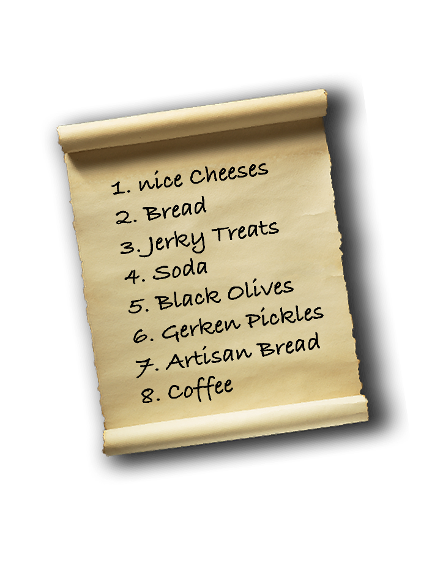

Another collection type we know about from daily life are dictionaries: we use one thing to "look up" a value. We "look up" the word "computer" in a real dictionary and we are "pointed to" a long String that tells us what the word means. Lookup tables, or dictionaries, in JavaScript, are called "Objects."



Learning to store and to work with the data held in data structures will be the focus of this section. In this lesson, we'll give you a broad, conceptual introduction to collection data types.

**Compare Collection Data Types to Scalar Data Types**

Strings and Numbers are scalar data types, they can be put on a scale. A collection type holds multiple pieces of data and allows us to talk about the collection as an *abstraction*. "The Beatles" is an *abstraction* used to refer to the individuals John, Paul, George, and Ringo. Because collection types can't be put on a scale, they ***are not*** called scalar data types.

**Define Array**

An Array is a collection that holds multiple pieces of data under a single name ("Countries", "Fast and the Furious Movies"). In daily life, we call them "lists."

**The Beatles**

| **Index** | **Data** |
| --- | --- |
| 0 | "John Lennon" |
| 1 | "Paul McCartney" |
| 2 | "Ringo Starr" |
| 3 | "George Harrison" |

or

**Groceries**

| **Index** | **Data** |
| --- | --- |
| 0 | "Parsnips" |
| 1 | "English Toffee" |
| 2 | "Milk" |
| 3 | "Sprouted Rye Bread" |

The individual *elements* that make up this collection (or list) name are identified by an *index*.

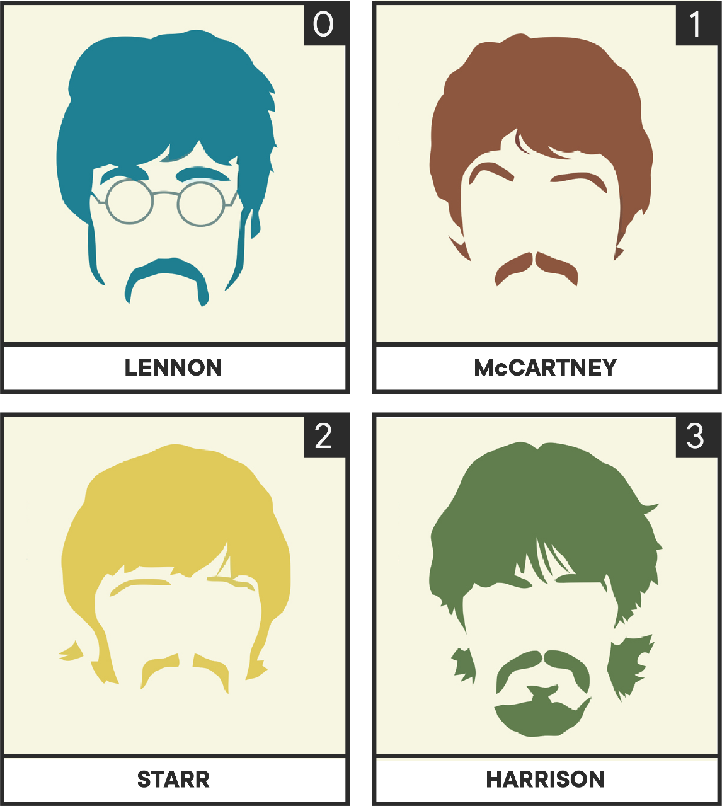

It might seem strange that we start our list at 0 instead of 1. Programmers like 0 and most programming languages start their index at 0. Otherwise, it's pretty much a list like you've been making most of your life.

To define this "list" in JavaScript we would type:

const theBeatles = [

"John Lennon",

"Paul McCartney",

"Ringo Starr",

"George Harrison",

];

You provide a name (theBeatles), an assignment operator (=) and then a list of data, separated by commas, that should go in the Array, wrapped in []. Each bit of information is often a scalar value, but it could also be another collection (more on that later).

**Define Array Element / Member**

The individual pieces of data inside an Array are called *elements*. Some people also call the *elements* the *members*. In a collection of theBeatles, the String "George Harrison" is an *element*.

**Define Array Index**

Arrays provide a number that identifies each *element* called an *index*. The index for the *element* "Ringo Starr" above is 2.

We'll cover adding, removing, retrieving, and deleting *elements* via their *index* in another lesson.

**Define Object**

Another way of thinking about Arrays is that they are like tables that have an identifier that is a Number. If we let the identifier be a String *instead* of an Number, then we'd basically be describing an Object.

What if we wanted to take our list of the Beatles and describe each member not by some Number *index*, but rather by the instrument they played in the band? As a table this might look like:

| **Instrument** | **Beatle** |
| --- | --- |
| "Rhythm Guitar" | "John Lennon" |
| "Bass" | "Paul McCartney" |
| "Drums" | "Ringo Starr" |
| "Lead Guitar" | "George Harrison" |

An Object is a collection data type that holds multiple pieces of data under a collected name whose members can be read and updated by using a *key* instead of an *index*. In daily conversation we use *keys* to retrieve *values* all the time: "Who was the guy who played **drums** in **The Beatles**?"

We can think of Objects like a table that looks like this:

| **Key** | **Value** |
| --- | --- |
| "liverpool" | "The Beatles" |
| "manchester" | "The Smiths" |
| "coventry" | "Delia Derbyshire and the BBC Radiophonic Band" |
| "london" | "Ziggy Stardust and the Spiders from Mars" |

To define this "table" in JavaScript we would type:

const englishBandsByCity = {

liverpool: "The Beatles",

manchester: "The Smiths",

coventry: "Delia Derbyshire and the BBC Radiophonic Band",

london: "Ziggy Stardust and the Spiders from Mars",

};

You provide a name (englishBandsByCity), an assignment operator (=) and then a list of pairs, separated by commas, that should go in the Object, wrapped in {}. Each pair should have a key, a colon (:), and a value. A value is often a scalar value, but it could be another collection; more on that later.

**Define Object Key**

Objects are like tables that have a name that is a piece of data, typically a Symbol or a String. This identifier is called a *key*.

**Define Object Value**

The value that's returned from asking an Object what a given *key* points to is known as the key's *value*.

We'll cover adding, removing, retrieving, and deleting *values* via their *key* in another lesson.

**Demonstrate Nesting of Collection Data Structures**

Now that you know about Arrays (grocery lists, band members, todo lists) and Objects (abbreviation to full name lookup, a stock symbol to trading value lookup, instrument to band member name lookup) you might be a bit unimpressed. "Surely the world's data needs are more complex than simple lists and lookup tables," you might exclaim.

You'd be right, but the amazing thing about collections is that they can contain *other* collections as part of a process called *nesting*. Can you imagine an Array of Objects? Or an Object of Arrays of Objects of Arrays? You can cover a staggeringly huge model of data with nesting of these two data types.

We want to provide a really complex example of Arrays and Objects working together. Most programming texts don't share this concept this early and it makes "nesting" sound scary and complex. We're going to give you a short demonstration here so that you can see why you want to have these complex data structures. The details on how to build them etc... will come in later lessons.

The *elements* in an *Array* and the *values* in an *Object* can be Objects or Arrays *themselves*. This leads to "nesting" such that you could build a complex data structure like the following:

const englishMusicByCity = {

manchester: [

{

bandName: "The Smiths",

memberNames: ["Morrissey", "Johnny", "Andy", "Mike"],

},

{

bandName: "Joy Division",

memberNames: ["Peter", "Stephen", "Bernard", "Ian"],

},

],

};

The *abstraction* englishMusicByCity hides the complexity in that piece of data.

As a peek ahead, we can use bracket notation ([]) to "dig into" this nested collection and get interesting information out:

englishMusicByCity["manchester"][0]["bandName"]; //=> "The Smiths"

englishMusicByCity["manchester"][0]["memberNames"]; //=> ["Morrissey", "Johnny", "Andy", "Mike"]

console.log(

`There were ${englishMusicByCity["manchester"][0]["memberNames"].length} members in ${englishMusicByCity["manchester"][0]["bandName"]}`

);

//=> "There were 4 members in The Smiths"

**Conclusion**

This has been a broad tour of JavaScript's collection data types, Object and Array. Individually, they are data structures that can hold list- and dictionary-like data. Amazingly, they can even *hold each other* — and that means we can make very complex data structures from them! We'll practice with these types in the following lessons!

**Arrays**

**Learning Goals**

* Identify data structures and Arrays
* Create Arrays
* Access the elements in an Array
* Learn about nested Arrays
* Introduce Array methods
* Understand mutability

**Introduction**

So far, we've been focusing on JavaScript's *primitive* data types — types that represent a single value — in particular, strings, Booleans, and numbers. But sometimes we need a way to store a *collection* of data. For this, we need data structures. In this and the next lesson, we will learn about a very useful data structure: Arrays.

Be sure to follow along with the examples in [repl.itLinks to an external site.](https://repl.it/languages/javascript" \t "_blank).

**Identify Data Structures and Arrays**

A *data structure* is a means for associating and organizing information. Outside of the programming world, we use data structures all the time. For example, we might have a shopping list of the items we need to buy on our next grocery run or an address book for organizing contact information.

If we have a lot of related data, it's best to represent it in a related system. Imagine that we're working on a lottery application that has to represent the winning lottery numbers. We could do that as follows:

const firstNumber = 32;

const secondNumber = 9;

const thirdNumber = 14;

const fourthNumber = 33;

const fifthNumber = 48;

const powerBall = 5;

We've represented all six pieces of data, but there's no way to refer to them as a group. Every single time we want to reference that combination of winning numbers, we need to remember and type out six different variable names:

const firstNumber = 32;

const secondNumber = 9;

const thirdNumber = 14;

const fourthNumber = 33;

const fifthNumber = 48;

const powerBall = 5;

function logWinningNumbers(first, second, third, fourth, fifth, power) {

console.log("Winning numbers:", first, second, third, fourth, fifth, power);

}

logWinningNumbers(

firstNumber,

secondNumber,

thirdNumber,

fourthNumber,

fifthNumber,

powerBall

);

// LOG: Winning numbers: 32 9 14 33 48 5

// => undefined

That's so much typing! There are much, much better ways to organize data in JavaScript. Let's learn about one of the most common: the *Array*.

**Create Arrays**

An Array is a list, with the items listed in a particular order, surrounded by square brackets ([]) and separated by commas:

["This", "is", "an", "array", "of", "strings."];

// => ["This", "is", "an", "array", "of", "strings."]

The *members* or *elements* in an Array can be data of any type in JavaScript:

["Hello, world!", 42, null, NaN];

// => ["Hello, world!", 42, null, NaN]

**NOTE**: In some other languages Arrays *cannot include elements of multiple types*. In C, C++, Java, Swift, and others you cannot mix types. JavaScript, Python, Ruby, Lisp, and others permit this.

Arrays are *ordered*, meaning that the elements in them will always appear in the same order. This also means that the Array [1, 2, 3] is different from the Array [3, 2, 1].

Just like any other type of JavaScript data, we can assign an Array to a variable:

const primeNumbers = [2, 3, 5, 7, 11, 13, 17, 19, 23, 29, 31, 37];

const tvShows = ["Game of Thrones", "Breaking Bad", "Veep", "Mad Men"];

We can find out how many elements an Array contains by checking the Array's built-in length property:

const myArray = ["This", "array", "has", 5, "elements"];

myArray.length;

// => 5

We defined the above Arrays using the *array literal* syntax — that is, we literally typed out the Array that we wanted to create, square brackets and all. There are other ways to create new Arrays, but they are only necessary for very rare circumstances. For now, use Array literals.

To get a sense of just how effective Arrays are at keeping data organized, let's rewrite our lottery code to use an Array:

const winningNumbers = [32, 9, 14, 33, 48, 5];

function logWinningNumbers(numbers) {

console.log("Winning numbers:", numbers);

}

logWinningNumbers(winningNumbers);

// LOG: Winning numbers: [32, 9, 14, 33, 48, 5]

// => undefined

The Array provides organization, and we only have to remember *one* identifier (winningNumbers) instead of six (firstNumber, secondNumber, and so on). We can also call Arrays *expressive* because putting all the winning numbers in a shared data structure communicates to other programmers "Hey, these things go together."

The one benefit of storing all six lottery numbers separately is that we had a really easy way to access each individual number. For example, we could just reference powerBall to grab the sixth number. Luckily, Arrays offer an equally simple syntax for accessing individual members.

**Using Bracket Notation**

Every element in an Array is assigned a unique index value that corresponds to its place within the collection, **starting at 0**. The first element in the Array is at index 0, the fifth element at index 4, and the 428th element at index 427. We can use **bracket notation** ([]) to access the element at a given index.

**Accessing an Element**

To access an element, we use bracket notation like this: nameOfArray[index].

const winningNumbers = [32, 9, 14, 33, 48, 5];

// => undefined

winningNumbers[0];

// => 32

winningNumbers[3];

// => 33

Let's take a minute to think about how we could access the **last** element in any Array.

If myArray contains 10 elements, the final element will be at myArray[9]. If myArray contains 15000 elements, the final element will be at myArray[14999]. So the index of the final element is always one less than the number of elements in the Array. If only we had an easy way to figure out how many elements are in the Array...

const alphabet = [

"a",

"b",

"c",

"d",

"e",

"f",

"g",

"h",

"i",

"j",

"k",

"l",

"m",

"n",

"o",

"p",

"q",

"r",

"s",

"t",

"u",

"v",

"w",

"x",

"y",

"z",

];

// => undefined

alphabet.length;

// => 26

alphabet[alphabet.length - 1];

// => "z"

We placed an expression (alphabet.length - 1) inside the square brackets, and the JavaScript engine *computed* the value of that expression to determine which element we were trying to access. In this case, alphabet.length - 1 evaluated to 25, so alphabet[alphabet.length - 1] became alphabet[25].

**Updating the Value of an Element**

We can also use bracket notation ([]) — along with the assignment operator (=) — to update the value of an element in the array. To do that, we access the element we want then reassign that element's value using =. Say we've defined an array, planets:

const planets = [

"Mercury",

"Venus",

"Earth",

"Mars",

"Juptier",

"Saturn",

"Uranus",

"Neptune",

];

//=> undefined

Looks like we've got a typo. Let's fix it:

planets[4] = "Jupiter";

//=> "Jupiter"

planets;

//=> ["Mercury", "Venus", "Earth", "Mars", "Jupiter", "Saturn", "Uranus", "Neptune"]

You might wonder why that worked, given that we declared planets using const. After all, declaring with const is supposed to prevent us from reassigning the value of the variable! This is an important thing to know about how const works with Arrays. We are not able to reassign the array *itself* but we **can** reassign any of its elements. We can also add or delete elements. JavaScript Objects work similarly when declared using const (which isn't surprising, given that Arrays are a special type of Object). The only thing const prevents us from doing is assigning a new value to the variable planets using the = operator:

planets = ["new", "array"];

//=> Uncaught TypeError: Assignment to constant variable.

**Nested Arrays**

We mentioned above that arrays can contain elements of **any** data type; this includes **other Arrays**:

const egregiouslyNestedArray = [

"How",

["deep", ["can", ["we", ["go", ["?"], "Pretty"], "dang"], "deep,"], "it"],

"seems.",

];

If you examine the array above, you'll see it contains three elements, the second of which is itself an array.

egregiouslyNestedArray[0];

//=> 'How'

egregiouslyNestedArray[1];

//=> [ 'deep', [ 'can', [ 'we', [Array], 'dang' ], 'deep,' ], 'it' ]

egregiouslyNestedArray[2];

//=> 'seems.'

So we know we can access the inner array using egregiouslyNestedArray[1], but how do we access the array nested inside *that* array? We simply add another set of brackets:

egregiouslyNestedArray[1][0];

//=> 'deep'

egregiouslyNestedArray[1][1];

//=> [ 'can', [ 'we', [ 'go', [Array], 'Pretty' ], 'dang' ], 'deep,' ]

egregiouslyNestedArray[1][2];

//=> 'it'

We can continue drilling down in this way, adding another set of brackets for each nested array, until we get to the innermost array:

egregiouslyNestedArray[1][1][1][1][1];

//=> ['?']

That innermost array contains only one element, so how would we access that?

egregiouslyNestedArray[1][1][1][1][1][0];

//=> '?'

While it's great that Arrays allow us to store other Arrays inside them, this is a terrible way to represent a deeply nested data structure. In general, it is best to keep your Arrays to *no more than two levels deep*. Two levels is perfect for representing two-dimensional things, like a tic-tac-toe board:

const board = [

["X", "O", " "],

[" ", "X", "O"],

["X", " ", "O"],

];

board;

// => [["X", "O", " "], [" ", "X", "O"], ["X", " ", "O"]]

The cool thing about representing a game board like that is in how we can access the different squares by specifying coordinates. The first [] operator grabs the **row** that we want, top (board[0]), middle (board[1]), or bottom (board[2]). For example:

board[1];

// => [" ", "X", "O"]

The second [] operator specifies the column, or the square within that row: left (board[1][0]), middle (board[1][1]), or right (board[1][2]). For example:

board[0][0];

// => "X"

board[0][2];

// => " "

board[2][2];

// => "O"

Effectively, we're using X and Y coordinates to refer to data within a two- dimensional structure.

**Array Methods**

JavaScript includes a number of built-in Array *methods*, functions that *belong to* (i.e., can only be called on) Arrays. These methods allow us to manipulate arrays in various ways, for example, to add an element to the beginning or end of an Array.

We have seen methods already in this course. In an earlier lesson, for example, we learned how to use a String method, toUpperCase(), to get the uppercase version of a String:

const string = "Hello";

string.toUpperCase();

//=> "HELLO"

As shown above, we call String methods *on* a string using dot notation. Array methods work in the same way. Some of them will take one or more arguments — for example, the element we want to add to the array. The arguments are passed in the parentheses after the method name.

We will learn about these Array methods in the next lesson. Before we get to that, however, we need to introduce one more concept.

**Mutability**

Some methods update or *mutate* the object they are called on; these methods are referred to as *destructive*. Other methods, known as *nondestructive* methods, leave the object intact. For example, the String method toUpperCase() is *nondestructive*:

const string = "Hello";

string.toUpperCase();

//=> "HELLO"

string;

//=> "Hello"

The toUpperCase() method returns the uppercased version of string, it does not *change* its value to uppercase.

Sometimes we want to mutate the original object but, in general, it's good practice to avoid mutating a program's state whenever possible. Otherwise, we won't always know what we're dealing with. You will learn more about immutability and why it's important later in the course. But, in the meantime, it's important to know which JavaScript methods are destructive and which are nondestructive so you can choose the appropriate method for what you need to accomplish.

**Conclusion**

In this lesson, we learned about JavaScript Arrays, including how to create them, access their elements, and change the value of elements. We also learned that arrays can contain elements of any data type, including other Arrays; we refer to these as *nested* arrays. Finally, we talked a little bit about the concept of mutability. Armed with this knowledge, we are now ready to tackle JavaScript Array methods.

**Resources**

* [MDN: Array referenceLinks to an external site.](https://developer.mozilla.org/en-US/docs/Web/JavaScript/Reference/Global_Objects/Array)

[Previous](https://moringa.instructure.com/courses/318/modules/items/59216)[Next](https://moringa.instructure.com/courses/318/modules/items/59218)

# Array Methods

## Learning Goals

* Add elements to an Array
* Remove elements from an Array
* Replace elements in an Array

## Introduction

In the last lesson, we learned about JavaScript Arrays, including how to create them and access their elements. In this lab, we will dive into JavaScript's Array methods, which enable us to add, remove, and change elements.

We discussed the fact that it's important to pay attention to whether the method is destructive (i.e., it mutates the array) or nondestructive. Another factor to pay attention to is what the return value of each of these methods is. Be sure to follow along and experiment with each method in [repl.itLinks to an external site.](https://repl.it/languages/javascript" \t "_blank) until you understand how it works, what it does to the original array, and what it returns.

## Add Elements to an Array

We'll start with the JavaScript methods we can use to add elements to an array: .push() and .unshift(), which are destructive methods, and the spread operator, which is nondestructive.

### .push() and .unshift()

These two methods work in the same way:

* They take one or more arguments (the element or elements you want to add)
* They return the length of the modified array
* They are destructive methods

The difference is that the .push() method adds elements to the end of an Array and .unshift() adds them to the beginning of the array:

const superheroes = ["Catwoman", "She-Hulk", "Jessica Jones"];

superheroes.push("Wonder Woman");

// => 4

superheroes;

// => ["Catwoman", "She-Hulk", "Jessica Jones", "Wonder Woman"]

const cities = ["New York", "San Francisco"];

cities.unshift("Boston", "Chicago");

// => 4

cities;

// => ["Boston", "Chicago", "New York", "San Francisco"]

Before moving on, try out the examples above as well as some examples of your own in the REPL.

### Spread Operator

The spread operator, which looks like an ellipsis: ..., allows us to "spread out" the elements of an existing Array into a new Array, creating a copy:

const coolCities = ["New York", "San Francisco"];

const copyOfCoolCities = [...coolCities];

copyOfCoolCities;

//=> ["New York", "San Francisco"]

**Note about copying arrays in Javascript** You might wonder why we would do this rather than just copyOfCoolCities = coolCities. The answer is that coolCities points to a location in memory and when you use the assignment operator to create a copy, you create a second variable that points to the same location. What this means is that, if you change copyOfCoolCities, coolCities is changed as well (and vice versa).

**A Second note about copying arrays in JavaScript** Copying arrays in JavaScript is complicated! Some methods of copying create deep copies and some create shallow copies. Using the spread operator to copy an array creates a shallow copy. What this means is that, if you use it to copy a nested array, the inner array (or arrays) still points to the same location in memory as in the original array. So if you modify the inner array in the copy, it changes the inner array in the original array as well (and vice versa). Don't worry too much about shallow and deep copies at this point: just know that you can safely use the spread operator to clone non-nested arrays.

Note that, because the spread operator is an operator rather than a method, it works differently than push() and unshift(): in the example above, we're constructing an Array using literal notation (i.e., typing the square brackets) and populating it by using the spread operator on the Array we want to copy.

Where the spread operator comes in especially handy is when we want to add one or more new elements either before or after the elements in the original array (or both) without mutating the original array. To add an element to the front of the new array, we simply type in the new element before spreading the elements in the original array:

const coolCities = ["New York", "San Francisco"];

const allCities = ["Los Angeles", ...coolCities];

coolCities;

// => ["New York", "San Francisco"]

allCities;

// => ["Los Angeles", "New York", "San Francisco"]

And, as you might expect, to add a new item to the end of an Array, we type in the new element after spreading the elements in the original array:

const coolCats = ["Hobbes", "Felix", "Tom"];

const allCats = [...coolCats, "Garfield"];

coolCats;

// => ["Hobbes", "Felix", "Tom"]

allCats;

// => ["Hobbes", "Felix", "Tom", "Garfield"]

Note that, in both cases, we created a new Array instead of modifying the original one — our coolCities and coolCats Arrays were untouched. Because we didn't modify the original array, in order to save the results of our work we had to assign it to a variable.

Be sure to experiment with the spread operator in [repl.itLinks to an external site.](https://repl.it/languages/javascript" \t "_blank) until you're comfortable with how it works — it will come in handy later!

## Remove Elements from an Array

As complements for .push() and .unshift(), respectively, we have .pop() and .shift().

### .pop() and .shift()

As with .push() and .unshift(), these two methods work in the same way:

* they don't take any arguments
* they remove a single element
* they return the element that is removed
* they are destructive methods

The .pop() method removes the last element in an Array:

const days = ["Mon", "Tue", "Wed", "Thu", "Fri", "Sat", "Sun"];

days.pop();

// => "Sun"

days;

// => ["Mon", "Tue", "Wed", "Thu", "Fri", "Sat"]

The .shift() method removes the first element in an Array:

const days = ["Mon", "Tue", "Wed", "Thu", "Fri", "Sat", "Sun"];

days.shift();

// => "Mon"

days;

// => [Tue", "Wed", "Thu", "Fri", "Sat", "Sun"]

Notice above that both methods returned the removed element and mutated the original array.

### .slice()

To remove elements from an Array nondestructively (without mutating the original Array), we can use the .slice() method. Just as the name implies, .slice() returns a portion, or **slice**, of an Array. The method takes 0, 1, or 2 arguments and returns a new array containing the sliced elements.

#### With No Arguments

If we don't provide any arguments, .slice() will return a copy of the original Array with all elements intact:

const primes = [2, 3, 5, 7];

const copyOfPrimes = primes.slice();

primes;

// => [2, 3, 5, 7]

copyOfPrimes;

// => [2, 3, 5, 7]

Note that creating a copy using .slice() works the same way as if you use the spread operator: they both create a shallow copy, and with both the copy points to a different object in memory than the original. If you add an element to one of the arrays, it does **not** get added to the others:

const primes = [2, 3, 5, 7];

const copyOfPrimesUsingSlice = primes.slice();

const copyOfPrimesUsingSpreadOperator = [...primes];

primes.push(11);

// => 5

primes;

// => [2, 3, 5, 7, 11]

copyOfPrimesUsingSlice;

// => [2, 3, 5, 7]

copyOfPrimesUsingSpreadOperator;

// => [2, 3, 5, 7]

#### With Arguments

We can also provide one or two arguments to .slice(): the first is the index where the slice should begin and the second is the index **before which** it should end:

const days = ["Mon", "Tue", "Wed", "Thu", "Fri", "Sat", "Sun"];

days.slice(2, 5);

// => ["Wed", "Thu", "Fri"]

If no second argument is provided, the slice will run from the index specified by the first argument to the end of the Array:

const days = ["Mon", "Tue", "Wed", "Thu", "Fri", "Sat", "Sun"];

days.slice(5);

// => ["Sat", "Sun"]

To return a new Array with the first element removed, we call .slice(1):

const days = ["Mon", "Tue", "Wed", "Thu", "Fri", "Sat", "Sun"];

days.slice(1);

// => ["Tue", "Wed", "Thu", "Fri", "Sat", "Sun"]

And we can return an array with the last element removed in a way that will look familiar from the previous lesson:

const days = ["Mon", "Tue", "Wed", "Thu", "Fri", "Sat", "Sun"];

days.slice(0, days.length - 1);

// => ["Mon", "Tue", "Wed", "Thu", "Fri", "Sat"]

However, .slice() provides an easier syntax for referencing the last element (or elements) in an Array:

const days = ["Mon", "Tue", "Wed", "Thu", "Fri", "Sat", "Sun"];

days.slice(-1);

// => ["Sun"]

days.slice(-3);

// => ["Fri", "Sat", "Sun"]

days.slice(0, -1);

// => ["Mon", "Tue", "Wed", "Thu", "Fri", "Sat"]

When we provide a negative index, the JavaScript engine knows to start counting from the last element in the Array instead of the first.

### .splice()

Unlike .slice(), which is nondestructive, .splice() performs destructive actions. Depending on how many arguments we give it, .splice() allows us to remove elements, add elements, or replace elements (or any combination of the three).

#### With a Single Argument

array.splice(start);

The first argument expected by .splice() is the index at which to begin the splice. If we only provide the one argument, .splice() will destructively remove a chunk of the original Array beginning at the provided index and continuing to the end of the Array:

const days = ["Mon", "Tue", "Wed", "Thu", "Fri", "Sat", "Sun"];

days.splice(2);

// => ["Wed", "Thu", "Fri", "Sat", "Sun"]

days;

// => ["Mon", "Tue"]

Notice that .splice() **both** mutated the original array (by removing a chunk) **and** returned a new array containing the removed chunk.

We can use a negative 'start' index with splice(), the same as with slice():

const days = ["Mon", "Tue", "Wed", "Thu", "Fri", "Sat", "Sun"];

// => ["Mon", "Tue", "Wed", "Thu", "Fri", "Sat", "Sun"]

days.splice(-2);

// => ["Sat", "Sun"]

days;

// => ["Mon", "Tue", "Wed", "Thu", "Fri"]

#### With Two Arguments

array.splice(start, deleteCount);

When we provide two arguments to .splice(), the first is still the index at which to begin splicing, and the second dictates how many elements we want to remove from the Array. For example, to remove 3 elements, starting with the element at index 2:

const days = ["Mon", "Tue", "Wed", "Thu", "Fri", "Sat", "Sun"];

// => ["Mon", "Tue", "Wed", "Thu", "Fri", "Sat", "Sun"]

days.splice(2, 3);

// => ["Wed", "Thu", "Fri"]

days;

// => ["Mon", "Tue", "Sat", "Sun"]

Here again, we see that splice() removed elements from the original array, mutating that array, and returned the removed elements in a new array.

## Replace Elements in an Array

### .splice() with 3+ arguments

array.splice(start, deleteCount, item1, item2, ...)

After the first two, every additional argument passed to .splice() will be inserted into the Array at the position indicated by the first argument. We can replace a single element in an Array as follows, discarding a card and drawing a new one:

const cards = [

"Ace of Spades",

"Jack of Clubs",

"Nine of Clubs",

"Nine of Diamonds",

"Three of Hearts",

];

cards.splice(2, 1, "Ace of Clubs");

// => ["Nine of Clubs"]

cards;

// => ["Ace of Spades", "Jack of Clubs", "Ace of Clubs", "Nine of Diamonds", "Three of Hearts"]

We have deleted "Nine of Clubs" and inserted "Ace of Clubs" in place, effectively replacing the original card.

Or we can remove two elements and insert three new ones as our restaurant expands its vegetarian options:

const menu = [

"Jalapeno Poppers",

"Cheeseburger",

"Fish and Chips",

"French Fries",

"Onion Rings",

];

menu.splice(1, 2, "Veggie Burger", "House Salad", "Teriyaki Tofu");

// => ["Cheeseburger", "Fish and Chips"]

menu;

// => ["Jalapeno Poppers", "Veggie Burger", "House Salad", "Teriyaki Tofu", "French Fries", "Onion Rings"]

We aren't required to remove anything with .splice() — we can use it to insert any number of elements anywhere within an Array by passing 0 as the second argument. Here we're adding new books to our library in alphabetical order:

const books = ["Bleak House", "David Copperfield", "Our Mutual Friend"];

books.splice(2, 0, "Great Expectations", "Oliver Twist");

// => []

books;

// => ["Bleak House", "David Copperfield", "Great Expectations", "Oliver Twist", "Our Mutual Friend"]

Notice that .splice() returns an empty Array when we provide a second argument of 0. This makes sense because the return value is the set of elements that were removed, and we're telling it to remove 0 elements.

Keep playing around with .splice() in the REPL to get comfortable with it.

### Using Bracket Notation to Replace Elements

Recall from the previous lesson that we can also use bracket notation to replace a single element in an Array. If we only need to replace one element, this is a simpler approach:

const cards = [

"Ace of Spades",

"Jack of Clubs",

"Nine of Clubs",

"Nine of Diamonds",

"Three of Hearts",

];

cards[2] = "Ace of Clubs";

// => "Ace of Clubs"

cards;

// => ["Ace of Spades", "Jack of Clubs", "Ace of Clubs", "Nine of Diamonds", "Three of Hearts"]

Both this approach and splice() are destructive — they modify the original Array. There's a nondestructive way to replace or add items at arbitrary points within an Array; to do it we need to combine the slice() method and the spread operator.

### Slicing and Spreading

Combining .slice() and the spread operator allows us to replace elements nondestructively, leaving the original Array unharmed:

const menu = [

"Jalapeno Poppers",

"Cheeseburger",

"Fish and Chips",

"French Fries",

"Onion Rings",

];

const newMenu = [

...menu.slice(0, 1),

"Veggie Burger",

"House Salad",

"Teriyaki Tofu",

...menu.slice(3),

];

menu;

// => ["Jalapeno Poppers", "Cheeseburger", "Fish and Chips", "French Fries", "Onion Rings"]

newMenu;

// => ["Jalapeno Poppers", "Veggie Burger", "House Salad", "Teriyaki Tofu", "French Fries", "Onion Rings"]

Let's unpack this a little bit. We're assigning an array to newMenu using literal notation. Inside the brackets, we are spreading the result of calling slice on menu with the arguments 0 and 1, then typing in three new elements, then spreading the result of calling slice on menu with the argument 3. Here, we are taking advantage of the fact that the slice() method **returns a new array**. We can spread the elements in **that** array just as we can with any other array.

Play around with this in the REPL until it makes sense; break it down into its component parts and try each piece on its own. It's the trickiest thing that we've encountered in this lesson, so don't sweat it if it takes a little while to sink in!

## Conclusion

In this lesson, we've learned a variety of methods we can use to remove, add, and replace the elements in Arrays. We've learned that some methods are destructive and some are nondestructive. With this knowledge, you have the tools you need to manipulate Arrays in very complex ways.

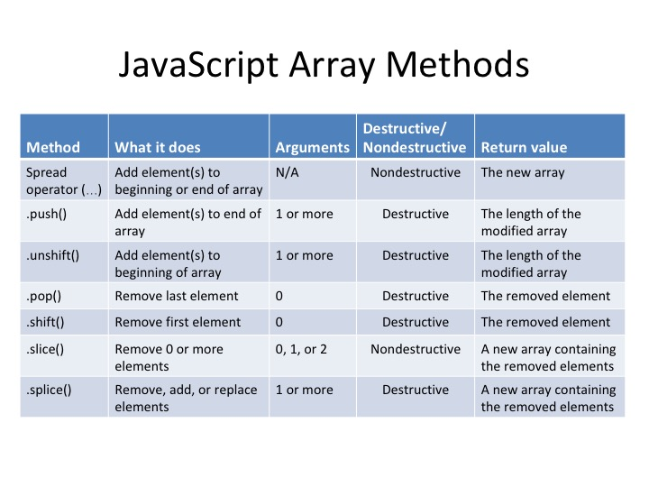

## Resources

* MDN
  + [ArrayLinks to an external site.](https://developer.mozilla.org/en-US/docs/Web/JavaScript/Reference/Global_Objects/Array)
  + [.slice()Links to an external site.](https://developer.mozilla.org/en-US/docs/Web/JavaScript/Reference/Global_Objects/Array/slice)
  + [.splice()Links to an external site.](https://developer.mozilla.org/en-US/docs/Web/JavaScript/Reference/Global_Objects/Array/splice)

[Previous](https://moringa.instructure.com/courses/318/modules/items/59217)[Next](https://moringa.instructure.com/courses/318/modules/items/59219)

Arrays Lab

* **Due** No Due Date

* **Points** 1

* **Submitting** a website url

**Learning Goals**

* Practice writing arrays
* Practice using *destructive* methods to manipulate arrays
* Practice using *nondestructive* methods to manipulate arrays

**Introduction**

We've learned about how arrays work and about the array methods built in to JavaScript that we can use to manipulate them. Now it's time to practice what we've learned.

If you haven't already, fork and clone this lab into your local environment. Navigate into its directory in the terminal, then run code . to open the files in Visual Studio Code. Finally, run npm install to install the lab's dependencies.

**Instructions**

Open up the test folder and take a look at indexTest.js. Note that some of the names of the functions you will be writing begin with destructively and some don't. This is a clue as to which Array method you will need to use for each function.

Note also that the first test asks for an array called cats, set to an initial value of ["Milo", "Otis", "Garfield"]. In your functions, you will be accessing and manipulating this array.

Near the top of indexTest.js you will see the following:

beforeEach(function () {

cats.length = 0;

cats.push("Milo", "Otis", "Garfield");

});

What this code does is *reset* the array to its original contents before each test is run. The reason we need to do this is because some of your functions will be *destructive* — they will change the original cats array. This is a problem because it means the input to the remaining functions will be dependent on the outcome of other functions. It also means that the expected return value of a function might change if the tests are run in a different order. This makes it more difficult both to write tests in the first place and to figure out how to get the tests to pass. Resetting the array returns us to a blank slate between tests.

This is also a good illustration of why it's generally good practice to avoid mutating a program's state whenever possible. If we use only *nondestructive* methods, we have complete control over what's going into and coming out of the function. This makes our programs more robust, easier to maintain, and less prone to bugs.

Remember the workflow:

1. Run the tests using npm test.
2. Read the errors; vocalize what they're asking you to do.
3. Write code; repeat steps 1 and 2 often until a test passes.
4. Repeat as needed for the remaining tests.

**Saving Your Work Remotely**

Currently, the work you've done on this assignment is only on your local machine. To preserve your solution on your GitHub fork, you will need to stage the changes you've made, commit them, and push the commit up to GitHub. Use the following commands to do this:

$ git add .

$ git commit -m "Completed assignment"

$ git push

If you visit your fork on GitHub, you should now see that *you've* made the most recent commit, and your code will be present in the files.

[Previous](https://moringa.instructure.com/courses/318/modules/items/59218)[Next](https://moringa.instructure.com/courses/318/modules/items/59220)

**Debugging in Node**

**Learning Goals**

* Use the Node.js debugger

**Introduction**

While console.log() is a valuable debugging tool, it only gets us so far. When we start running JavaScript code in the browser, we will have access to the browser's debugger. The debugger allows you to set [breakpointsLinks to an external site.](https://en.wikipedia.org/wiki/Breakpoint" \t "_blank) in your code that will stop the execution of the code at that point. You can then inspect the values of your variables at that point in your code.

We will start running JavaScript in the browser a bit later in the course. In the meantime, Node.js (which is the *runtime environment* that enables us to run our JavaScript outside the browser) includes a similar debugging tool. In this lesson, we will walk through how to use the [Node.js debuggerLinks to an external site.](https://nodejs.org/api/debugger.html).

Fork and clone this lesson into your local environment. To do this, click the GitHub "octocat" button at the top of the page to open the lesson's GitHub repo, then click "Fork." Once you've cloned it down to your machine, navigate into the lesson's directory in the terminal, then run code . to open the files in Visual Studio Code. There are no tests so you do not need to run npm install.

**The Node.js Debugger**

Open index.js and take a look. You will see we have created a simple while loop that console.log()s a message. Run node index.js to see it in action.

Using the debugger is a simple matter of adding the debugger keyword at the point in our code where we want to place a breakpoint (i.e., where we want to pause execution). Modify the code in index.js as follows:

let count = 1;

while (count < 5) {

debugger;

if (count === 1) {

console.log(`This loop has executed ${count} time.`);

} else {

console.log(`This loop has executed ${count} times.`);

}

count += 1;

}

To start the debugger, run node inspect index.js. You should see this in your terminal:

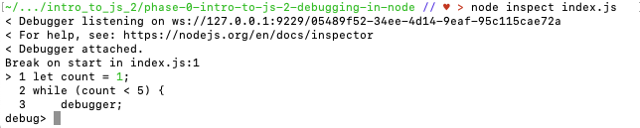

Next, enter cont at the debug prompt to start executing the code. You will see a > pointing to line 3, indicating that the execution of the code has been stopped at that point:

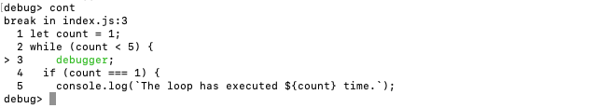

Now say we want to check the value of our count variable. To do that, we need to enter the debugger's REPL by running repl. You will now have a > prompt in place of the debug> prompt. Type in count to see the current value of the variable:

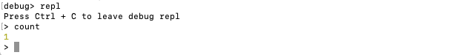

Then to continue executing the code, we first need to exit the REPL by typing Ctrl-C, then run cont at the debug prompt:

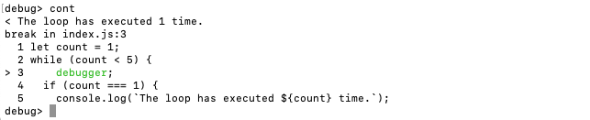

Note that our logged message shows at the top of the screenshot above. When we ran cont, the execution of the code resumed so the console.log() was run, the count variable was incremented, and the execution continued to the next loop. If you enter the REPL and check the value of count, you will see that it's now equal to 2.

But what if we wanted to check the value of count both before *and* after the incrementation? We can simply add a second breakpoint:

let count = 1;

while (count < 5) {

debugger;

if (count === 1) {

console.log(`This loop has executed ${count} time.`);

} else {

console.log(`This loop has executed ${count} times.`);

}

count += 1;

debugger;

}

In order for the debugger to recognize the change to our code, we'll need to exit and restart it. If you're in the REPL, type ctrl-C to exit that, then type .exit at the debug prompt or ctrl-C twice to exit the debugger. Finally, run node inspect index.js to relaunch the debugger.

Now if you run cont, the code will begin executing and will pause at the first breakpoint. To continue executing the code and advance to the second breakpoint, simply enter cont again. At any point, you can enter the debugger's REPL to check the value of count, then exit the REPL and continue execution of the code.

**Conclusion**

In this lesson we've learned about using the debugger built in to Node.js. To review, the process is as follows:

* Place one or more breakpoints in your code using the debugger keyword
* Run node inspect <filename> in the terminal to launch the debugger
* Run cont at the debug prompt to start execution of the code and advance to the first breakpoint
* Run repl at the debug prompt to enter the debugger's REPL
* Check the value of any variables by entering the variable name at the > prompt
* Exit the REPL using ctrl-C
* Continue stepping through the code using cont
* Run .exit or type ctrl-C twice to exit the debugger

Debugging tools will get more and more useful to you as you progress through the curriculum and your programs get more complex. The time you spend now getting comfortable with debugging will pay off in the long run.

We will get more practice using the debugger in an upcoming lesson.

**Resources**

* [W3schools - JavaScript DebuggingLinks to an external site.](https://www.w3schools.com/js/js_debugging.asp)
* [Difference between Node.js and JavascriptLinks to an external site.](https://www.geeksforgeeks.org/difference-between-node-js-and-javascript/)

[Previous](https://moringa.instructure.com/courses/318/modules/items/59219)[Next](https://moringa.instructure.com/courses/318/modules/items/59221)

**Errors and Stack Traces**

**Learning Goals**

* Recognize common JavaScript errors.
* Read a stack trace to discern where an error originated.

**Introduction**

No one writes perfect code the first time. Or the second time. Or the third time.



We all make mistakes. One of the biggest advantages an experienced programmer has is knowing how to quickly troubleshoot and fix errors they encounter. You **will** reach this point — it's just a matter of practice. To get started, let's look at some of the common types of error messages you'll encounter when writing JavaScript code.

**Uncaught ReferenceError: \_\_\_\_\_ is not defined**

This is one of the simplest and most common errors, and it's pretty explicitly telling us what went wrong. We tried to reference a variable or function that doesn't exist in the current scope. For example:

myVar;

// ERROR: Uncaught ReferenceError: myVar is not defined

It can also arise if you forget to put quotation marks around a string:

Hello, world;

// ERROR: Uncaught ReferenceError: Hello is not defined

('Hello, world');

// => "Hello, world"

If you meant to declare the variable in the current scope and simply forgot, declaring the variable should solve the issue:

const myVar = 'Hello, world!';

myVar;

// => "Hello, world!"

**Uncaught TypeError: \_\_\_\_\_ is not a function**

This one usually indicates that you tried to invoke something that isn't actually a function. For example:

const myVar = 'Hello, world!';

myVar();

// ERROR: Uncaught TypeError: myVar is not a function

A common variant of this error that you'll run into later in the course is Uncaught TypeError: undefined is not a function. The JavaScript engine is telling us that we tried to invoke undefined, which is obviously not invocable. This happens when we've tried to store a function in a variable but the variable is undefined for some reason.

**Aside:** Wait? We can store functions in variables? Yes we can! In JavaScript, functions are objects, which means we can do anything with them that we can do with any other object: assign it properties, store it in a variable, pass it as an argument, etc.

**Uncaught SyntaxError: missing ) after argument list**

When you see this error, it means you tried to invoke a function but forgot the closing parenthesis:

console.log('Hello,', 'world!';

// ERROR: Uncaught SyntaxError: missing ) after argument list

function myAdder (num1, num2) {

return num1 + num2;

}

myAdder(10, 4;

// ERROR: Uncaught SyntaxError: missing ) after argument list

**Uncaught TypeError: Assignment to constant variable.**

You're probably familiar with this one by now — it means we accidentally tried to assign a new value to a variable declared with the const keyword, which prevents reassignment. However, sometimes you rightfully feel that you didn't try to reassign anything, and it boils down to a small typo:

const snackSelection = 'Pretzels';

if ((snackSelection = 'Pretzels')) {

console.log("That'll be $1, please!");

}

// ERROR: Uncaught TypeError: Assignment to constant variable.

In this case, we accidentally used the *assignment operator*, a single = sign, instead of a comparison operator, such as the *strict equality operator* (===).

This is just a selection of some of the many types of errors you might encounter while writing JavaScript code. The main point is to use the information you're given. The JavaScript engine isn't trying to trick you — on the contrary, it's trying to **help** you debug.

**Stack traces**

One of the really neat pieces of information provided with the error messages is what's called a *stack trace*. Let's take a look at an example. Fork and clone this lesson into your local environment. Navigate into its directory in the terminal, then run code . to open the files in Visual Studio Code. Finally, execute the code in errors.js by running node errors.js. You should see something like this:

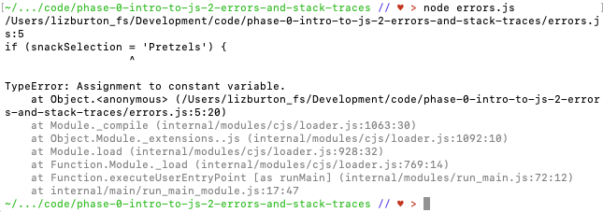

Whoa — there's a lot going on there! Let's break it down a bit.

Near the top, you'll see JavaScript showing us the exact piece of code that's throwing the error. It's even pointing to the exact character it thinks is the problem! (Warning: JavaScript isn't always right.) Below that is the error itself: TypeError: Assignment to constant variable.. Hopefully you recognize what's causing the error and how to fix it.

Under the identification of the error is the stack trace. For this example, most of the information we're seeing in the stack trace is related to what's going on under the hood in Node.js and, therefore, isn't especially helpful for debugging (we'll look at a more helpful example shortly). But let's look at a couple of things before we move on.

First, you'll see at Object.<anonymous> followed by the file path for the errors.js file. The at Object.<anonymous> is under-the-hood info: basically, it means that an object is being created by Node when our code runs and that object is not assigned a name. But the file path does contain some helpful information. Notice that it ends with errors.js:5:20. Those numbers at the end are telling us that JavaScript thinks the error is on line 5 of our file, at character 20.

Let's go ahead and fix our error and run node errors.js again. Now you should see something like this:

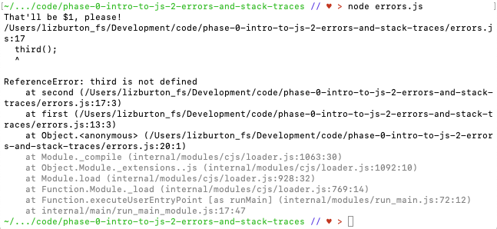

Looks like we're making some progress! First you'll see the message that was logged by the if statement, so we know it's now working. This is followed by the information about the current error: the code that's throwing the error and the error itself. The next three lines give us the stack trace. Note that it's identifying three lines of code: 17, 13, and 20. Let's take a look at those lines:

function first() {

second(); // Line 13

}

function second() {

third(); // Line 17

}

first(); // Line 20

Now that we're dealing with a series of function invocations, we can really see the power of the stack trace: it traces the error up through the stack of function calls that led to it. Let's read it backwards and reconstruct the events that led to the error:

1. The JavaScript engine reaches line 20 and invokes first().
2. Inside first(): the engine reaches line 13 and invokes second().
3. Inside second(): the engine reaches line 17 and sees the identifier third.
4. The engine can't find a declared variable or function with that name so it throws an error inside second().

To fix the third is not defined error, let's first try declaring third as the simplest thing we know, a variable:

function first() {

second();

}

function second() {

third();

}

const third = 'Declaring a new variable.';

first();

Remember what we learned earlier in the section on common JavaScript errors. If our understanding is correct, this should fix the third is not defined error and, in its place, throw a new error. Can you guess what the new error will be?

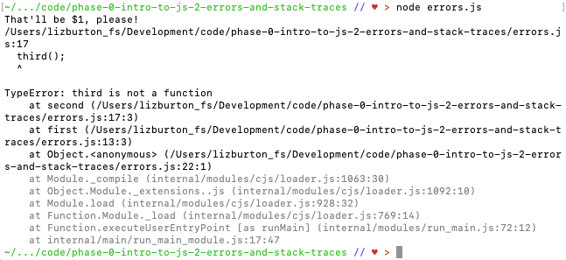

Did you correctly deduce what the new error would be?

The new error is telling us that third is not a function. It may have been pretty easy to figure out that our initial solution would just result in another error, but intentionally breaking your code and seeing whether it breaks in the exact way you predicted is a great technique for improving your debugging and general JavaScript skills. The more you understand the errors and their causes, the easier debugging will become.

We'll fix this by declaring third() as a function instead of a simple variable:

function first() {

second();

}

function second() {

third();

}

function third() {

console.log("Now I'm a function!");

}

first();

When we save the file and run the code again, all of the errors should be gone and we should see our two messages logged to the terminal.

**Conclusion**

Arguably the biggest difference between being a novice and an expert developer is how comfortable you feel with reading and debugging error messages. JavaScript — and, indeed, every programming language — is designed **by** programmers **for** programmers. The language doesn't intentionally make things more difficult for you. On the contrary, every time you write code that results in some sort of error, JavaScript goes out of its way to provide you with the information you need to find and fix the error. When you see one of those error messages pop up, don't freak out! It's the JavaScript engine starting a friendly dialog with you: "Hey, I tried to do what you asked of me, but I ran into a problem. Here's where the problem occurred, and here's what happened."

As you become more comfortable diagnosing and solving error messages, you'll become a faster, better programmer, and writing JavaScript code will become more and more enjoyable!

**Resources**

* [MDN — ErrorsLinks to an external site.](https://developer.mozilla.org/en-US/docs/Web/JavaScript/Reference/Errors)
  + [Uncaught ReferenceError: \_\_\_\_\_ is not definedLinks to an external site.](https://developer.mozilla.org/en-US/docs/Web/JavaScript/Reference/Errors/Not_defined)
  + [Uncaught TypeError: \_\_\_\_\_ is not a functionLinks to an external site.](https://developer.mozilla.org/en-US/docs/Web/JavaScript/Reference/Errors/Not_a_function)
  + [Uncaught SyntaxError: missing ) after argument listLinks to an external site.](https://developer.mozilla.org/en-US/docs/Web/JavaScript/Reference/Errors/Missing_parenthesis_after_argument_list)
  + [Uncaught TypeError: Assignment to constant variable.Links to an external site.](https://developer.mozilla.org/en-US/docs/Web/JavaScript/Reference/Errors/Invalid_const_assignment)

# Looping Lab

* **Due** No Due Date

* **Points** 1

* **Submitting** a website url

## Learning Goals

* Build a for loop.
* Build a while loop.
* Explain the purpose of a loop.
* Understand when to use each type of loop.

## Introduction

In an earlier lesson, we learned about repetition statements — statements that allow us to break out of the default sequence and repeat a section of code multiple times. We also learned about two of JavaScript's repetition constructs: the while loop and the do...while loop. In this lesson we will learn about a third: the for loop.

Let's say we have a bunch of gifts to wrap. They all happen to be the same size and shape, so for every gift, we need to cut a similarly sized piece of wrapping paper, fold it up over the edges of the gift, tape it together, and add a nice little card. Then we set the wrapped gift aside and move on to the next gift.

In programming terms, we can think of our **collection** of gifts as an **Array** and the act of wrapping them as a function. For example:

const gifts = ["teddy bear", "drone", "doll"];

function wrapGift(gift) {

console.log(`Wrapped ${gift} and added a bow!`);

}

We could then call wrapGift() on each gift individually:

wrapGift(gifts[0]);

wrapGift(gifts[1]);

wrapGift(gifts[2]);

However, this isn't very efficient or extensible. It's a lot of repetitive code to write out, and if we had more gifts we'd have to write a whole new line for each.

This is where loops come in handy! With a loop, we can just write the repeated action **once** and perform the action on **every item in the collection**.

This is a code-along, so follow along with the instructions in each section. There are tests to make sure you're coding your solutions correctly. If you haven't already, fork and clone this lab into your local environment. Navigate into its directory in the terminal, then run code . to open the files in Visual Studio Code. Finally, run npm install to install the lab's dependencies.

## The for loop

Of the loops in JavaScript, the for loop is the most common. The for loop is made up of four statements in the following structure:

for ([initialization]; [condition]; [iteration]) {

[loop body]

}

* Initialization
  + Typically used to initialize a **counter** variable.
* Condition
  + An expression evaluated before each pass through the loop. If this expression evaluates to true, the statements in the loop body are executed. If the expression evaluates to false, the loop exits.
* Iteration
  + An expression executed at the end of each iteration. Typically, this will involve incrementing or decrementing a counter, bringing the loop ever closer to completion.
* Loop body
  + Code that runs on each pass through the loop.

**Usage**: Use a for loop when you know how many times you want the loop to run (for example, when you're looping through elements in an array).

#### Examples

Let's take a look at an example and get some practice using the Node debugger. Enter the code below into the index.js file.

**Note:** You can, of course, copy/paste the code rather than typing it in yourself, but we recommend typing it in for now. The act of typing code develops muscle memory and helps your brain understand and internalize the syntax.

for (let age = 30; age < 40; age++) {

console.log(`I'm ${age} years old. Happy birthday to me!`);

debugger;

}

In the above code, let age = 30 is the **initialization**: we're creating a variable, age, that we'll use in the next three phases of the loop. Notice that we use let instead of const because we need to increment the value of age.

The **condition** for the above loop is age < 40, or, in other words, "Run the code in the loop body until age is NOT less than 40." As long as the condition evaluates to true, the code in the loop body is executed, the value of age is incremented, and the condition is reevaluated. As soon as the condition evaluates to false, the loop ends.

The **iteration** is age++, which increments the value of age by 1 after every pass through the loop. We initialized age as 30, and it retains that value during the first pass through the loop. At the end of the first pass, we increment age to 31, check whether the condition still holds true, and, since it does, run the loop body again with age as 31. After that second loop, we increment age to 32, and so on.

The **loop body** is the set of statements that we want to run when the condition evaluates to true.

Let's take a look at what's happening in our loop using debugger. Run node inspect index.js in the terminal to start the debugger. You should see the following:

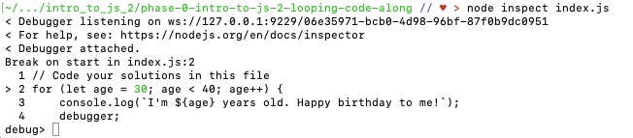

Now run cont at the debug prompt to start executing the loop and advance to the breakpoint. It should look like this:

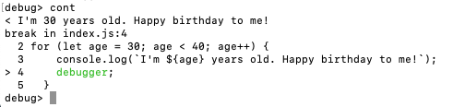

Note, in the first line, that the message has been logged and that age is equal to 30. To verify that, enter repl at the debug prompt to open the REPL, then enter age. You should see 30 output. Now type Ctrl-C to exit the repl, and enter cont at the debug prompt to advance to the next iteration of the loop. You should see the following:

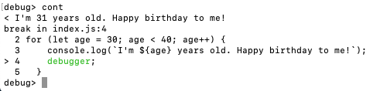

Note that the logged output now shows that age is 31. You can continue to step through the iterations by running cont at the debug prompt. At any point you can verify the value of age by entering the REPL and typing age at the prompt, then exit the REPL to continue stepping through. When you're done, enter .exit or Ctrl-C twice to exit the debugger.

Now let's remove debugger; from our code and execute it by running node index.js. You should see the following:

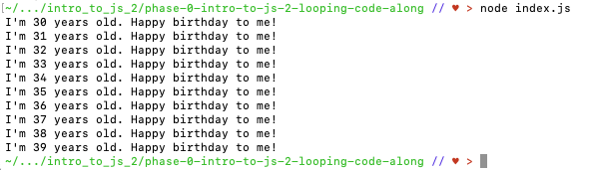

### Using for with Arrays

The for loop is often used to iterate over every element in an array. Let's rewrite our gift-wrapping action above as a for loop. Enter the following code into index.js:

const gifts = ["teddy bear", "drone", "doll"];

function wrapGifts(gifts) {

for (let i = 0; i < gifts.length; i++) {

console.log(`Wrapped ${gifts[i]} and added a bow!`);

debugger;

}

return gifts;

}

wrapGifts(gifts);

We started our counter, i, at 0 because arrays have zero-based indexes. Our condition states that we should run the code in the loop body while i is less than gifts.length (3 in the above example). Our iteration, i++, increments our counter by 1 at the end of each pass through the loop.

Run node inspect index.js in the terminal to enter the debugger, and cont at the debug prompt to advance to the breakpoint. You should see Wrapped teddy bear and added a bow! logged. In our loop body, we reference gifts[i]. Since i starts out as 0, during the first pass through the loop gifts[i] is gifts[0], which is 'teddy bear'. Continue stepping through the loop by entering cont at thedebug prompt and remember you can enter the REPL at any point to check the values of our variables, i and gifts[i].

When you're done, remove the debugger and execute the code by running node index.js. You should see the following logged to the terminal:

Wrapped teddy bear and added a bow!

Wrapped drone and added a bow!

Wrapped doll and added a bow!

### Assignment

In the previous section, the wrapGifts() function allowed us to take any array of gifts and loop over them, logging our own message. Let's practice that with a slightly different idea. To complement our gift wrapping function, your task is to create a thank you card creator.

**Note**: Recall the difference between logging and returning values from a function. When we log information we are simply outputting text to a terminal or console. When we return data from a function we will be able to reference and use that information elsewhere because the data is being passed out of the function.

In index.js, build a function named writeCards() that accepts two arguments: an array of string names, and an event name. Create a for loop with a counter that starts at 0 and increments at the end of each loop. The for loop should stop once it has iterated over the length of the array.

As with our previous wrapGifts() function, you will create a custom message for each name inside the loop. Unlike that example, however, instead of simply logging the messages to the console, you will collect them in a new array and **return** this array at the end of the function. (Refer back to the Array Methods lesson if you need a refresher on how we can add an element to an array.) The overall process should be:

1. create a new, empty array to hold the messages;
2. iterate through the input array and, inside the loop, build out the 'thank you' message for each name using string interpolation, then add that message to the new array you created;
3. after the loop finishes and all of the messages have been added to the new array, return the new array.

Here is an example of what a call to the writeCards() function might look like:

writeCards(["Ada", "Brendan", "Ali"], "birthday");

If we were to call the function using this function call, it should produce the following array as the return value:

[

"Thank you, Ada, for the wonderful birthday gift!",

"Thank you, Brendan, for the wonderful birthday gift!",

"Thank you, Ali, for the wonderful birthday gift!",

];

**Top Tip**: The debugger isn't just for debugging code — you can also use it to help you write your function! Try building the structure of the loop, putting the debugger inside the loop body. Even before you start writing the code, you can enter the debugger's REPL and try out code until you figure out how to create the message and add it to an array. Once it's working in the REPL, transfer the code to index.js, exit the debugger, and run the tests.

## The while loop

Recall from the earlier lesson that the while loop is similar to a for loop, repeating an action in a loop based on a condition. Both will continue to loop until that condition evaluates to false. Unlike for, while only requires condition and loop statements:

while ([condition]) {

[loop body]

}

The initialization and iteration statements of the for loop have not disappeared, though. In fact, we could rewrite our original for loop gift wrapping example using a while loop and achieve the exact same result:

const gifts = ["teddy bear", "drone", "doll"];

function wrapGifts(gifts) {

let i = 0; // the initialization moves OUTSIDE the body of the loop!

while (i < gifts.length) {

console.log(`Wrapped ${gifts[i]} and added a bow!`);

i++; // the iteration moves INSIDE the body of the loop!

}

return gifts;

}

wrapGifts(gifts);

// LOG: Wrapped teddy bear and added a bow!

// LOG: Wrapped drone and added a bow!

// LOG: Wrapped doll and added a bow!

// => ["teddy bear", "drone", "doll"]

Notice that we've just moved the initialization and iteration statements — declaring the i variable outside the loop, and incrementing it inside the loop.

**CAUTION**: When using while loops, it is easy to forget to involve iteration. Leaving iteration out can result in a condition that always evaluates to true, causing an infinite loop!

Using a while loop enables us to check conditions that aren't based on a counter. Take a look at the following *[pseudocodeLinks to an external site.](https://en.wikipedia.org/wiki/Pseudocode" \t "_blank)* for an example of how we could use while in a program for planting a garden:

function plantGarden() {

let keepWorking = true;

while (keepWorking) {

chooseSeedLocation();

plantSeed();

waterSeed();

keepWorking = checkForMoreSeeds();

}

}

We can imagine that while we have seeds, we take the same steps over and over: choose a location for a seed; plant it; water it. Then, check if there are more seeds. If not, do not keep working.

## When to Use for and while

JavaScript, like many programming languages, provides a variety of looping options. Loops like for and while are actually just slight variations of the same process. By providing a variety, we as programmers have a larger vocabulary to work with.

Often, you will see while loops simply being used as an alternative to for loops:

let countup = 0;

while (countup < 10) {

console.log(countup++);

}

This is perfectly fine as an alternative way to describe:

for (let countup = 0; countup < 10; countup++) {

console.log(countup);

}

If you're feeling a bit lost about when to use a for vs. a while loop, take a deep breath. Most of the time, a regular for loop will suffice. It's by far the most common looping construct in JavaScript. A general heuristic for choosing which loop to use is to first try a for loop. If that doesn't serve your purposes, then go ahead and try a while loop. Also, remember that you can always refer to the [documentation on these loopsLinks to an external site.](https://developer.mozilla.org/en-US/docs/Web/JavaScript/Guide/Loops_and_iteration) at any time.

Just don't forget: with while, make sure you are updating the condition on each loop so that the loop eventually terminates!

## Assignment

To get more acquainted with while, your task is to write a function, countDown, that takes in any positive integer and, starting from that number, counts down to zero using console.log(). Note that this means that running countDown(10); would actually log 11 times:

10

9

8

7

6

5

4

3

2

1

0

## Saving Your Work Remotely

Currently, the work you've done on this assignment is only on your local machine. To preserve your solution on your GitHub fork, you will need to stage the changes you've made, commit them, and push the commit up to GitHub. Use the following commands to do this:

$ git add .

$ git commit -m "Completed assignment"

$ git push

If you visit your fork on GitHub, you should now see that you've made the most recent commit, and your code will be present in the files.

## Conclusion

After some time programming in JavaScript, writing a for loop will come as naturally to you as wrapping one gift after another. Just as you slowly become comfortable using different words and vocabulary to better express yourself, you will become more acquainted with concepts like for and while until you are able to discern the nuanced differences in usage between them.

## Resources

* Codecademy
  + [for loopLinks to an external site.](http://www.codecademy.com/glossary/javascript/loops#for-loops)
  + [while loopLinks to an external site.](http://www.codecademy.com/glossary/javascript/loops#while-loops)
* MDN
  + [for loopLinks to an external site.](https://developer.mozilla.org/en-US/docs/Web/JavaScript/Reference/Statements/for)
  + [while loopLinks to an external site.](https://developer.mozilla.org/en-US/docs/Web/JavaScript/Reference/Statements/while)
  + [Loops and iterationLinks to an external site.](https://developer.mozilla.org/en-US/docs/Web/JavaScript/Guide/Loops_and_iteration)

[Previous](https://moringa.instructure.com/courses/318/modules/items/59221)[Next](https://moringa.instructure.com/courses/318/modules/items/59223)

# Objects

## Learning Goals

* Identify JavaScript Objects
* Access a value stored in an Object
* Learn about JavaScript's Object methods

## Introduction

While Arrays are great for representing simple, ordered data sets, they're generally not so great at modeling a more complex structure. For that, we need Objects. In this lesson, we'll begin to learn about Objects, specifically, what they are, how to create them, and how to access values stored in them. In the next lesson, we'll learn how to modify Objects, both destructively and nondestructively.

Be sure to follow along with the examples in this lesson in [repl.itLinks to an external site.](https://repl.it/languages/javascript" \t "_blank).

**ASIDE**: You may have heard about or be familiar with the concept of object-oriented programming. Un-helpfully JavaScript called this thing with curly braces ({}) an Object, but it is not related to object orientation. There was initially no thought that JavaScript would ever need to accommodate object-oriented programming but as it grew in popularity, the ability to use object orientation was added to the language. A JavaScript Object, however, is a data structure consisting of keys and values, similar to Ruby's Hash, Python's Dictionary or C-like languages' struct(ure). It is important not to confuse the two.

## Identify JavaScript Objects

Let's think about how we could represent a company's address in JavaScript. Addresses are made up of words and numbers, so at first it might make sense to store the address as a string:

const address = "11 Broadway, 2nd Floor, New York, NY 10004";

That looks decent enough, but what happens if the company moves to a different floor in the same building? We just need to modify one piece of the address, but with a string we'd have to involve some pretty complicated find-and-replace pattern matching or replace the entire thing. Instead, let's throw the different pieces of the address into an Array:

const address = ["11 Broadway", "2nd Floor", "New York", "NY", "10004"];

Now, we can just grab the small piece that we want to update and leave the rest as is:

address[1] = "3rd Floor";

address;

//=> ["11 Broadway", "3rd Floor", "New York", "NY", "10004"]

This seems like a better solution, but it still has its drawbacks. Namely, address[1] is a **terrible** way to refer to the second line of an address. What if there is no second line, e.g., ['11 Broadway', 'New York', 'NY', '10004']? Then address[1] will contain the city name instead of the floor number.

We could standardize it, putting an empty string in address[1] if there's no second line in the address, but it's still poorly named. address[1] offers very little insight into what data we should expect to find in there. It's a part of an address, sure, but which part?

To get around this, we could store the individual pieces of the address in separate, appropriately-named variables:

const street1 = "11 Broadway";

const street2 = "2nd Floor";

const city = "New York";

const state = "NY";

const zipCode = "10004";

That's solved one issue but reintroduced the same problem we tackled in the lesson on Arrays: storing pieces of related data in a bunch of unrelated variables is not a great idea! If only there were a best-of-both-worlds solution — a way to store all of our address information in a single data structure while also maintaining a descriptive naming scheme. The data structure we're after here is the ***Object***.

### What Is an Object?

Like Arrays, JavaScript Objects are collections of data. They consist of a list of properties (key-value pairs) bounded by curly braces ({ }). The properties can point to values of any data type — even other Objects.

We can have empty Objects:

const obj = {};

Or Objects with a single property:

const obj = { key: value };

When we have to represent multiple properties in the same Object (which is most of the time), we use commas to separate them:

const obj = {

key1: value1,

key2: value2,

};

We can also have nested Objects, in which the values associated with one or more of the keys is another Object:

const obj = {

key1: value1,

key2: {

innerKey1: innerValue1,

innerKey2: innerValue2,

},

};

There is no limit to how deeply nested our Objects can be.

For a real example, let's define our address as an Object:

const address = {

street: {

line1: "11 Broadway",

line2: "2nd Floor",

},

city: "New York",

state: "NY",

zipCode: "10004",

};

Here we're defining address using Object literal syntax: literally typing out the Object inside the {}. Our address Object has four keys: street, city, state, and zipCode. The first key points to another Object which itself has two keys: line1 and line2. Note that there's a comma between each key-value pair in both the top-level Object and the nested Object. Practice creating an object in the REPL; then try leaving out a comma to see what happens.

Multiple properties can have the same value:

const meals = {

breakfast: "Avocado toast",

lunch: "Avocado toast",

dinner: "Avocado toast",

};

meals.breakfast;

// => "Avocado toast"

meals.dinner;

// => "Avocado toast"

But keys must be unique. If the same key is used for multiple properties, only the final value will be retained. The rest will be overwritten:

const meals = {

breakfast: "Avocado toast",

breakfast: "Oatmeal",

breakfast: "Scrambled eggs",

};

meals;

// => { breakfast: "Scrambled eggs" }

The real data in an Object is stored in the value half of the key-value pairings. The key is what lets us access that value. In the same way we use identifiers to name variables and functions, inside an Object we assign each value a key. We can then refer to that key and the JavaScript engine knows exactly which value we're trying to access.

## Access a Value Stored in an Object

We access an Object stored in a variable in the same way we access any variable's value: by typing the variable name. Then, to access one of the values inside our Object, we add a reference to the key associated with the value we want; we can do that using either dot notation or bracket notation.

### Dot Notation

With dot notation, we use the member access operator (a single period) to access values in an Object. For example, we can grab the individual pieces of our address, above, as follows:

address.street;

//=> { line1: "11 Broadway", line2: "2nd Floor" }

address.city;

//=> "New York"

address.state;

//=> "NY"

address.zipCode;

//=> "10004"

Then to access a value inside address.street, we simply append the inner key, again using dot notation:

address.street.line1;

//=> "11 Broadway"

address.street.line2;

//=> "2nd Floor"

**Note**: You might initially think we should use address.line1 to access the value associated with the line1 key, but address and address.street are separate Objects. address.street is the identifier for the nested Object — the one that contains the line1 key — and we can use dot notation on that just the same as on the top-level Object, address. Experiment in the REPL to make sure you understand how it works.

Dot notation is fantastic for readability, as we can just reference the bare key name (e.g., street or zipCode). Because of this simple syntax, it should be your go-to strategy for accessing the properties of an Object.

**NOTE**: Most people just call it dot notation or the dot operator, so don't worry too much about remembering the term member access operator.

#### Accessing Nonexistent Properties

If we try to access the country property of our address Object, what will happen?

address.country;

//=> undefined

It returns undefined because there is no matching key on the Object. JavaScript is too nice to throw an error, so it lets us down gently. Keep one thing in mind, though: if you're seeing undefined when trying to access an Object's properties, you should recheck which properties exist on the Object (along with your spelling and capitalization)!

### Bracket Notation

With bracket notation, we use the computed member access operator, which, recall from the lesson on Arrays, is a pair of square brackets ([]). To access the same properties as above, we need to represent them as strings inside the operator:

address["street"];

//=> { line1: "11 Broadway", line2: "2nd Floor" }

address["street"]["line1"];

//=> "11 Broadway"

address["street"]["line2"];

//=> "2nd Floor"

address["city"];

//=> "New York"

address["state"];

//=> "NY"

address["zipCode"];

//=> "10004"

Bracket notation is a bit harder to read than dot notation, so we always default to the latter. However, there are two main situations in which we need to use bracket notation.

#### Nonstandard Keys

If (for whatever reason) you need to use a nonstandard string as the key in an Object, you'll only be able to access the properties with bracket notation. For example, this is a valid Object:

const wildKeys = {

"Cash rules everything around me.": "Wu",

"C.R.E.A.M.": "Tang",

"Get the money.": "For",

"$ $ bill, y'all!": "Ever",

};

It's impossible to access those properties with dot notation:

wildKeys.'Cash rules everything around me.';

// ERROR: Uncaught SyntaxError: Unexpected string

But bracket notation works just fine:

wildKeys["$ $ bill, y'all!"];

//=> "Ever"

In order to access a property via dot notation, **the key must follow the same naming rules applied to variables and functions**. It's also important to note that under the hood **all keys are strings**. Don't waste too much time worrying whether a key is accessible via dot notation. If you follow these rules when naming your keys, everything will work out:

* camelCaseEverything
* Start the key with a lowercase letter
* No spaces or punctuation

If you follow those three rules, you'll be able to access all of an Object's properties via bracket notation **or** dot notation.

**Top Tip**: Always name your Object's keys according to the above three rules. Keeping everything standardized is good, and being able to access properties via dot notation makes the code much more readable.

#### Accessing Properties Dynamically

The other situation in which bracket notation is required is if we want to dynamically access properties (i.e., using variables rather than literal identifiers). The reason we need to enclose the key inside quotes when we use the literal key is because, when we **don't** use the quotes, JavaScript will interpret what's inside the brackets as a variable.

From the lesson on Arrays, remember why we call it the computed member access operator: we can place any expression inside the brackets and JavaScript will compute its value to figure out which property to access. For example, we can access the zipCode property from our address Object like so:

address["zip" + "Code"];

//=> "10004"

Pretty neat, but the real strength of bracket notation is its ability to compute the value of variables on the fly. For example:

const meals = {

breakfast: "Oatmeal",

lunch: "Caesar salad",

dinner: "Chimichangas",

};

let mealName = "lunch";

meals[mealName];

//=> "Caesar salad"

By placing mealName in the square brackets, we're telling the JavaScript engine it needs to interpret the value inside those brackets. It evaluates mealName, resolves it to 'lunch', and returns "Caesar salad". Note that we didn't enclose the key in quotes: the keys themselves are strings, but mealName is a variable containing a string. If we try to use the mealName variable with dot notation instead, it doesn't work:

mealName = "dinner";

//=> "dinner"

meals.mealName;

//=> undefined

With dot notation, JavaScript doesn't treat mealName as a variable — instead it checks whether a property exists with the literal key mealName, only finds properties named breakfast, lunch, and dinner, and so returns undefined. Essentially, dot notation is for when you know the exact name of the property in advance, and bracket notation is for when you need to compute it when the program runs.

The need for bracket notation doesn't stop at dynamically accessing properties on an already-created Object. We can also use bracket notation to dynamically set properties during the creation of a new *Object*. For example:

const morningMeal = "breakfast";

const middayMeal = "lunch";

const eveningMeal = "dinner";

const meals = {

[morningMeal]: "French toast",

[middayMeal]: "Personal pizza",

[eveningMeal]: "Fish and chips",

};

meals;

//=> { breakfast: "French toast", lunch: "Personal pizza", dinner: "Fish and chips" }

Once again, by wrapping the variable names in square brackets, we're letting JavaScript know that it needs to interpret the contents. Let's try doing the same thing without the square brackets:

const morningMeal = "breakfast";

const middayMeal = "lunch";

const eveningMeal = "dinner";

const meals = {

morningMeal: "French toast",

middayMeal: "Personal pizza",

eveningMeal: "Fish and chips",

};

meals;

//=> { morningMeal: "French toast", middayMeal: "Personal pizza", eveningMeal: "Fish and chips" }

Without the square brackets, JavaScript treated each key as a literal identifier instead of a variable. Bracket notation — the computed member access operator — once again shows its powers of computation!

Bracket notation will really come in handy when we start iterating over Objects and programmatically accessing and assigning properties.

## JavaScript's Object Methods

JavaScript includes a number of built-in [static Object methodsLinks to an external site.](https://developer.mozilla.org/en-US/docs/Web/JavaScript/Reference/Classes/static) (static means that these methods are called on the Object class itself, rather than on an instance of an Object). We will talk briefly about a couple of them here and go into detail about one more in the next lesson.

### Object.keys()

We can get a list of the top-level keys in an Object by using the [Object.keys()Links to an external site.](https://developer.mozilla.org/en-US/docs/Web/JavaScript/Reference/Global_Objects/Object/keys" \t "_blank) static method. We do that by calling Object.keys() and passing the Object instance as an argument. The return value is an Array containing all of the keys at the top level of the Object instance.

const wednesdayMenu = {

cheesePlate: {

soft: "Brie",

semiSoft: "Fontina",

hard: "Provolone",

},

fries: "Sweet potato",

salad: "Southwestern",

};

Object.keys(wednesdayMenu);

//=> ["cheesePlate", "fries", "salad"]

Notice that it didn't pick up the keys in the nested cheesePlate Object — just the keys from the properties declared at the top level within wednesdayMenu. How do you think we could use Object.keys() to get a list of the keys inside the nested Object? Try it out in the REPL.

**NOTE**: The sequence in which keys are ordered in the returned Array is not consistent across browsers and should not be relied upon. All of the Object's keys will be in the Array, but you can't count on keyA always being at index 0 of the Array and keyB always being at index 1.

### Object.values()

The [Object.values()Links to an external site.](https://developer.mozilla.org/en-US/docs/Web/JavaScript/Reference/Global_Objects/Object/values" \t "_blank) static method behaves similarly to Object.keys() but, as you might expect, returns an array containing values rather than keys. Try this out in the REPL as well.

## Conclusion

In this lesson, we identified what an Object is and how it gives us a better way to keep track of more complicated sets of related data. We also learned how to access values stored in an Object using dot notation and bracket notation, as well as when to use each. In the next lesson, we'll learn how to modify Objects. We'll also explore the relationship between Objects and Arrays.

Creating and interacting with Objects is an important skill in JavaScript programming. Before moving on, be sure to use [repl.itLinks to an external site.](https://repl.it/languages/javascript" \t "_blank) to practice creating Objects (including nested Objects) and accessing properties.

## Resources

* MDN
  + [Object basicsLinks to an external site.](https://developer.mozilla.org/en-US/docs/Learn/JavaScript/Objects/Basics)

[Previous](https://moringa.instructure.com/courses/318/modules/items/59222)[Next](https://moringa.instructure.com/courses/318/modules/items/59224)

**Object Iteration**

**Learning Goals**

* Explain the difference between looping and iteration.
* Iterate over arrays with the for...of statement.
* Enumerate an object's properties with the for...in statement.

**Introduction**

When we create a for loop to loop over an array, we base the loop's condition off of the .length of the array. This works, but it's a lot of syntactic cruft to remember:

for (let i = 0; i < array.length; i++) {

// Loop body

}

The problem is that we're using a *looping* construct to perform *iteration*.

**Looping vs. Iteration**

There's a pretty fine line separating the concepts of *looping* and *iteration*, and only the truly pedantic will call you out if you use one in place of the other.

Looping is the process of executing a set of statements **repeatedly until a condition is met**. It's great for when we want to do something a specific number of times (for loop) or unlimited times until the condition is met (while or do while loop).

Iteration is the process of executing a set of statements **once for each element in a collection**. We can accomplish this with a for loop:

let myArray = ['a', 'b', 'c', 'd', 'e', 'f', 'g'];

for (let i = 0; i < myArray.length; i++) {

console.log(myArray[i]);

}

or with a while loop:

let myArray = ['a', 'b', 'c', 'd', 'e', 'f', 'g'];

let j = 0;

while (j < myArray.length) {

console.log(myArray[j++]);

}

but neither is very pretty. The for...of statement gives us a better way.

**for...of**

Using for...of, the code above becomes:

const myArray = ['a', 'b', 'c', 'd', 'e', 'f', 'g'];

for (const element of myArray) {

console.log(element);

}

Using a construct that is specifically meant for iteration results in much cleaner code: there's no initialization of a counter, no condition, no incrementing the counter, and no bracket notation to access elements in the array (myArray[i]).

**const vs. let**

As you might've noticed, for...of allows us to use const instead of let. In for and while statements, let is required because we are incrementing a counter variable. The incrementing process involves taking the counter's current value, adding 1 to it, and then assigning that new value to the variable. That reassignment precludes us from using our beloved const, which cannot be reassigned.

Delightfully, the for...of statement involves no such reassignment. On each trip into the loop body (which is a *block* — note the curly braces), we assign the next element in the collection to a **new** element variable. Upon reaching the end of the block, the block-scoped variable vanishes, and we return to the top. Then we repeat the process, assigning the next element in the collection to a **new** element variable.

**Iterating over... strings?**

A string is effectively an ordered collection (like an array) of characters, which for...of is more than happy to iterate over:

for (const char of 'Hello, world!') {

console.log(char);

}

// LOG: H

// LOG: e

// LOG: l

// LOG: l

// LOG: o

// LOG: ,

// LOG:

// LOG: w

// LOG: o

// LOG: r

// LOG: l

// LOG: d

// LOG: !

**Usage**

Use a for...of statement anytime you want to iterate over an array.

**Iterating over objects**

The for...in statement is similar to for...of; it's generally used for iterating over the properties in an object. The statement follows this syntax:

for (const [KEY] in [OBJECT]) {

// Code in the statement body

}

The for...in statement iterates over the properties in an object, but it doesn't pass the entire property into the block. Instead, it only passes in the *keys*:

const address = {

street1: '11 Broadway',

street2: '2nd Floor',

city: 'New York',

state: 'NY',

zipCode: '10004',

};

for (const key in address) {

console.log(key);

}

// LOG: street1

// LOG: street2

// LOG: city

// LOG: state

// LOG: zipCode

Accessing the object's values is as simple as combining the passed-in key with the *bracket operator*:

const address = {

street1: '11 Broadway',

street2: '2nd Floor',

city: 'New York',

state: 'NY',

zipCode: "10004"

};

for (const key in address) {

console.log(address[key]);

}

// LOG: 11 Broadway

// LOG: 2nd Floor

// LOG: New York

// LOG: NY

// LOG: 10004

**But... but I want to use the dot operator!**

Can you think of why the bracket operator is required? Let's see what happens when we use the *dot operator*:

const address = {

street1: '11 Broadway',

street2: '2nd Floor',

city: 'New York',

state: 'NY',

zipCode: '10004'

};

for (const key in address) {

console.log(address.key);

}

// LOG: undefined

// LOG: undefined

// LOG: undefined

// LOG: undefined

// LOG: undefined

The for...in statement iterates over the five properties in address, successively passing in the object's keys. However, inside the statement body we're trying to access address.key. If you recall from the lesson on objects, variables don't work with the dot operator because it treats the variable name as a literal key — that is, address.key is trying to access the property on address with a key of key. Since there is no key property in address, it returns undefined. To prove this, let's add a key property to address:

address.key = "Let's have a 'key' key!";

for (const key in address) {

console.log(address.key);

}

// LOG: Let's have a 'key' key!

// LOG: Let's have a 'key' key!

// LOG: Let's have a 'key' key!

// LOG: Let's have a 'key' key!

// LOG: Let's have a 'key' key!

// LOG: Let's have a 'key' key!

**Usage**

Use a for...in statement whenever you want to enumerate the properties of an object.

**for...in and order**

Because **arrays are objects**, for...in *will work* with arrays. In fact, because for...of was added to JavaScript later than for...in, you might see older code that uses for...in to iterate over arrays. However, as a general rule, **don't use for...in with arrays**. When iterating over an array, an **ordered** collection, we would expect the elements in the array to be dealt with **in order**. However, because of how for...in works under the hood, there's no guarantee of order. From the [MDN documentationLinks to an external site.](https://developer.mozilla.org/en-US/docs/Web/JavaScript/Reference/Statements/for...in):

A for...in loop iterates over the properties of an object in an **arbitrary order** ... one cannot depend on the seeming orderliness of iteration, at least in a cross-browser setting.

What this means is that, with for...in, different browsers might iterate over the same object's properties in different orders. That's not cool! Cross-browser consistency is very important. A lot of progress has been made towards standardizing the behavior of for...in across all major browsers, but there's still no reason to use for...in with arrays when we have the wonderfully consistent for...of tailor-made for the job.

**Resources**

* [MDN — for...ofLinks to an external site.](https://developer.mozilla.org/en-US/docs/Web/JavaScript/Reference/Statements/for...of)
* [MDN — for...inLinks to an external site.](https://developer.mozilla.org/en-US/docs/Web/JavaScript/Reference/Statements/for...in)

[Previous](https://moringa.instructure.com/courses/318/modules/items/59223)[Next](https://moringa.instructure.com/courses/318/modules/items/59225)

**Modifying Objects**

**Learning Goals**

* Add an Object property using dot or bracket notation
* Modify a property using dot or bracket notation
* Update an Object nondestructively using the spread operator
* Remove a property from an Object
* Identify the relationship between Arrays and Objects

**Introduction**

In the previous lesson, we learned the basics of creating Objects and accessing their properties. In this lesson we'll learn how to modify and remove properties, both destructively and nondestructively. Finally, we'll explore the relationship between Arrays and Objects.

As always, don't forget to follow along in [repl.itLinks to an external site.](https://repl.it/languages/javascript" \t "_blank).

**Add an Object Property Using Dot or Bracket Notation**

We know how to initialize a variable by declaring it and assigning it a value using the assignment operator:

const city = "New York";

The process of creating a property inside an existing object is similar; we specify the key and assign it a value:

const circle = {}; // Create `circle` and set it to an empty Object

circle;

//=> {}

circle.radius = 5; // Create the key inside `circle` and set its value to 5

circle;

//=> { radius: 5 }

We can do this using either dot or bracket notation, and we can use any expression as the value:

const circle = {};

circle.radius = 5;

circle["diameter"] = 10;

circle.circumference = circle.diameter \* Math.PI;

//=> 31.41592653589793

circle["area"] = Math.PI \* circle.radius \*\* 2;

//=> 78.53981633974483

circle;

//=> { radius: 5, diameter: 10, circumference: 31.41592653589793, area: 78.53981633974483 }

**A Side Note**: Recall from the lesson on Arrays that we can add, modify or delete elements even if we use const to initialize the Array. The same thing applies here: we can add, modify or delete properties, but we can't reassign the variable itself.

**Top Tip**: Note that the process above gives us an alternative to typing out our Object using literal syntax: we can initialize an empty object and then use dot notation or bracket notation to create the properties programmatically. This approach is less error-prone than using literal syntax since JavaScript creates the correct Object syntax for us. Try it out in the REPL.

**Modify a Property Using Dot or Bracket Notation**

We can update or overwrite existing properties simply by assigning a new value to an existing key:

const mondayMenu = {

cheesePlate: {

soft: "Chèvre",

semiSoft: "Gruyère",

hard: "Manchego",

},

fries: "Curly",

salad: "Cobb",

};

mondayMenu.fries = "Sweet potato";

mondayMenu;

//=> { cheesePlate: { soft: "Chèvre", semiSoft: "Gruyère", hard: "Manchego" }, fries: "Sweet potato", salad: "Cobb" }

Note that modifying an Object's properties in the way we did above is *destructive*. This means that we're making changes directly to the original Object.

Let's take a look at an example. We'll start by creating a function to encapsulate this modification process:

function destructivelyUpdateObject(obj, key, value) {

obj[key] = value; //Why are we using bracket notation here?

return obj;

}

Our function takes three arguments: the original menu Object, the key identifying the property we want to update, and the value we want to change its value to.

At our restaurant, we've finished serving for the day. It's time to update our mondayMenu to the tuesdayMenu:

const mondayMenu = {

cheesePlate: {

soft: "Chèvre",

semiSoft: "Gruyère",

hard: "Manchego",

},

fries: "Sweet potato",

salad: "Cobb",

};

const tuesdayMenu = destructivelyUpdateObject(mondayMenu, "salad", "Caesar");

tuesdayMenu;

//=> { cheesePlate: { soft: "Chèvre", semiSoft: "Gruyère", hard: "Manchego" }, fries: "Sweet potato", salad: "Caesar" }

tuesdayMenu.salad;

//=> "Caesar"

Looks like our tuesdayMenu came out perfectly. But what about mondayMenu?

mondayMenu.salad;

//=> "Caesar"

Dang! We don't serve Caesar salad on Mondays. Instead of destructively updating the original menu, is there a way to nondestructively merge the change(s) into a new Object, leaving the original intact?

**Update an Object Nondestructively Using the Spread Operator**

Let's create a new method; it will take the same three arguments as the previous method:

function nondestructivelyUpdateObject(obj, key, value) {

// Code to return new, updated menu object

}

Recall from the lessons on Arrays that we can use the [**spread operator**Links to an external site.](https://developer.mozilla.org/en-US/docs/Web/JavaScript/Reference/Operators/Spread_syntax#spread_in_object_literals) to copy all the elements of an existing array into a new array. We can do the same thing with Objects. Let's use the spread operator to copy all of the old menu Object's properties into a new Object:

function nondestructivelyUpdateObject(obj, key, value) {

const newObj = { ...obj };

// Code to return new, updated menu object goes here

}

This will create a clone of the original object and save it into a new variable. We can then update the newly-created newObj with the desired change and return that updated menu, leaving the original menu Object unchanged:

function nondestructivelyUpdateObject(obj, key, value) {

const newObj = { ...obj };

newObj[key] = value;

return newObj;

}

const sundayMenu = nondestructivelyUpdateObject(

tuesdayMenu,

"fries",

"Shoestring"

);

tuesdayMenu.fries;

//=> "Sweet potato"

sundayMenu.fries;

//=> "Shoestring"

To review, we are calling our nondestructivelyUpdateObject() function, passing as our arguments the original menu (tuesdayMenu) and the key and value representing the desired change. The function first makes a copy of tuesdayMenu, then changes the value associated with the fries key to "Shoestring". Finally, it returns the updated menu, which is stored into the variable sundayMenu.

We can refactor the function to be a bit more concise and still achieve the same outcome:

function nondestructivelyUpdateObject(obj, key, value) {

return {

...obj,

[key]: value,

};

}

const sundayMenu = nondestructivelyUpdateObject(

tuesdayMenu,

"fries",

"Shoestring"

);

tuesdayMenu.fries;

//=> "Sweet potato"

sundayMenu.fries;

//=> "Shoestring"

Here, we're still returning a new object that has all the key-value pairs from the original object copied into it. We're also using bracket notation ([]) to dynamically assign a key on the object being returned with the value passed as an argument.

**Note**: The spread operator has been around for a while, but there's still a chance you'll encounter similar code written using another method, [Object.assign()Links to an external site.](https://developer.mozilla.org/en-US/docs/Web/JavaScript/Reference/Global_Objects/Object/assign" \t "_blank). Like the spread operator, Object.assign allow us to combine properties from multiple Objects into a single Object.

In other languages (like Ruby), this behavior is called "merging." You take an original base Object (maybe with some typical "standard" attribute / value pairs already set), and then you "merge" in additional Object(s).

**NOTE:** Doing nondestructive updates (i.e. "creating new things and merging on top") is a really important pattern. It turns out that, in many places, nondestructive updates are more performant. The main reason for this is when you add something to an existing Object, the computer has to make sure that the Object has enough room to add what you're saying to add. If it doesn't, the computer needs to do cleanup work, find some more space, copy the old thing over, add the new thing, and then resume work. That "accounting" process is actually quite slow.

**Remove a Property from an Object**

Uh oh, we ran out of Southwestern dressing, so we have to take the salad off the menu. In JavaScript, that's as easy as:

const wednesdayMenu = {

cheesePlate: {

soft: "Brie",

semiSoft: "Fontina",

hard: "Provolone",

},

fries: "Sweet potato",

salad: "Southwestern",

};

delete wednesdayMenu.salad;

//=> true

wednesdayMenu;

//=> { cheesePlate: { soft: "Brie", semiSoft: "Fontina", hard: "Provolone" }, fries: "Sweet potato" }

We pass the property that we'd like to remove to the [deleteLinks to an external site.](https://developer.mozilla.org/en-US/docs/Web/JavaScript/Reference/Operators/delete" \t "_blank) operator, and JavaScript takes care of the rest. Poof! No more salad property on the wednesdayMenu Object.

**Identify the Relationship Between Arrays and Objects**

Think back to the early lesson on data types in JavaScript. We listed off seven types into which all data falls: numbers, strings, booleans, symbols, Objects, null, and undefined. Notice anything missing? Arrays!

Why isn't an Array a fundamental data type in JavaScript? The answer is that **it's actually a special type of Object**. Yes, that's right: ***Arrays are Objects***. To underscore this point, check out what the typeof operator returns when we use it on an Array:

typeof [];

//=> "object"

We can set properties on an Array just like a regular Object:

const myArray = [];

myArray.summary = "Empty array!";

myArray;

//=> [summary: "Empty array!"]

And we can modify and access those properties, too:

myArray["summary"] = "This array is totally empty.";

myArray;

//=> [summary: "This array is totally empty."]

myArray.summary;

//=> "This array is totally empty."

In fact, *everything* we just learned how to do to Objects can also be done to Arrays because Arrays **are** Objects. Just special ones. To see the special stuff, let's .push() some values into our Array:

myArray.push(2, 3, 5, 7);

//=> 4

myArray;

//=> [2, 3, 5, 7, summary: "This array is totally empty."]

Cool, looks like everything's still in there. What's your guess about the Array's .length?

myArray.length;

//=> 4

Huh, that's interesting. Surely our summary must be the first element in the Array, no? After all, we did add it before we .push()ed all those values in.

myArray[0];

//=> 2

Hm, then maybe it's the last element?

myArray[myArray.length - 1];

//=> 7

What the heck? Where is it?

You see, one of the 'special' features of an Array is that **its Array-style elements are stored separately from its Object-style properties**. The .length property of an Array describes how many items exist in its special list of elements. Its Object-style properties are not included in that calculation.

This brings up an interesting question: if we add a new property to an Array that has a key of 0, how does the JavaScript engine know whether it should be an Object-style property or an Array-style element?

const myArray = [];

myArray[0] = "Will this be an `Object` property or an `Array` element?";

//=> "Will this be an `Object` property or an `Array` element?"

// Moment of truth...

myArray.length;

//=> 1

myArray;

//=> ["Will this be an `Object` property or an `Array` element?"]

So JavaScript used that assignment operation to add a new Array-style element. What happens if we enclose the integer in quotation marks, turning it into a string?

myArray["0"] = "What about this one?";

//=> "What about this one?"

myArray.length;

//=> 1

myArray;

//=> ["What about this one?"]

This is hitting on a fundamental truth: **all keys in Objects and all indexes in Arrays are actually strings**. In myArray[0] we're using the integer 0, but under the hood the JavaScript engine automatically converts that to the string "0". When we access elements or properties of an Array, the engine routes all integers and integers masquerading as strings (e.g., '14', "953", etc.) to the Array's special list of elements, and it treats everything else as a simple Object property. For example:

const myArray = [2, 3, 5, 7];

myArray["1"] = "Hi";

//=> "Hi"

myArray;

//=> [2, "Hi", 5, 7]

myArray["01"] = "Ho";

//=> "Ho"

myArray;

//=> [2, "Hi", 5, 7, 01: "Ho"]

myArray[01];

//=> "Hi"

myArray["01"];

//=> "Ho"

After adding our weird '01' property, the .length property still returns 4:

myArray.length;

//=> 4

So it would stand to reason that Object.keys() would only return '01', right?

Object.keys(myArray);

//=> ["0", "1", "2", "3", "01"]

Unfortunately not. The reason why Arrays have this behavior would take us deep inside the JavaScript source code, and it's frankly not that important. Just remember these simple guidelines, and you'll be just fine:

* **For accessing elements in an Array, always use integers**.
* **Be wary of setting Object-style properties on an Array**. There's rarely any reason to, and it's usually more trouble than it's worth.
* **Remember that all Object keys, including Array indexes, are strings**. This will really come into play when we learn how to iterate over Objects, so keep it in the back of your mind.

**Conclusion**

In this and the previous lesson, we dug deep into Objects in JavaScript. We identified what an Object is and how to access values stored in it. We also covered how to add and remove properties and how to use some of JavaScript's convenience methods (Object.keys(), Object.values(), and the spread operator). We also explored the relationship between Objects and Arrays.

**Resources**

* MDN
  + [Object basicsLinks to an external site.](https://developer.mozilla.org/en-US/docs/Learn/JavaScript/Objects/Basics)
  + [Object.assign()Links to an external site.](https://developer.mozilla.org/en-US/docs/Web/JavaScript/Reference/Global_Objects/Object/assign)
  + [deleteLinks to an external site.](https://developer.mozilla.org/en-US/docs/Web/JavaScript/Reference/Operators/delete)
  + [Spread Syntax in Object LiteralsLinks to an external site.](https://developer.mozilla.org/en-US/docs/Web/JavaScript/Reference/Operators/Spread_syntax#spread_in_object_literals)

[Previous](https://moringa.instructure.com/courses/318/modules/items/59224)[Next](https://moringa.instructure.com/courses/318/modules/items/59226)

**Traversing Nested Objects**

**Learning Goals**

* Revisit why nested objects are useful
* Review how to access inner properties
* Use recursion to iterate over nested objects and arrays

**Introduction**

You've just been onboarded to the dev team working on Flatbook, the world's premier Flatiron School-based social network. Here at Flatbook, we have some pretty complex data-modeling needs. For instance, think about the breadth of information we might want to display on each user's profile page:

* First name
* Last name
* Employer
  + Company name
  + Job title
* Friends
  + First name
  + Last name
  + Employer
  + Company name
  + Job title
* Projects
  + Title
  + Description

We can already start to see some problems with trying to fit all of this into a *shallow* (non-nested) JavaScript object:

const userInfo = {

firstName: "Avi",

lastName: "Flombaum",

companyName: "Flatbook Labs",

jobTitle: "Developer Apprentice",

friend1firstName: "Nancy",

friend1lastName: "Burgess",

friend1companyName: "Flatbook Labs",

friend1jobTitle: "Developer Apprentice",

friend2firstName: "Corinna",

friend2lastName: "Jackson",

friend2companyName: "Flatbook Labs",

friend2jobTitle: "Senior Developer",

project1title: "Flatbook",

project1description:

"The premier Flatiron School-based social network in the world.",

project2title: "Scuber",

project2description:

"A burgeoning startup helping busy parents transport their children to and from all of their activities on scooters.",

};

Goodness, that's messy. It would be a nightmare to keep the object updated. If Avi un-friends Nancy, do we shift Corinna's info into the friend1... slots and delete the friend2... properties, or do we leave Corinna as friend2... and delete the friend1... properties? There are no good answers. Except...

**Objects in Objects**

Recall from the lesson on objects that the values in an object can be *anything*, including another object. If we reorganize the above object a bit, it becomes significantly easier to read and update:

const userInfo = {

firstName: "Avi",

lastName: "Flombaum",

company: {

name: "Flatbook Labs",

jobTitle: "Developer Apprentice",

},

friends: [

{

firstName: "Nancy",

lastName: "Burgess",

company: {

name: "Flatbook Labs",

jobTitle: "Developer Apprentice",

},

},

{

firstName: "Corinna",

lastName: "Jackson",

company: {

name: "Flatbook Labs",

jobTitle: "Lead Developer",

},

},

],

projects: [

{

title: "Flatbook",

description:

"The premier Flatiron School-based social network in the world.",

},

{

title: "Scuber",

description:

"A burgeoning startup helping busy parents transport their children to and from all of their activities on scooters.",

},

],

};

We've pared the sixteen messy properties in our first attempt down to a svelte five: firstName, lastName, company, friends, and projects. company points at another object, and both friends and projects point to arrays of objects. Let's practice accessing some of those beautifully nested data points. Copy userInfo into [repl.itLinks to an external site.](https://repl.it/languages/javascript" \t "_blank) and follow along.

To review, for a property at the top level of our object, we can grab a value using dot notation:

userInfo.lastName;

//=> "Flombaum"

If the property we're accessing is nested inside another object, we just append the additional key(s):

userInfo.company.jobTitle;

//=> "Developer Apprentice"

If the property is nested inside an array, we need to specify the index in the array for the object that we want. To get the first name of Avi's first friend and the title of his second project:

userInfo.friends[0].firstName;

//=> "Nancy"

userInfo.projects[1].title;

//=> "Scuber"

It's worth spending some time getting comfortable with nested data structures — you will see a lot of them as you proceed through the curriculum and in your career as a developer. Create your own in the REPL and practice accessing various pieces of data.

**Arrays in arrays**

Working with nested arrays isn't all that different from nested objects. Simply replace the named properties of nested objects with indexes of nested arrays. Let's review with an example:

const letters = ["a", ["b", ["c", ["d", ["e"]], "f"]]];

Given the above nested array, how would we get the letter 'e'? First, we'd need the second element in letters, letters[1]:

letters[1];

//=> ["b", ["c", ["d", ["e"]], "f"]]

Then we'd need the second element of that element, so letters[1][1]:

letters[1][1];

//=> ["c", ["d", ["e"]], "f"]

Then the second element of **that** element, letters[1][1][1]:

letters[1][1][1];

//=> ["d", ["e"]]

And the second element of ***that*** element, letters[1][1][1][1]:

letters[1][1][1][1];

//=> ["e"]

Finally, we want the first element in that final nested array, letters[1][1][1][1][0]:

letters[1][1][1][1][0];

//=> "e"

Whew! That's a lot to keep track of. Just remember that each lookup (each set of square brackets) "drills down" into each successive nested array.

**Bonus: Iterating over nested objects and arrays**

**Note**: From here on out, this lesson gets pretty abstract! If you're feeling confident with arrays and objects and are curious how to write some abstract code to iterate over nested objects, continue on; otherwise, feel free to skip to the conclusion.

Our initial shallow object had a lot of drawbacks, but one advantage of it is that it was very easy to iterate over all of the information:

const userInfo = {

firstName: "Avi",

lastName: "Flombaum",

companyName: "Flatbook Labs",

jobTitle: "Developer Apprentice",

friend1firstName: "Nancy",

friend1lastName: "Burgess",

friend1companyName: "Flatbook Labs",

friend1jobTitle: "Developer Apprentice",

friend2firstName: "Corinna",

friend2lastName: "Jackson",

friend2companyName: "Flatbook Labs",

friend2jobTitle: "Senior Developer",

project1title: "Flatbook",

project1description:

"The premier Flatiron School-based social network in the world.",

project2title: "Scuber",

project2description:

"A burgeoning startup helping busy parents transport their children to and from all of their activities on scooters.",

};

function shallowIterator(target) {

for (const key in target) {

console.log(target[key]);

}

}

shallowIterator(userInfo);

// LOG: Avi

// LOG: Flombaum

// LOG: Flatbook Labs

// LOG: Developer Apprentice

// LOG: Nancy

// LOG: Burgess

// LOG: Flatbook Labs

// LOG: Developer Apprentice

// LOG: Corinna

// LOG: Jackson

// LOG: Flatbook Labs

// LOG: Senior Developer

// LOG: Flatbook

// LOG: The premier Flatiron School-based social network in the world.

// LOG: Scuber

// LOG: A burgeoning startup helping busy parents transport their children to and from all of their activities on scooters.

We can also use it with arrays:

const primes = [2, 3, 5, 7, 11];

shallowIterator(primes);

// LOG: 2

// LOG: 3

// LOG: 5

// LOG: 7

// LOG: 11

**Note**: our shallowIterator() function uses for...in to iterate through the object that's passed to it. We learned in the previous lesson that for...in is not the best iterator to use with arrays. Because we're not currently working in the browser (and therefore cross-browser consistency isn't an issue), we can safely ignore that problem for the moment. Since this example is fairly complicated, we'll work through the process using for...in first then, once we've got that working, build a modification that will handle arrays appropriately.

Unfortunately, as you may be able to guess from its name, our shallowIterator() function can't handle nested collections:

const numbers = [1, [2, [4, [5, [6]], 3]]];

shallowIterator(numbers);

// LOG: 1

// LOG: [2, [4, [5, [6]], 3]]

It's trained to iterate over the passed-in array's elements or object's properties, but our function has no concept of *depth*. When it tries to iterate over the above nested numbers array, it sees only two elements at the top level of the array: the number 1 and **another** array, [2, [4, [5, [6]], 3]]. It console.log()s out both of those elements and calls it a day, never realizing that we also want it to print out the elements inside the nested array.

It behaves similarly with objects. If we passed the nested version of userInfo to it, the values at the top level of the object ("Avi" and "Flombaum") would be logged correctly, but for the company key, the object it points to would be logged, and, for friends and projects, arrays of objects would be logged. Try it out for yourself in the REPL.

Let's modify our function so that if it encounters a nested object or array, it will additionally print out all of the data contained therein. We can do this using an if condition and the typeof operator:

function shallowIterator(target) {

for (const key in target) {

if (typeof target[key] === "object") {

for (const nestedKey in target[key]) {

console.log(target[key][nestedKey]);

}

} else {

console.log(target[key]);

}

}

}

shallowIterator(numbers);

// LOG: 1

// LOG: 2

// LOG: [4, [5, [6]], 3]

Now we've gone two levels deep, which gets us a bit closer to our goal. However, there are two pretty clear drawbacks to this strategy:

1. We'll have to add a new for...in statement for every level of nesting, quickly ballooning our function out to an unmanageable size.
2. Since we need to add a separate for...in statement for each additional level, we'll have to know exactly what the target structure looks like ahead of time and update our function accordingly. That's a lot of repetitive, error-prone work, and it results in a function that can only be used for data with that particular structure.

There has to be another way!

**Recursion**

Lucky for us, there **is** another way: recursion. It's one of the more powerful concepts in programming, but it's also pretty hard to grasp at first. **Don't sweat it if it doesn't click immediately**. We'll introduce the concept here but come back to it periodically throughout the rest of the JavaScript material. Essentially, **a recursive function is a function that calls itself**.

Let's take a look at a better way to write our shallowIterator() to take advantage of recursion:

function deepIterator(target) {

if (typeof target === "object") {

for (const key in target) {

deepIterator(target[key]);

}

} else {

console.log(target);

}

}

When we invoke deepIterator() with an argument, the function first checks if the argument is an object (recall that the typeof operator returns "object" for arrays as well). If the argument **isn't** an object, deepIterator() simply console.log()s out the argument and exits. However, if the argument **is** an object, we iterate over the properties (or elements) in the object, passing each to deepIterator() and **re-invoking the function**. That's recursion!

Let's see it in action:

const numbers = [1, [2, [4, [5, [6]], 3]]];

deepIterator(numbers);

// LOG: 1

// LOG: 2

// LOG: 4

// LOG: 5

// LOG: 6

// LOG: 3

To help us see what's going on here let's use a REPL. Notice that, in the version of the function in the REPL, we've added a console.log() at the top of the function that will log whatever argument was passed to our function. We've also added a label to the second console.log() so you can see the values that are getting logged from the else statement. If you press the "Run" button, you will see an "Argument" logged for each time the function is called. You will also see a "Logged value" for each time the code in the else executes. Referring to the output of the console.log()s, step through the function for each element to trace what's happening.

Our function also works with combinations of nested objects and arrays:

const userInfo = {

firstName: "Avi",

lastName: "Flombaum",

company: {

name: "Flatbook Labs",

jobTitle: "Developer Apprentice",

},

friends: [

{

firstName: "Nancy",

lastName: "Burgess",

company: {

name: "Flatbook Labs",

jobTitle: "Developer Apprentice",

},

},

{

firstName: "Corinna",

lastName: "Jackson",

company: {

name: "Flatbook Labs",

jobTitle: "Lead Developer",

},

},

],

projects: [

{

title: "Flatbook",

description:

"The premier Flatiron School-based social network in the world.",

},

{

title: "Scuber",

description:

"A burgeoning startup helping busy parents transport their children to and from all of their activities on scooters.",

},

],

};

deepIterator(userInfo);

// LOG: Avi

// LOG: Flombaum

// LOG: Flatbook Labs

// LOG: Developer Apprentice

// LOG: Nancy

// LOG: Burgess

// LOG: Flatbook Labs

// LOG: Developer Apprentice

// LOG: Corinna

// LOG: Jackson

// LOG: Flatbook Labs

// LOG: Lead Developer

// LOG: Flatbook

// LOG: The premier Flatiron School-based social network in the world.

// LOG: Scuber

// LOG: A burgeoning startup helping busy parents transport their children to and from all of their activities on scooters.

To keep track of how many times our function is recursively invoking itself, it might be helpful to use a counter variable:

let counter = 0;

function deepIterator(target) {

counter++;

if (typeof target === "object") {

for (const key in target) {

deepIterator(target[key]);

}

} else {

console.log(target);

}

}

deepIterator(userInfo);

// LOG: Avi

// LOG: Flombaum

// LOG: Flatbook Labs

// LOG: Developer Apprentice

// LOG: Nancy

// LOG: Burgess

// LOG: Flatbook Labs

// LOG: Developer Apprentice

// LOG: Corinna

// LOG: Jackson

// LOG: Flatbook Labs

// LOG: Lead Developer

// LOG: Flatbook

// LOG: The premier Flatiron School-based social network in the world.

// LOG: Scuber

// LOG: A burgeoning startup helping busy parents transport their children to and from all of their activities on scooters.

counter;

//=> 26

So we invoked deepIterator() once, and it invoked itself 25 additional times! If we look closely at our nested userInfo object, we can see that it contains two arrays, seven nested objects, and sixteen key-value pairs where the value is a string. Add those all up (2 + 7 + 16), and you get our 25 recursive invocations! (If you're following along in the REPL, you can check the value of counter by either adding it to the end of your code as shown above or by typing it into in the repl.it terminal window after running the code.)

**Modifying our Program to Better Handle Arrays**

In our deepIterator() function, we're using an if statement to evaluate the argument that's passed in. We do one thing if target is an object and something else if it's not. Now we want to modify our function to handle one more situation: when target is an array. Doing this is a simple matter of adding an else if to our if statement; its code block will execute **if** target is an array.

We can determine whether a variable is an array using an [Array Static MethodLinks to an external site.](https://developer.mozilla.org/en-US/docs/Web/JavaScript/Reference/Global_Objects/Array#static_methods), [Array.isArray()Links to an external site.](https://developer.mozilla.org/en-US/docs/Web/JavaScript/Reference/Global_Objects/Array/isArray" \t "_blank). Let's use that in our new condition. We'll also add a new console.log() to verify that our code is correctly detecting the arrays (we've commented out the final console.log() for now):

function deepIterator(target) {

if (typeof target === "object") {

for (const key in target) {

deepIterator(target[key]);

}

} else if (Array.isArray(target)) {

console.log("We found an array");

// iterate through the array

} else {

// console.log(target);

}

}

deepIterator(userInfo);

Now if we run the code, we see ...nothing. For some reason, our code isn't detecting the arrays. Remember that **arrays are objects**, so our if condition returns true for arrays as well as objects and the else if never executes. We can fix this by reversing the order of our conditions. Let's also put the second console.log() back in, and try running the code again.

function deepIterator(target) {

if (Array.isArray(target)) {

// iterate through the array

console.log("We found an array");

} else if (typeof target === "object") {

for (const key in target) {

deepIterator(target[key]);

}

} else {

console.log(target);

}

}

deepIterator(userInfo);

// LOG: Avi

// LOG: Flombaum

// LOG: Flatbook Labs

// LOG: Developer Apprentice

// LOG: We found an array

// LOG: We found an array

Much better! The logs are working for the primitive values and the non-array object, so now we just need to code the body of our new if statement, using for...of:

function deepIterator(target) {

if (Array.isArray(target)) {

for (const element of target) {

deepIterator(element);

}

} else if (typeof target === "object") {

for (const key in target) {

deepIterator(target[key]);

}

} else {

console.log(target);

}

}

deepIterator(userInfo);

// LOG: Avi

// LOG: Flombaum

// LOG: Flatbook Labs

// LOG: Developer Apprentice

// LOG: Nancy

// LOG: Burgess

// LOG: Flatbook Labs

// LOG: Developer Apprentice

// LOG: Corinna

// LOG: Jackson

// LOG: Flatbook Labs

// LOG: Lead Developer

// LOG: Flatbook

// LOG: The premier Flatiron School-based social network in the world.

// LOG: Scuber

// LOG: A burgeoning startup helping busy parents transport their children to and from all of their activities on scooters.

Whew!

**Conclusion**

This is very advanced stuff, and you should absolutely not get discouraged if it doesn't click at first. Create some other nested data structures and traverse over them with shallowIterator() and deepIterator(), noting the limitations of the former. Use the debugging tools available to you to get a handle on what's happening at each step of the process.

You got this!

**Resources**

* [MDN: Recursion (JavaScript)Links to an external site.](https://docs.microsoft.com/en-us/scripting/javascript/advanced/recursion-javascript)
* [freeCodeCamp: Recursion in JavaScriptLinks to an external site.](https://medium.freecodecamp.org/recursion-in-javascript-1608032c7a1f)
* [JavaScript.info: Debugging in ChromeLinks to an external site.](https://javascript.info/debugging-chrome)

Objects Lab

* **Due** No Due Date

* **Points** 1

* **Submitting** a website url

**Learning Goals**

* Create an Object
* Perform operations on an Object

**Introduction**

We covered the concepts of Objects in JavaScript. Now it's time to put the concepts into practice.

If you haven't already, fork and clone this lab into your local environment. Navigate into its directory in the terminal, then run code . to open the files in Visual Studio Code. Finally, run npm install to install the lab's dependencies.

**Instructions**

Follow the steps below, running npm test as you go to get additional information from the tests.

Let's say we are working on a program that will keep track of a company's employees. We want to store each employee as an Object. We're starting small, so to begin with we'll only keep track of the employee's name and street address.

To start, define a employee variable and assign it to an Object containing name and streetAddress keys; you can use whatever values you like. Use literal syntax to create your Object. Various updates will be applied to this variable (destructively and non-destructively) in this lab.

Once you've initialized the employee Object, you'll need to create the following four functions:

* updateEmployeeWithKeyAndValue(): this function should take in three arguments: a employee Object, a key and a value. This function should not mutate the employee; it should return a *new* Object that has an updated value for the key passed in. **Hint**: use the spread operator!
* destructivelyUpdateEmployeeWithKeyAndValue(): this function should work the same as updateEmployeeWithKeyAndValue() but it *should* mutate the employee Object passed in.
* deleteFromEmployeeByKey(): this function should take in a employee Object and a key. It should delete the property with that key from the employee Object. This should not mutate the original employee Object; it should return a *new* Object that doesn't include the identified key-value pair. **Hint**: use the spread operator!
* destructivelyDeleteFromEmployeeByKey(): this function should work the same as deleteFromEmployeeByKey() but it *should* mutate the employee Object.

As you work on your functions, be sure to think about when to use dot notation vs. bracket notation.

**Saving Your Work Remotely**

Currently, the work you've done on this assignment is only on your local machine. To preserve your solution on your GitHub fork, you will need to stage the changes you've made, commit them, and push the commit up to GitHub. Use the following commands to do this:

$ git add .

$ git commit -m "Completed assignment"

$ git push

If you visit your fork on GitHub, you should now see that *you've* made the most recent commit, and your code will be present in the files.

**Conclusion**

In this lab, we practiced creating an Object and performing operations on it.

**Resources**

* [MDN: ObjectLinks to an external site.](https://developer.mozilla.org/en-US/docs/Web/JavaScript/Reference/Global_Objects/Object)

[Previous](https://moringa.instructure.com/courses/318/modules/items/59226)[Next](https://moringa.instructure.com/courses/318/modules/items/59228)

**Introduction to the DOM**

**Learning Goals**

* Identify the Document Object Model (DOM)
* Explain how the DOM is created
* Identify the DOM as accessed by JavaScript objects
* Introduce the Console and Chrome DevTools
* Learn how to open HTML files in the browser

**Introduction**

We have learned how to write HTML and style it with CSS. We have also built our JavaScript programming skills. With this knowledge, we're now ready to learn **Document\_Object Model (DOM) programming**.

DOM programming consists of using JavaScript to:

1. Ask the DOM to find or select an HTML element or elements in the rendered page
2. Remove and/or insert one or more elements
3. Adjust a property of selected element(s)

In other words, we can use DOM programming to create and modify content that users see in their browsers and add interactivity to our web pages.

**Identify the Document Object Model**

Let's start with a biology metaphor. Your DNA represents a code-based version of *you*. The DOM represents a code-based version of *a web page*. If something edits your DNA, changes will be made in your body (perhaps giving you mutant powers). Similarly, when you change something in the DOM, you change what's displayed in the browser.

But what exactly ***is*** the DOM? You can think of it as a "middle layer" between the user and the underlying HTML, CSS, and JavaScript that makes up the page. What the user is actually seeing on the page is the DOM. When the page initially loads, the DOM represents the underlying HTML, CSS and JavaScript. When we use JavaScript and DOM programming to modify the DOM and change what the user sees, the underlying code is not modified: if we refresh the page, it goes back to its original state.

**Explain How the DOM Is Created**

The DOM is created when the page loads from the HTML/CSS/JavaScript that the web server provides to the browser. Let's examine this process step-by-step:

**NOTE**: To ensure that instructions and screenshots match up with your experience, be sure to use the [Google ChromeLinks to an external site.](https://www.google.com/chrome/browser/desktop/index.html) browser.

1. In Google Chrome, open a tab and navigate to the [Wikipedia page for Ada LovelaceLinks to an external site.](https://en.wikipedia.org/wiki/Ada_Lovelace).
2. To see the HTML of this page, add view-source: to the front of the URL in the URL bar. Using the view-source URL prefix will display all the page's source HTML. It will look something like this: 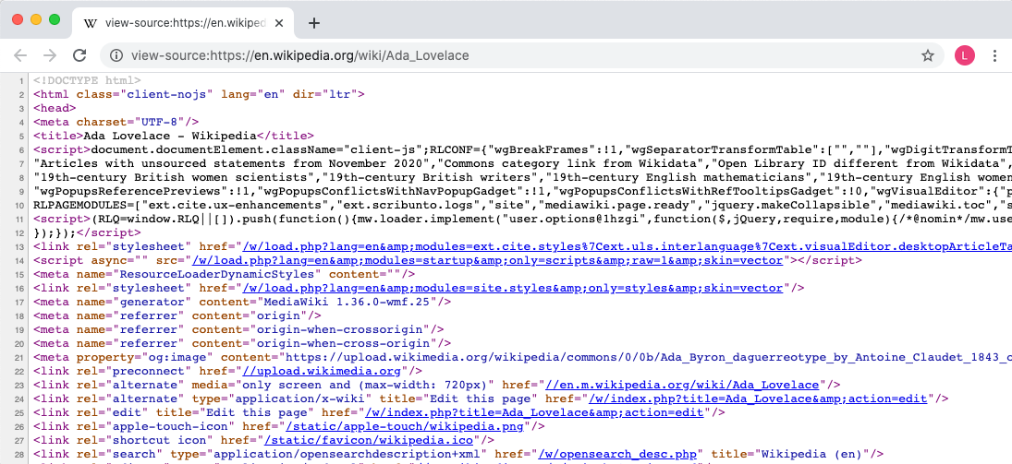
3. The browser reads this HTML, along with CSS and JavaScript defined in <script> or <link> tags, to create the DOM inside the browser. At this point, nothing is displayed on the screen. This time when nothing is displayed is very brief so our human eyes never really catch it.
4. The browser then uses the DOM object to create the rendered page. While we often learn that browsers "display HTML," that's not exactly accurate. Browsers use the HTML to create a "middleman" that they, in turn, use to display the structured and styled content.

**Identify the DOM as Accessed by JavaScript Objects**

We can access the DOM, using JavaScript and DOM programming, through two *variables*: window and document.

The window variable points to an *object* that represents Chrome's information about the browser, well, "window." It has many functions, but the main one is "it's a place where everything is." Not to be Zen here, but a browser without a window is like the universe before the Big Bang; there's just... *nothing*.

Like all objects, the window has properties and methods. For example, we can access operating system browser information like:

window.innerHeight;

// returns the inner height of the browser window.

For the most part, we won't interact with window: we don't want to mess with the container of everything or with operating system stuff. We want, rather, to change content. To do that, we'll focus on an object called document.

As an *object*, document has *properties*:

document.URL;

//=> https://en.wikipedia.org/wiki/Ada\_Lovelace

As an *object*, document also has *methods*:

document.querySelector("h1");

//=> Returns the element on the page with an id attribute equal to "firstHeading"

The *methods* and *properties* that the DOM provides via its objects is called the DOM's "Application Programming Interface," or "API." It's just a programming word that you're likely to see online. But it just means "the things that these objects know how to do."

**The Browser Console and Chrome Developer Tools**

Every major browser comes with a built-in set of developer tools that you can use to inspect, modify, and debug the content of a web page. To [open the dev tools in ChromeLinks to an external site.](https://developers.google.com/web/tools/chrome-devtools/console/#open_as_panel), press Ctrl+Shift+J (Windows / Linux) or Cmd+Opt+J (Mac). Chrome ships with a whole suite of useful developer tools, but the only one we care about for now is the JavaScript console.

The console is an environment in the browser where we can type and run JavaScript code in the context of the current browser window. The console is *sandboxed*, meaning the only resources it has access to are those loaded on the current page. Once we start declaring variables and functions in separate JavaScript files, we'll be able to access and play around with them in the console. The console is the single best tool for debugging JavaScript in the browser, so start familiarizing yourself with it now.

The Ctrl+Shift+J / Cmd+Opt+J command should open up straight into the console. If for whatever reason, it doesn't, you can always click on Console in the dropdown (when the DevTools are collapsed) or in the list of tabs:



If at any point the console becomes cluttered with errors, warnings, or anything else, click the Clear console button:



Okay, okay, enough background and setup. Let's write some code!

**Coding in the Console**

You can write and test out JavaScript code in the console. We'll start off with some simple math. In the console, type 1 + 1 and press enter. You should see the number 2 appear.



Try out some other mathematical expressions and see what they return.

Next up, let's write some text. To make sure the JavaScript engine knows that we're trying to write some literal text, we need to wrap it in quotation marks, like so:

"This is some literal text in JavaScript!";

Go ahead and type that classic phrase, "Hello, world!", into the console and press enter. It returned "Hello, world!" right back to us. Try typing some more literal text into the console, such as your name. Don't forget the quotation marks!



We can go far beyond simple literal expressions: we can create variables, loops, or if statements in the console. We can even define and run functions!

**Note:** It's impossible to overstate how important practice is when you're learning a new programming language. As you continue moving through the JavaScript curriculum, you should almost always have a browser console open. Code along with every example. Get used to the syntax and familiarize yourself with the errors that arise when you mistype something. Clear the console or simply refresh the page whenever you need a clean slate. Code, code, code, **code**, ***code***.

**Opening Files in the Browser**

In this section, you will begin working with HTML files (most often, index.html). In order to view the results of the coding you'll be doing, you'll need to open the file in the browser. Instructions for each programming environment are as follows:

* **Local environment on Mac**: Run open index.html in the terminal.
* **Local environment using WSL/Ubuntu**: Run explorer.exe index.html in the terminal.
* **AWS IDE**: right-click on the index.html file in the file tree and select "Preview." There will be a button in the upper right corner that will "pop" the page into a new tab in the browser.

Keep these instructions handy — you will be doing this often.

**Note:** In order for these instructions to work, you will need to have Google Chrome set as your default browser. You can find [instructions for Mac and Windows hereLinks to an external site.](https://support.google.com/chrome/answer/95417?hl=en&co=GENIE.Platform=Desktop).

**Conclusion**

In this lesson we learned about the DOM, which is a "middle layer" that presents the HTML, CSS and JavaScript loaded by the browser when we visit a page. We normally interact with it through the document object. Because it is the "source of truth" for what browsers display, changes to the DOM create changes in the browser screen. We also learned how to access the Chrome Developer Tools and use the Console to try out code as we're building our programs.

**Resources**

* [CSS Tricks - What is the DOM?Links to an external site.](https://css-tricks.com/dom/)
* [MDN - The DOMLinks to an external site.](https://developer.mozilla.org/en-US/docs/Web/API/Document_Object_Model/Introduction)

DOM Editing Lab

* **Due** No Due Date

* **Points** 1

* **Submitting** a website url

**Learning Goals**

* Identify that DOM nodes are written as HTML

**Introduction**

We've started looking at the DOM and how it's created. Now it's time to see its structure.

If you haven't already, fork and clone this lab into your local environment. Navigate into its directory in the terminal, then run code . to open the files in Visual Studio Code. Finally, run npm install to install the lab's dependencies.

**Identify That DOM Nodes Are Written As HTML**

In the previous lesson, we learned that, when we load a web page in a browser, the content we see in the DOM is a representation of the underlying HTML, CSS and JavaScript. If we were to view the DOM in Chrome Dev Tools (we'll learn how to do that shortly), we would see HTML that is a clone of the HTML found in the source HTML file. As we learned earlier in the course, that HTML consists of *elements* that in turn consist of HTML *tags* and their content.

When we're working in the DOM, the structure is the same. We can access objects in the DOM (called *nodes*) that consist of tags, just like the HTML elements that make up the base HTML. Nodes and elements are not the same thing — all elements in the DOM are nodes but not all nodes are HTML elements. However, when we're working in the DOM, the nodes we access and modify are virtually always HTML elements.

**The Structure of DOM Content**

We'll start by going over how content in the DOM is structured using nodes. The information below should be familiar from what you've learned about HTML elements.

DOM nodes most often have a starting tag and an ending tag. Examples include a paragraph:

<p>I am a paragraph.</p>

or a main section:

<main></main>

Because they have both starting and ending tags, we can nest other nodes inside them. The inner node is called a child node, and the outer node is called a parent node. To nest items, we simply add the child node and its content between its parent's starting and ending tags:

<body>

<main>

<p>I am a nested paragraph, inside the main element, inside the body!</p>

</main>

</body>

Some nodes only have a starting tag. Those are called *self-closing elements* or *void elements*. Void elements do not have any content nested inside of them and cannot be parent nodes.

An example of a self-closing tag is an image:

<img

src="https://media.giphy.com/media/3o6MbkZSYy4mI3gLYc/giphy.gif"

alt="A policeman"

/>

In self-closing tags, the trailing / is optional. This is valid too:

<img

src="https://media.giphy.com/media/3o6MbkZSYy4mI3gLYc/giphy.gif"

alt="A policeman"

>

Enough review, let's write some HTML!

**Instructions**

Start by running the tests and taking a look through the errors. You'll see that the tests are looking for certain content to be present in the HTML file.

Next, open the index.html file in the browser using the instructions in the previous lesson for your development environment.

Just to speed things up a bit, paste the following code into index.html:

<!DOCTYPE html>

<html lang="en">

<head>

<meta charset="UTF-8" />

<meta name="viewport" content="width=device-width, initial-scale=1.0" />

<meta http-equiv="X-UA-Compatible" content="ie=edge" />

<title>Introduction to the DOM Lab</title>

</head>

<body>

<!--All our work for this lesson will go here-->

</body>

</html>

Refresh the browser page to see the changes.

Open the Google Developer Tools by clicking on the "View" menu and selecting Developer -> Developer Tools. The Elements tab should be selected but, if it isn't, click on it. Here we have the DOM representation of the HTML source loaded by the browser. You should see the head and body elements nested inside the html element. If the body element is collapsed, use the disclosure triangle to expand it. You should see that the body element is, temporarily, child-less. Let's go ahead and start adding some content in index.html.

**Note**: the [disclosure triangleLinks to an external site.](https://en.wikipedia.org/wiki/Disclosure_widget) is the triangle to the left of the <body> tag. When you first open the Elements tab, the nodes are generally collapsed, hiding their contents. You can click the triangle to expand the node and see its contents. Disclosure triangles are standard for hiding information throughout Chrome DevTools. If you want to see more, feel free to click on the triangle! You're not going to break anything.

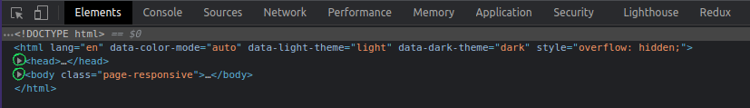

First, let's add a title to our page:

<h1>My HTML adventure</h1>

Refresh the page to see the changes displayed in the browser. If you view the Elements tab again, you should see that a new child node is nested inside the body. Finally, run the tests again; the first test should now be passing.

Next, we'll add a paragraph below the title. We'll also add some highlighted bits of text to the paragraph to make it stand out a little.

<p>

We're writing HTML markup to display in our <strong>browser</strong>. We're

basically telling computers what to do. <em>Neat!</em>

</p>

Save the file and check out the page in the 'Elements' tab. What's happening above is that we added some inline elements, <strong> and <em> to our paragraph to style things a little. The <strong> tag makes any text within look **important**. It's usually bold in browsers by default. The <em> tag allows us to *emphasize* certain text. This text is typically rendered as italic in browsers.

Run the tests again; you should now have all but two of the tests passing.

In our paragraph, let's make "HTML" a hyperlink and link to the MDN definition. We'll use the<a> tag for this. Add this to our existing <p>:

We're writing

<a href="https://developer.mozilla.org/en-US/docs/Web/HTML">HTML</a> markup to

display in our <strong>browser</strong>.

Notice that HTML attributes (in this case, the href attribute) are shown alongside their opening tag.

Lastly, we'll add a table below the paragraph to recap some of the stuff in this lesson:

<table>

<thead>

<tr>

<th>Element name</th>

<th>Display value</th>

</tr>

</thead>

<tbody>

<tr>

<td>h1</td>

<td>block</td>

</tr>

<tr>

<td>p</td>

<td>block</td>

</tr>

<tr>

<td>strong</td>

<td>inline</td>

</tr>

<tr>

<td>em</td>

<td>inline</td>

</tr>

</tbody>

</table>

Woah. That's a **lot** of markup! If you take a look at the result, though, you'll see that it's a fairly complex visual — it's a table! Our table consists of a header and a body. The header allows us to give the columns a name, and the table body contains the rows of content. Both <thead> and <tbody> tags contains rows, which are represented as <tr> (table row). These rows then contain cells which form the table's columns. In the <thead> row, cells are represented as <th>, while cells in <tbody> have their content in <td> tags.

That's a *lot* of nesting.

Look again at the Elements tab. Expand out all the children of the table. This is the DOM tree!

When you're done, go ahead and run the tests. They should now all be passing.

**Saving Your Work Remotely**

Currently, the work you've done on this assignment is only on your local machine. To preserve your solution on your GitHub fork, you will need to stage the changes you've made, commit them, and push the commit up to GitHub. Use the following commands to do this:

$ git add .

$ git commit -m "Completed assignment"

$ git push

If you visit your fork on GitHub, you should now see that *you've* made the most recent commit, and your code will be present in the files.

[Previous](https://moringa.instructure.com/courses/318/modules/items/59229)[Next](https://moringa.instructure.com/courses/318/modules/items/59231)

**Changing The DOM with DevTools and JavaScript**

**Learning Goals**

* Demonstrate viewing the DOM through Chrome DevTools
* Select an element with Chrome DevTools
* Delete an element with Chrome DevTools
* Demonstrate that the source is not changed when the DOM is
* Demonstrate opening the DevTools' JavaScript console
* Select an element with JavaScript
* Delete an element with JavaScript
* Storing node references in variables

**Introduction**

We've read that updating the DOM will update the browser's rendered page. Let's try this out. We're going to change the DOM in two ways. First, we'll use Chrome's Developer Tools ("DevTools") and our mouse to remove an element from the DOM. Then we'll use the DevTools' JavaScript console to run JavaScript that does the same thing.

**Demonstrate Viewing the DOM Through Chrome DevTools**

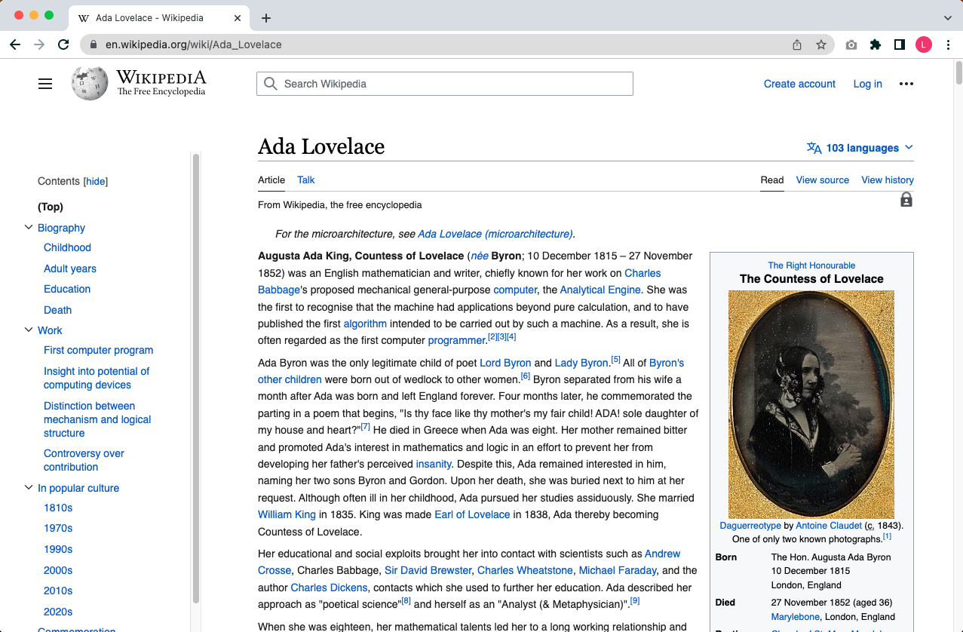

Let's head back to the [Wikipedia page for Ada LovelaceLinks to an external site.](https://en.wikipedia.org/wiki/Ada_Lovelace). From this web page, look at the Chrome menu bar at the top of the page. Click on "View", then select "Developer", then "Developer Tools." This will open the Google Developer Tools. Click on the "Elements" tab. Here we see the DOM representation of the HTML source that was loaded into the browser.

**Select an Element With Chrome DevTools**

Scroll through the Elements panel. You will see some HTML: head tags, body tags, divs, etc. If the body element is collapsed, use the disclosure triangle to expand it. Notice that you can mouse over different elements in the Elements panel and see them highlighted in the browser window. Locate the div nested inside body that has an id attribute of "content" and expand that as well.

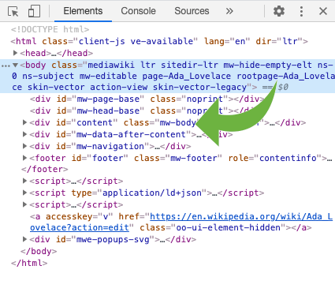

Next, locate the h1 element nested inside the "content" div. It should look something like this:

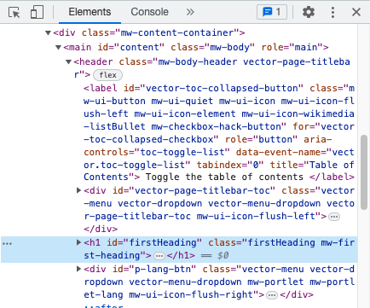

Click on the h1 element; you'll see that it's highlighted in the Elements panel. You've now selected an element with the DevTools.

**Delete an Element With Chrome DevTools**

Press the delete button on your keyboard. The element will vanish from the browser's rendered page.

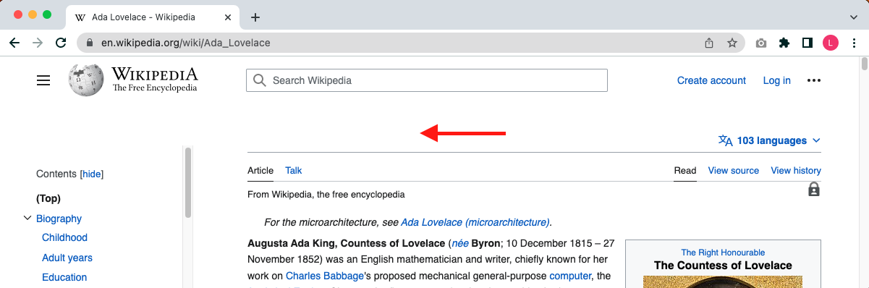

**Demonstrate That the Source is Not Changed When the DOM Is**

View the page source. In the Chrome menu bar, click on "View", then select "Developer", then "View Source." You will see that the HTML is just as it always was, with the deleted element still present.

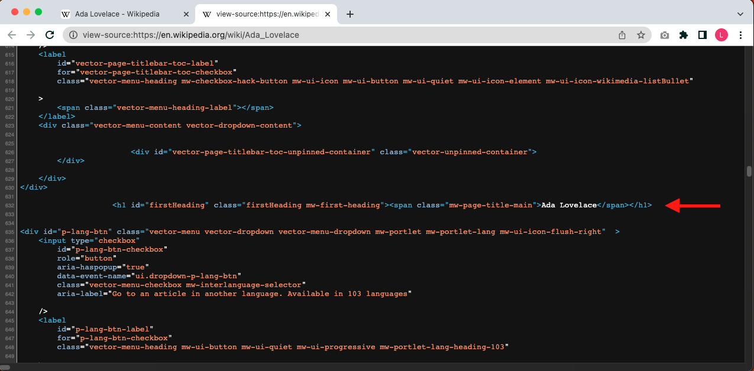

The changes in the DOM do not affect the HTML file on the server. When you think about it, that makes sense. If that were true then anyone could be changing carefully-written HTML. (Of course, in the case of Wikipedia, people *can* edit the content using Wikipedia's editor, but they aren't directly accessing the underlying HTML.)

The HTML, which lives on the server, **is unchanged**.

Refresh the page by going to "View" and choosing "Reload this Page." You will be reloading the DOM *from the source*. The page content will come back.

**Demonstrate Opening the DevTools' JavaScript Console**

Above, we deleted an element by selecting it in the DevTools and pressing the delete key. We can accomplish the same thing using JavaScript.

In DevTools, click the **Console** tab. At the prompt, type the word document and press "Enter." You'll get a #document returned. If you hover your mouse over the element, you'll see the entire page highlighted in the browser window. If you expand it, you'll see that it's the exact HTML that you saw in the **Elements** tab.

Recall that document is an object; as such, it has properties and methods, including a number of different methods that can be used to return elements. Let's find or select an element by speaking JavaScript with the DOM.

**Select an Element With JavaScript**

In the **Console** type:

document.querySelector('h1');

This will return something like this:

<h1 id="firstHeading" class="firstHeading" lang="en">...</h1>

Go ahead and click on that disclosure triangle to see more.

The return value of document.querySelector('h1'); is the DOM node, which is also a JavaScript object. This means that it, in turn, can have methods called on it! This is called *method chaining*. Let's use *method chaining* to remove our node from the DOM.

**Delete an Element with JavaScript**

Now type:

document.querySelector('h1').remove();

The heading is gone! We called document.querySelector('h1') to get the node; we then used *method chaining* to call the remove() method on the node object. We use dot notation to *chain* the calls.

Follow the same process we used earlier to verify that the source has not changed. To restore it, simply refresh the page (i.e. reload the DOM).

**Storing Node References in Variables**

Query methods like querySelector() and the other methods we'll be learning about are expressions: they return a value (specifically, a DOM node). As such, we can save the results of the query into a variable. For example:

const header = document.querySelector('h1');

We now have a reference to that node with a meaningful name; we can simply use header any time we need to refer to our node, rather than always having to look it up with document.querySelector().

You can perhaps imagine how, if we have a program that selects, creates, modifies, or removes a large number of nodes, using this approach will result in code that's easier to read, debug and maintain.

**Conclusion**

DOM programming is using JavaScript to:

1. Ask the DOM to find or select an HTML element or elements in the rendered page
2. Remove the selected element(s) and/or insert new element(s)
3. Adjust a property of the selected element(s)

In this lesson you just did all that stuff! Learning to duplicate what you can do in DevTools with JavaScript ***is*** DOM programming. The next lessons are going to give you more methods for selecting elements and changing them, but you just changed the DOM. High fives are in order.

[Previous](https://moringa.instructure.com/courses/318/modules/items/59230)[Next](https://moringa.instructure.com/courses/318/modules/items/59232)

# The DOM Is a Tree

## Learning Goals

* Describe how the DOM works as a tree
* Define the computer science version of "Tree"
* Ask the DOM to find or "select" an HTML element or elements in the rendered page

## Introduction

DOM programming is using JavaScript to:

1. Ask the DOM to find an HTML element or elements in the rendered page
2. Remove the selected element(s) or add a new element next to the selected element
3. Adjust a property of the selected element(s)

In previous lessons we were given the command to find the HTML element we wanted:

document.querySelector(selector);

The selector is like a query string that lets us find things within an HTML page. What is the syntax of this selector? How does the selector navigate through our document to find the DOM nodes that we want to work with (update, move, even delete!)?

To understand those queries or selectors, we first need to talk about how the DOM tree (i.e. what we see in the 'Elements' panel of our DevTools) is used to help the DOM's methods find the right nodes.

### Define the Computer Science Version of "Tree"

What do we mean when we say that the DOM is a tree? Trees make a good metaphor for the DOM because almost everyone has seen a tree. Starting at the bottom, you can climb up the tree and out to the farthest — and smallest — branches. The thicker a branch is, the stronger its connections are and the more it holds within it. Likewise, the thinner a branch is, the less it holds inside.

The DOM works basically the same way, except we usually talk about the root as being at the top of the DOM and the leaves being the most deeply nested HTML elements. So basically, we can imagine a tree upside down.

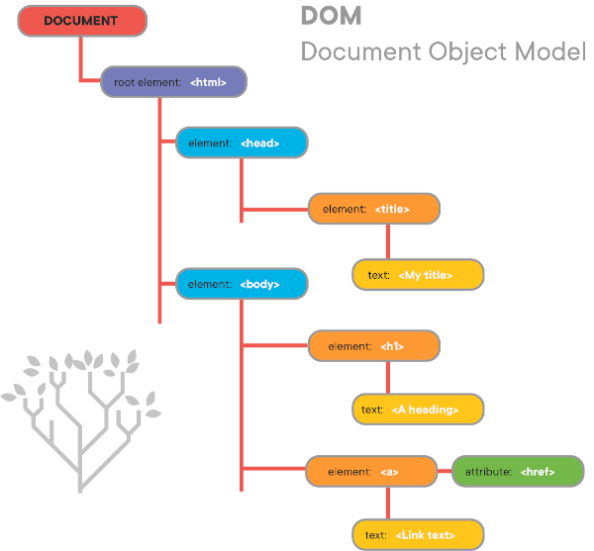

The HTML for this "tree" would be:

<!DOCTYPE html>

<html>

<head>

<title>My Title</title>

</head>

<body>

<h1>A heading</h1>

<a href="http://example.com">Link text</a>

</body>

</html>

### Describe How the DOM Works as a Tree

Every tree can contain subtrees, which we can treat independently of their parent trees. They repeat the pattern and appearance of the full tree, despite being a smaller part of a tree, like branches. Every child has experienced this sense of wonder when they take a fallen branch and stick it in the ground and think that they've planted their own tree.

Practically speaking, the DOM begins at <html>, but for now we should avoid changing what's between the <head></head> tags. Most of the time, we will look at the DOM subtree with its root at <body> and only change things that will be visible on the page. We might also deal with subtrees. For example, if we have

<body>

<div>

<p>Hi!</p>

</div>

<div>

<p>Bye!</p>

</div>

</body>

Our tree looks like this:

body

/ \

div div

/ \

p p

/ \

"Hi!" "Bye!"

Similarly, if we had a DOM subtree that looked like

<div>

<div>

<h1>Hello!</h1>

</div>

<div>

<h5>Sup?</h5>

</div>

</div>

The tree would look like:

div

/ \

div div

/ \

h1 h5

/ \

"Hello!" "Sup?"

### Finding HTML Elements

In creating the HTML for a page, including metadata for a node (e.g., a class or id attribute) will not only provide useful information about that node, but will also make it and its children easier to find. The more specific the metadata is, the more helpful it is for finding the desired element.

For the following exercises, you can experiment with any web page you like. It's fun to change The New York Times or Facebook.

#### Finding a Node

JavaScript exposes a few ways of finding DOM nodes, either directly or in stages, courtesy of the document object. We will introduce three here, in order from most to least specific: getElementByID(), getElementsByClassName(), and getElementsByTagName().

##### document.getElementById()

This method provides the quickest access to a node, but it requires that we know a very specific piece of information — its id. This method can only return one element, since CSS ids are expected to be unique.

Given the following DOM tree:

<div>

<h5 id="greeting">Hello!</h5>

</div>

We could find the h5 element with document.getElementById('greeting').

Notice how the id that we pass to getElementById is identical to the id in <h5 id="greeting">.

**Note:** You can use either single('') or double("") quotes around the id within the parentheses in document.getElementById('yourIDGoesHere'), as long as you use the same kind to open and close them!

**Try it out!**

Open up your DevTools and find an element on the page that has an id attribute. Then open up your console, type document.getElementById('theIdOfTheElement'), and check out your handy-dandy DOM node.

#### document.getElementsByClassName()

This one is also very commonly used in DOM programming.

This method finds elements by their className. Unlike the previous method, class names do not need to be unique, so this method returns an HTMLCollection of all the elements with the given class. An HTMLCollection is an array-like structure containing a list of elements. You can iterate over an HTMLCollection with a simple for loop.

Given the following DOM tree:

<!-- the `className` attribute is called `class` in HTML -->

<div>

<div class="banner">

<h1>Hello!</h1>

</div>

<div class="banner">

<h1>Sup?</h1>

</div>

<div class="banner">

<h5>Tinier heading</h5>

</div>

</div>

We could find all of the elements with the class name "banner" by calling document.getElementsByClassName('banner').

**Try it out!**

Inspect your web page again, this time making note of a class. Get all elements with that class and give 'em a look. On the returned object you can use the .length property to find out how many came back.

If you recall the for loop syntax you might try to write a loop which prints out the innerHTML property of every element in the collection. You might find doing so much easier if you save the results of document.getElementsByClassName() to a variable:

const elements = document.getElementsByClassName("yourClassNameHere");

#### document.getElementsByTagName()

You can use this method if you don't know an element's id or class, but you do know its tag name (the tag name is the thing between the <>, e.g., 'div', 'h1', header, article etc.). Since tag names aren't unique, this method also returns an HTMLCollection.

**Try it out!**

Explore the DOM in the console by typing document.getElementsByTagName('div'). You can iterate through these elements using a simple for loop as well.

#### Finding a Node Without Knowing Anything About It

What if we don't have an id or className to help us find a particular element? This is where our knowledge of trees comes in handy!

Given the following DOM tree:

<main>

<div>

<div>

<p>Hello!</p>

</div>

</div>

<div>

<div>

<p>Hello!</p>

</div>

</div>

<div>

<div>

<p>Hello!</p>

</div>

</div>

</main>

How would we go about changing only the second "Hello!" to "Goodbye!"?

Here we're going to use a mix of different methods to accomplish the goal.

Let's start by getting the <main> element

const main = document.getElementsByTagName("main")[0];

We can get the children of main using main.children. This returns an HTMLCollection, so we can get the second child with main.children[1].

const secondChild = main.children[1];

Next, we can get our <p> element. To constrain the search to just the children of the second child, we can call getElementsByTagName() **directly on secondChild**:

const p = secondChild.getElementsByTagName("p")[0];

And lastly we can change an attribute on the p node:

p.textContent = "Goodbye!";

Obviously, this way of accessing that text isn't very efficient and won't work on all pages but it does a good job of demonstrating the basic tools available to us for finding and manipulating HTML elements.

## Conclusion

Understanding the tree structure of the DOM helps us navigate all kinds of trees. In subtrees and branches we can find the nodes we need by IDs, class names or tag names, or by using element attributes like children. Once we've selected our elements, we can use JavaScript to manipulate them. By using these techniques, we can start to build a richer user experience.

## Resources

* [MDN - Document Object ModelLinks to an external site.](https://developer.mozilla.org/en-US/docs/Web/API/Document_Object_Model)

[Previous](https://moringa.instructure.com/courses/318/modules/items/59231)[Next](https://moringa.instructure.com/courses/318/modules/items/59233)

# JavaScript Query Selector Methods

## Learning Goals

* Use querySelector() and querySelectorAll() to find nested nodes
* Modify attributes of DOM nodes

## Introduction

One of the most essential skills in our web development toolbox is finding elements in the DOM.

While document.getElementById() and document.getElementsByClassName() are good, we can improve our search when we use document structure (tag, id, class) **along with** the tree structure of the DOM. It turns out CSS is a great language for expressing those relationships! With the querySelector() and querySelectorAll() methods, we provide one or more CSS selectors as an argument and we get back the matching element or elements. Because they can take a string containing multiple selectors, they allow us to create very specific, complex queries.

## Finding Nested Nodes

If you would like to follow along in the console, fork and clone this lesson, open the files in your text editor, and open index.html in Google Chrome. As you go, copy each HTML example into index.html.

### querySelector()

The querySelector() method takes one argument, a string of one or more CSS-compatible [selectorsLinks to an external site.](https://developer.mozilla.org/en-US/docs/Web/Guide/CSS/Getting_Started/Selectors" \t "_blank), and returns the first element that matches.

Given a document like:

<body>

<div>Hello!</div>

<div>Goodbye!</div>

</body>

If we called document.querySelector('div'), the method would return the first div. If we check its innerHTML, we should see Hello!.

Selectors aren't limited to one tag name, though. Otherwise, why not just use document.getElementsByTagName('div')[0]? We can get very specific.

<body>

<div>

<ul class="ranked-list">

<li>1</li>

<li>

<div>

<ul>

<li>2</li>

</ul>

</div>

</li>

<li>3</li>

</ul>

</div>

<div>

<ul class="unranked-list">

<li>6</li>

<li>2</li>

<li>

<div>4</div>

</li>

</ul>

</div>

</body>

const li2 = document.querySelector("ul.ranked-list li ul li");

li2;

//=> <li>2</li>

const div4 = document.querySelector("ul.unranked-list li div");

div4;

//=> <div>4</div>

In the above example, the first query says, "Starting from document (the object we've called querySelector() on), find a ul with a className of ranked-list (recall from CSS that the . indicates that ranked-list is a className). Then find an li that is a descendant of that ul. Next find a ul that is a descendant (but not necessarily a direct child) of that li. Finally, find an li that is a descendant of that (second) ul."

**Note**: The HTML property class is referred to as className in JavaScript.

What does the second call to querySelector() say? Think about it for a minute, and then read on.

Wait for it...

The second call says, "Starting from document, find a ul with a className of unranked-list. Then find an li descended from ul.unranked-list and a div descended from that li."

#### CSS Selectors

If using CSS to target elements isn't feeling natural, now might be a good time to brush up on [selectorsLinks to an external site.](https://developer.mozilla.org/en-US/docs/Web/Guide/CSS/Getting_Started/Selectors" \t "_blank). Play around on the MDN page, then come back when you're ready.

### querySelectorAll()

querySelectorAll() works a lot like querySelector() — it accepts a string containing one or more selectors as its argument, and it searches starting from the object that it's called on (either document or an element). However, instead of returning the first match, it returns a NodeList collection of all matching elements. A NodeList is similar to an HTMLCollection: it is an array-like structure containing, in this case, a list of DOM nodes.

Given a document like

<body>

<main id="app">

<ul class="ranked-list">

<li>1</li>

<li>2</li>

</ul>

<ul class="ranked-list">

<li>10</li>

<li>11</li>

</ul>

</main>

</body>

If we called:

document.getElementById("app").querySelectorAll("ul.ranked-list li");

We'd get back a list of nodes corresponding to:

<li>1</li>, <li>2</li>, <li>10</li>, <li>11</li>

## Conclusion

The DOM selection methods document.querySelector() and document.querySelectorAll() are powerful tools for finding the elements we need to update and change. They use the familiar CSS selector syntax and allow us to create very specific queries that give us access to elements in complex DOM trees.

## Resources

* [document.querySelector()Links to an external site.](https://developer.mozilla.org/en-US/docs/Web/API/Document/querySelector)
* [document.querySelectorAll()Links to an external site.](https://developer.mozilla.org/en-US/docs/Web/API/Document/querySelectorAll)

[Previous](https://moringa.instructure.com/courses/318/modules/items/59232)[Next](https://moringa.instructure.com/courses/318/modules/items/59234)

Creating and Inserting DOM Nodes Lab

* **Due** No Due Date

* **Points** 1

* **Submitting** a website url

**Learning Goals**

* Create DOM elements programmatically
* Add elements to the DOM
* Update elements using innerHTML
* Change properties on DOM nodes
* Remove elements from the DOM

**Introduction**

Now that you have an understanding of the DOM and powerful tools for selecting the right elements, it's time to learn how to:

1. Create new nodes
2. Delete nodes
3. Update node properties

If you haven't already, fork and clone this lab into your local environment. Navigate into its directory in the terminal, then run code . to open the files in Visual Studio Code. Finally, run npm install to install the lab's dependencies.

**Create DOM Elements Programmatically**

**document.createElement()**

Creating an element in JavaScript is an easy process. You simply call document.createElement('tagName'), where tagName is the name of any valid HTML tag ('p', 'div', 'span', etc.).

Open the index.html file in your browser and open up the browser's console. In the console, enter:

const element = document.createElement("div");

Then take a look at the Elements tab. The element doesn't show up on the page. Why not?

**Add Elements to the DOM**

To get an element to appear in the DOM, we have to append it to an existing DOM node. To go back to our tree metaphor, we have to glue our new leaf onto a branch that's already there. We can start as high up on the tree as document.body, or we can find a more specific element using any of the methods we've learned for traversing the DOM.

**append()**

Let's append element to body to start:

document.body.append(element);

Now if you look at the Elements tab, you'll see our new (empty) <div> nested inside the body element. Let's give it some content:

const ul = document.createElement("ul");

for (let i = 0; i < 3; i++) {

const li = document.createElement("li");

li.textContent = (i + 1).toString();

ul.append(li);

}

element.append(ul);

You should now see the unordered list rendered on the page, and see the new elements in the "Elements" tab, like this:

<div>

<ul>

<li>1</li>

<li>2</li>

<li>3</li>

</ul>

</div>

Note that, each time we create a new element, we create a variable and save a reference to it. That makes it quite easy to make additional updates and to add it to the DOM using append().

**Add Elements to the DOM via innerHTML**

Creating elements and then appending them into the DOM is a multi-step process. It's also the ***safest and most reliable way*** to add content to the DOM. Most repeated code can be removed by using variables, functions and loops. It's The Right Way.

That said, however, there's another process that will also work, using Element.innerHTML. Inside our loop above, we create an li element and set its textContent property to a simple number (expressed as a string) that represents the current iteration through the loop. Once we append the li to the ul and the ul to the document body, we see our unordered list in the browser window. This is a perfectly valid way to use textContent to add content to the DOM — essentially, textContent changes only what text shows up inside a DOM element:

li.textContent = "Hi there!";

// => <li>Hi there!</li>

console.log(li.textContent);

// => "Hi there!"

Imagine, however, that we want to add content that's more complicated.

Assume our HTML includes a main element with an id of "main." We can grab that element and set its innerHTML attribute to any HTML we like:

const main = document.getElementById("main");

main.innerHTML =

"<h1>Poodles!</h1><h3>An Essay into the Pom-Pom as Aesthetic Reconfiguration of the Other from a post-Frankfurt School Appropriationist Perspective</h3><p><em>By: Byron Q. Poodle, Esq., BA.</em></p>";

Here we are using one big, long string, complete with multiple HTML tags, to create the following HTML in the DOM:

<main id="main">

<h1>Poodles!</h1>

<h3>

An Essay into the Pom-Pom as Aesthetic Reconfiguration of the Other from a

post-Frankfurt School Appropriationist Perspective

</h3>

<p><em>By: Byron Q. Poodle, Esq., BA.</em></p>

</main>

This process works but it is **not** recommended for several reasons. First, it's more error-prone, and the errors can be difficult to find. Second, it can negatively impact site performance. Finally, if you're inserting user-derived data (e.g., comments) into the DOM using innerHTML, you can expose your site to the risk of users [injecting malicious codeLinks to an external site.](https://www.reddit.com/r/learnjavascript/comments/9502x5/is_innerhtml_still_considered_bad/e3p31go/?utm_source=share&utm_medium=web2x&context=3).

Programmatically creating and appending elements is safer and more efficient, and it results in code that's easier to read, easier to debug, and easier to maintain.

**Change Properties on DOM Nodes**

We can change the appearance of a DOM node using its style attribute. Try this out in the console:

const element = document.getElementById("main");

element.style.height = "300px";

element.style.backgroundColor = "#27647B";

You've changed what's on the screen!

Feel free to set as many properties as you'd like — this is a good chance to look around and explore different properties of DOM elements.

Let's adjust the display. Add some text:

element.textContent = "You've changed what's on the screen!";

Then change the style to see the effect:

element.style.fontSize = "24px";

element.style.marginLeft = "30px";

element.style.lineHeight = 2;

Perhaps the most common way to change how things appear in the DOM is by changing an element's class attribute. As you know from CSS, we often change the way a bit of rendered HTML appears by adding or removing a class.

For example, we could create an alert class that turns the text red (using the CSS color attribute) and makes it big (using the CSS font-size attribute). We can then use JavaScript to first grab the element and then add the class by updating the element's className property. This has the same effect as setting the class property in the HTML. The className property expects a String with one or more class names, separated by spaces:

element.className = "pet-listing dog";

Check out the Elements tab to see the effect of this change:

<main id="main" class="pet-listing dog"></main>

Another way to accomplish the same thing is by using the [Element.classList propertyLinks to an external site.](https://developer.mozilla.org/en-US/docs/Web/API/Element/classList" \t "_blank). This property has .add() and .remove() methods that can be used as follows:

element.classList.remove("dog");

element.classList.add("cat", "sale");

This approach allows you to easily add and remove classes programmatically, without having to create a long string of class names.

<main id="main" class="pet-listing cat sale"></main>

**Separation of Concerns**

An important thing to bear in mind is that we only want to use JavaScript to change the appearance of an element when we need to make a change dynamically, i.e., in response to user actions. This goes back to a fundamental programming concept about separating concerns between technologies:

* HTML defines the structure of the website (not appearance or functionality)
* JavaScript defines functionality of the website (not structure or styling)
* CSS defines the visualization and style of the website (not structure or functionality)

Defining the base CSS should still happen in the CSS files that are loaded into the DOM when the page is opened.

**Remove Elements from the DOM**

We know how to add elements and change their attributes. What if we want to remove an element from a page?

**removeChild()**

We use removeChild(), as you might guess, to remove a particular child of an element:

someElement.removeChild(someChildElement);

Let's take a look at a more complex example:

const ul = document.getElementsByTagName("ul")[0];

const secondChild = ul.querySelector("li:nth-child(2)");

ul.removeChild(secondChild);

Here you can see the power of querySelector(): we can use it to find the second li element of ul. We then pass that element as the argument to our removeChild method, which removes the element from our ul.

What if we want to remove the whole unordered list (ul)?

**element.remove()**

We can just call remove() on the element itself:

ul.remove();

And it's gone!

**Instructions**

From this point forward, many of the labs will work a little differently from ones you've done before. Specifically, the tests will mock the process of 1) running JavaScript code in the browser and 2) seeing the results of that code represented in the DOM. Take a look at test/indexTest.js to see the tests' descriptions of the changes your code should be making to the DOM elements.

Note that you do not need to create functions for this lab. Just create the line or lines of JavaScript necessary to pass each test. As usual, you will write your code in the index.js file.

**Saving Your Work Remotely**

Currently, the work you've done on this assignment is only on your local machine. To preserve your solution on your GitHub fork, you will need to stage the changes you've made, commit them, and push the commit up to GitHub. Use the following commands to do this:

$ git add .

$ git commit -m "Completed assignment"

$ git push

If you visit your fork on GitHub, you should now see that *you've* made the most recent commit, and your code will be present in the files.

**Resources**

* [document.createElement()Links to an external site.](https://developer.mozilla.org/en-US/docs/Web/API/Document/createElement)
* [append()Links to an external site.](https://developer.mozilla.org/en-US/docs/Web/API/Element/append)
* [removeChild()Links to an external site.](https://developer.mozilla.org/en-US/docs/Web/API/Node/removeChild)
* [element.remove()Links to an external site.](https://developer.mozilla.org/en-US/docs/Web/API/ChildNode/remove)
* [classList PropertyLinks to an external site.](https://developer.mozilla.org/en-US/docs/Web/API/Element/classList)

[Previous](https://moringa.instructure.com/courses/318/modules/items/59233)[Next](https://moringa.instructure.com/courses/318/modules/items/59235)

**JavaScript Events**

**Learning Goals**

* Define a JavaScript event
* Identify different types of user events

**Introduction**

We've experimented with selecting and manipulating nodes in the DOM using JavaScript: deleting nodes, editing nodes, etc. But most web applications are *not* used by people opening up the console and editing the DOM using Chrome's DevTools. Instead, people *do something* and then *work happens*.

"Doing work" in response to "something happening" is known as *event handling*. *Events* are the "something the user does" and the "*callback function*" is the work that will happen in response to the event being triggered.

In this lesson we'll go over some of the most commonly-used JavaScript events. In the following lessons, we'll learn how to use *event listeners* to tell JavaScript which event or events we want it to listen for. We'll also learn how to implement *callback functions* to handle the *work happens* part of event handling.

**Define a JavaScript Event**

JavaScript has the ability to "listen" for things that happen inside the browser. It can listen for events like whether the browser is resized, or whether someone clicked on a specific image on the screen. The event you're probably most familiar with is "click."

We'll go over a few of the more common types of events in this lesson.

**Identify Different Types of User Events**

**Mouse Click**

Mouse or trackpad events are some of the most common ones you'll be handling using JavaScript eventing. For example, JavaScript can recognize a single click on an element in the page and change the styling of the element to highlight it. Or it can recognize a double-click on an element and open a zoomed-in view of that element.

There are many other mouse events you can use; take a look at the list of JavaScript's [mouse events hereLinks to an external site.](https://developer.mozilla.org/en-US/docs/Web/Events#Mouse_events).

**Key Press**

While click events will likely make up the majority of events you'll use, the keyboard is another important source of events. JavaScript currently includes two [keyboard eventsLinks to an external site.](https://developer.mozilla.org/en-US/docs/Web/Events#Keyboard_events): keydown and keyup. (A third, keypress, has been deprecated.) When a key is pressed, these events provide a code to indicate which key it was. For example, a game program might listen for keydown events and, if the space bar was pressed, make the character jump over the hole.

**Form Submission**

HTML pages often use a submit button to submit a form to a server. When a user submits a form, the submit event is fired. An event handler here might pop up a thank you overlay or log in the user and take them to their home page.

**Other Events**

As you seek to build more complicated applications, you'll need to handle and trigger work on many more events than the few we've discussed in this lesson. Some other common events you are likely to encounter are scroll, mouseenter and mouseleave, focus, blur, and onchange.

One important thing to keep in mind is that not all JavaScript events are supported by all browsers. This [list of browser eventsLinks to an external site.](https://developer.mozilla.org/en-US/docs/Web/Events#standard_events) includes the ones that can be used in most browsers.

**Conclusion**

JavaScript allows us to trigger work when it detects events. You set up an event handler and, when JavaScript recognizes that event, it will execute the event handler's work, which is stored in a *callback function*.

Take a few minutes to look through the [list of common eventsLinks to an external site.](https://developer.mozilla.org/en-US/docs/Web/Events#standard_events) to familiarize yourself with the many many ways you can use event handling to enhance your users' experience.

**Resources**

* [MDN - Web EventsLinks to an external site.](https://developer.mozilla.org/en-US/docs/Web/Events)

[Previous](https://moringa.instructure.com/courses/318/modules/items/59235)[Next](https://moringa.instructure.com/courses/318/modules/items/59237)

# JavaScript Event Listeners Lab

* **Due** No Due Date

* **Points** 1

* **Submitting** a website url

## Learning Goals

* Create event listeners on DOM nodes using addEventListener()

## Introduction

In this lab we will learn how to teach nodes to "listen" for an event using addEventListener().

If you haven't already, fork and clone this lab into your local environment. Navigate into its directory in the terminal, then run code . to open the files in Visual Studio Code. Finally, run npm install to install the lab's dependencies.

## Create Event Listeners on DOM Nodes with addEventListener()

In order for JavaScript to handle an event, we first need to tell it to listen for that event. We do this by calling the addEventListener() method on the element we want to add the listener to, and passing it two arguments:

1. the name of the event to listen for, and
2. a callback function to "handle" the event

Open up index.html in the browser. When you click in the <input> area, nothing happens. Let's set up some event handling. Specifically, let's add an event listener for the click event on the input#input element in index.html.

Try out the following in the Chrome DevTools console:

const input = document.getElementById('input');

input.addEventListener('click', function() {

alert('I was clicked!');

});

Now when you click inside of input#input, you will get an alert box.

Let's review what's happening in this code.

First, we grab the element that we want to add the event listener to and save a reference to it in the input variable.

Next, we call addEventListener() on that element to tell JavaScript to listen for the event. We pass two arguments to addEventListener(): the name of the event to listen for (in this case, click) and a callback function that will be executed when the event is "heard."

[According to MDNLinks to an external site.](https://developer.mozilla.org/en-US/docs/Glossary/Callback_function):

A callback function is a function passed into another function as an argument, which is then invoked inside the outer function to complete some kind of routine or action.

That's exactly what's happening here: we're passing a callback function as the second argument to the addEventListener() function; the callback will be invoked as soon as the event occurs.

Let's pull out that second argument and take a look at it:

function() {

alert('I was clicked!');

}

This function has all the components of functions we've seen before (the function keyword, a pair of parentheses, and the body of the function enclosed in curly braces) except one: it doesn't have a name assigned to it. This is what's called an anonymous function. Because it doesn't have a name, it can't be invoked directly. But the event listener knows to execute whatever function is passed as the second argument when it detects the event, so it doesn't need to be named.

If we are only calling our callback function in that one place, using an anonymous function makes sense. However, what if we wanted to use that same alert message on a bunch of elements? In that case, it would make more sense to create a separate, named function that could be called by all of our event listeners. With this approach, we would pass the function name as the second argument to addEventListener() rather than the function itself:

const input = document.getElementById('input');

function clickAlert() {

alert('I was clicked!');

}

input.addEventListener('click', clickAlert);

We could then hook up as many elements as we'd like to our clickAlert. Just as we did for the input element, we would first use our CSS selector skills to grab the desired element and save it to a variable, then add the click event listener to that element. Give it a try!

With this approach, even if we're using our clickAlert with a whole bunch of elements, if we decide later that we want to change the text of the alert to "Hee hee, that tickles!" instead, we would only need to make that change in one place: inside our clickAlert() function.

**Note**: we pass clickAlert as the argument, not clickAlert(). This is because we don't want to invoke the function in this line of code. Instead, we want to pass a reference to the function to addEventListener() so it can call the function when the time comes.

Refresh your browser and try out the latest version of the code in the console to verify that it works. Also try passing clickAlert() as the second argument rather than clickAlert and see what happens.

## Passing the Tests

Now let's set up index.js to do the same thing so we can get our test passing. To do that, simply copy the code into the index.js file's addingEventListener() function and run the test. Either version should pass the test — just make sure that the code creating the event listener is **inside** the addingEventListener() function.

#### Checking the Code in the Browser

We know that the code works in the console and passes the test, but we should also check our changes to index.js in the browser. Because you've added the addEventListener() function inside the addingEventListener() function, recall that you will need to call the outer function in index.js to execute addEventListener() and activate the event listener. Be sure to refresh the page to load the new code in index.js.

## Saving Your Work Remotely

Currently, the work you've done on this assignment is only on your local machine. To preserve your solution on your GitHub fork, you will need to stage the changes you've made, commit them, and push the commit up to GitHub. Use the following commands to do this:

$ git add .

$ git commit -m "Completed assignment"

$ git push

If you visit your fork on GitHub, you should now see that you've made the most recent commit, and your code will be present in the files.

## Resources

* [MDN - Web EventsLinks to an external site.](https://developer.mozilla.org/en-US/docs/Web/Events)

[Previous](https://moringa.instructure.com/courses/318/modules/items/59236)[Next](https://moringa.instructure.com/courses/318/modules/items/59238)

Moving Things with JavaScript by Acting on Events

* **Due** No Due Date

* **Points** 1

* **Submitting** a website url

**Learning Goals**

* Practice moving elements on the page
* Demonstrate how to move an element in response to a browser event
* Demonstrate how to update an element's position on the page conditionally

**Introduction**

Think back to the first video game you played.

Think about the mechanics of that game. When you *tilted* a joystick or *pressed* a button it responded to your whims. It pulled you into its story by giving you a window into its world and a way of interacting with — shaping, even — that world. When you performed an ***event***, the computer made the world respond: the little plumber from Brooklyn jumped (*Super Mario Franchise*), the undead warrior slashed at an evil foe (*Dark Souls*), or the banana-yellow guy ate the power pellet (*Pac-Man*).

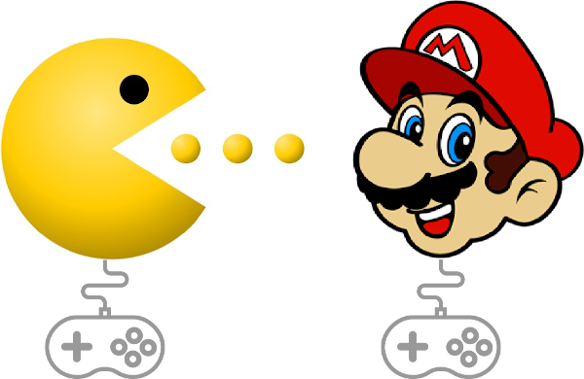

*Programming means that you can create such a world for other people.* Sure, it'll be a while before you're ready to build something like one of the classic games above, but we can start with the essential steps. In this lab we'll learn how to move an element on a page in response to an *event*.

If you haven't already, fork and clone this lab into your local environment. Navigate into its directory in the terminal, then run code . to open the files in Visual Studio Code. Finally, run npm install to install the lab's dependencies.

Go ahead and run the tests. You'll see that you need to create two functions to get the tests passing: moveDodgerLeft() and moveDodgerRight(). We'll write moveDodgerLeft() together, then you'll create moveDodgerRight() on your own.

**Practice Moving Elements on the Page**

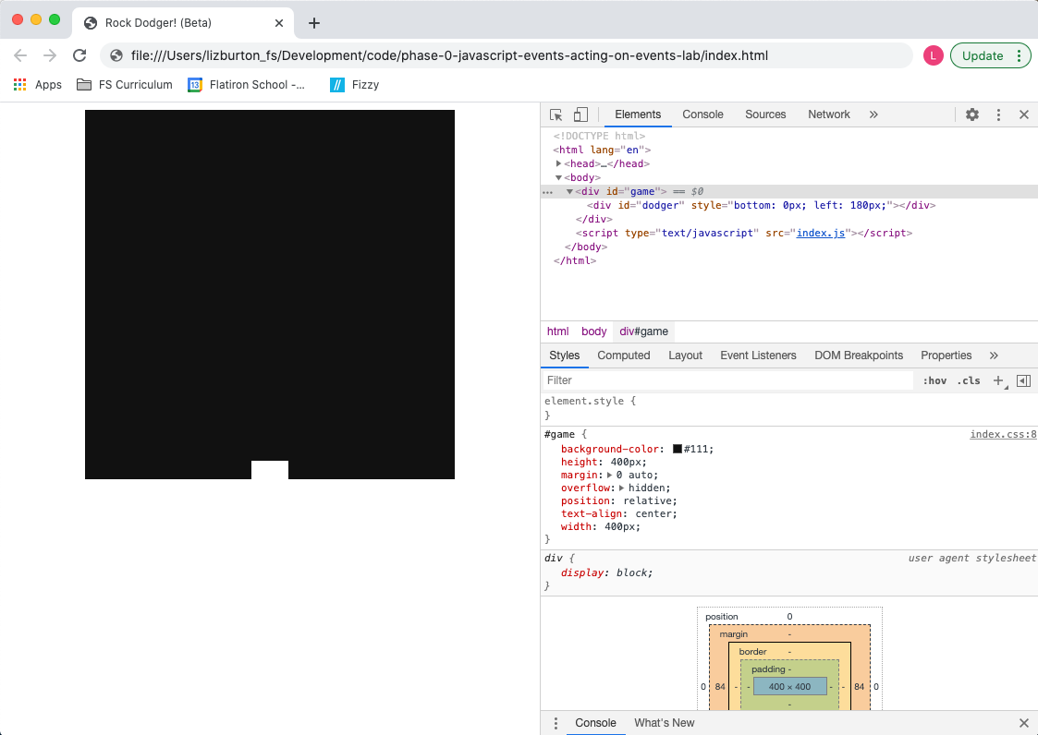

Open index.html in the browser. You'll see a black square which represents the game field and a white rectangle at the bottom of that field which is our game piece, the dodger. Now open DevTools and click on the Elements tab. You'll see that the game field is a <div> with an id of "game." Expand that div and you'll see that the game piece is a second, nested <div> with an id of "dodger."

Click on the game div and take a look at its CSS in the styles tab. You'll see that the game field has a height and width of 400px. Now click on the dodger and note that it has a height of 20px and a width of 40px. Finally, take a look at the inline style on the dodger <div>: the bottom and left properties define the dodger's starting position *relative to its parent element, the game field*. In other words, the lower left corner of the game field corresponds toleft and bottom positions of 0px. The starting values of the dodger's bottom and left properties are what places it at the bottom center of the game field when our game launches.

Before we can use JavaScript to move the dodger, we first need to grab it and save a reference to it in a variable. Enter the following in the console:

const dodger = document.getElementById("dodger");

Awesome. Now let's change its color:

dodger.style.backgroundColor = "#000000";

Whoa, where'd it go? Well, we changed the color to #000000, another way of expressing "black." So it just blends in with the background.

Let's change it to something more visible.

dodger.style.backgroundColor = "#FF69B4";

Much better!



Accessing the style property of the dodger element allows us to change things like the backgroundColor, height, width, etc. We can also use it to change an element's position on the page.

Let's start by moving the element up:

dodger.style.bottom = "100px";

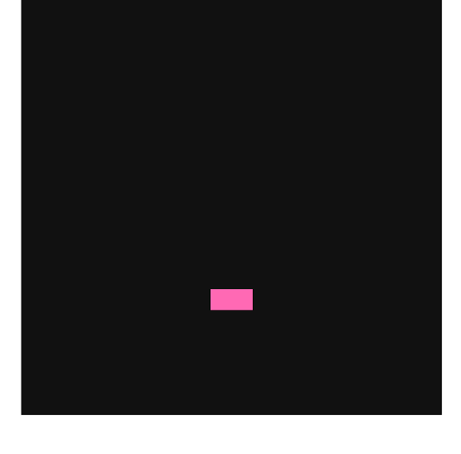

**Note:** Even though we're talking about *numeric* coordinates, note that we need to move the dodger by assigning a new *string value*.

We can verify our dodger's current position by simply typing dodger.style.left or dodger.style.bottom into the console.

Let's return it to where it started by resetting the bottom attribute:

dodger.style.bottom = "0px";

Now let's visually verify that the dodger's position is determined relative to the game field by changing its left attribute:

dodger.style.left = "0px";

You should see the dodger nestled up against the bottom left corner of the game field.

**Demonstrate How to Move an Element in Response to a Browser Event**

Now that we know how to write the code to move the dodger, let's figure out how to tie that action to an event.

Let's say we want the user to be able to move the dodger to the left using the left arrow key. We learned in an earlier lesson that, when a key is pressed, the keydown event provides a code to indicate which key it was. So the first thing we have to do is figure out what code is used to identify the left arrow key. We could look it up, but we're programmers — let's explore!

So what do we mean when we say that an event provides a code? Any time an event listener is in place and the event it's listening for is triggered, a JavaScript object containing a bunch of information about the event is **automatically** passed as an argument to the callback function. We can access that object and the information it contains by defining a parameter for the callback. It looks like this:

document.addEventListener("keydown", function (event) {

console.log(event);

});

By defining the event parameter in the parentheses, we've given the body of the callback access to that event object, which is what allows us to log it to the console. Note that, as with any JavaScript parameter (and, in fact, any JavaScript variable), we can give it any valid JavaScript variable name we like. By convention, and in keeping with programming best practice of using meaningful variable names, the name JavaScript programmers use for this parameter is usually either event or e. You will see these in a lot of JavaScript code, and we recommend you use them as well.

This pattern, when you first encounter it, is tricky to wrap your head around. Don't worry if it doesn't make total sense yet — it will become clearer as you continue through the curriculum. You might also want to read the excellent accepted answer in [this Stack Overflow threadLinks to an external site.](https://stackoverflow.com/questions/35936365/what-exactly-is-the-parameter-e-event-and-why-pass-it-to-javascript-functions).

Let's take a look at what that event object looks like. Enter the code above into the console then click in the browser window (where the game field and dodger are rendered). Now, if you press the left arrow key, you should see a KeyboardEvent logged in the console. Expand the event and you'll see its properties listed; the one we're interested in is the key property. Try pressing some other keys as well and check out their key properties.

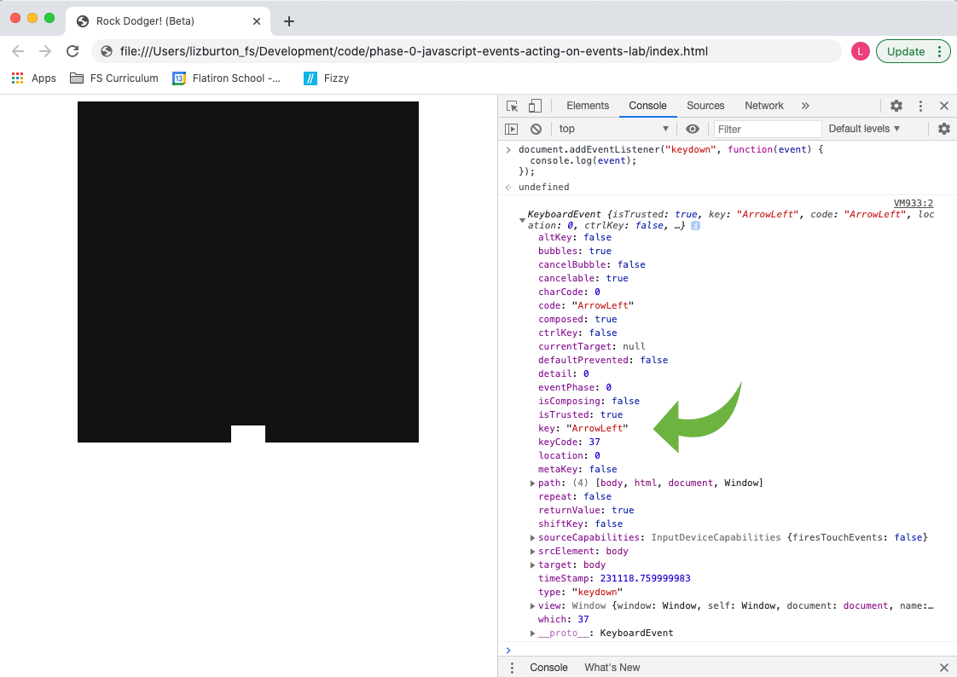

**Top Tip:** You can explore other event types as well: just change the name of the event in the code above.

Now that we know the code the event uses to identify the left arrow key, we can write the JavaScript code to move the dodger left when the key is pressed:

document.addEventListener("keydown", function (event) {

if (event.key === "ArrowLeft") {

const leftNumbers = dodger.style.left.replace("px", "");

const left = parseInt(leftNumbers, 10);

dodger.style.left = `${left - 1}px`;

}

});

So what are we doing here? Well, when our event listener detects a keydown event, we first check to see whether the key property of the event object has the value "ArrowLeft." If it does, we get the current value of the dodger's style.left property and use the [String replace() methodLinks to an external site.](https://www.w3schools.com/jsref/jsref_replace.asp) to strip out the "px", then store the result in leftNumbers. Next, we parse leftNumbers as an integer and store that result in left. Finally, we update the dodger's style.left property using string interpolation, injecting the current value minus 1. If the key that's pressed is *not* the left arrow key, we do zilch. Try it out in the browser yourself!! (Be sure to refresh the page first.)

We do still have a problem, though. Even though we're only going one pixel at a time, eventually our dodger will zoom (well, relatively speaking) right out of view.

How can we prevent this? We need to check where the left edge of the dodger is and only move it if it hasn't yet reached the left edge of the game field.

**Update an Element's Position on the Page Conditionally**

Our callback function is starting to get pretty complex. This is probably a good time to break the dodger's movement out into a separate function. We want to move the dodger left if our if statement returns true, so let's pull out the body of that if statement into a function called moveDodgerLeft().

Refresh the page so we're starting with a blank slate, then grab the dodger again:

const dodger = document.getElementById("dodger");

Now we'll build our moveDodgerLeft() function, adding a check on the current position of the dodger:

function moveDodgerLeft() {

const leftNumbers = dodger.style.left.replace("px", "");

const left = parseInt(leftNumbers, 10);

if (left > 0) {

dodger.style.left = `${left - 1}px`;

}

}

We're doing essentially the same thing, but we first ensure that the dodger's left edge has not reached the left edge of its container.

Now let's wire this up to our event listener:

document.addEventListener("keydown", function (e) {

if (e.key === "ArrowLeft") {

moveDodgerLeft();

}

});

Now try moving the dodger past the left edge. No can do!

Copy the final code into index.js and run the tests. You should now have the first one passing.

**Lab**

Now it's your turn. With the code implemented from the code-along, think about what needs to change to make a moveDodgerRight() function. You'll need to add another condition to your event listener's callback function to call moveDodgerRight(). Then, inside the function, instead of moving the dodger ${left - 1}px, you'll be moving it ${left + 1}px.

**Note:** It may seem logical that you would use the dodger's style.right property to move the dodger right, but that won't work. The reason is that changing the style.right property *doesn't change* the style.left property, which means we'd have conflicting information about where the dodger should be on the screen. JavaScript solves this problem by giving precedence to style.left. In other words, once the user presses the left arrow key for the first time and the value of style.left is changed, any subsequent changes to style.right will be ignored.

Finally, implement the code needed to prevent the dodger from escaping off the right-hand side. How can we check whether the *right* edge of the dodger has reached the *right* edge of the game field? (Keep in mind that the dodger is 40px wide.)

Once you've completed the work to get the tests to pass, the last step is to "try out" your application. Make sure it works the way you expect in the browser. In professional applications, tests can't cover 100% of the use of the application. It's important to realize that "passing all the tests" *is not the same* as "building a working application."

Be sure to do a human-level manual "play through" with your dodger to make sure your working code *really works*!



**Saving Your Work Remotely**

Currently, the work you've done on this assignment is only on your local machine. To preserve your solution on your GitHub fork, you will need to stage the changes you've made, commit them, and push the commit up to GitHub. Use the following commands to do this:

$ git add .

$ git commit -m "Completed assignment"

$ git push

If you visit your fork on GitHub, you should now see that *you've* made the most recent commit, and your code will be present in the files.

**Conclusion**

Events and event handling are vital to web programming. JavaScript allows for dynamic page rendering, so users can interact with the contents of the page in real time. Knowledge of the basic techniques we've learned so far sets you on the road toward being able to create complex interactions like those in video games you may have played before!

[Previous](https://moringa.instructure.com/courses/318/modules/items/59237)[Next](https://moringa.instructure.com/courses/318/modules/items/59239)

**Hosting a Website on GitHub Pages**

**Learning Goals**

* Understand what it means to host a website
* Use GitHub to host a website from a Git repository

**Introduction**

In the earlier days of the internet, if you wanted to publish a custom website, your options were limited, and the process was often complicated. Hosting a site required registering a domain, paying a hosting service, then going through a trial and error process of uploading your website's files to that service.

Now, things are a bit different. Hosting services are still around and you can still register custom domains, but there are many ways to publish websites online now, including a few ways that are totally free for basic websites.

In this lesson, we're going to walk through one free option for hosting HTML and JavaScript based websites. As it happens, we'll be using a service we're already familiar with — GitHub!

**Hosting on GitHub**

Any repository on GitHub can be published as a website — even if the repo doesn't contain any HTML files. By default, GitHub will take a repository's README.md file and convert it to an HTML page. This lesson's repo, for instance, [is also published as a GitHub PageLinks to an external site.](https://learn-co-curriculum.github.io/phase-0-hosting-on-github-pages/).

In addition to this behavior, if we include an index.html in the repository beside the README.md file, GitHub will automatically display the HTML file instead! This is how we'll be publishing our site.

To create and publish your own personal website, the overall process will be:

* Create a local repository folder
* Create a remote GitHub repository
* Add the new remote to the local repository
* Create an index.html file with some basic content
* Add, commit and push the new content to the remote
* Enable GitHub Pages in the remote repository's settings
* Check out the published site
* Continue building out the HTML and add CSS and JavaScript files

**Creating a Local Repository Folder**

In the terminal, choose a good location to store your local repository and navigate to it.

Next, choose a good name for your repo. Names are important. Once you've chosen, create a folder with mkdir then cd into it:

$ mkdir example-repository

$ cd example-repository

We'll come back to this folder in just a few moments. Next, we need to create a GitHub remote repository.

**Creating a New GitHub Repository**

To create a new GitHub repository, go to [https://github.com/Links to an external site.](https://github.com/), click the **+** icon in the upper-right corner of the screen, and choose 'New repository' in the drop-down menu.

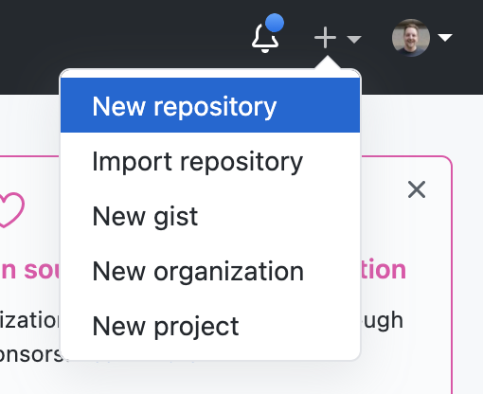

This will bring you to a page where you can set the new repository's name and other settings

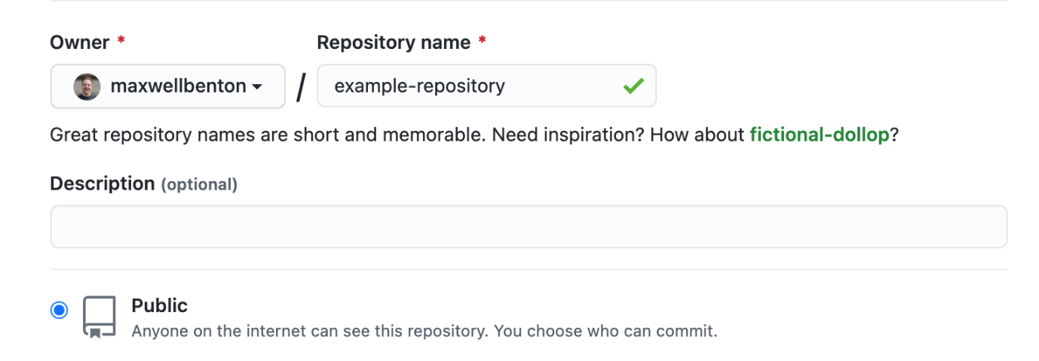

Choose a good name. Names are important. Once the repository is given a name, we'll leave the other options as they are and click the "Create Repository" button.

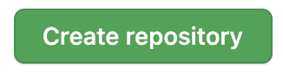

An empty repository will be created.

**Add The New Remote To Your Local Repository**

Because it has no content, you'll be presented with a set of different options for getting things started. This time, we'll choose to **create a new repository on the command line**.

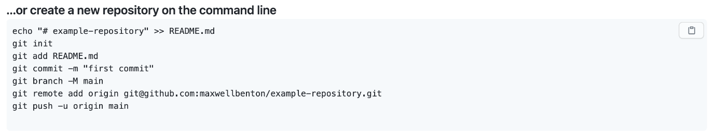

Notice that some of the commands shown here have information unique to the repository and GitHub user. Your commands will differ slightly from the examples because of this.

All the commands we need to get set up are provided here. You can choose to copy and paste these commands from GitHub one at a time or copy and paste them all at once. We recommend you take a moment to review what each command does:

1. echo "# example-repository" >> README.md creates a README.md file and adds some markdown.
2. git init initializes a local repository in the folder you're currently in on the command line
3. git add README.md stages the newly created README.md file, getting it ready to be committed
4. git commit -m "first commit" creates the repository's first commit, preserving the newly created README.md file in the history of the repository
5. git branch -M main ensures the default repository branch is set to main
6. git remote add origin git@github... associates the remote GitHub repository with the new local repository. This association is given the name origin.
7. git push -u origin main pushes the commit we just created to the remote repository.

Once all commands are executed, refresh your GitHub repository and you should see that the README.md file now appears on GitHub. With a repository set up, the next step is to create a basic HTML file to serve as the start of our website.

**Build an HTML file**

In the terminal, create an index.html file:

$ touch index.html

Open this file in your text editor so we can add some basic HTML content. In the file, we'll start with the minimum — a DOCTYPE tag indicating HTML and an html tag containing head and body tags:

<!DOCTYPE html>

<html lang="en">

<head> </head>

<body></body>

</html>

Let's give this HTML a title tag and place it inside head:

<head>

<title>My Website</title>

</head>

Finally, we'll add a bit of starter content in the body:

<body>

<h1>Hello World!</h1>

</body>

Including some example text to start is important — when we publish the site, we'll be looking for this message to confirm everything worked. The completed file should look like this:

<!DOCTYPE html>

<html lang="en">

<head>

<title>My Website</title>

</head>

<body>

<h1>Hello World!</h1>

</body>

</html>

Save the file. We now need to commit this file and push it to GitHub:

$ git add index.html

$ git commit -m "create basic HTML file"

$ git push

Time to head back to GitHub!

**Publish HTML as a GitHub Page**

In your GitHub repository, click the **Settings** tab:

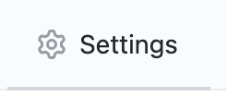

Scroll through the settings until you find the **GitHub Pages** section:

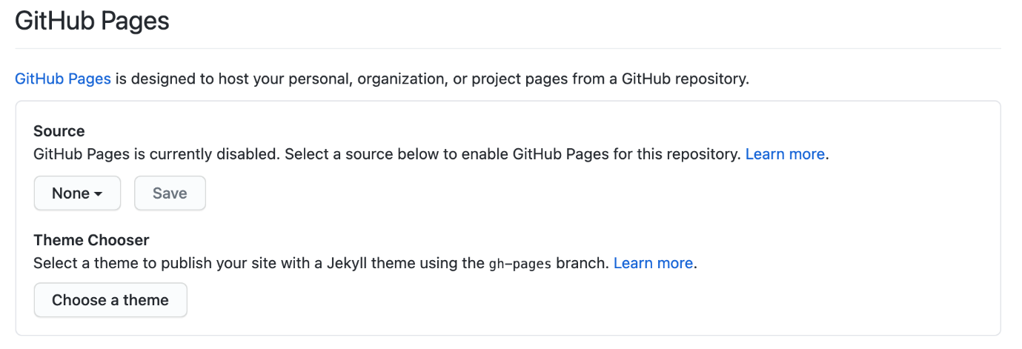

To enable GitHub Pages, first we need to set the **Source** to the default branch. Click the drop-down that says "None," then choose main.

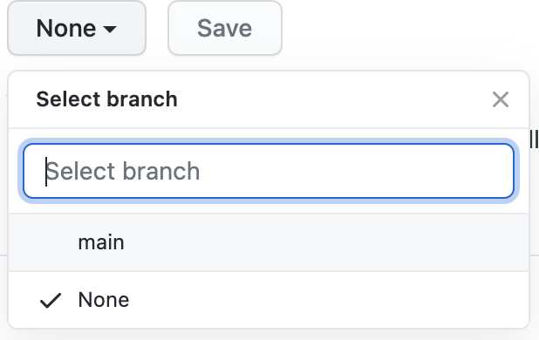

Once set, click **Save**:

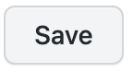

The page will refresh. Along the top, a banner should appear that states the GitHub Page source was saved:

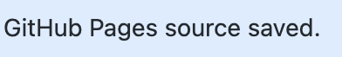

Scroll back to the **GitHub Page** settings. A new message will be present that includes a link to the newly published page:

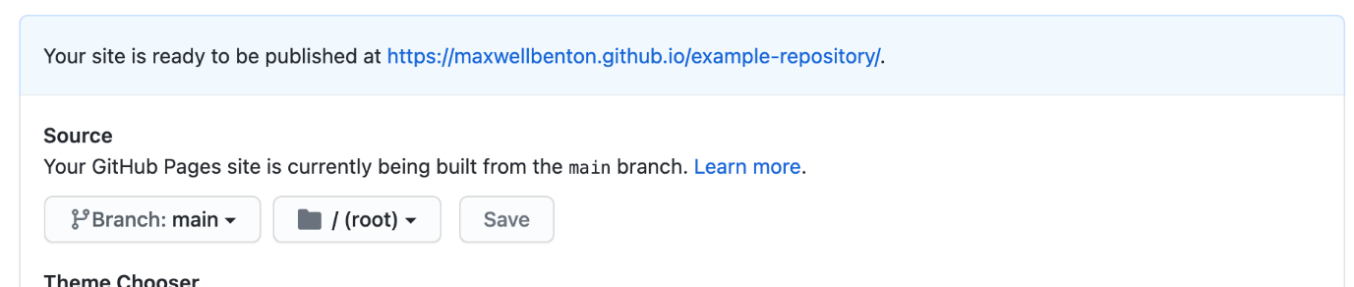

Notice the URL isn't github.com/<your-username>, but instead, <your-username>.github.io.

Clicking on this link immediately may bring you to an error page. It can typically take up to ten minutes for the page to appear after being published, so wait a little bit and refresh. On refresh, you should see your HTML page rendered:

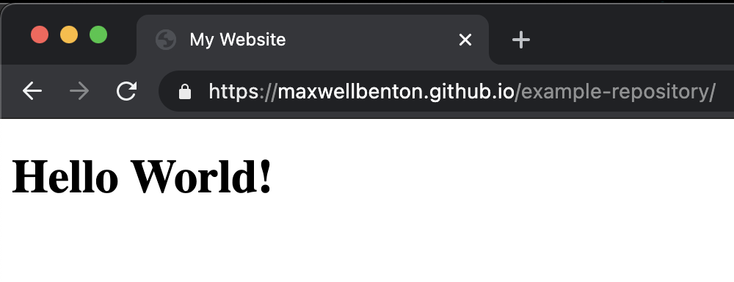

Woo-hoo!

**Troubleshooting**

In the event that it isn't a woo-hoo for you, here are a few troubleshooting options to try:

* Double check the GitHub Page settings and make sure main is set as the source
* If settings are correct, review the index.html file to make sure there are no typos or syntax errors
* Create a new repository again, but hold off on creating an HTML file. Instead, only create a README.md file with some example text and use GitHub Pages to publish the repo. Once the Readme file is displaying as a GitHub Page, start going through the HTML file creation process again.

**Continuing To Build**

With an index.html file created, it is possible to add additional files to the site to incorporate CSS and JavaScript. One of the great things about GitHub Pages is that your published website will automatically update as you make changes to the repository files and push them to your remote. The process for updating becomes:

* Create or modify a file
* Add, commit, and push it to your remote
* Wait a few minutes for GitHub to update your page
* Visit your GitHub Page to see the newest changes

From here, you can choose to do whatever you like and customize your site as you please. However, we recommend adding and connecting two files now: a CSS file to style your HTML, and a JavaScript file to run code and manipulate the DOM.

**Add and Connect a CSS File**

In the terminal, create a CSS file alongside your index.html file

$ touch style.css

Before we connect this file to our HTML, let's add a basic style rule to the file and save it so we'll know when the styling is working.

body {

background: blue;

}

Now, to connect this CSS file to our index.html, we need to modify the HTML head to include a link tag:

<head>

<link rel="stylesheet" href="style.css" />

<title>My Website</title>

</head>

The link tag is used to connect files to the HTML page. Note the tag has two attributes. The first is rel, which specifies how the connected file relates to the HTML. In this case, we're indicating that we're relating a *stylesheet*.

The second attribute is href, which specifies the location of the file we're linking. Since we've put style.css right beside index.html in our repository, we can just provide the file name here.

Save the HTML file and open it locally. Your page should now be very blue.

Go ahead and add some better styling, then add, commit, and push the changes you've made. Remember, since you've added a style.css file and modified the index.html file, we'll need to add both files before committing:

$ git add style.css

$ git add index.html

$ git commit -m "add style.css, connect to index.html"

$ git push

**Add and Connect a JavaScript File**

In the terminal, create a JS file alongside index.html.

$ touch script.js

Let's add some basic code so we can see something once we've connected the JS file to our HTML file.

In script.js, let's create an h2 element and add some text content to it:

const h2 = document.createElement("h2");

h2.textContent = "This content added by JavaScript";

Now, we'll include code to add this h2 element to the body element in the DOM.

document.querySelector("body").appendChild(h2);

Save this and switch over to index.html. To connect script.js to our HTML, we add a script tag inside body.

<script src="script.js"></script>

This tag includes a src attribute. Like href from the link tag, src specifies the location of the script we want to run. Since script.js is side by side with index.html, we just write the file name.

After adding the script tag for JavaScript and the link tag for CSS, our HTML will look like this:

<!DOCTYPE html>

<html lang="en">

<head>

<link rel="stylesheet" href="style.css" />

<title>My Website</title>

</head>

<body>

<h1>Hello World!</h1>

<script src="script.js"></script>

</body>

</html>

Open the file locally. In addition to "Hello World!" being displayed, you should also see "This content added by JavaScript," confirming the code successfully ran.

Go ahead and add other JavaScript if you'd like, then add, commit, and push the changes you've made. Since you've added a script.js file and modified the index.html file, we'll need to add both files before committing:

$ git add script.js

$ git add index.html

$ git commit -m "add script.js, connect to index.html"

$ git push

Remember when you push changes to GitHub, they will take a few moments to appear in GitHub Pages.

**Conclusion**

As it turns out, the technology we were already using to store our code is also useful for publishing websites. If you have any existing repositories that include HTML, you can now quickly turn your work there into shareable websites.

It makes sense if you consider GitHub is *already* storing your code. The work required to display the contents of an HTML file in your browser versus *render* that HTML file is similar.

As you continue your programming journey, you'll eventually start building parts of websites that can't be published using GitHub. Sites that require a server to store data, for instance, can't be published on GitHub Pages. GitHub is just rendering files it already has; it won't do more work than that. It turns out, that is actually quite a lot, though.

Many websites are made up of two pieces, a frontend and a backend. The frontend is what the client experiences, what renders in the browser, while the backend handles data storage and other work we don't want to burden the frontend with. GitHub Pages will work well as a host for most frontends, even those using modern frameworks like React. You'll soon see that frontends alone can actually be quite interesting and useful, even without a backend.

For simpler websites — personal sites, projects, etc... — GitHub pages is a great, free option for publishing content online.

[Previous](https://moringa.instructure.com/courses/318/modules/items/59239)[Next](https://moringa.instructure.com/courses/318/modules/items/59241)

**Project: Build a Personal Website**

**Learning Goals**

* Build a website using HTML, CSS and JavaScript
* Publish a website

**Introduction**

You've been learning HTML, CSS, and JavaScript over the previous lessons. You've been receiving specific guidance ("Use a <link> tag!") and have been steered by our documentation or tests. In an effort to help you build your confidence, we're going to give you *nothing* except some specifications and leave the document structure and styling *to you*. It's time to tie all your learning together into one project. You must create...

...*a personal website*!

Professional software engineers and web developers often have a personal website. In some ways, it is the industry's alternative to a business card. A personal website can showcase your abilities while also giving visitors a sense of your personality.

**Requirements**

This project is an opportunity to showcase what you've learned so far, so it is important that HTML, CSS, and JavaScript are incorporated into the project in some way. For example, you could use a mouseover event to change the appearance of an element when the user mouses over it. Or use a click event to toggle some content between being visible and hidden. There are a variety of ways to do this using the CSS and JavaScript you've learned so far, but don't forget you can always use Google if you get stuck. Google is an invaluable tool for developers! Try to use this project as an opportunity to stretch your coding skills!

The content, styling, and functionality of your site are up to you. Keep in mind that you may show this project to your peers and future instructors, so be considerate of content/subject matter and your potential audience.

**Getting Started and a Recommended Workflow**

Review the previous lesson, **Host a Site on GitHub**, for guidance on setting up the necessary HTML, CSS, and JS files, and instructions on how to publish a site on GitHub Pages.

We recommend going through these steps first — create and connect the necessary files *and* get them published before diving into writing too much HTML and JavaScript. If you've got everything published, you'll be able to continuously push updates to your site *as you build it*.

In general, when it comes to building code-related projects, it is often best to establish a routine of making small improvements, checking to make sure those improvements work and don't break things. After creating the basic files and connecting them, open your HTML file in a browser tab and your files in a code editor, this routine might look something like the following:

1) Write some HTML, CSS or JavaScript 2) Go to your browser and refresh the page to see the changes 3) Adjust your code and repeat until you're satisfied 4) Move on to the next task and repeat the process

It is very common to get lost in coding and to keep going from one task to the next without checking your work. The problem here is that if you make a mistake it becomes more and more difficult to spot the error and can cause you to backtrack and spend extra time debugging.

By frequently checking your work, you'll set your own project milestones — at each one, you can verify everything is working so when you *do* make a mistake, you'll know it was made recently.

**Professional Git Development Workflow**

When it comes to Git, there is ultimately no rule that says you *must* do things a certain way. However, if there was anything we could impart to you regarding good version control habits, it would be this — commit code frequently.

As mentioned, it is a common habit to dive into the code of a project and write as much as you can, for as long as you can. However, not only does this increase the chance for bugs, it will result in very large Git commits or just *one* big commit for everything.

Repositories with a good commit history can relay a story about their development from just the commit messages alone. For example, instead of the commit history looking like this:

* Commit 1: "Initialize Repository"
* Commit 2: "Finish website"

A good history might look closer to this:

* Commit 1: "Initialize Repository"
* Commit 2: "Add basic HTML, CSS and JavaScript files"
* Commit 3: "Create initial HTML content"
* Commit 4: "Add CSS rules"
* Commit 5: "Fix syntax issue in HTML"
* Commit 6: "Finish bio/about section"
* Commit 7: "Add JS event listeners"
* etc...
* Commit 22: "Adjust styling for new HTML layout"
* Commit 23: "Finish website"

The commit messages here suggest that each commit above addressed a small, often *singular* task.

Good commit practices are critical for large companies and organizations where many developers are working on large code-bases — in these cases, limiting the size of commits makes it easier for others to understand what changes the commit brings. If a commit introduces a bug into the code base, it is fairly easy to revert a *small* commit. A big commit, on the other hand, may require lots of extra work to untangle and fix.

For personal development, though, the same concerns apply. In addition, when you start building more complex projects, you may find yourself in situations where you'd like to go back to an earlier version of a project. Taking the time now to build good habits will help you many times over in the future. Think of good version control habits as a favor to your future self!

**Conclusion**

Once you've finished building your website, make sure to push it all up to GitHub. If you followed our advice and set up GitHub Pages first, you've now successfully built *and* published a website! Fantastic work!

[Previous](https://moringa.instructure.com/courses/318/modules/items/59240)[Next](https://moringa.instructure.com/courses/318/modules/items/59242)

Configuring the Flatiron Student Portal

* **Due** No Due Date

* **Points** 1

* **Submitting** a website url

**Introduction**

**NOTE:** In this lab, you will be setting up a new tool that will simplify the process for forking labs, running tests, and submitting your work. **Please wait to fork this lab until you are told to do so in the instructions below!**

As you continue your journey into programming, you will learn to use many tools to make your work easier that you only *sort of* understand. Node packages, Ruby gems, libraries, command-line applications, frontend frameworks, etc... many of these tools are actually built out of *other* tools, things you may never have heard of. That is okay.

Thanks to the collective work of many programmers around the world, we're able to tap in to a diverse ecosystem of tools. We don't need to know how they all work together for them to be useful to us. You might one day know JavaScript well enough to build your own version of [ReactLinks to an external site.](https://reactjs.org/" \t "_blank), but you'll be able to use React long before you know how all the parts work. Many of these tools are designed to solve problems so we can focus our energy and time elsewhere.

We've already used a few tools to help us get started with programming. If you recall from the previous installation instructions, we've installed NVM, the Node Version Manager, which manages which version of Node you're using on your computer. We've been using NPM, Node **Package** Manager, to run local tests. We've also been using Git in the command line to interface remotely with GitHub.

In this lesson, we're going to introduce another tool that will help us going forward, the learn-co gem.

**The learn-co Gem**

So, if all these tools we use are meant to solve problems, what problems does the learn-co gem solve?

In your assignments so far, after cloning a repository, you typically do a few things while working through the assignment:

1. Run npm install or bundle to install any necessary dependencies for the repository (*...tools others have built to make things easier for us*)
2. Run npm test or rspec to run tests
3. Git commit and push your work to your GitHub remote repo

Once you've pushed your solution up to GitHub, you then have to submit a link in Canvas.

The learn-co gem will take care of all of these steps using a single command, learn test! Let's get the gem installed and configured so we can test it out.

**Note:** The instructions here assume you've successfully installed Ruby and Node in the previous environment setup instructions.

**Install the learn-co Gem**

To install the gem, run the following in your terminal:

gem install learn-co

Before we can use the gem, we'll need to do a few things:

* Connect your Flatiron School Portal account to GitHub
* Connect the local gem to your Flatiron School Portal account

**Connect Your GitHub Account to your Flatiron School Portal Account**

**Action Item**

1. Open [Flatiron School's Base Account Management pageLinks to an external site.](https://base.flatironschool.com/account/manage) ([https://base.flatironschool.com/account/manageLinks to an external site.](https://base.flatironschool.com/account/manage))
2. Connect your GitHub account to your Flatiron School Portal account

You should now see something similar to this:

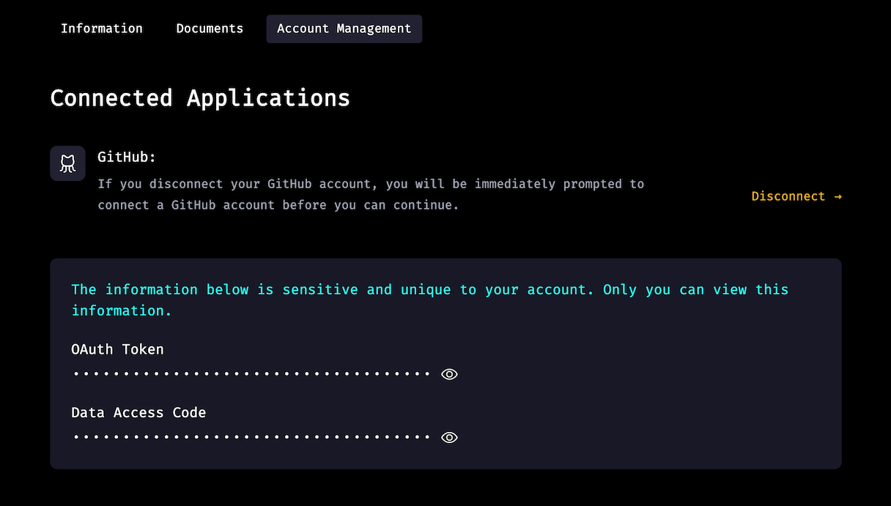

**Configure the learn-co Gem**

This step will ask you to do work both in your browser and your terminal.

**Action Item**

1. Open the "Terminal" application (or "Ubuntu" for WSL users).
2. Type touch ~/.netrc && chmod 0600 ~/.netrc and press <Enter>. *(Note: you may be asked to enter your password.)*
3. Open [Flatiron School's Base Account Management pageLinks to an external site.](https://base.flatironschool.com/account/manage) ([https://base.flatironschool.com/account/manageLinks to an external site.](https://base.flatironschool.com/account/manage))
4. Click the icon under "OAuth Token" to reveal your GitHub OAuth token.
5. Copy the string of characters under the "OAuth Token" header.
6. Go back to the terminal, type learn whoami and press <Enter>.
7. Paste the string of characters at the prompt and press <Enter>.

**Check Your Work**

Type learn whoami in the terminal. If you see a message with your name, username, and email, you've successfully configured the gem.

**Using the learn-co Gem**

The learn-co gem replaces some steps in the assignment workflow you've learned so far and alters others. Let's walk through the updated process. Use this assignment to follow along:

1) On this assignment's Canvas page, click the **Fork** button in the upper right corner of the page:



You should notice a change in the button's behavior — rather than bringing you to the fork page in GitHub, you'll be redirected to your repository *already in the process* of being forked.

2) Once your fork is ready, click the **Code** button and copy the **SSH** repository info by clicking the clipboard button.



**Note:** Make sure you're choosing SSH and not HTTPS.

3) In your terminal, navigate to where you'd like to put this repository locally, clone it down and navigate into the folder.

git clone git@github.com:<your-github-account-name>/macos-env-flatiron-student-portal.git

cd macos-env-flatiron-student-portal

4) Instead of running npm install and npm test (or bundle and rspec), you can now run one command, learn test, to handle this step. This command will automatically run the installation and test commands. You should see a flurry of text as dependencies are installed, then the results of your test. This assignment has the same test as the previous **Complete Your First Software Engineering Assignment**. By cloning this assignment down, you've already passed the test!

This assignment

✓ has been correctly cloned to your local environment

1 passing (5ms)

When all tests are passing, you can head back to the assignment on Canvas. Refresh the assignment page and you should see that Canvas now registers the assignment as both **Submitted** and **Complete**. A URL to your fork of the assignment has been submitted in Canvas, so you are ready to move on to the next lesson.

Each assignment will be different and will include instructions on what is required to complete it. Some labs will have many tests. You can run learn test as many times as you'd like while working to solve these labs. You will submit your work to Canvas each time you do, but the assignment will be marked **Incomplete** until all tests are passing.

**Your Work in GitHub**

Every time you run learn test, all the changes you've made locally will be stored on your GitHub fork of the repo. If you head back to your repo after running learn test, you should see a message that a new branch, fis-wip, has been created. This branch contains the work you've done so far. If you ever want to go back to a previous solution, go to that repository on GitHub and switch to the fis-wip branch.

You no longer need to commit and push your local work for these assignments.

**Note:** if you see the following message on your repo's page in GitHub, please disregard it:



**Types of Assignments**

For most assignments, you will go through the process we just walked through. In our curriculum, these assignments are often referred to as **labs** — coding lessons that include tests. There are a few other types of assignments, though, that require slightly different submission steps:

* **Code-alongs:** These also require code, but will guide you through what needs to be written. There are no tests to pass, but you will still need to go through forking, cloning, and running learn test. You should see a message stating that no tests were found, but if you check the assignment in Canvas, you should see it is marked as **Complete**.
* **Portfolio Projects:** For these assignments, you'll be building fully functional applications. Some guidelines and requirements will be provided, but it will be up to you to design and create your own app. These will eventually become the projects you showcase to potential employers! You will submit your projects in Canvas by submitting a link to your GitHub repo.
* **Blog Submissions:** Blogs are a required part of our Software Engineering courses. They help to develop your online presence and are a great way to reinforce the concepts you learn. You'll write your blog posts on a different platform, but submit links to them in Canvas.

**Submitting Projects and Blogs**

For both portfolio projects and blog posts, you'll need to manually submit a link to your work on Canvas. While viewing the assignment, you should see a **Submit Assignment** button in the upper-right section of the page.

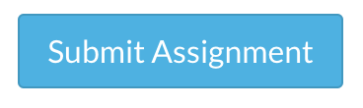

Clicking this button will bring you to the bottom of the page where you can submit a URL link to your work.

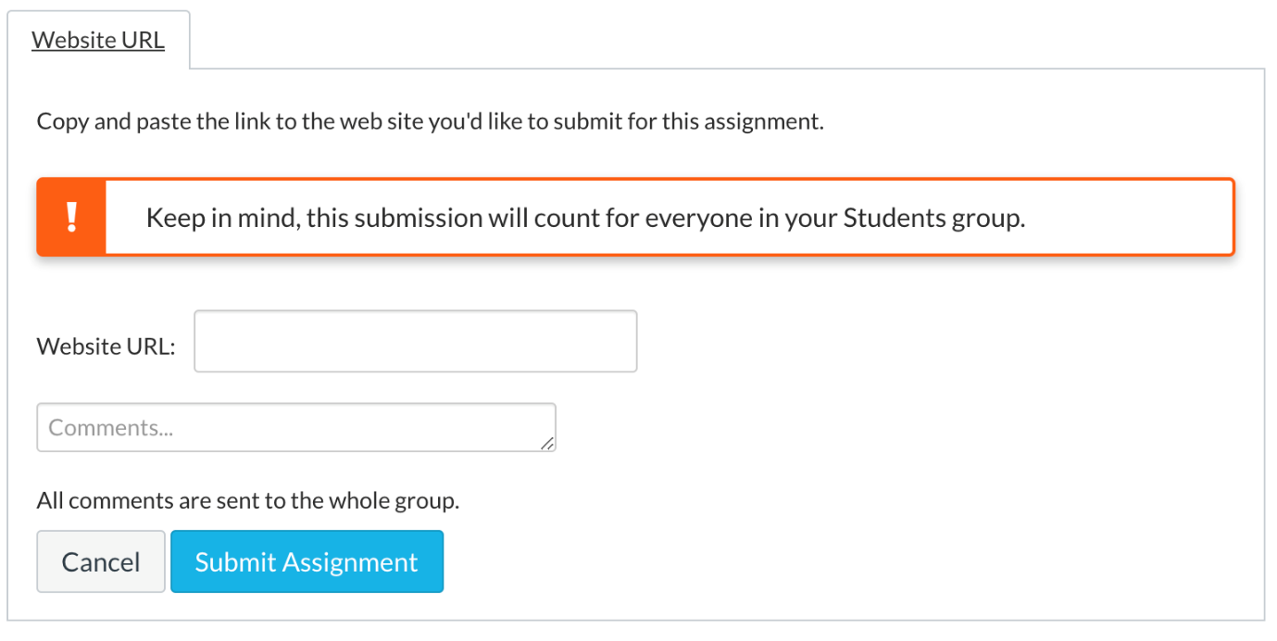

Upon submission you should see confetti appear, indicating that your submission has been accepted.

**Note:** It is possible to submit lab and code-along assignments manually this way. However, the assignment will only be marked as **Submitted**, not **Complete**.

**Conclusion**

You've completed your first assignment using the learn-co gem! You now know how to work on and submit assignments going forward:

* Click the **Fork** button on the Canvas assignment
* Once the assignment is forked, clone it down to your local machine
* Complete any required work, then run learn test
* If all tests pass, the assignment will be submitted to Canvas and marked as **Complete**
* Your work will also be pushed to GitHub and will be available on the fis-wip branch

Equipped with this knowledge, you are now ready to tackle greater challenges!

[Previous](https://moringa.instructure.com/courses/318/modules/items/59244)[Next](https://moringa.instructure.com/courses/318/modules/items/59246)

**Useful Reading & Exploration**

If you have successfully completed all your installations and checks for understanding, consider engaging in the readings below.

Remember, it is important for you to complete the installations first. Please reach out to your TMs if you need support.

1. [Everything HTML (Links to an external site.)](https://www.w3schools.com/html/html_basic.asp)
2. [Contains a bunch of resources that will help you understand HTML  (Links to an external site.)](https://medium.com/level-up-web/30-html-css-resources-for-beginners-4e4d0af4b44b)
3. [Simple introduction to HTML & CSS + responsive design (Links to an external site.)](https://www.universalclass.com/articles/computers/an-css3-and-html5-introduction-to-responsive-web-design.htm)
4. [Contains a walk-through of creating a simple login page design (Links to an external site.)](https://medium.com/the-andela-way/basic-introduction-to-css-81f6041b92d0)
5. [Eloquent Javascript  (Links to an external site.)](https://drive.google.com/file/d/1oZLuPvBUXeNqHvcpr-VsjGkc6tWIsO9M/view)

We look forward to working more closely with you during Prep!

[Previous](https://moringa.instructure.com/courses/318/modules/items/59245)